Cover Allocation Program NEA (Saif Emara)

Table of Contents

1. Analysis 5

1.1 Background Info & Introduction: 5

1.2 Research and Interviews: 5

1.2.1 Interview 1: 5

1.2.2 Summary of Interview 1: 7

1.2.3 Interview 2: 7

1.2.4 Summary of Interview 2: 9

1.2.5 Interview 3: 9

1.2.6 Summary of Interview 3: 10

1.2.7 Questionnaire: 11

1.2.8 Questionnaire Observations: 14

1.3 Current System: 14

1.3.1 Observations: 14

1.3.2 Step by Step Overview: 15

1.3.3 Current System’s Documents: 17

1.3.4 IPSO: 18

1.3.5 Data Dictionary: 19

1.3.6 Context Diagram: 19

1.3.7 Data Flow Diagram: 20

1.3.8 System Flowchart: 20

1.3.9 Overall Problems with the Current System: 22

1.4 Users: 23

1.4.1 Prospective Users: 23

1.4.2 User Needs: 23

1.5 Objectives: 23

1.5.1 Acceptable Limitations: 23

1.5.2 Final Objectives: 24

1.6 Solutions: 25

1.6.1 Languages: 25

1.6.2 Chosen Solution: 26

2. Documented Design 26

2.1 Data Handling Models and Diagrams: 26

2.1.1 Pre-Normalization: 26

2.1.2 Normalization Process: 28

2.1.3 Post-Normalization: 30

2.1.4 Data Dictionaries: 31

2.1.5 SQL Statements: 35

2.1.6 Data Flow Diagrams: 38

2.2 Overall System Design: 39

2.2.1 Top-Down Diagram: 39

2.2.2 IPSO Chart (Input, Process, Storage, Output): 39

2.3 Data Structures: 40

2.3.1 Data Dictionary: 40

2.3.2 Record Structure: 40

2.3.3 Data Structure: 41

2.3.4 Hashing: 41

2.4 OOP Class Design: 42

2.4.1 Inheritance Diagram: 42

2.5 Interface Design: 43

2.5.1 Interface Flowchart: 44

2.5.2 Login and Registration: 44

2.5.3 Main Screen: 45

2.5.4 Absence Reports: 47

2.5.5 Adding Teacher Data 49

2.5.6 Accessing the Database: 50

2.6 Algorithms: 52

2.6.1 Cover Allocation Algorithm: 52

2.6.2 Validating Password Algorithm: 58

3. Testing: 58

3.1 Test Plan: 58

3.1.1 Part 1 (User Authentication and Access Control): 58

3.1.2 Part 2 (User Friendly GUI Design): 60

3.1.3 Part 3 (Cover Allocation Algorithm): 61

3.1.4 Part 4 (Database Update and Verification): 62

3.1.5 Part 5 (SQL queries view, edit, and delete): 62

3.1.6 Part 6 (Qualitative Factors): 63

3.1.7 Part 7 (Failed Tests and Fixes): 63

3.2 Testing Video Evidence: 64

3.3 Screenshot Evidence for the Main 7 Objectives: 64

3.3.1 Objective 1: 65

3.3.2 Objective 2: 68

3.3.3 Objective 3: 73

3.3.4 Objective 4: 75

3.3.5 Objective 5: 79

3.3.6 Objective 6: 80

3.3.7 Objective 7: 81

4 Technical Solution: 84

4.1 Tables and Relationships: 84

4.1.1 Creating Teachers Table: 84

4.1.2 Creating Weekly Lessons Table: 84

4.1.3 Creating Absence Table: 85

4.1.4 Creating Hashing Table: 86

4.2 System Overview: 86

4.2.1 System Overview Diagram (Top Down): 86

4.2.2 Evidence of Built Classes, UI, Procedures and Variables: 86

4.3 Skills Checklist: 209

4.3.1 Skill Table: 209

4.3.1 Candidate written classes (OOP): 209

4.3.2 Complex standard algorithms and structures (trees): 210

4.3.3 Use of regular expressions: 215

4.3.4 Use of hashing techniques: 216

4.3.5 Use of recursion: 218

4.3.6 Merge sorting: 219

4.3.7 Time simulation / scheduling: 220

4.3.8 Complex client server model: 221

4.3.9 A complex data model with many related tables: 225

4.3.10 Using parameterized cross-table SQL statements: 227

4.3.11 User generated Data Definition statements: 228

5 Evaluation: 230

5.1 Comparing Performance against Objectives: 230

5.2 Getting and Analyzing Independant Feedback: 232

5.2.1 Response from End User: 233

5.2.2 Response from Mr. Jeremy: 234

5.2.3 Comments: 234

5.2.4 Improvements: 235

5.2.5 Things I would do differently: 235

6 References & Sources: 236

6.1 References: 236

6.2 Sources: 236

# 1. Analysis

## 1.1 Background Info & Introduction:

**GEMS Founders School** is a private educational institution located in Dubai, United Arab Emirates. Established in 2016, the school has seen remarkable growth, currently serving 6239 students and continuing to expand each year. GEMS Founders School offers a comprehensive education across three key academic levels: **Foundation Stage**, **Primary**, and **Secondary**.

For this project's purpose, **our focus will be on the Secondary School**, which accommodates 2744 students and is staffed by a dedicated team of 200 teachers.

Like any large organization, GEMS Founders School faces operational challenges, one of which involves managing unexpected teacher absences. On the mornings when teachers call in sick or are otherwise unable to attend, it becomes the responsibility of the **Senior Leadership Team (SLT)** to assign substitute teachers to cover those classes. This often involves coordinating with unoccupied teachers or adjusting schedules to ensure minimal disruption to students' learning, which has proven to be a challenge both coordination wise and in the spirit of ensuring teachers do not cover too many or too less.

## 1.2 Research and Interviews:

### 1.2.1 Interview 1:

Date: 8/9/2024  
Interviewee: Mr. Jeremy Grigg

* Good afternoon, sir. Thank you for meeting with me. Can you please state your name and position for the record?
* My name is Jeremy Grigg, and I am the Deputy Headteacher of Secondary.
* Okay, great. So, I just want to ask you a few questions.   
  Could you provide a brief overview of the current cover system?
* Yes. So, staff are required to phone in in the morning between 6am and 6.30am to report any absence. And then the Deputy Headteachers organize the cover for the day from there, based on the timetables of all the other teachers in school.
* What improvements do you think could be made to the current system? And are there any specific challenges that you're currently facing?
* So, I think a change that could be made to the system is to identify who is free at that time, on a fair basis, based on their allocations, depending on their position. And because the current challenge now is being fair to everyone. So, when you're setting cover throughout the week, you have an awareness of who you've already given cover to, so you try to be fair and not allocate them again if you can.
* Okay. So, on average, how many teachers would you say call in absent on a weekly basis?
* It varies, but probably somewhere between 5 and 10, probably nearer to 10. And as the term goes on, and people work longer, and their immune system gets weaker, because they're working for longer hours, you find that the absent rate goes up. So, at the beginning of the term, it's quite low, because people have just had a holiday, and they're relaxed and rejuvenated, but then after maybe 3 or 4 weeks, it starts to become more common for people to phone in absence.
* Can you recall a time when it was extreme?
* I recall there was a bout of food poisoning in one of our departments, where they all went out for a meal together. So, that meant that 7 out of the 20 were absent for 2 days running. So, that's 35% out.
* Where is the data related to all cover lessons stored, in terms of documents? And would it be possible to grant me access to this data?
* It's stored in the Deputy Head's Cover Folder. I believe we would be able to provide you with the data, but I might have to remove the names, and just have them saved as Teacher 1, Teacher 2, Teacher 3 etc. But in terms of the data that you need, in terms of a teacher timetable, we'd be able to provide you with that.
* Great. Could you describe the cover allocation process in as much detail as possible, including when, how and where data is received?
* Okay, so, if we were informed about the absence at least 24 hours in advance, the teacher will let their head of department know, and the head of department will record that in a central file, so that the deputies can look at that and plan. However, If the absence is only known about on that day, where the teacher calls in between 6 and 6.30, and then that gives the deputy head between 6 and 7, to work out who's going to be covering that lesson. So, the deputy head will organize that and then publish that by 7am, to all the secondary staff.
* That is all for now thank you for your time.
* Of course it has been a pleasure

### 1.2.2 Summary of Interview 1:

After my meeting with Mr. Jeremy, I was able to develop a clear idea of how the current cover allocation system worked in the secondary school and I started to have a brief idea of the exact problem I plan to solve.

### 1.2.3 Interview 2:

Date: 11/9/2024  
Interviewee: Mrs. Sharol Serrao

* Good morning, thank you for meeting me today, I'd like to ask you a few questions about your interactions with the current system put in place to handle cover allocations.
* Of course, I’d love to answer a few questions.
* To begin do you mind stating your name and position?
* My name is Sharol Serrao and I’m a mathematics teacher for KS4 and KS5 in GFS.
* Can you describe your overall experience with the current cover allocation system?
* I suppose I can say that the system works fine, it can be a little hectic at times especially when there are multiple absences on the same day.
* How often do you find yourself having to cover for an absent colleague?
* Honestly, it varies. There are some weeks where I don’t have to cover any lessons at all, on the other hand during flu season or when there are lots of planned absences, it can be more frequent like 2 or 3 times a week.
* Do you feel the current system is efficient at allocating covers?
* If we are referring to efficiency, I wouldn't call it the most efficient, since it is done manually, it often depends on which member of staff is available at the current moment rather than finding the teacher best suited to that specific class or subject.
* How long would you say it takes for you to receive the final cover allocations for that day?
* Well, the first lesson starts at 7:40 so on average I would say I am informed 15 to 30 minutes before that. However sometimes it's done at the last minute just before the lesson starts.
* How do last minute allocations affect your teaching schedule and lesson preparation?
* Usually if im covering a class im not familiar with I would have to quickly go over their lesson plan which can impact the quality of the classes I teach.
* Do you believe having covers automatically allocated would be beneficial?
* Yes, because I think again it would allow for covers to be allocated more efficiently taking all factors into account and making sure that teachers cover lessons equally or for a lack of a better work fairly.
* What improvements or changes would you suggest making the current system better?
* As you mentioned I think an automated system that can efficiently match teachers to the most suitable cover lesson based on their schedule and field would be extremely helpful. Moreover, it would give us more time to prepare, improving the quality of the lessons we cover.
* Those are all the questions I have, thank you for meeting me.
* You're very welcome.

### 1.2.4 Summary of Interview 2:

After my meeting with Mrs. Sharol, I now have a clear idea of how the current system works from the end users’ point of view and what it affects, with some of its main flaws being highlighted.

### 1.2.5 Interview 3:

Date: 13/9/2024  
Interviewee: Mr. Jeremy Grigg

* Good morning, Sir, I’d like to thank you for meeting on short notice, I'd like to ask you a few questions about prospects for the system I plan to develop.
* Of course, what would you like to know
* If the new software had a login system, do you believe different permission levels for different users would be beneficial? And if so, what information do you think would be required for these logins?
* Yeah, I think it could be beneficial, so that there's one version of the data accessible to all leaders, and then another version accessible only to the deputy heads. The reason for that is, because the more people you grant access to data, the more chance there are going to be mistakes. Whereas, if there's fewer people working on it, like two or three, we can communicate a lot more efficiently, and we know the issues that people are facing.
* In the software’s case, it would be automated. So, how do you think that would play in?
* I think it would be good, since it would judge in terms of fairness, based on allocations, and I would imagine you could come up with a formula for each allocation, based on a staff member’s leadership position.
* How often would you say leaders cover lessons, and do you think it would be beneficial to have leaders have an option, in whether they cover a specific lesson or not?
* I would say leaders cover lessons quite regularly. Sometimes that's emergency cover, that you know about with short notice, and sometimes that is a head of department, making sure that the students get the best education that they can, and taught by a specialist. So, leaders teach quite regularly, senior leaders less so, so I believe the opt-in process could work, it could make people commit a little bit more, but we also need to bear in mind, that the nature of a senior leader's job is quite different from that of a teacher. So, they're asked to do various tasks at much shorter notice, based on needs. So, that's why the opt-in might not work, because you can't guarantee a senior leader will be free at a certain time.
* Do you believe having covers automatically allocated would be beneficial?
* Yes, because I think again it would help promote fairness.
* As far as you remember, when was the last time the current system caused a major issue?
* When there are a lot of trips out, or a big event, for example a sports day, because that requires lots and lots of people to be out. Another issue might be when the calendar isn't followed properly, so people book events without looking at the calendar. So, in that sense, if there's four or five things happening on the same day, that's another strain on cover. So, I think careful planning of when things are happening in the calendar is also worth bearing in mind.
* Lastly, do you believe there are any additional features that you think could be beneficial to implement into the system?
* A total count, and some kind of code for the reasons a teacher is unable to cover. Some examples may be away on a training course, or due to illness, or due to childcare. So, if you could just track the reasons, that might be useful. As well as a reward system for certain amounts of cover lessons covered to promote engagement and positivity.
* Thank you so much sir.
* You're welcome.

### 1.2.6 Summary of Interview 3:

After my second meeting with Mr. Jeremy, I now have an expansive idea of what my end user desires and the details of the aspects of the new program.

### 1.2.7 Questionnaire:

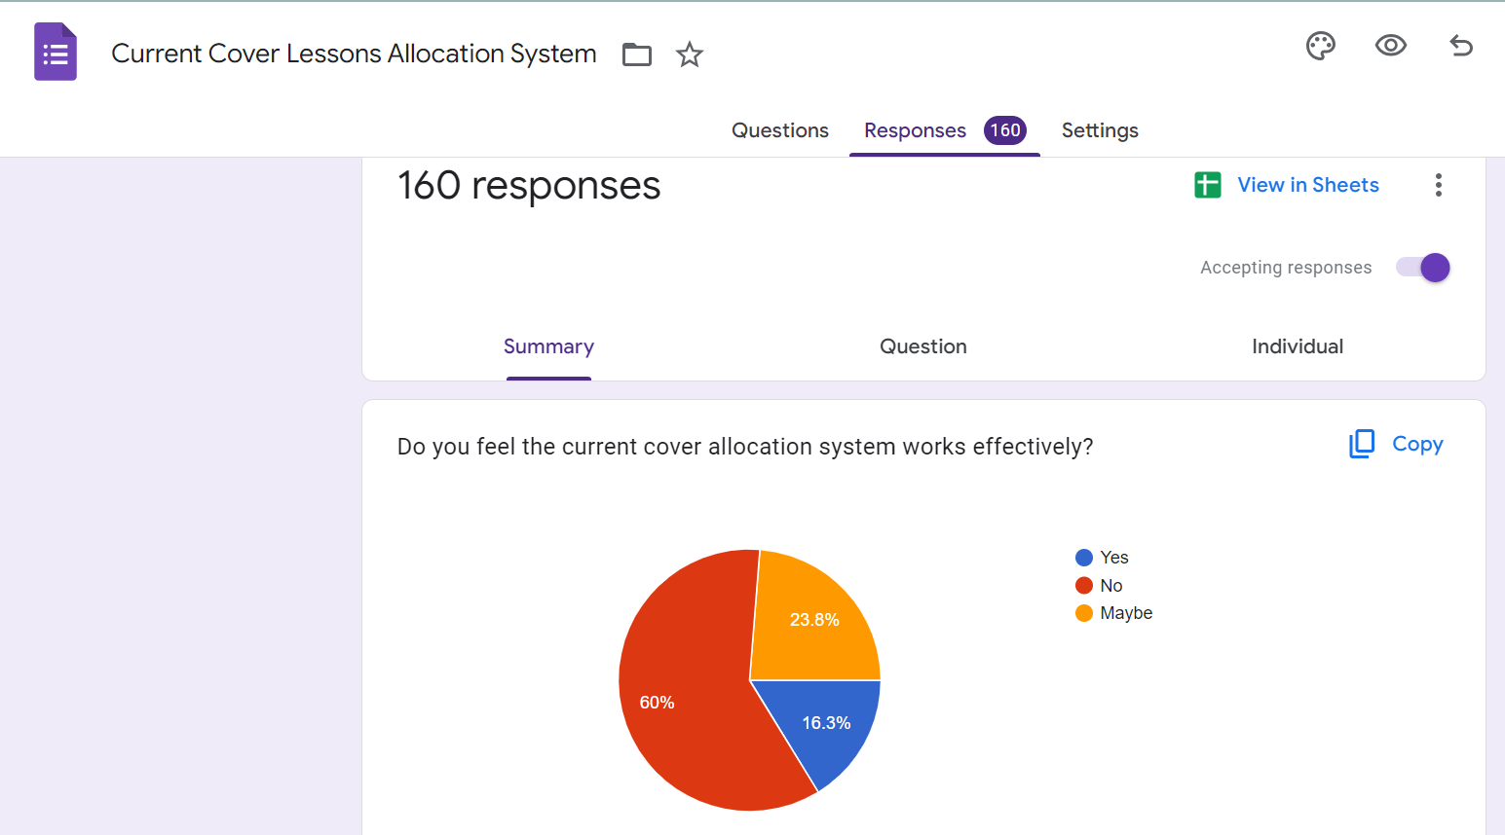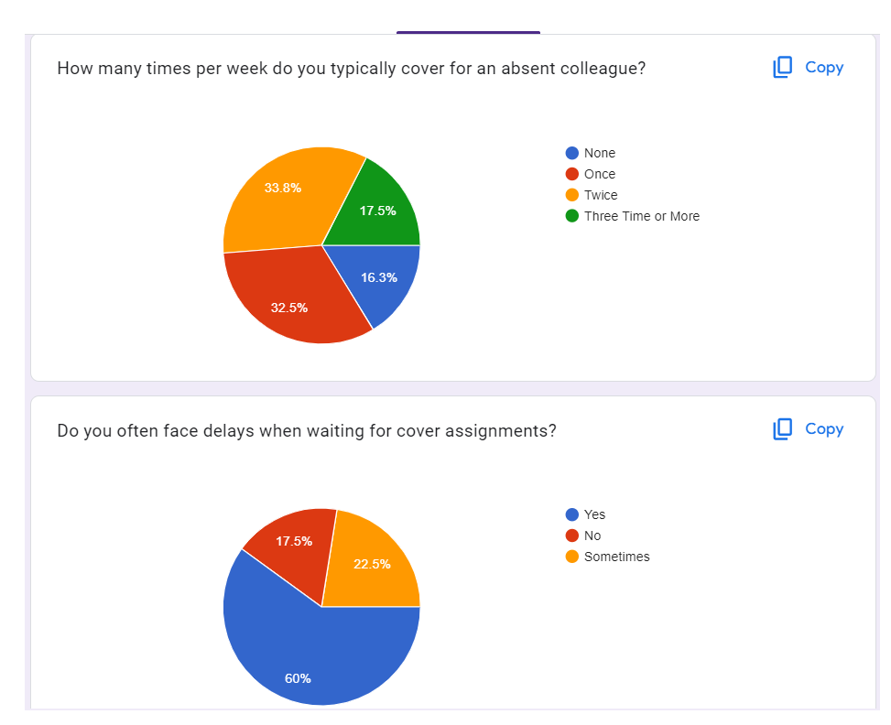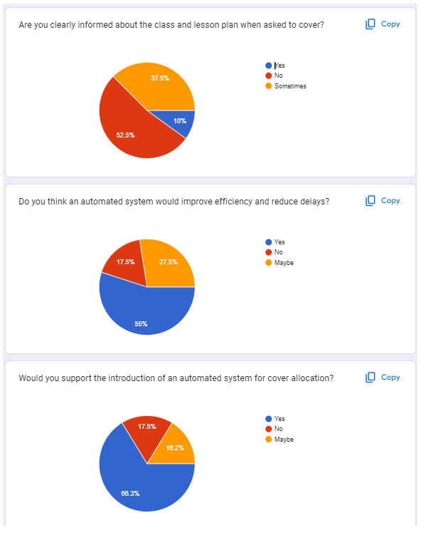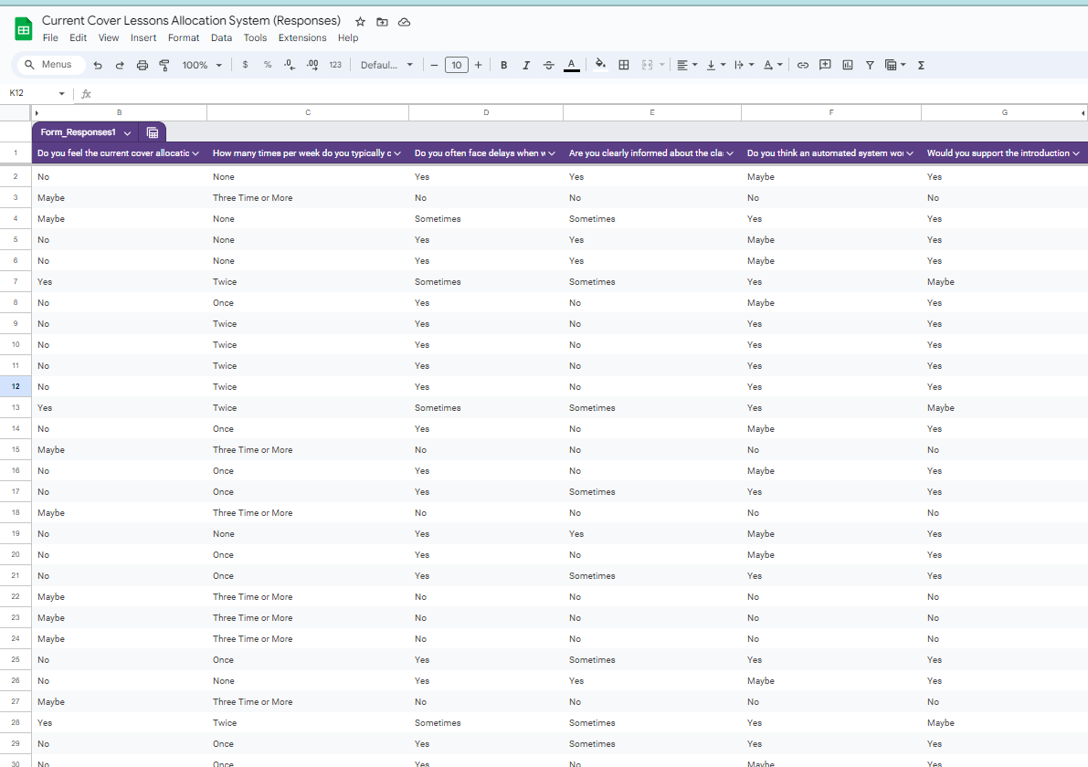

### 1.2.8 Questionnaire Observations:

The survey had responses from over 160 teachers, this considered most of the teacher body (80%). We can observe that the majority believe that the current system is inefficient, often faces delays when waiting for cover allocation and isn’t clearly informed about the class and lesson plan they were meant to cover.

On average most teachers covered one or two lessons a week and the majority believe an automated system would be more efficient and that they would support a transition to an automated system.

## 1.3 Current System:

I decided the next step would be to observe how the current cover system works; I requested Mr. Jeremy and Mr. Kyle (Head of Mathematics Faculty) to watch them from 6 am to 7 am to observe how the cover allocation was done. Moreover, I was emailed when there was a last-minute cover in the middle of the day.

### 1.3.1 Observations:

Scenario 1-

A teacher calls in sick at 6:08, a member of the SLT that is the head of faculty, in this case Mr. Kyle Lewis since it was a mathematics teacher, would access the password protected working excel sheet and check the time tables of the rest of the mathematics team to find teachers to cover the absent teacher’s lessons.

This was done based on whichever teacher appeared to have multiple free lessons on that day while being free in a certain lesson that needed to be covered.

Afterwards at 7am the final timetable for that day is released on teams by the SLT members for teachers to access.

I was able to notice the SLT’s proficiency in using excel and Microsoft teams to communicate and edit documents however I noticed that when covers were allocated factors such as how many frees that teacher had on that week or how many covers the teacher has already done were not considered.

Scenario 2-

A teacher declares her absence 24 hours earlier to that morning, the specific head of faculty would then find a suitable teacher to cover the lesson and / or inform their deputies to do so. The final timetable is then released at 7 of the next morning for teachers to access.

I noticed that in this scenario when covers were allocated factors such as how many frees the teacher had on that week or how many covers the teacher has already done were considered, but this scenario is less frequent than Scenario 1.

Scenario 3-

A teacher for a list of various reasons were not able to appear to a lesson without informing any SLT member, in this case a nearby teacher would notice and the patrolling SLT members would be informed where they would have to allocate a teacher to that cover last minute and inform the teacher on teams or in this case Mr. Jeremy had to take the cover himself.

This scenario is the least frequent, I noticed that it is disorganized and has various areas to improve on.

### 1.3.2 Step by Step Overview:

Step 1: Early Morning Monitoring (6:00 AM – 7:00 AM)

SLT members, such as Mr. Jeremy and Mr. Kyle (Head of Mathematics), begin monitoring staff absences.

If a teacher calls in sick during this time, the Head of Faculty for that subject acts.

Step 2: Identifying a Cover Teacher (Scenario 1 – Short Notice Absence)

Example: A math teacher reports illness at 6:08 AM.

Mr. Kyle accesses a password-protected Excel sheet containing all timetables.

He scans through the department's schedules, selecting a teacher with:

Availability during the required period

Several free periods that day

However, long-term fairness factors like weekly free periods or previous cover load are not considered in these rushed cases.

Step 3: Finalizing and Sharing the Day’s Timetable

By 7:00 AM, SLT finalizes the updated cover timetable.

It’s shared with all teachers via Microsoft Teams.

Step 4: Planned Absences (Scenario 2 – Notified in Advance)

If a teacher notifies their absence at least a day in advance, the Head of Faculty plans accordingly.

The head may personally allocate a cover or assign the task to a deputy.

In this case, there is more time to consider:

How many covers each teacher has done

Weekly free periods

However, this more balanced approach is less common than last-minute adjustments.

Step 5: Emergency Situations (Scenario 3 – No Show Without Notice)

In rare cases, a teacher fails to show up with no prior notice.

A nearby teacher usually reports it.

A patrolling SLT member responds, quickly allocating someone to cover the lesson.

Communication happens in-person or via Microsoft Teams.

In one case, Mr. Jeremy had to take the cover himself due to time pressure.

This scenario is disorganized and highlights the need for quicker, automated response systems.

### 1.3.3 Current System’s Documents:

Excel Document-

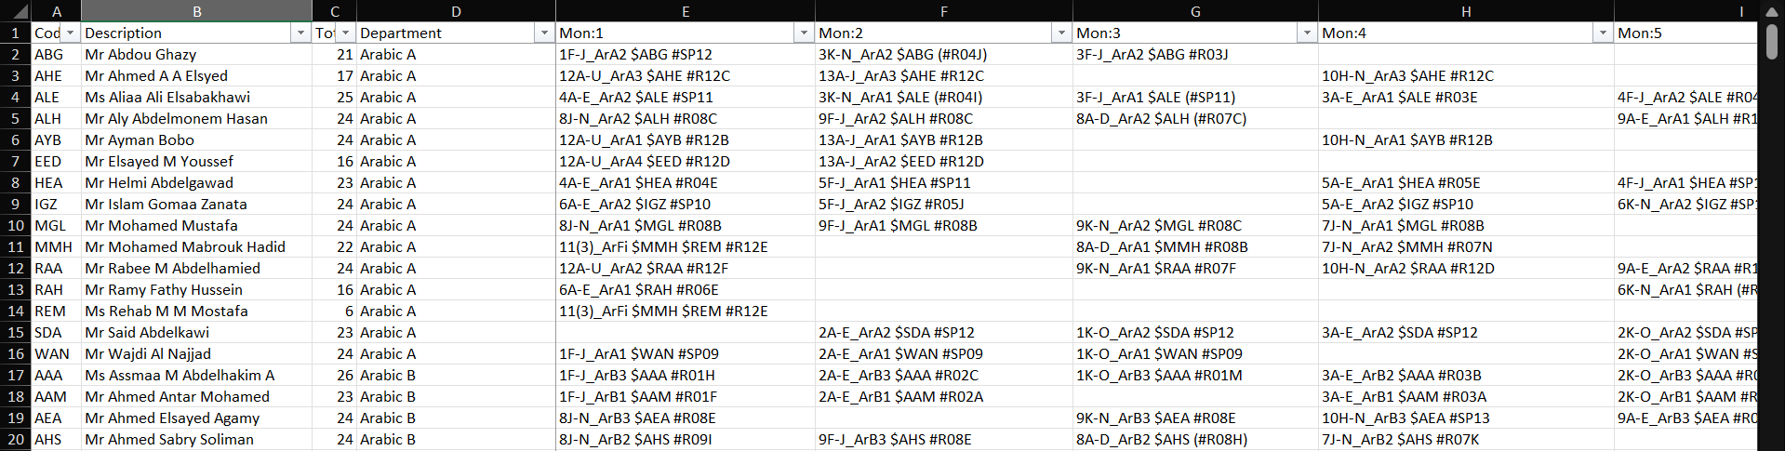

Column 1: Teacher Initials e.g. WAN for Mr Wajdi Al Najjad

Column 2: Teacher Full name e.g. Mr Wajdi Al Najjad

Column 3: Number of weekly lessons e.g. 24

Column 4: Department of Teacher e.g. Arabic A

Columns 5 to 37: Lesson Information, Beginning with Year Group (1), Then Form Classes (F-J), Subject Code (ArA1), Teacher Initials ($WAN), Classroom the lesson is taught in (#SP09), e.g. 1F-J_ArA1 $WAN #SP09

This excel sheet, although can be messy and hard to navigate, allows teachers to identify what lesson they have, who they are teaching, and where that lesson is held, and SLT members can identify where each teacher is supposed to be and how many lessons each teacher currently has for that week.

Currently the data is edited and managed by editing the excel sheet manually and saving it on the cloud for other SLT members to edit. However frequently multiple edits of a cell at the same time creates data loss and issues.

Microsoft Teams-

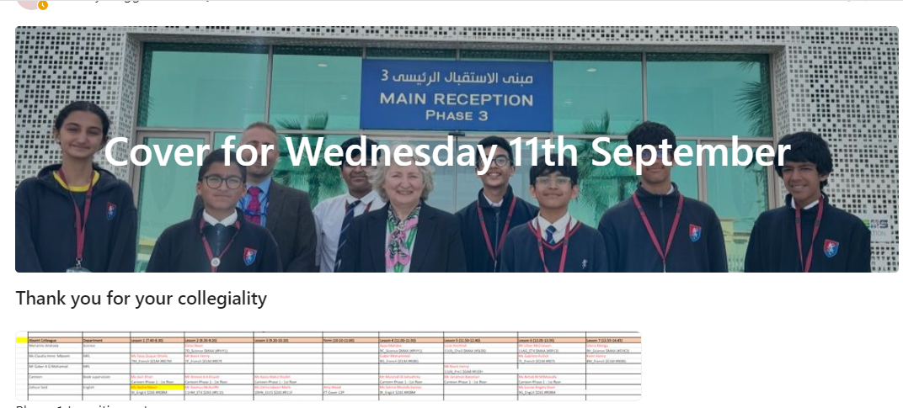

Cover Timetable-



### 1.3.4 IPSO:

|  |  |  |
| --- | --- | --- |
| IPSO | Information / Data | Evidence |
| Input | Teacher Info: Full Name, Initials, Department | Current System, Current System’s Documents, Excel |
| Input | Timetable Info: Classes Assigned from Lesson 1 to 7, from Monday to Thursday, from Lesson 1 to 5, for Friday, Total Classes Count | Current System, Current System’s Documents, Excel |
| Process | Find Absent Teacher’s Lessons and match them with available teacher free lessons | Research and Interviews, Interview 1 |
| Input | Absent Teacher Info: Full Name, Department, Covering Teacher per Lesson | Current System, Current System’s Documents, Cover Timetable |
| Store | Absent Teacher Info (see items above) | Current System, Current System’s Documents, Cover Timetable |
| Output | Absent Teacher Info | Current System, Current System’s Documents, Microsoft Teams |

### 1.3.5 Data Dictionary:

|  |  |  |  |
| --- | --- | --- | --- |
| Data Item | Data Type | Validation | Sample Data |
| Teacher Full Name | String |  | Mr Abdou Ghazy |
| Teacher Code / Initial | String | = 3 Characters | ABG |
| Total Number of Classes | Integer |  | 21 |
| Department | String |  | Arabic A |
| Lesson Time | Time |  | 7:40 – 8:30 |
| Lesson Location | String |  | SP12 |
| Lesson Subject | String |  | ArA2 |
| Date | Date | = Current Date | Wednesday 11th September |

### 1.3.6 Context Diagram:

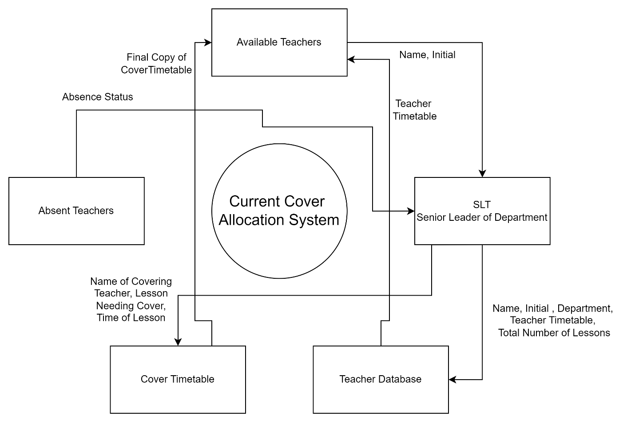

### 1.3.7 Data Flow Diagram:

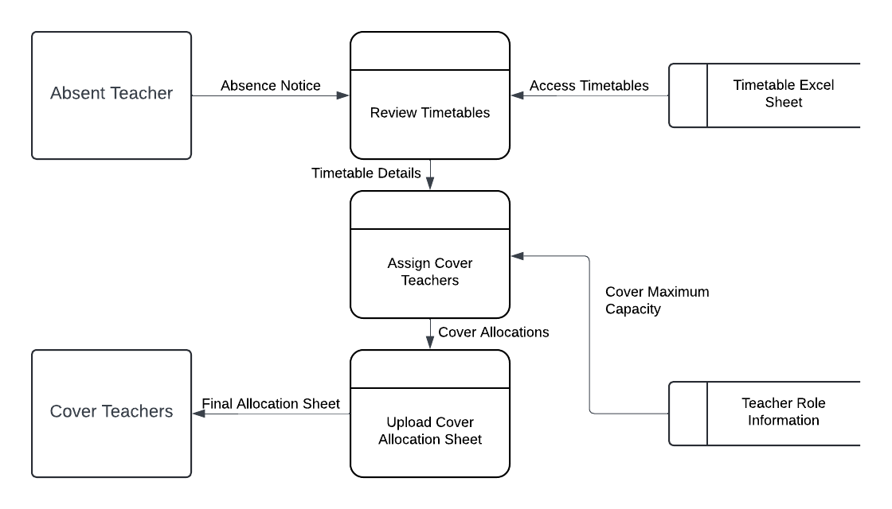

### 1.3.8 System Flowchart:

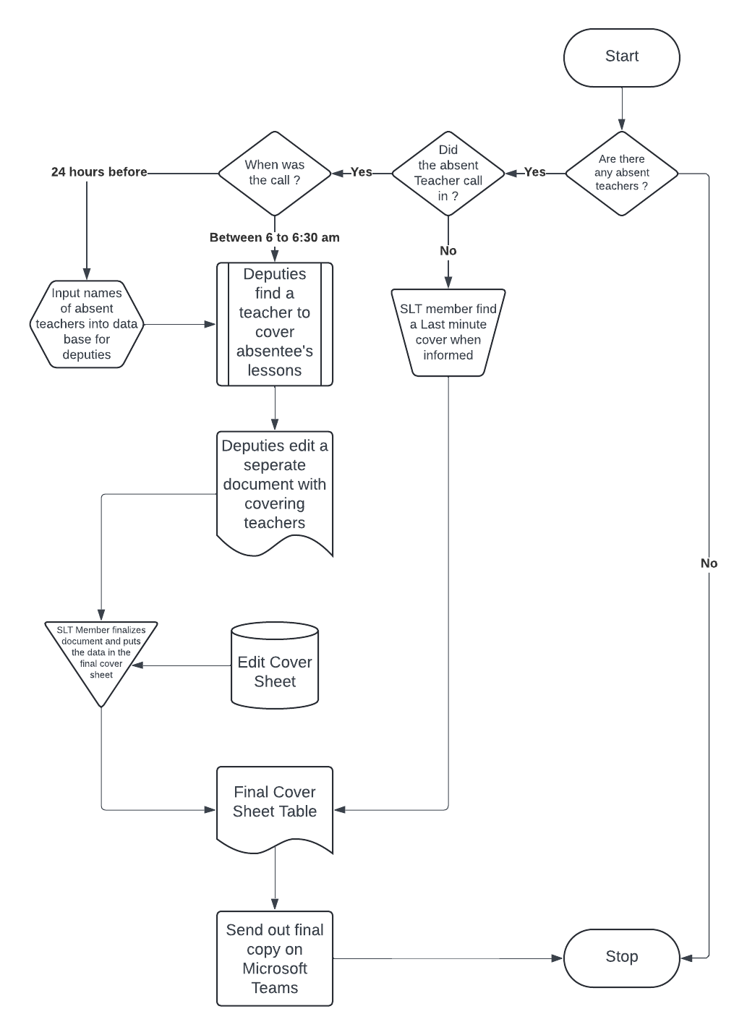

### 1.3.9 Overall Problems with the Current System:

Manual and Time-Consuming Process:

Allocation relies heavily on SLT manually scanning Excel sheets early in the morning, which is inefficient and prone to human error.

No Historical Tracking of Cover Load:

In last-minute cases, decisions don’t account for how many covers a teacher has already done that week or month, leading to potential overloading and unfairness.

Inconsistent Fairness Criteria:

Advance absences may be handled with more balanced logic, but last-minute ones often ignore important factors like total frees or cover history.

Lack of Automation or Smart Filtering:

There’s no automated system to flag the most appropriate cover candidates based on multiple criteria (subject expertise, availability, previous covers, etc.).

Vulnerability to Disruption During Emergencies:

In cases where a teacher doesn’t show up without warning, the response is reactive and disorganized. Sometimes SLT members (e.g., Mr. Jeremy) must take the class themselves.

Limited Communication Efficiency:

While Microsoft Teams is used, cover details are still manually updated and posted, leaving room for delay or miscommunication.

No Centralized Logging of Changes:

There’s no clear record of who made what change or allocation in Excel, making accountability and audits difficult.

Interface is Not Designed for Scalability:

Excel may work now, but it becomes increasingly difficult to manage as the school grows or if more detailed data points are introduced.

Lack of Backup or Redundancy:

If the Excel file becomes corrupted while it is being edited, there’s no backup and it may be lost.

The current cover allocation system, while functional, is heavily reliant on manual actions which causes inefficiency and inconsistency. Most decisions are made early in the morning using Excel spreadsheets, often without considering key fairness factors like prior cover history or weekly workload. The lack of automation, smart filtering, and centralized tracking makes the system time-consuming and prone to human error, highlighting the need for a more automated and organized solution.

## 1.4 Users:

### 1.4.1 Prospective Users:

Mr. Jeremy and Mr. Luke are currently the members of the SLT that I will be most in contact with for information and to be able to take an agile approach. However, the system will be used by all the senior SLT and deputies and will support and inform all our teachers in secondary.

The SLT members have a reasonable ICT skill level, but not as advanced as to be able to handle errors generated by the code. For this reason, the user interface complexity and type must be simple, clean, easy to work with, and require minimal training.

### 1.4.2 User Needs:

The program should have an easy, simple interface that requires minimal training and upkeep.

SLT members should be able to access and edit the cover assignments if needed, but teachers cannot.

SLT members should be able to enter the names of the absent teachers.

The program must be able to allocate cover lessons automatically based on free lessons available and the number of covers already considering a teacher’s role.

The program should be able to display the covers for teachers to access before 7 am.

The program should be able to track the numbers of lessons a teacher has covered.

The program must be able to run using the school-provided desktops, keyboards, and mice.

## 1.5 Objectives:

### 1.5.1 Acceptable Limitations:

Due to the strict time constraint, I may not be able to get all the program to be bug-free. For this reason, I have decided to approach development by tackling different units/modules so that the individual aspects can run to the extent with which they were developed.

The program will only be able to run on the school desktop computers. It will not be able to run on mobile devices and due to the limitations of SQL lite which is a single user database the program will be limited to one user at a time, not multiple logins simultaneously, This is to limit the program to no extra cost on the school for extra storage/processing equipment.

Additionally, some features may not work as intended, for example current covers reset on the 1st of the month and allocations revert back after 3pm. Since the program cannot be always running, it is limited to temporarily running when the user decides rather than the database being always active since SQLite has its limitations additional email functionality was attempted however due to SMTP server changes with Gmail may not always work perfectly.

Learning an entirely new programming language for my GUI in such a strict time schedule is unrealistic therefore the GUI may limit how far and developed my application’s user interface may be.

### 1.5.2 Final Objectives:

|  |  |  |
| --- | --- | --- |
| No. | Objective | Performance Criteria |
| 1 | Design a user-friendly graphical user interface. | Must be straightforward and intuitive to use and disguises complexity of the operations executed in the background to be easy to navigate. |
| 2 | A secure login system. | A separate view for login, registration, and deletion of accounts. Robust use of validation for formatting of passwords. Generate a hash key as well as a salt for every password and store only the hash key and salt on the database. Must be able to create and delete accounts easily. |
| 3 | Create a secure program to store teacher timetables and cover lesson information securely in the database. | Uses separate permissions for SLT members and normal teachers regarding database editing and viewing.  Must be secure enough so that only the end user can access the contents of the database. |
| 4 | Using SQL queries; delete, insert, and view timetable data. | Uses a central database system to contain all information about lessons.  Displays specific teacher names and corresponding timetable.  SLT members must be able to insert and delete records to the timetables. |
| 5 | Create an automatic sorting system to allocate lessons needing cover. | Checks against the database and calculates which teachers should cover which lessons based on cover limit, free lessons available, number of covers taken and department. |
| 6 | Create a feature to display a complete cover timetable daily. | Displays final cover timetable daily for teachers to access. |
| 7 | Create an interface for admins to access and edit sensitive parts of the database | Creates a password protected GUI where admins can edit a teacher’s role and thus permissions, cover limit and current number of lessons covered. |

## 1.6 Solutions:

### 1.6.1 Languages:

For my programming language choice, I've decided on Python. As noted on python.org, the initial install size for Python 3.8.3 is approximately 18 MB (Python 3.8.3, 2020). Additionally, since our school desktops already have Python installed, it reduces the need for extra administrative setup. Python is an interpreted language (Subasi, 2020), making it a convenient option, particularly because of its small installation size and the ease of use on our existing systems.

For my database management language (SQL), I have opted against libraries that restrict the use of direct SQL queries and statements. Instead, I considered both SQLite and MySQL. MySQL is a web-based option, while SQLite can be fully run offline, which aligns better with my client’s requirements. Additionally, SQLite has a much smaller size—just 250 KB—compared to MySQL's 600 MB initial installation size. Although SQLite lacks advanced security features, I am confident I can compensate for this with robust login security measures, so it shouldn't be an issue. Therefore, I have decided to use SQLite for my database development.

Regarding my user interface I will be using Tkinter as a python import to generate the GUI.

In regards of security, I will incorporate my own hashing algorithm into my login system to ensure that the passwords of users cannot be accessed.

### 1.6.2 Chosen Solution:

After exploring the systems that my client has tried, I have eliminated a few solutions that do not meet the client’s requirements and the project limitations.

Manually deciding upon which teachers take which covers could not meet my client’s requirements of a cover allocation system. Although it made allocation easy to use, it was inefficient, not secure, and prone to human error since all factors were not considered. Moreover, it made keeping track of how many covers teachers have done undoable, and it was simply too time consuming.

Automating the cover allocation process will help how teacher absences are managed by using a database centered system to assign covers. This will reduce the workload of SLT members and will give teachers more time to prepare better lessons. By minimizing manual decision-making and potential bias, the automation will enhance efficiency, transparency, and staff satisfaction across the school.

Ideally, I could create a fully web-based system with cloud storage and mobile device capabilities. These features cannot be implemented simply because of time constraints and my skills. The system should run exclusively on the school desktop computer to reduce costs. This also means that there would be absolutely no need to have an online version of this application simply because it will run locally permanently.

Therefore, I have concluded that I will create a multi-purposed application with automatic cover allocation, secure access to database, and cover timetable output.

# 2. Documented Design

## 2.1 Data Handling Models and Diagrams:

### 2.1.1 Pre-Normalization:

#### 2.1.1.1 Entity Relationship Diagram:

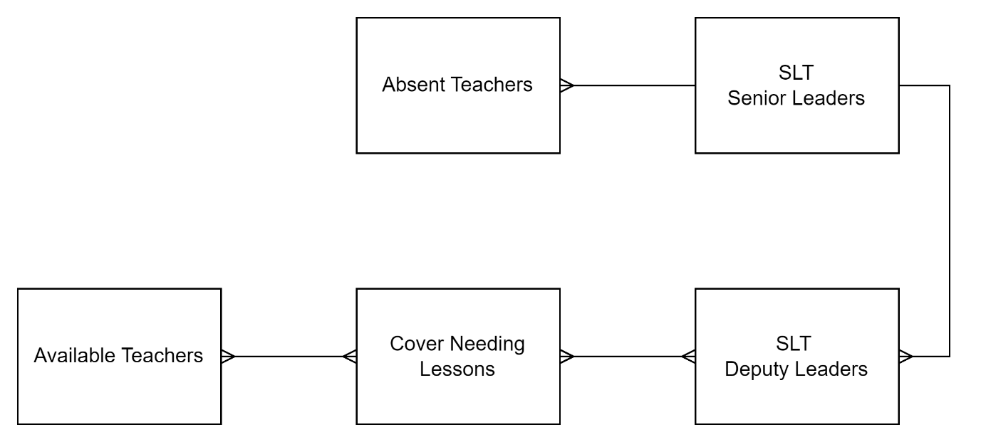

* Many Absent Teachers contact one SLT member to inform them of absence therefore their relationship is (Many to One).
* Each Senior Leader informs their Deputies of the Absent Teacher’s Data therefore their relationship is (One to Many).
* Many Deputy Leaders edit / decide which teachers cover the many lessons of the absent teachers therefore their relationship is (Many to Many).
* The many covers needing lessons document are shared with the many teachers therefore their relationship is (Many to Many).

#### 2.1.1.2 Entity Attribute Model:

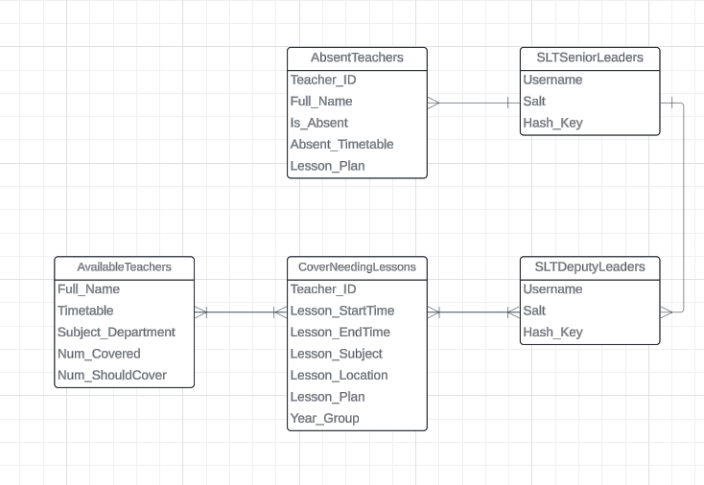

### 2.1.2 Normalization Process:

I began the normalization process by placing each entities’ attributes into its standard notation for database tables.

**tbl**AbsentTeachers(**Teacher_ID**, Full_Name, Is_Absent, Absent_Timetable, Lesson_Plan)

**tbl**SLTSeniorLeaders(**Username**, Salt, Hash_Key)

**tbl**SLTDeputyLeaders(**Username**, Salt, Hash_Key)

**tbl**CoverNeedingLessons(**Teacher_ID**, Lesson_StartTime, Lesson_EndTime, Lesson_Subject, Lesson_Location, Lesson_Plan, Year_Group)

**tbl**AvailableTeachers(**Teacher_ID**, Full_Name, Timetable, Subject_Department, Num_Covered, Num_ShouldCover)

Now that the database is in standard notation, the next step is first normalization. Which can be achieved by ensuring that there are no multivalued fields.

I noticed a redenduncy in the SLTSeniorLeaders and SLTDeputyLeaders tables therefore i have merged them into one table being SLTLeaders.

The new SLTLeaders table will hold the attributes of either original tables as they had the same attributes.

The table CoverNeedingLessons would be changed to LessonInfo and the primary key switched to **Lesson_ID**.

I believe a new table needs to be put in place named TeacherInfo, this table’s primary key would be **Teacher_ID**, and its attributes would be Full_Name, Timetable and Subject_Department.

The table AbsentTeachers would be changed to AbsenceStatus, without the attributes Absent_Timetable and Lesson_Plan.

Hence, we have therefore achieved 1NF by since there are no multivalued fields and no repeating groups.

**tbl**SLTLeaders(**Username**, Salt, Hash_Key)

**tbl**TeacherInfo(**Teacher_ID**, Full_Name, Timetable, Subject_Department)

**tbl**AbsenceStatus(**Teacher_ID**, Full_Name, Is_Absent)

**tbl**LessonInfo(**Lesson_ID**, Lesson_StartTime, Lesson_EndTime, Lesson_Subject, Lesson_Location, Lesson_Plan, Year_Group)

**tbl**AvailableTeachers(**Teacher_ID**, Full_Name, Timetable, Subject_Department, Num_Covered, Num_ShouldCover)

I then decided that it would be more normalized to change the SLTLeaders table to Teachers merging it with TeacherInfo and Available Teachers to instead have role decided as a variable and cover details all in one table.

I decided that the Hash related variables should be separated and have its own table named Hashing to make it clear.

I then decided to update the AbsenceStatus table and its variables changing it to AbsenceLog instead making the variable Is_Absent redundant, moreover a composite primary key will be made being the variables Username and Date.

Finally, I decided to split LessonInfo into 5 identical tables for each day of the working week with a composite primary key made up of the variables Username and Lesson Number. This was done to make the separation clear and avoid data mixing when coding and editing / creating timetables.

Hence 2NF has now been achieved.

**tbl**Teachers(**Username**, Fullname, Role, Subject_Department, Current_Covers, Cover_Limit)

**tbl**MondayLessons(**Username**, **Lesson_Number**, Subject, Class, Substitute)

**tb1**TuesdayLessons(**Username**, **Lesson_Number**, Subject, Class, Substitute)

**tbl**WednesdayLessons(**Username**, **Lesson_Number**, Subject, Class, Substitute)

**tbl**ThursdayLessons(**Username**, **Lesson_Number**, Subject, Class, Substitute)

**tbl**FridayLessons(**Username**, **Lesson_Number**, Subject, Class, Substitute)

**tbl**AbsenceLog(**Username,** **Date,** Reason)

**tbl**Hashing(**Username**, Salt, Hash_Value)

### 2.1.3 Post-Normalization:

#### 2.1.3.1 Entity Relationship Diagram:

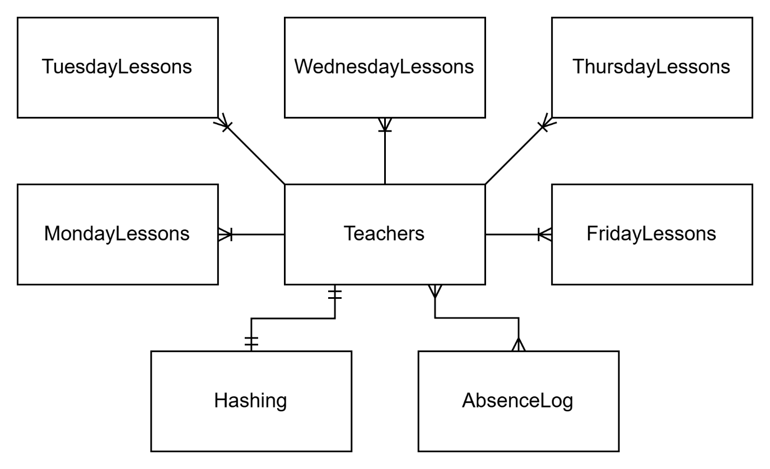

* Each Teacher has one set of lessons on Monday therefore their relationship is (One to Many).
* Each Teacher has one set of lessons on Tuesday therefore their relationship is (One to Many).
* Each Teacher has one set of lessons on Wednesday therefore their relationship is (One to Many).
* Each Teacher has one set of lessons on Thursday therefore their relationship is (One to Many).
* Each Teacher has one set of lessons on Friday therefore their relationship is (One to Many).
* Each Teacher can only have one password and does hash details therefore their relationship is (One to One).
* Many Teachers can be absent on the same day and a teacher can be absent on multiple days therefore their relationship is (Many to Many).

#### 2.1.3.2 Entity Attribute Model:

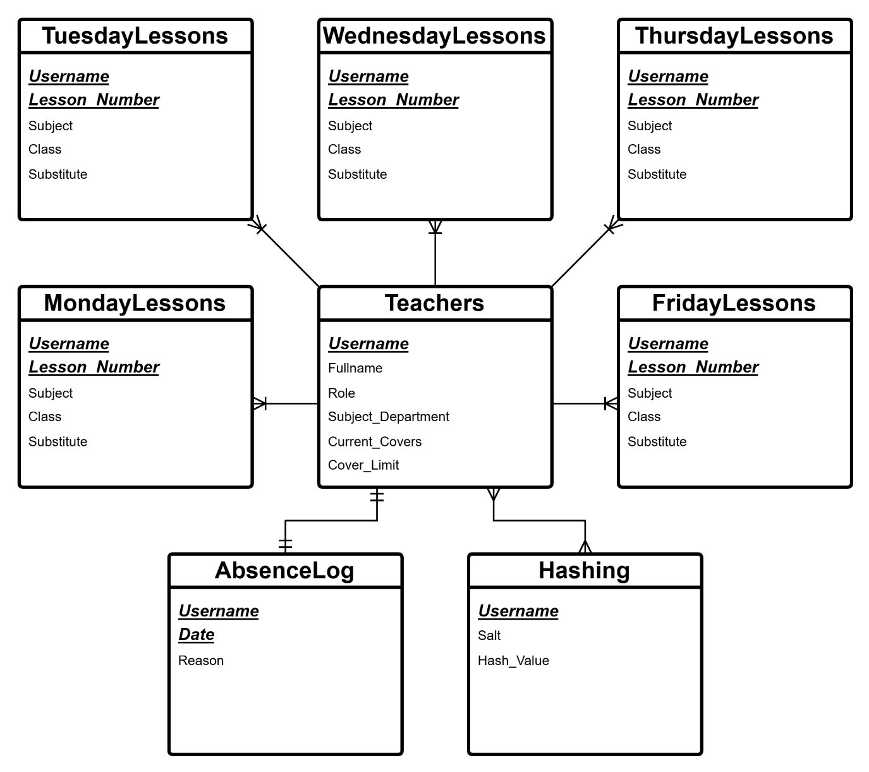

### 2.1.4 Data Dictionaries:

|  |  |  |  |  |
| --- | --- | --- | --- | --- |
| Table Name | | Teachers | | |
| Primary Key(s) | | Username | | |
| Foreign Key(s) | | N/A | | |
| Data Item | Data Type | | Validation | Sample data |
| Username | String | | Starts with a letter of the alphabet.  Includes all other characters, which can be alphabets, numbers or an underscore. | k.lewis1_gfs |
| Fullname | String | | The fullname must be made of characters that are all alphabets and at least two words. | Hylos@23 |
| Role | String | | SLT or Normal Teacher | SLT |
| Subject_Department | String | | One of the specified departments allowed in the list | Mathematics |
| Current_Covers | Integer | | Integer that is 0 or greater | 8 |
| Cover_Limit | Integer | | Integer that is 0 or greater | 25 |
|  |  |  |  |  |

|  |  |  |  |  |
| --- | --- | --- | --- | --- |
| Table Name | | MondayLessons | | |
| Primary Key(s) | | Username, Lesson_Number | | |
| Foreign Key(s) | | Username | | |
| Data Item | Data Type | | Validation | Sample data |
| Username | String | | Starts with a letter of the alphabet.  Includes all other characters, which can be alphabets, numbers or an underscore. | k.lewis1_gfs |
| Lesson_Number | Integer | | Must be a whole number between 1 and 7 inclusive. | 2 |
| Subject | String | |  | Chem |
| Class | String | |  | 13J |
| Substitute | String | | Must begin with Subbing or Subbed by | Kyle Lewis |
|  |  |  |  |  |
| Table Name | | TuedayLessons | | |
| Primary Key(s) | | Username, Lesson_Number | | |
| Foreign Key(s) | | Username | | |
| Data Item | Data Type | | Validation | Sample data |
| Username | String | | Starts with a letter of the alphabet.  Includes all other characters, which can be alphabets, numbers or an underscore. | k.lewis1_gfs |
| Lesson_Number | Integer | | Must be a whole number between 1 and 7 inclusive. | 2 |
| Subject | String | |  | Chem |
| Class | String | |  | 13J |
| Substitute | String | | Must begin with Subbing or Subbed by | Kyle Lewis |
|  |  |  |  |  |
| Table Name | | WednesdayLessons | | |
| Primary Key(s) | | Username, Lesson_Number | | |
| Foreign Key(s) | | Username | | |
| Data Item | Data Type | | Validation | Sample data |
| Username | String | | Starts with a letter of the alphabet.  Includes all other characters, which can be alphabets, numbers or an underscore. | k.lewis1_gfs |
| Lesson_Number | Integer | | Must be a whole number between 1 and 7 inclusive. | 2 |
| Subject | String | |  | Chem |
| Class | String | |  | 13J |
| Substitute | String | | Must begin with Subbing or Subbed by | Kyle Lewis |
|  |  |  |  |  |
| Table Name | | ThursdayLessons | | |
| Primary Key(s) | | Username, Lesson_Number | | |
| Foreign Key(s) | | Username | | |
| Data Item | Data Type | | Validation | Sample data |
| Username | String | | Starts with a letter of the alphabet.  Includes all other characters, which can be alphabets, numbers or an underscore. | k.lewis1_gfs |
| Lesson_Number | Integer | | Must be a whole number between 1 and 7 inclusive. | 2 |
| Subject | String | |  | Chem |
| Class | String | |  | 13J |
| Substitute | String | | Must begin with Subbing or Subbed by | Kyle Lewis |
|  |  |  |  |  |
| Table Name | | FridayLessons | | |
| Primary Key(s) | | Username, Lesson_Number | | |
| Foreign Key(s) | | Username | | |
| Data Item | Data Type | | Validation | Sample data |
| Username | String | | Starts with a letter of the alphabet.  Includes all other characters, which can be alphabets, numbers or an underscore. | k.lewis1_gfs |
| Lesson_Number | Integer | | Must be a whole number between 1 and 5 inclusive. | 2 |
| Subject | String | |  | Chem |
| Class | String | |  | 13J |
| Substitute | String | | Must begin with Subbing or Subbed by | Kyle Lewis |
|  |  |  |  |  |

|  |  |  |  |  |
| --- | --- | --- | --- | --- |
| Table Name | | AbsenceLog | | |
| Primary Key(s) | | Username, Date | | |
| Foreign Key(s) | | Username | | |
| Data Item | Data Type | | Validation | Sample data |
| Username | String | | Starts with a letter of the alphabet.  Includes all other characters, which can be alphabets, numbers or an underscore. | k.lewis1_gfs |
| Date | Date | | Must be in date format | 13/05/2025 |
| Reason | String | | Must begin with a letter of the alphabet | Sick Leave |
|  |  |  |  |  |

|  |  |  |  |  |
| --- | --- | --- | --- | --- |
| Table Name | | Hashing | | |
| Primary Key(s) | | Username | | |
| Foreign Key(s) | | Username | | |
| Data Item | Data Type | | Validation | Sample data |
| Username | String | | Starts with a letter of the alphabet.  Includes all other characters, which can be alphabets, numbers or an underscore. | k.lewis3_gfs |
| Salt | String | |  | rxaax85xc2Oxe8xb5xf4xa29xe0txacx19xf1q |
| Hash_Value | Integer | |  | 2156371292 |
|  |  |  |  |  |

### 2.1.5 SQL Statements:

Im basing my statements on SQLite3. The statement aims to handle creating a normalized teacher table with their timetables, indexing SLT leaders, inserting data, selecting data, creating temporary daily cover timetable, and exporting the daily cover timetable.

1. Create a New Teacher Table

cursor.execute("""CREATE TABLE IF NOT EXISTS Teachers (

Username TEXT PRIMARY KEY,

Fullname TEXT,

Role TEXT,

Subject_Department TEXT,

Current_Covers INTEGER,

Cover_Limit INTEGER

)""")

2. Create a table for each of the week days

cursor.execute("""CREATE TABLE IF NOT EXISTS MondayLessons (

Username TEXT,

Lesson_Number INTEGER,

Subject TEXT,

Class TEXT,

Substitute TEXT,

PRIMARY KEY (Username, Lesson_Number),

FOREIGN KEY (Username) REFERENCES Teachers(Username)

)""")

cursor.execute("""CREATE TABLE IF NOT EXISTS TuesdayLessons (

Username TEXT,

Lesson_Number INTEGER,

Subject TEXT,

Class TEXT,

Substitute TEXT,

PRIMARY KEY (Username, Lesson_Number),

FOREIGN KEY (Username) REFERENCES Teachers(Username)

)""")

cursor.execute("""CREATE TABLE IF NOT EXISTS WednesdayLessons (

Username TEXT,

Lesson_Number INTEGER,

Subject TEXT,

Class TEXT,

Substitute TEXT,

PRIMARY KEY (Username, Lesson_Number),

FOREIGN KEY (Username) REFERENCES Teachers(Username)

)""")

cursor.execute("""CREATE TABLE IF NOT EXISTS ThursdayLessons (

Username TEXT,

Lesson_Number INTEGER,

Subject TEXT,

Class TEXT,

Substitute TEXT,

PRIMARY KEY (Username, Lesson_Number),

FOREIGN KEY (Username) REFERENCES Teachers(Username)

)""")

cursor.execute("""CREATE TABLE IF NOT EXISTS FridayLessons (

Username TEXT,

Lesson_Number INTEGER,

Subject TEXT,

Class TEXT,

Substitute TEXT,

PRIMARY KEY (Username, Lesson_Number),

FOREIGN KEY (Username) REFERENCES Teachers(Username)

)""")

3. Create a table to keep track of absences

cursor.execute("""CREATE TABLE IF NOT EXISTS AbsenceLog (

Username TEXT,

Date TEXT,

Reason TEXT,

PRIMARY KEY (Username, Date)

)""")

4. Create a table for storing hashes and salt

cursor.execute("""CREATE TABLE IF NOT EXISTS Hashing (

Username TEXT,

Salt TEXT,

Hash_Value TEXT,

PRIMARY KEY (Username)

)""")

5. Insert New Teachers into the Teacher Table

Now that the teacher table is normalized, you can insert new teacher records.

Inserting a new teacher into the Teachers table

cursor.execute("""INSERT INTO Teachers VALUES (?, ?, ?, ?, ?, ?)""", (username, fullname, role, subject_department, current_covers, cover_limit)

6. Select/Extract Data from Teachers Table

To extract teacher info and their associated timetables, select teacher details along with their details

cursor.execute("""SELECT * FROM Teachers""")

teachers = cursor.fetchall()

7. Export Final Cover Timetable Once Allocated

Once the cover timetable is completed, you can insert the data into the permanent table by using an edit function.

database.edit_lesson(teacher, days[x], lesson_num, subject, class_name, substitute)

These SQL statements should handle my requested tasks, including creating tables, indexing, inserting and extracting data, and displaying the final cover data.

### 2.1.6 Data Flow Diagrams:

#### 2.1.6.1 Login system data flow diagram – Level 1:

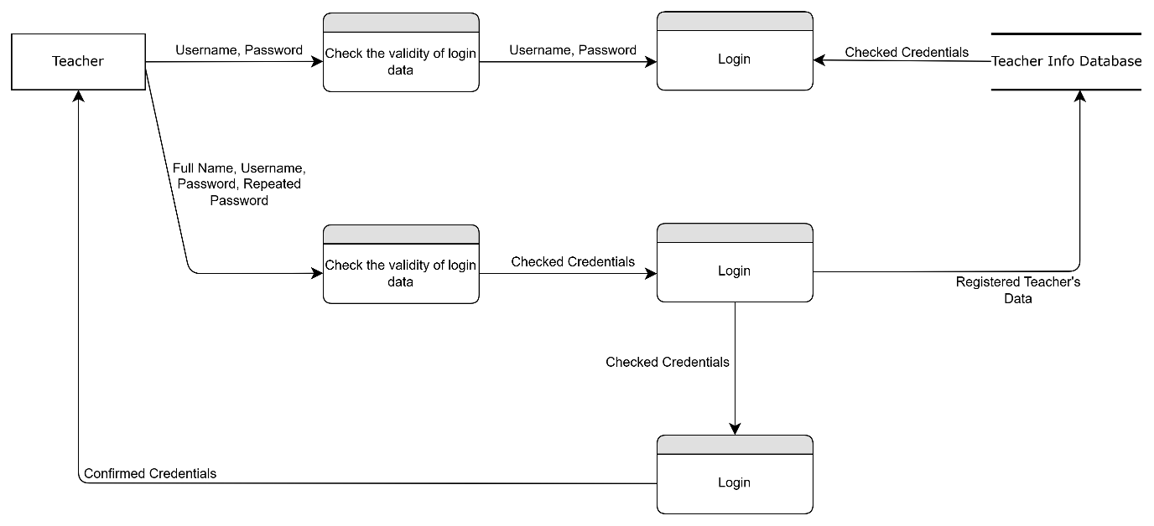This diagram displays the teacher login and registration process in the system. Teachers can either log in using their existing credentials (username and password) or register by providing their full name, desired username, and password (entered twice for confirmation). The system first validates the input credentials. If valid, the login module compares the data with records in the Teacher Info Database. Upon successful verification, access is granted and confirmed to the teacher. The diagram clearly separates the logging in and registering features, ensuring secure authentication.

## 2.2 Overall System Design:

### 2.2.1 Top-Down Diagram:

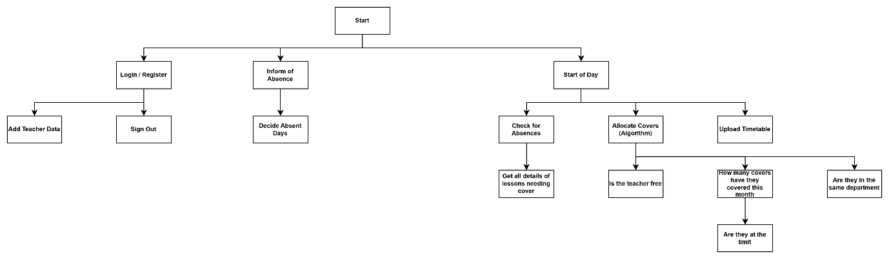

The diagram outlines the three main processes, login/registration, teacher absence notification, and daily tasks.

Login/Register Process:

Teachers can log in, register, add data, or sign out.

Absence Notification Process:

Teachers inform the system of an absence and specify the days they’ll be absent.

Daily tasks:

The system begins by checking for absences.

If absences are found, it gathers lesson details needing cover.

It then allocates cover using an algorithm that checks if a teacher is:

Free, within monthly cover limits and from the same department

The Timetables are updated based on these checks.

### 2.2.2 IPSO Chart (Input, Process, Storage, Output):

|  |  |  |
| --- | --- | --- |
| IPSO | Program Section | Item |
| Input | Login / Register | Full name, Username, Password |
| Add Teacher Data | Teacher Name, Teacher Username, Teacher Department, Subject of Lesson, Class of Lesson |
| Inform of Absence | Days Absent, Reason for Absence |
| Processing | Check for Absences | Are there any teachers absent? |
| Get all details  of lessons  needing cover | Which lessons need to be covered?, What department are they part of?, When are they going to take place?, What class are they in? |
| Allocate Covers | Is the teacher free?, How many covers have they covered this month?, Are they at the limit?, Are they from the same department? |
| Storage | New Teacher Data | Data of all new teachers along with their timetables stored in a database. |
| Absences | All previous absences are stored on a text file. |
| Output | Welcome Message | Message “Welcome *Teacher Name*” |
| Timetable | Displays Timetable on the main screen |

## 2.3 Data Structures:

### 2.3.1 Data Dictionary:

|  |  |  |  |
| --- | --- | --- | --- |
| **Data Item** | **Data Type** | **Validation** | **Sample Data** |
| Full Name | String | <>”” | Sharol Serrao |
| Username | String | Ends in “_gfs” | s.serrao_gfs |
| Password | String | <= 8 Characters | Hello@123 |
| Department | String | <>”” | Science |
| Subject | String | <>”” | Biology |
| Class | String | <>”” | 12K |
| Absent Status | Boolean |  | True |
| Absent Teacher Name | String | <>”” | Kyle Lewis |
| Teacher Availability | Boolean |  | True |
| Absent Days | Date | > 0 | 13/02/2025 |
| Absent Reason | String | <>”” | Sick |
| Amount Covered | Integer | >= 0 | 3 |
| Cover Limit | Integer | >= 0 | 11 |

### 2.3.2 Record Structure:

Absent Record saved to a text file.

|  |  |
| --- | --- |
| **Record Element** | **Size** |
| Absent Teacher Name | 50 characters = 400 bytes |
| Absent Day/s | 250 characters = 2000 bytes |
| Absent Reason | 50 characters = 400 bytes |
| One Record = 2.8 Kilobytes | |

### 2.3.3 Data Structure:

STRUCTURE TEACHER

Fullname as String

Username as String

Password as String

Department as String

AbsentStatus as Boolean

AmountCovered as Integer

CoverLimit as Integer

IsSLT as Boolean

END STRUCTURE

### 2.3.4 Hashing:

Hashing is going to be implemented in the login system to securely store the teacher’s passwords.

When a user registers or logs in, the entered password is passed through my custom hashing algorithm.

The password is combined with a randomly generated 16-byte salt to ensure each hash is unique even if two teachers have the same password.

The hashing algorithm runs for 100 iterations to increase its complexity and reduce vulnerability to malicious attacks.

In each iteration, the combined password and salt are processed character by character. With their ASCII values being multiplied and bit shifted to produce a 32-bit hash value.

After all the iterations, the final hash value is generated.

Both the salt and the hash value are stored in the database.

#### 2.3.4.1 Hashing Algorithm:

def hashing_algorithm(self, password, salt): # Use of hashing

        """Hashes a password using a custom algorithm with the provided salt"""

        hash_value = 0 # Initializes the hash value variable

        combined = salt + password # Combines the salt and password

        for _ in range(100): # Performs the process 100 iterations for safety purposes

            for char in combined:

                hash_value += ord(char) # Adds the ASCII values

                hash_value = (hash_value * 31) ^ (hash_value >> 16) # Hashing operation

                hash_value = hash_value % (2**32) # Ensures hash value fits in 32 bits making sure its a limited size

            combined = salt + str(hash_value) # Updates the combined value for the next iteration

        return hash_value # Returns the final hash value

## 2.4 OOP Class Design:

Minimum OOP is needed in the program however one instance may be the teacher's separate abilities.

### 2.4.1 Inheritance Diagram:

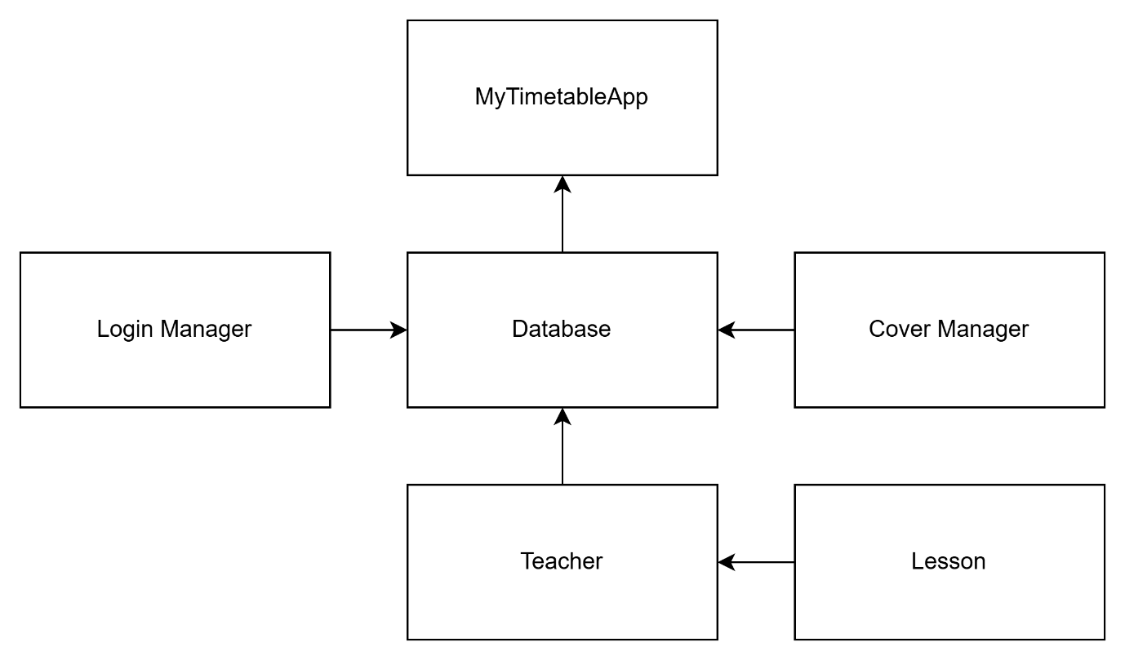

**Key Relationships:**

MyTimetableApp (Main controller class):

Contains 1 instance of Database

Manages all the GUI frames

Manages all the other components

Database:

Acts as a centralized location for all stored data

Manages all Teacher and Lesson data

Handles password hashing and verification

Teacher:

Represents a teacher with their respective data and information

Contains multiple Lesson instances (timetable)

Managed by the Database

Lesson:

Represents a single lesson in a teacher's timetable

Contains information about subject, class, and substitute

CoverManager:

Handles the actual logic for cover allocation

Uses Teacher and Lesson data from Database

LoginManager:

Handles authentication and user management

Works closely with Database for credential verification

## 2.5 Interface Design:

I have decided to use Tkinter GUI python import to keep all aspects of the program user-friendly.

All the user’s entries are validated against a database before being passed through for processing by the program.

Additionaly Admin Access screens may be added

### 2.5.1 Interface Flowchart:

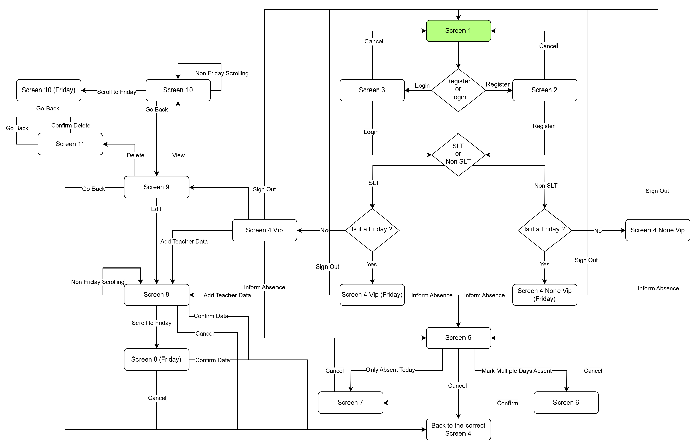

### 2.5.2 Login and Registration:

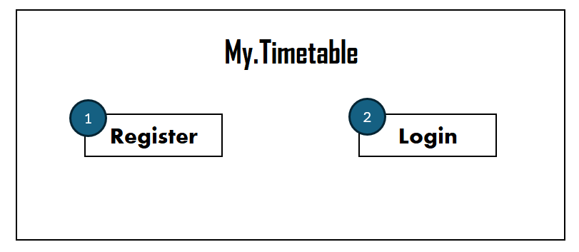Screen 1

1 – Switches to the registration screen (Screen 2)

2 – Switches to the login screen (Screen 3)

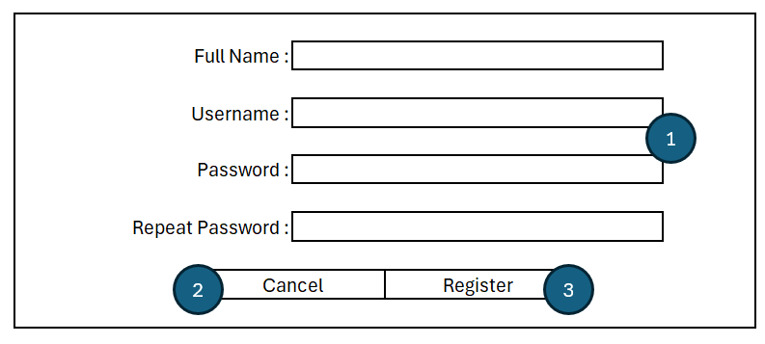Screen 2

1 – Input of information such as Full Name, Username and Password

2 – Takes you back to the start screen (Screen 1)

3 – Confirms the details and takes you to the relevant main screen based on the day and teacher’s status (Screen 4)

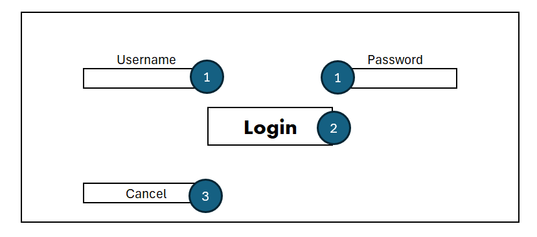

Screen 3

1 – Input for Username and Password

2 – Confirms the login details and takes you to the relevant main screen based on the day and teacher’s status (Screen 4)

3 – Takes you back to the start screen (Screen 1)

### 2.5.3 Main Screen:

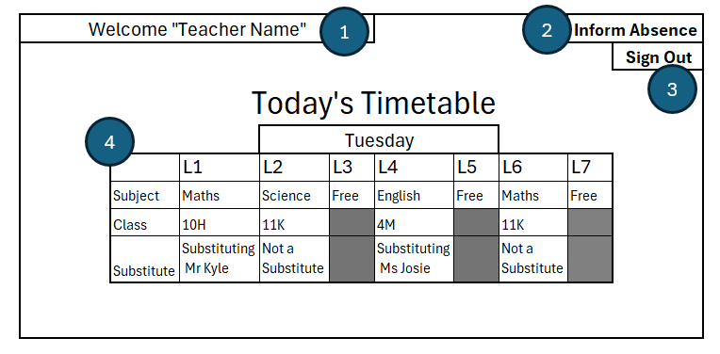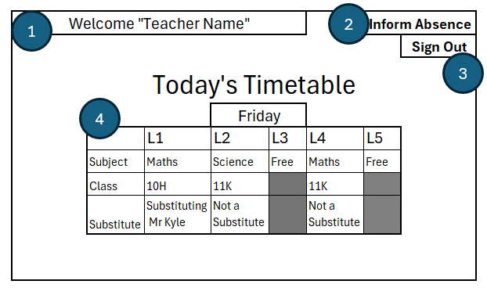

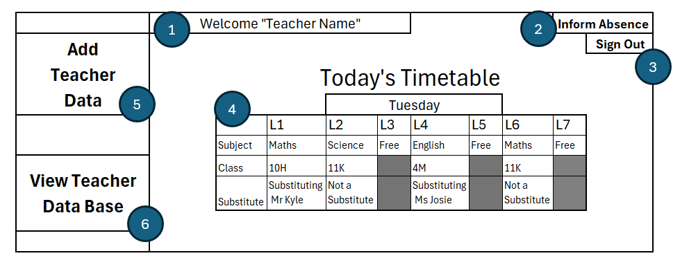

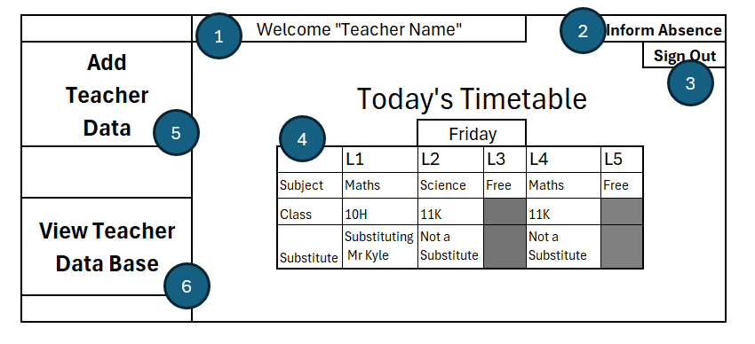Screen 4 ( Variants: Non VIP, Non VIP (Friday), VIP and VIP (Friday) )

1 – Displays a welcome including the teacher’s name

2 – Takes you to the absence specifying screen (Screen 5)

3 – Signs you out and returns you to the start screen (Screen 1)

4 – Displays today’s timetable including information such as the day of the week, lessons paired with the subject and class, and whether it is a substitute and if so who they are covering for.

5 – Only included in VIP Main Screens and takes you to the screen to add teachers to the data base (Screen 8)

6 – Only included in VIP Main Screens and takes you the screen to view, edit and delete data in the data base (Screen 9)

### 2.5.4 Absence Reports:

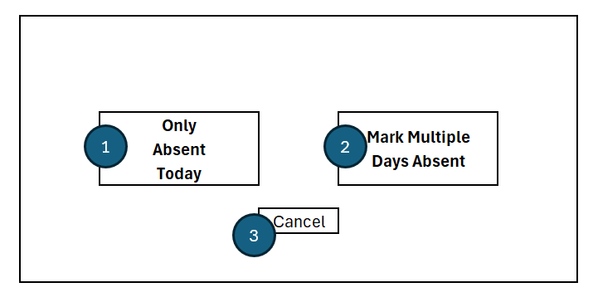Screen 5

1 – Confirms the user only being absent for one day and takes you the absence confirmation screen (Screen 7)

2 – Confirms the user will be absent for multiple days and takes you to the absence days selection screen (Screen 6)

3 – Cancels and takes you back to the previous Main Screen (Screen 4)

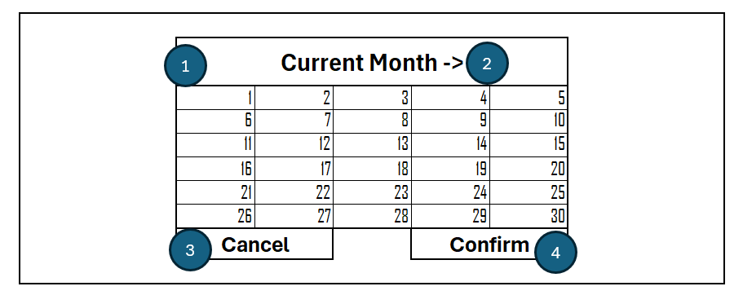Screen 6

1 – Displays the current month’s calendar allowing the user to select days they plan on being absent

2 – Allows the user to switch to the following months

3 – Cancels and takes the user back to the original absent amount selection screen (Screen 5)

4 – Confirms the user will be absent for the days selected and takes you to the absence confirmation screen (Screen 7)

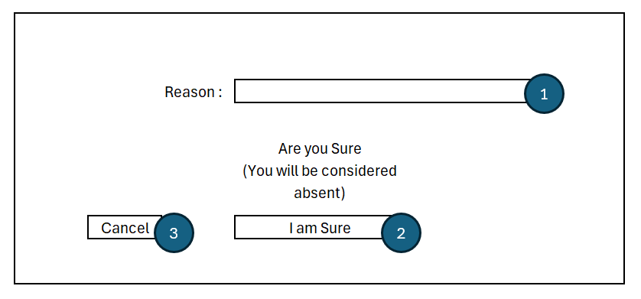Screen 7

1 – Inputs for the reason of absence to be added in the database

2 – Confirms the absence adding the days and the reason to the database, prompts the program to find substitutes for the teacher’s lessons on the absent days and takes you back to the main screen (Screen 4)

3 – Cancels and takes the user back to the original absent amount selection screen (Screen 5)

### 2.5.5 Adding Teacher Data

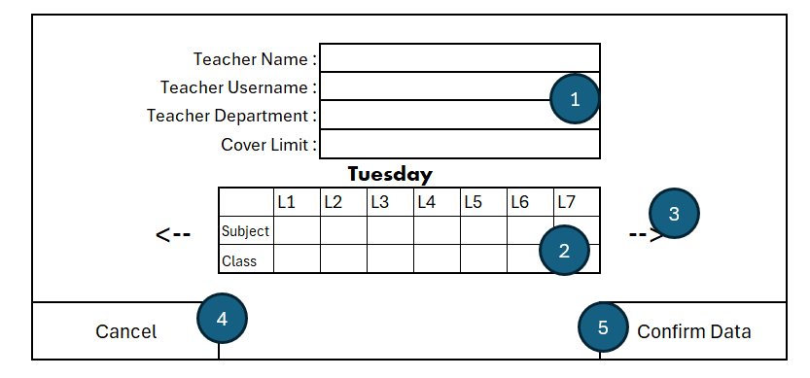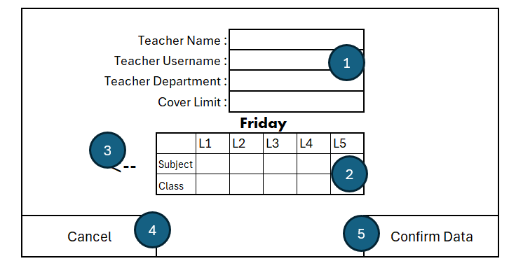Screen 8 (Variants: Not Friday and Friday)

1 – Input or edit the teacher’s name, username, department and cover limit

2 – Input or edit a timetable layout to specify the subject and class

3 – Arrow to move between the days of the week

4 – Cancels and returns to the relevant main screen (Screen 4) or (Screen 9) if editing

5 – Confirms the data entered and adds or edits the teacher’s data in the database and returns the user to the relevant main screen (Screen 4) or (Screen 9) if editing

### 2.5.6 Accessing the Database:

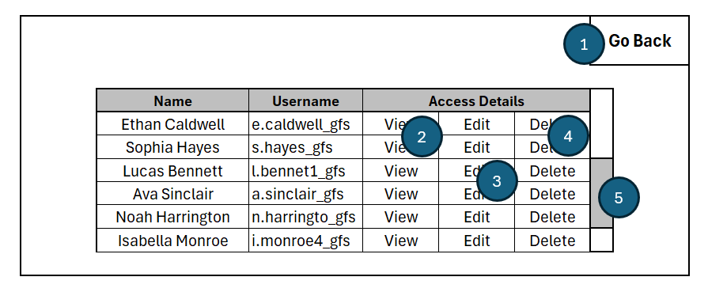Screen 9

1 – Returns you to the relevant main screen (Screen 4)

2 – Takes you a screen to view the specific teacher’s data (Screen 10)

3 – Takes you a screen to edit the specific teacher’s data (Screen 8)

4 – Takes you a screen to confirm deletion (Screen 11)

5 – Allows the user to scroll through the database

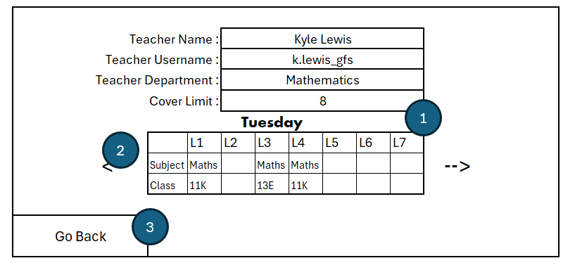

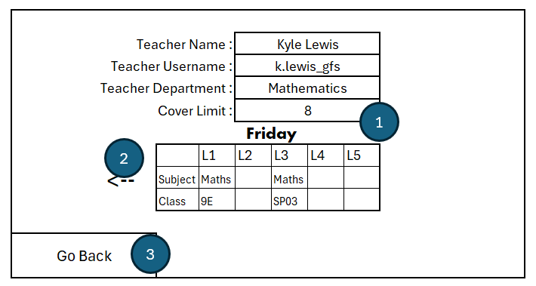Screen 10 ( Variants: Not Friday, Friday)

1 – View all the data in the text boxes and timetable

2 – Scroll to other days of the week

3 – Go back to the Data Base accessing screen (Screen 9)

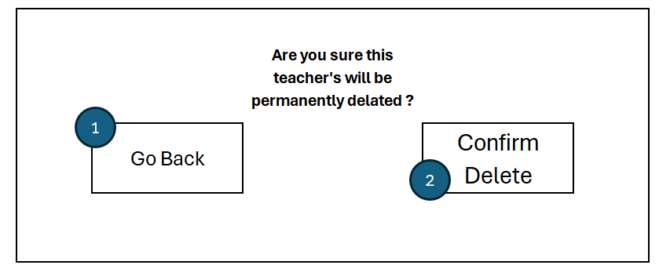Screen 11

1 – Cancel and go back to the Data Base accessing screen (Screen 9)

2 – Confirm Deletion and go back to the Data Base accessing screen (Screen 9)

## 2.6 Algorithms:

### 2.6.1 Cover Allocation Algorithm:

The algorithm is aimed at finding the most suitable teacher to cover a lesson.

#### 2.6.1.1 Pseudo Code:

CLASS MainAlgorithm

    METHOD __init__(controller)

        SET self.controller = controller

        SET self.date = CURRENT_DATETIME()

        SET self.weekday = GET_CURRENT_DAY_OF_WEEK()

        SET self.AllTeachers = []

        SET self.AllTeachers = database.get_all_usernames()

        SET self.AbsentTeachers = []

        SET self.NonAbsentTeachers = []

        SET self.CoverNeedingLessons = []

        SET self.CoverAllocations = []

    METHOD cover_allocation()

        // Identify absent teachers

        FOR Teacher IN self.AllTeachers

            IF database.is_absent(Teacher, self.date)

                APPEND Teacher TO self.AbsentTeachers

        self.NonAbsentTeachers = self.AllTeachers

        FOR Teacher IN self.AbsentTeachers

            REMOVE Teacher FROM self.NonAbsentTeachers

        FOR Teacher IN self.AbsentTeachers

            lessons = database.get_all_lessons(Teacher, self.weekday)

            FOR lesson IN lessons

                IF lesson[2] != "Free" AND lesson[3] != "" AND lesson[4] == "None" AND lesson[2] != "Empty"

                    APPEND lesson TO self.CoverNeedingLessons

        FOR x FROM 0 TO LENGTH(self.CoverNeedingLessons) - 1

            absent_teacher = self.CoverNeedingLessons[x][0]

            absent_teacher_name = database.get_fullname(absent_teacher)

            absent_teacher_department = database.get_subject_department(absent_teacher)

            absent_lesson_num = self.CoverNeedingLessons[x][1]

            absent_subject = self.CoverNeedingLessons[x][2]

            absent_class = self.CoverNeedingLessons[x][3]

            FreeTeachers = []

            SameDepartmentTeachers = []

            SuitableTeachers = []

            FOR teacher IN self.NonAbsentTeachers

                lesson = database.get_one_lesson(teacher, self.weekday, absent_lesson_num)

                IF lesson[2] == "Free"

                    APPEND teacher TO FreeTeachers

            IF LENGTH(FreeTeachers) == 0

                CALL self.send_email(absent_teacher_name, absent_lesson_num, absent_subject, absent_class)

            ELSE

                FOR teacher IN FreeTeachers

                    department = database.get_subject_department(teacher)

                    IF department == absent_teacher_department

                        APPEND teacher TO SameDepartmentTeachers

                IF LENGTH(SameDepartmentTeachers) == 0

                    lowest_cover_percentage = 9999

                    FOR teacher IN FreeTeachers

                        current = database.get_current_covers(teacher)

                        limit = database.get_cover_limit(teacher)

                        cover_percentage = (current / limit) * 100

                        IF cover_percentage < lowest_cover_percentage

                            lowest_cover_percentage = cover_percentage

                            SuitableTeachers = [teacher]

                        ELSE IF cover_percentage == lowest_cover_percentage

                            APPEND teacher TO SuitableTeachers

                    selected_teacher = RANDOM_CHOICE(SuitableTeachers)

                    APPEND [absent_teacher, selected_teacher, self.weekday, absent_lesson_num, absent_subject, absent_class] TO self.CoverAllocations

                    database.edit_lesson(selected_teacher, self.weekday, absent_lesson_num, absent_subject, absent_class, "Subbing " + absent_teacher_name)

                    database.edit_lesson(absent_teacher, self.weekday, absent_lesson_num, absent_subject, absent_class, "Subbed by " + selected_teacher[0])

                    database.increment_current_covers(selected_teacher)

                ELSE

                    lowest_cover_percentage = 999

                    FOR teacher IN SameDepartmentTeachers

                        current = database.get_current_covers(teacher)

                        limit = database.get_cover_limit(teacher)

                        cover_percentage = (current / limit) * 100

                        IF cover_percentage < lowest_cover_percentage

                            lowest_cover_percentage = cover_percentage

                            SuitableTeachers = [teacher]

                        ELSE IF cover_percentage == lowest_cover_percentage

                            APPEND teacher TO SuitableTeachers

                    selected_teacher = RANDOM_CHOICE(SuitableTeachers)

                    APPEND [absent_teacher, selected_teacher, self.weekday, absent_lesson_num, absent_subject, absent_class] TO self.CoverAllocations

                    database.edit_lesson(selected_teacher, self.weekday, absent_lesson_num, absent_subject, absent_class, "Subbing " + absent_teacher_name)

                    database.edit_lesson(absent_teacher, self.weekday, absent_lesson_num, absent_subject, absent_class, "Subbed by " + selected_teacher[0])

                    database.increment_current_covers(selected_teacher)

        // Refresh the entire timetable UI

        self.controller.frames[SLTScreen].timetable.update_timetable()

        self.controller.frames[TeacherScreen].timetable.update_timetable()

        self.controller.frames[AccessDatabaseScreen].update_treeview()

        self.controller.frames[ViewDatabaseScreen].update_labels()

        self.controller.frames[AdminViewDatabase].update_labels()

        self.controller.frames[SLTAbsenceConfirmation].update_absent_teachers()

END CLASS

#### 2.6.1.2 Python Code:

class MainAlgorithm():

    def __init__(self, controller):

        self.controller = controller  # Store reference to MyTimetableApp

        self.date = datetime.datetime.now() # Gets the current data and time

        self.weekday = datetime.datetime.today().strftime('%A') # Gets the current day of the week

        self.AllTeachers = [] # List to store all the teachers

        self.AllTeachers = database.get_all_usernames() # Fetches all usernames from the database

        self.AbsentTeachers = [] # List to store absent teachers

        self.NonAbsentTeachers = [] # List to store teachers that aren't absent

        self.CoverNeedingLessons = [] # List to store lessons that need cover

        self.CoverAllocations = [] # List to store cover allocations

    def cover_allocation(self):

        """Allocates cover for absent teachers based on their lessons."""

        # Identify absent teachers

        for Teacher in self.AllTeachers: # Iterate all the teachers

            if database.is_absent(Teacher, self.date): # Check if they are absent

                self.AbsentTeachers.append(Teacher) # Appends them to the AbsentTeachers list

        self.NonAbsentTeachers = self.AllTeachers

        for Teacher in self.AbsentTeachers: # Iterates all the absent teachers

            self.NonAbsentTeachers.remove(Teacher) # Removes teachers who are absent from the non absent teachers list

        for Teacher in self.AbsentTeachers: # Iterates all the absent teachers

            lessons = database.get_all_lessons(Teacher, self.weekday) # Gets all the lessons of the teacher

            for lesson in lessons: # Iterates all lessons

                if lesson[2] != "Free" and lesson[3] != "" and lesson[4] == "None" and lesson[2] != "Empty":

                    self.CoverNeedingLessons.append(lesson) # Appends all non free lessons

        for x in range(len(self.CoverNeedingLessons)): # Iterates all cover need lessons

            # Defines absent teacher's info

            absent_teacher = self.CoverNeedingLessons[x][0]

            absent_teacher_name = database.get_fullname(absent_teacher)

            absent_teacher_department = database.get_subject_department(absent_teacher)

            absent_lesson_num = self.CoverNeedingLessons[x][1]

            absent_subject = self.CoverNeedingLessons[x][2]

            absent_class = self.CoverNeedingLessons[x][3]

            FreeTeachers = []

            SameDepartmentTeachers = []

            SuitableTeachers = []

            for teacher in self.NonAbsentTeachers: # Iterates all non absent teachers

                lesson = database.get_one_lesson(teacher, self.weekday, absent_lesson_num)

                if lesson[2] == "Free":

                    FreeTeachers.append(teacher) # Appends if they are free during a cover needing lesson

            if not FreeTeachers: # Sends an email if there are no free teachers found for a certain cover needing lesson

                self.send_email(absent_teacher_name, absent_lesson_num, absent_subject, absent_class)

            else:

                for teacher in FreeTeachers: # Iterates through free teachers

                    department = database.get_subject_department(teacher)

                    if department == absent_teacher_department: # Checks teacher's department against the absent teacher's department

                        SameDepartmentTeachers.append(teacher) # Appends if same department

                if not SameDepartmentTeachers: # If there are no same department teachers

                    lowest_cover_percentage = 9999 # Sets lowest percentage to an extremely high amount

                    for teacher in FreeTeachers: # Iterates through free teachers since there are no same department teachers

                        current = database.get_current_covers(teacher)

                        limit = database.get_cover_limit(teacher)

                        cover_precentage = ( current / limit ) * 100 # Calculates cover percentage using curren covers and cover limit

                        # Iterates to find the teacher with the lowest cover percentage

                        if cover_precentage < lowest_cover_percentage:

                            lowest_cover_percentage = cover_precentage

                            SuitableTeachers = [teacher]

                        elif cover_precentage == lowest_cover_percentage:

                            SuitableTeachers.append(teacher)

                    selected_teacher = random.choice(SuitableTeachers) # Randomly selects between suitable teachers

                    # Appends the cover allocation list and edits the lessons in the database

                    self.CoverAllocations.append([absent_teacher, selected_teacher, self.weekday, absent_lesson_num, absent_subject, absent_class])

                    database.edit_lesson(selected_teacher, self.weekday, absent_lesson_num, absent_subject, absent_class, f"Subbing\n{absent_teacher_name}")

                    database.edit_lesson(absent_teacher, self.weekday, absent_lesson_num, absent_subject, absent_class, f"Subbed\nby {selected_teacher[0]}")

                    database.increment_current_covers(selected_teacher) # Increments the current covers

                else:

                    # Iterates similarly based on cover percentage but for same department teachers

                    lowest_cover_percentage = 999

                    for teacher in SameDepartmentTeachers:

                        current = database.get_current_covers(teacher)

                        limit = database.get_cover_limit(teacher)

                        cover_precentage = ( current / limit ) * 100

                        if cover_precentage < lowest_cover_percentage:

                            lowest_cover_percentage = cover_precentage

                            SuitableTeachers = [teacher]

                        elif cover_precentage == lowest_cover_percentage:

                            SuitableTeachers.append(teacher)

                    selected_teacher = random.choice(SuitableTeachers)

                    self.CoverAllocations.append([absent_teacher, selected_teacher, self.weekday, absent_lesson_num, absent_subject, absent_class])

                    database.edit_lesson(selected_teacher, self.weekday, absent_lesson_num, absent_subject, absent_class, f"Subbing\n{absent_teacher_name}")

                    database.edit_lesson(absent_teacher, self.weekday, absent_lesson_num, absent_subject, absent_class, f"Subbed\nby {selected_teacher[0]}")

                    database.increment_current_covers(selected_teacher)

        #Refresh the entire timetable UI

        self.controller.frames[SLTScreen].timetable.update_timetable()

        self.controller.frames[TeacherScreen].timetable.update_timetable()

        self.controller.frames[AccessDatabaseScreen].update_treeview()

        self.controller.frames[ViewDatabaseScreen].update_labels()

        self.controller.frames[AdminViewDatabase].update_labels()

        self.controller.frames[SLTAbsenceConfirmation].update_absent_teachers()

### 2.6.2 Validating Password Algorithm:

The algorithm validates the password is in the correct format

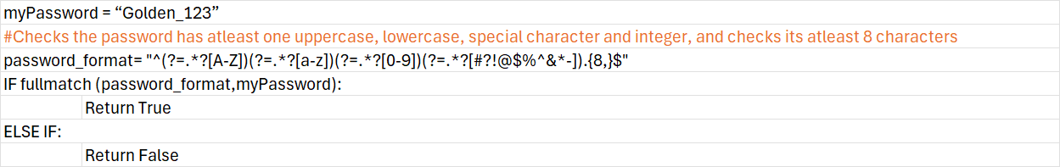

# 3. Testing:

## 3.1 Test Plan:

I have decided to approach testing mainly using module testing and end user tests to test the qualitative aspect being User-Friendliness.

For the purpose of testing a Run Cover Allocation button was added to SLT screens and a user with a default timetable the username “a” and password “a” was hardcoded into the program temporarily.

### 3.1.1 Part 1 (User Authentication and Access Control):

|  |  |  |  |  |  |  |
| --- | --- | --- | --- | --- | --- | --- |
| **Test No.** | **Test Case** | **Test Data** | **Expected Result** | **Actual Result** | **Test Type** | **Video Timestamps** |
| 1 | User registers in with all field empty | None | Error | Success, All Fields are required | Normal | 00:00 |
| 2 | User registers with only first name | Saif Saif.e_gfs Saif123  Saif123 | Error | Success, Fullname must include at least First and Last name | Normal | 00:10 |
| 3 | User registers with different passwords | Saif Emara Saif.e_gfs Saif123  Saif321 | Error | Success, Passwords do not match | Normal | 00:31 |
| 4 | User registers with username not ending in _gfs | Saif Emara  Saif.e  Saif123  Saif123 | Error | Success, Username must end with _gfs | Normal | 00:47 |
| 5 | User registers with a username that has special characters | Saif Emara  S@if.e_gfs  Saif123  Saif123 | Error | Success, start of username must only include alphanumeric characters and one full stop | Normal | 01:05 |
| 6 | User registers with username beginning with a number | Saif Emara  1Saif.e_gfs  Saif123  Saif123 | Error | Success, Username must start with a letter | Normal | 01:22 |
| 7 | User registers with username ending in _GFS | Saif Emara  Saif.e_GFS  Saif123@@  Saif123@@ | Successful Registration | Success, User  registered  successfully | Boundary | 01:37 |
| 8 | User registers with already existing username | Saif Emara  Saif.e_gfs  Saif123  Saif123 | Error | Success, Username already exists | Normal | 02:01 |
| 9 | User registers with a space in the password | Saif Emara  S.emara_gfsSaif 123  Saif 123 | Error | Success, Password must not contain spaces | Normal | 02:30 |
| 10 | User registers with non-regular expression password | Saif Emara  S.emara_gfsSaif123  Saif123 | Error | Success, Password must contain 9 characters...... e.g. | Normal | 02:51 |
| 11 |  |  |  |  |  |  |
| 12 | User registers with regular expression password and all other requirements | Saif Emara  S.emara_gfsSaif1234@  Saif1234@ | Successful Registration | Success, User registered successfully | Normal | 03:19 |
| 13 | Password Hashing Check | Database Check | Correct Hash Value format | Success, 3286184457 | Normal | 03:41 |
| 14 | Salt generation check | Database Check | Correct Salt formal | Success, b"O'\x8ap\xd3\x1d\x8bfv\xcf\xc0\xec\xc5\xb8\x8f " | Normal | 04:22 |
| 15 | User logs in with all fields empty | None | Error | Success, All fields are required | Normal | 04:30 |
| 16 | User logs in with incorrect credentials | S.emara_gfsSaif12@ | Error | Success, Invalid username or password | Normal | 04:39 |
| 17 | User logs in with correct credentials | S.emara_gfsSaif1234@ | Successful Login | Success,  User logged in successfully | Normal | 05:00 |
| 18 | User logs in to admin access with incorrect password | 12345678 | Error | Success, Wrong password entry denied | Normal | 05:14 |
| 19 | User logs in to admin access with correct password | 11235813 | Successful Admin Login | Success,  User logged in as admin successfully | Normal | 05:32 |

### 3.1.2 Part 2 (User Friendly GUI Design):

|  |  |  |  |  |  |  |
| --- | --- | --- | --- | --- | --- | --- |
| **Test No.** | **Test Case** | **Test Data** | **Expected Result** | **Actual Result** | **Test Type** | **Video Timestamps** |
| 1 | Registration Buttons: Main, Cancel, Register | Button Clicks | Go to Appropriate Screens: Registration Screen, Main Menu Screen, Teacher Screen | Success, All buttons go to correct screens | Normal | 05:49 |
| 2 | Login Buttons: Main, Cancel, Login | Button Clicks | Go to Appropriate Screens: Login Screen, Main Menu Screen, Teacher or SLT Screen | Success, All buttons go to correct screens | Normal | 06:44 |
| 3 | Admin Buttons: Main, Cancel, Ok | Button Clicks | Go to Appropriate Screens and/or show message boxes: Admin Password Message, Main Menu Screen, Admin Choice Screen | Success, Passwords do not match | Normal | 07:07 |
| 4 | Verification of hover functionality | Cursor hover | Buttons darken / change color as hover and return to previous as leaving hover | Success, Buttons changes color appropriately | Normal | 07:29 |
| 5 | Digital Clock and Logo Visibility | Viewing of screen | Clock changing every minute to reflect time and logos visible on main menu screen | Success, Logos are clearly visible and clock changes to display time | Normal | 07:46 |
| 6 | Session control | Button Clicks | Signing out and logging back in works | Success, Signing out and logging in works as intended | Normal | 09:02 |

### 3.1.3 Part 3 (Cover Allocation Algorithm):

|  |  |  |  |  |  |  |
| --- | --- | --- | --- | --- | --- | --- |
| **Test No.** | **Test Case** | **Test Data** | **Expected Result** | **Actual Result** | **Test Type** | **Video Timestamps** |
| 1 | Normal teacher marks absent before 6:30 | Sick Leave | Allows absence to be recorded | Success, You are marked absent | Normal | 09:17 |
| 2 | Normal teacher marks absent after 6:30 | Sick Leave | Does not allow absence to be recorded | Success, Cannot select today as it is past 6:30 AM | Normal | 13:38 |
| 3 | SLT teacher marks self absent before 6:30 | Sick Leave | Allows absence to be recorded but doesn't run cover algorithm | Success, You are marked absent , and doesn’t run cover algorithm | Normal | 10:02 |
| 4 | SLT teacher marks self absent after 6:30 but before 15:00 | Sick Leave | Allows absence to be recorded and runs cover algorithm | Success, You are marked absent , and runs the cover algorithm | Normal | 14:07 |
| 5 | SLT teacher marks self absent after 15:00 | Sick Leave | Allows absence to be recorded but doesn’t run cover algorithm | Success, You are marked absent , and doesn’t run cover algorithm | Normal | 15:27 |
| 6 | SLT teacher marks another teacher absent before 6:30 | Sick Leave | Allows absence to be recorded but doesn’t run cover algorithm | Success, You are marked absent , and doesn’t run cover algorithm | Normal | 10:43 |
| 7 | SLT teacher marks another teacher absent after 6:30 | Sick Leave | Allows absence to be recorded and runs cover algorithm | Success, You are marked absent , and runs the cover algorithm | Normal | 14:40 |
| 8 | User marks absent for multiple days | Sick Leave | Allows absences to be recorded | Success, You are marked absence on dates | Normal | 11:21 |
| 9 | User duplicates absence | Sick Leave | Error does not allow absence to be recorded | Success, You are already marked absent | Normal | 11:50 |
| 10 | Manual cover allocation | Cover Allocation Button | Allocates covers for absent teachers | Success, covers are allocated and reflected in timetables and database | Normal | 12:03 |

### 3.1.4 Part 4 (Database Update and Verification):

|  |  |  |  |  |  |  |
| --- | --- | --- | --- | --- | --- | --- |
| **Test No.** | **Test Case** | **Test Data** | **Expected Result** | **Actual Result** | **Test Type** | **Video Timestamps** |
| 1 | Add teacher through registration screen | Alpha Ah  Alpha.a_gfsAlpha123@Alpha123@ | Adds teacher to database | Success, Teacher added in database | Normal | 16:02 |
| 2 | Add teacher through SLT screen | Delta Ad  delta.a_gfs  Mathematics  15 | Adds teacher to database | Success, Teacher added in database | Normal | 16:47 |
| 3 | Add teacher through admin screen | Sigma As  sigma.a_gfs  Mathematics  15 | Adds teacher to database | Success, Teacher added in database | Normal | 17:46 |
| 4 | User marks absent | Sick Leave | Allows absence to be recorded and display in database and text file | Success, You are marked absent and reflected in database | Normal | 19:06 |
| 5 | Edits teacher data from SLT screen | Change details | Edits teachers data | Success, Edits teacher details | Normal | 20:03 |
| 6 | Edits teacher data from Admin screen | Change details | Edits teachers data | Success, Edits teacher details | Normal | 20:36 |
| 7 | Deleting teacher from database | Button Clicks | Deletes teacher and all their details from the database | Success, User deleted and reflected in the database | Normal | 21:13 |

### 3.1.5 Part 5 (SQL queries view, edit, and delete):

|  |  |  |  |  |  |  |
| --- | --- | --- | --- | --- | --- | --- |
| **Test No.** | **Test Case** | **Test Data** | **Expected Result** | **Actual Result** | **Test Type** | **Video Timestamps** |
| 1 | View teacher from SLT account | Button Clicks | Adds teacher to database | Success, Teacher data viewed in database | Normal | 21:50 |
| 2 | Edit teacher credentials from SLT account | Change credentials | Adds teacher to database | Success, Teacher credentials edited in database | Normal | 22:13 |
| 3 | Edit teacher timetable from SLT account | Change timetable details | Adds teacher to database | Success, Teacher timetable edited in database | Normal | 22:36 |
| 4 | Delete teacher data from SLT account | Delete button clicks | Allows absence to be recorded and display in database and text file | Success, User deleted and reflected in the database | Normal | 23:17 |

### 3.1.6 Part 6 (Qualitative Factors):

|  |  |  |  |  |  |  |
| --- | --- | --- | --- | --- | --- | --- |
| **Test No.** | **Test Case** | **Test Data** | **Expected Result** | **Actual Result** | **Test Type** | **Video Timestamps** |
| 1 | Verification of field labels | End User Viewing | All field labels are accurate and convey meaning to user | Success, All spelling accurate and accurate meaning | Normal | 23:25 |
| 2 | User Friendliness | End User Viewing | User conveys ease of use and clear navigation | Failed, User couldn’t figure out how to edit cells and add and remove absence dates | Normal | 23:57 |
| 2 Repeat | User Friendliness | End User Viewing | User conveys ease of use and clear navigation | Success, User was able to figure out how to edit cells and add and remove absence dates | Normal | 24:39 |

### 3.1.7 Part 7 (Failed Tests and Fixes):

|  |  |  |  |  |  |  |
| --- | --- | --- | --- | --- | --- | --- |
| **Test No.** | **Test Case** | **Test Data** | **Expected Result** | **Actual Result** | **Test Type** | **Video Timestamps** |
| 1 | User logs into SLT account signs out and relogs in | a  a | Sessions allow for signing out and logging back in with no issues | Failed, username and password entries were not cleared | Normal | 25:25 |
| 1 Repeat | User logs into SLT account signs out and relogs in | a  a | Sessions allow for signing out and logging back in with no issues | Success, signing in and out works and entries are cleared | Normal | 27:15 |
| 2 | SLT member delete teacher from database | Button Clicks | Teacher gets deleted and deletion is corroborated across the screens | Failed, deletion of teacher was not corroborated instantly in access database screen | Normal | 26:14 |
| 2 Repeat | SLT member delete teacher from database | Button Clicks | Teacher gets deleted and deletion is corroborated across the screens | Success, teacher gets deleted from database and screens reflect the same | Normal | 27:50 |
| 3 | SLT member inform self absent | Sick Leave | Allows absence | Failed, Sick Leave was not recognized as a valid input for absence reason | Normal | 26:51 |
| 3 Repeat | SLT member inform self absent | Sick Leave | Allows absence | Success, Absence was recorded and allowed Sick Leave as a valid input | Normal | 28:13 |

## 3.2 Testing Video Evidence:

<https://youtu.be/S4ItjzRI50Q.com>

## 3.3 Screenshot Evidence for the Main 7 Objectives:

|  |  |  |
| --- | --- | --- |
| No. | Objective | Performance Criteria |
| 1 | Design a user-friendly graphical user interface. | Must be straightforward and intuitive to use and disguises complexity of the operations executed in the background to be easy to navigate. |
| 2 | A secure login system. | A separate view for login, registration, and deletion of accounts. Robust use of validation for formatting of passwords. Generate a hash key as well as a salt for every password and store only the hash key and salt on the database. Must be able to create and delete accounts easily. |
| 3 | Create a secure program to store teacher timetables and cover lesson information securely in the database. | Uses separate permissions for SLT members and normal teachers regarding database editing and viewing.  Must be secure enough so that only the end user can access the contents of the database. |
| 4 | Using SQL queries; delete, insert, and view timetable data. | Uses a central database system to contain all information about lessons.  Displays specific teacher names and corresponding timetable.  SLT members must be able to insert and delete records to the timetables. |
| 5 | Create an automatic sorting system to allocate lessons needing cover. | Checks against the database and calculates which teachers should cover which lessons based on cover limit, free lessons available, number of covers taken and department. |
| 6 | Create a feature to display a complete cover timetable daily. | Displays final cover timetable daily for teachers to access. |
| 7 | Create an interface for admins to access and edit sensitive parts of the database | Creates a password protected GUI where admins can edit a teacher’s role and thus permissions, cover limit and current number of lessons covered. |

### 3.3.1 Objective 1:

**Clear titles and logos:**

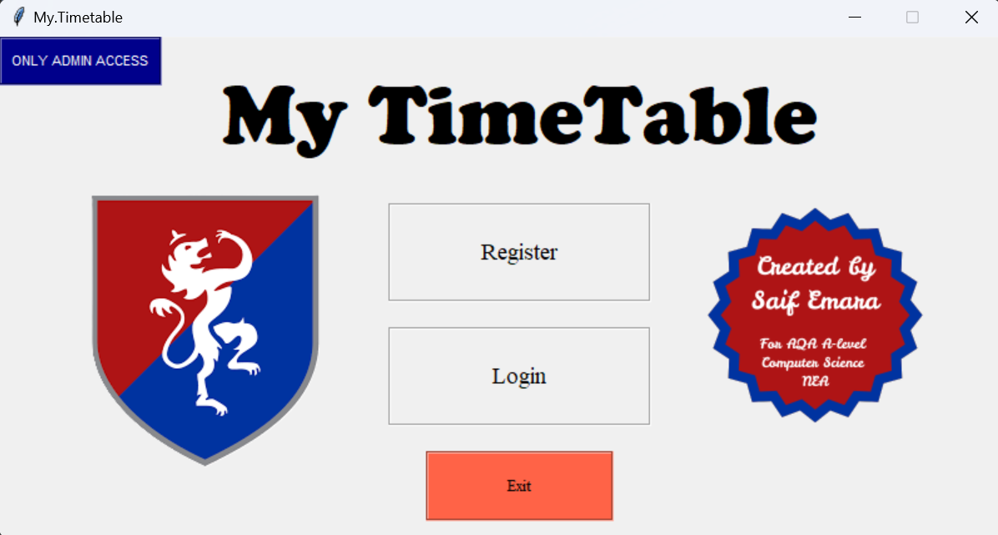

**Button Hovers darkens button color:**

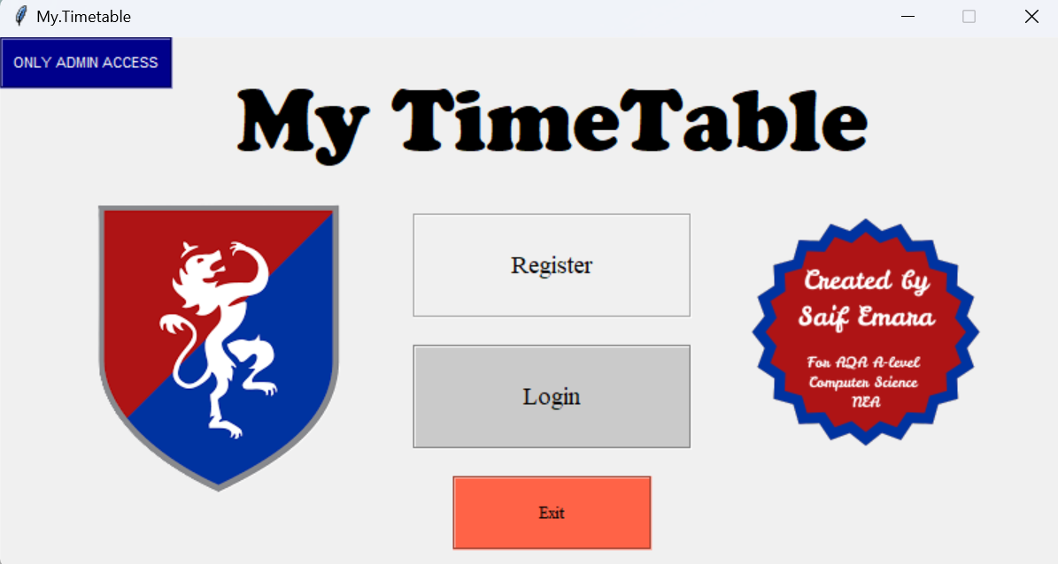

**Clear Instructions:**

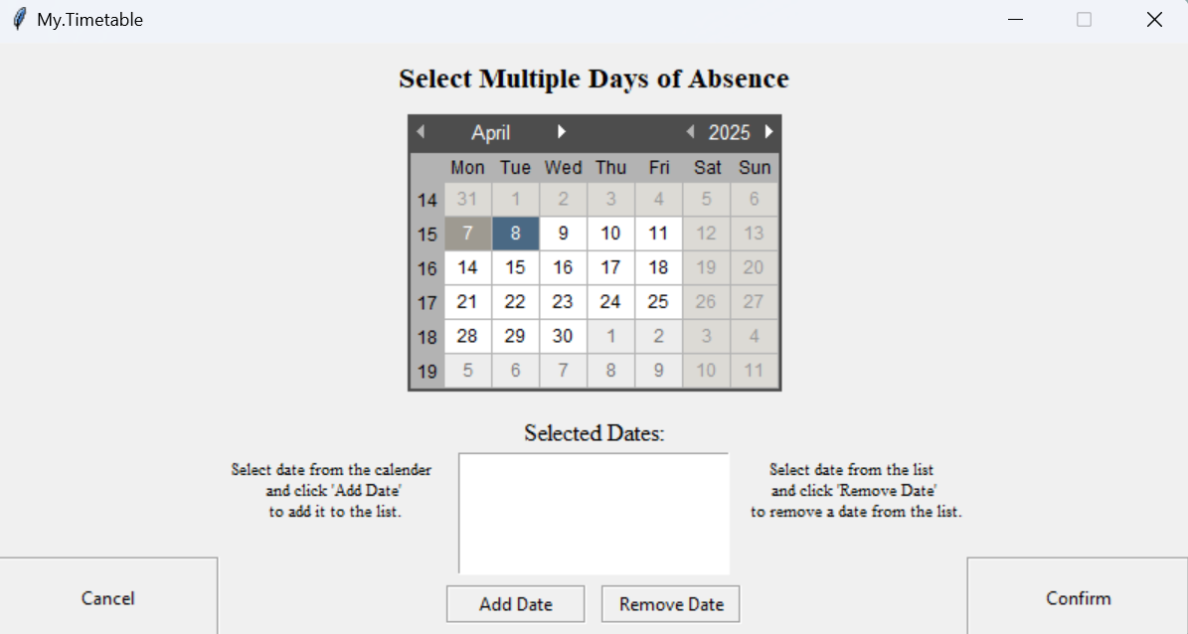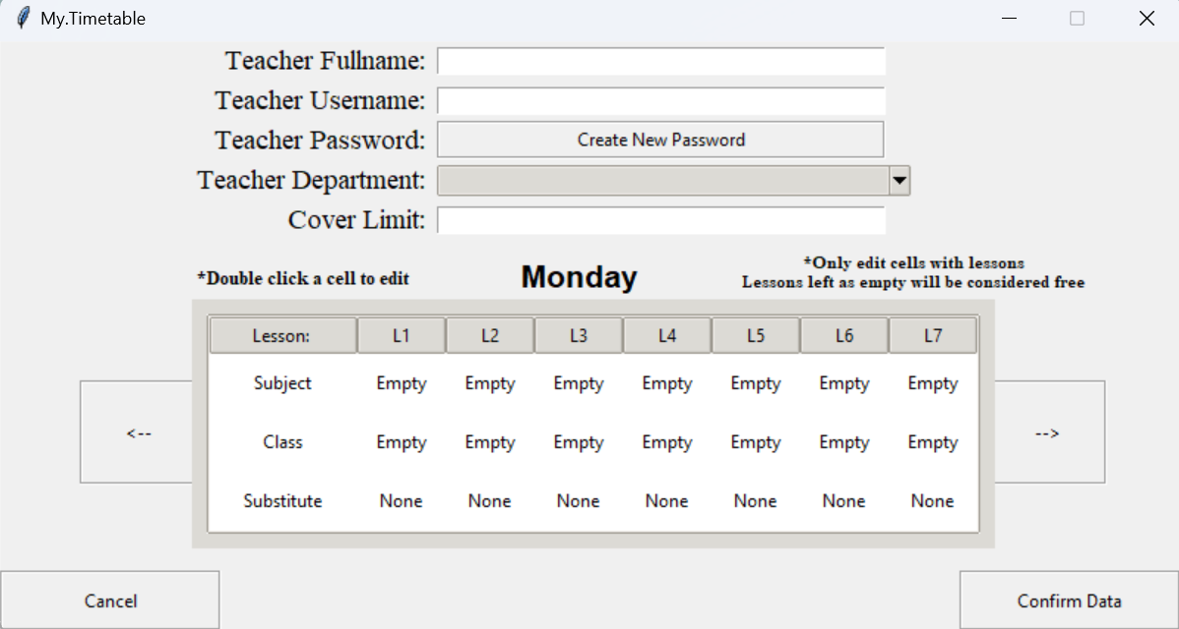

**Well Planned Layout, Hover Rows on timetable and display clock:**

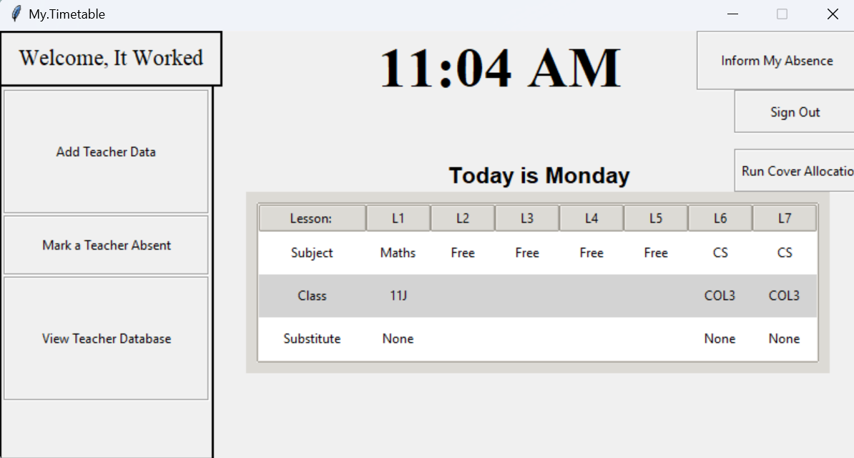

### 3.3.2 Objective 2:

**Separate View for Login and Registration:**

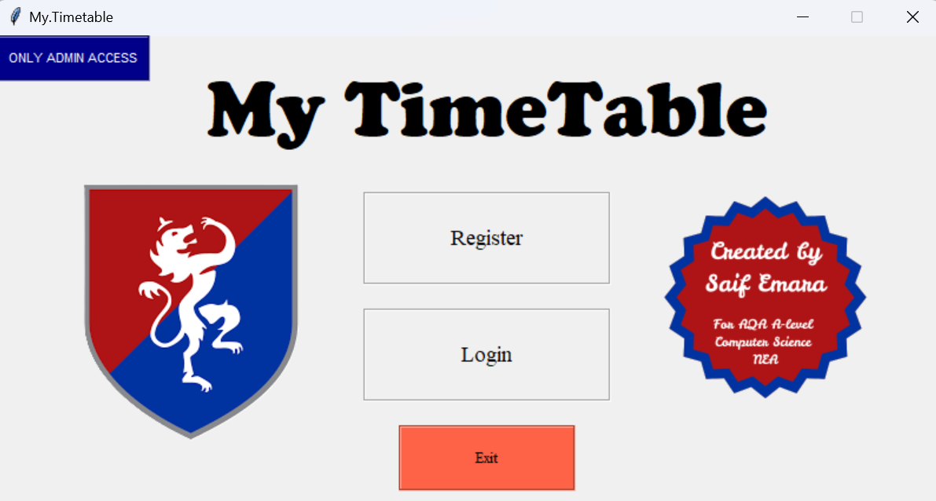

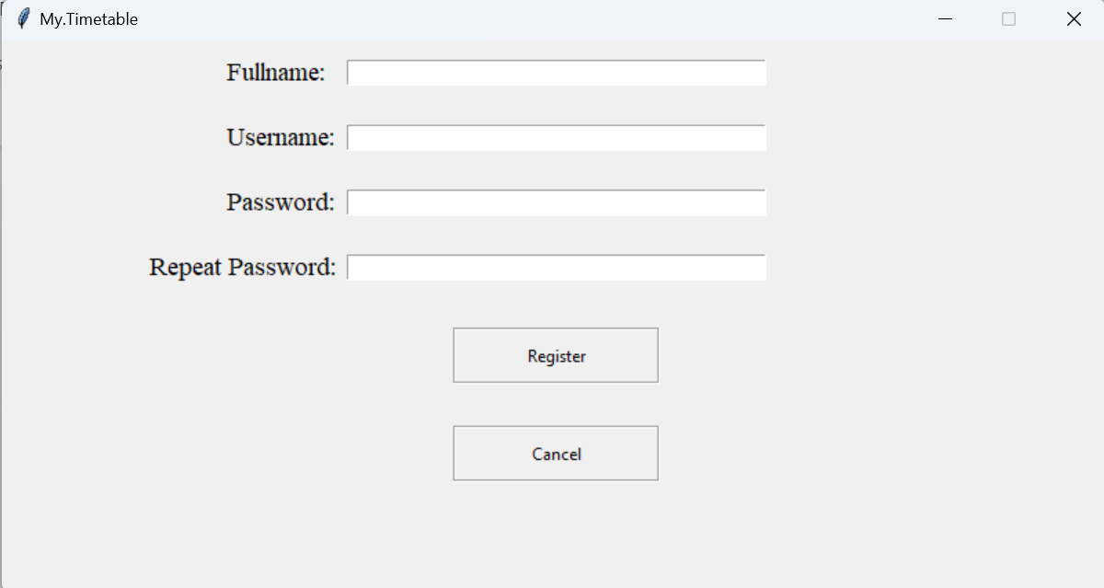

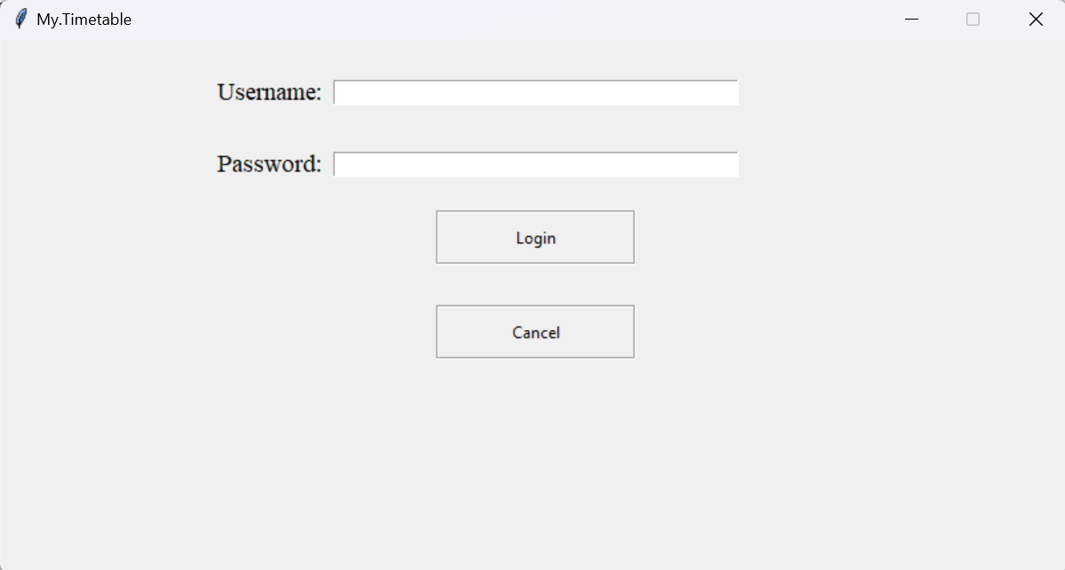

**Formatting of password using regular expression:**

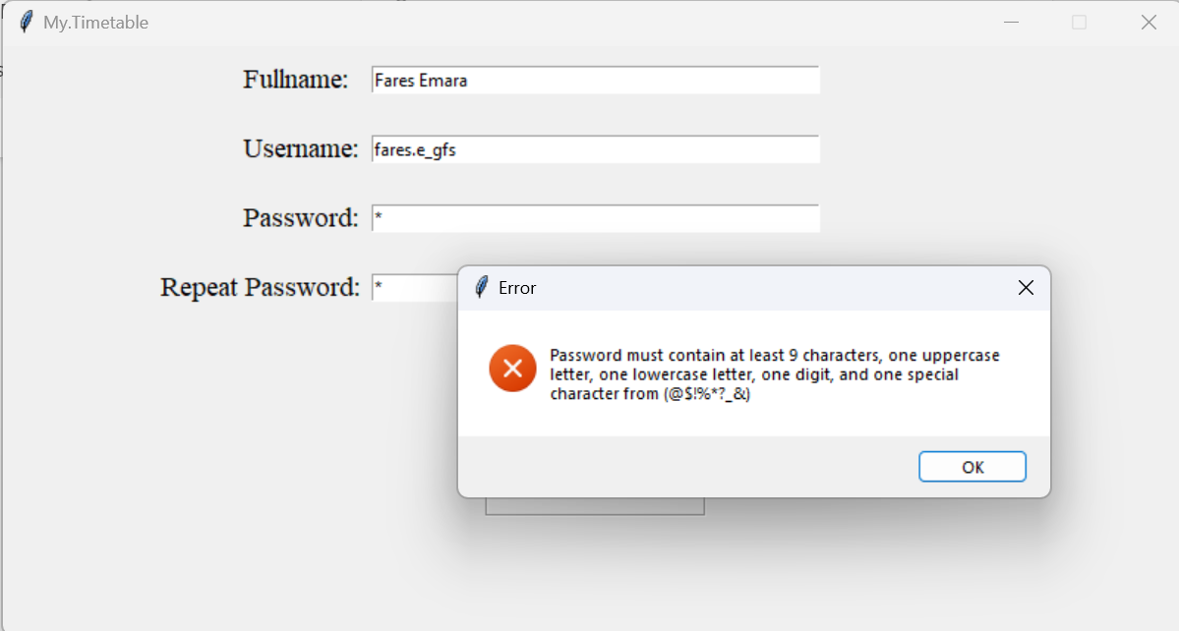

**Clear Deletion and Creation of Accounts:**

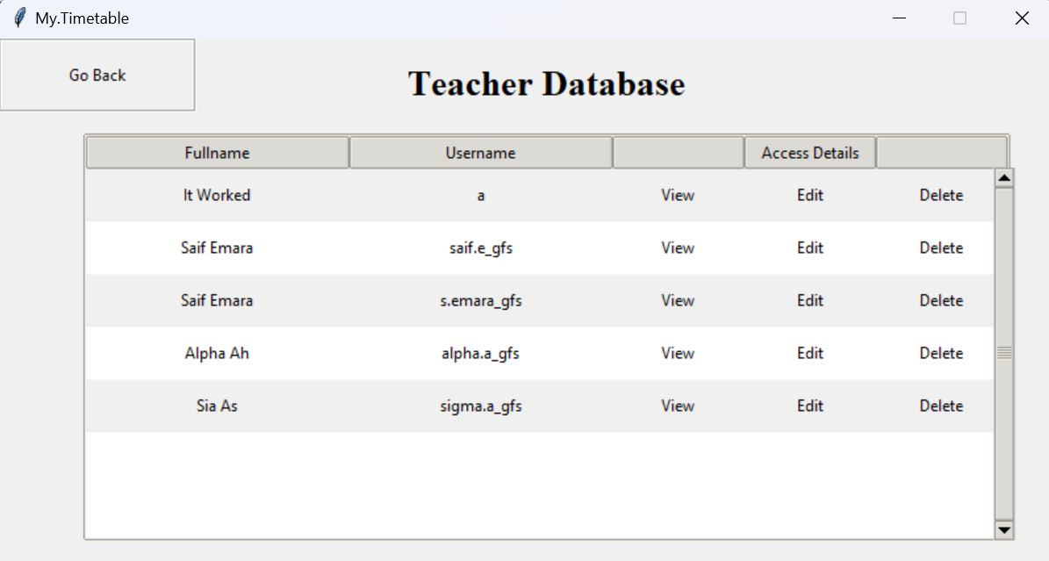

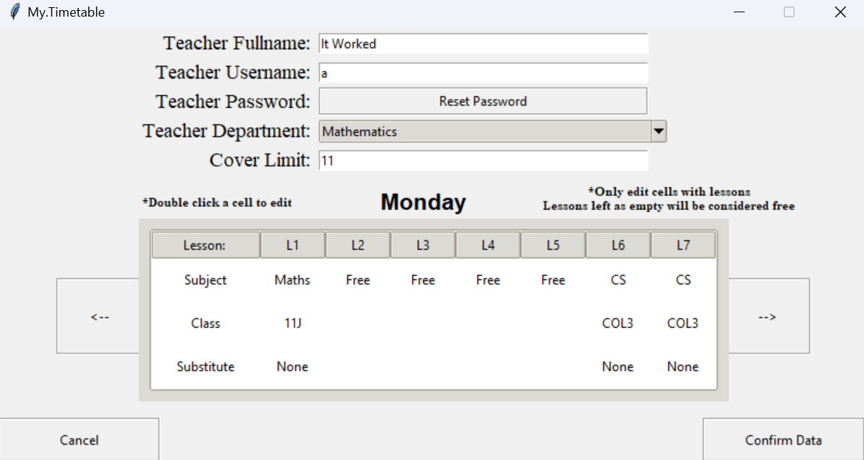

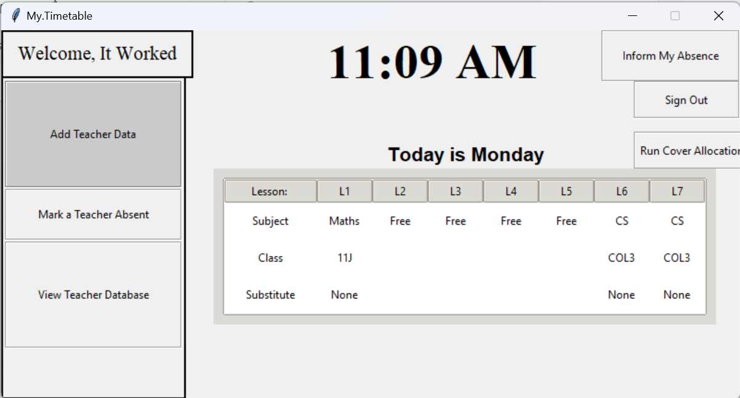

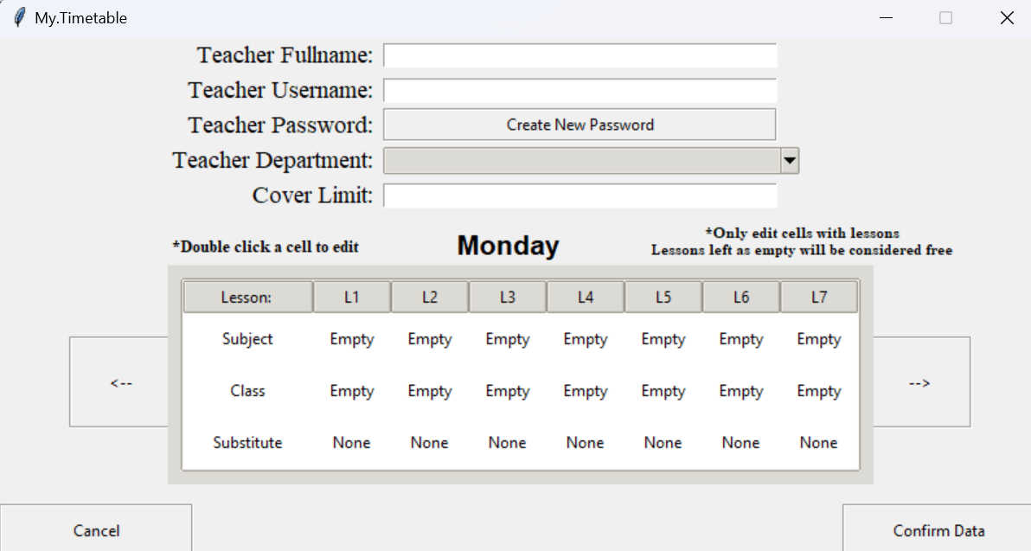

**Resetting of password and not saving them elsewhere:**

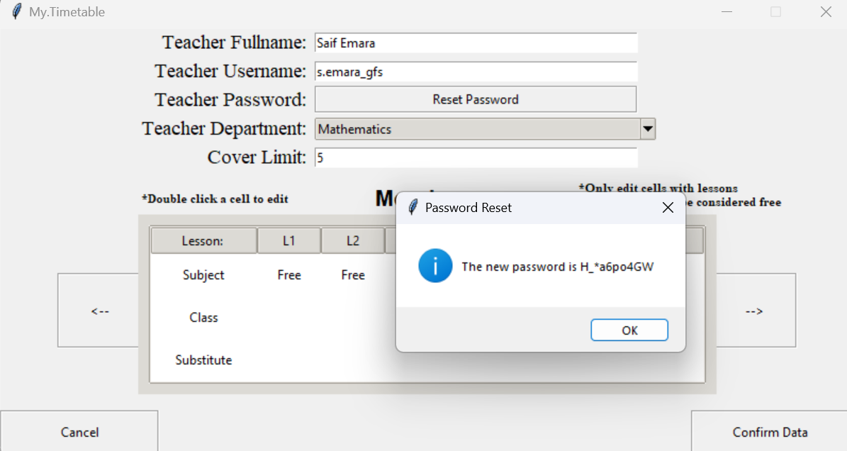

**Database view of hash value and salt stored:**

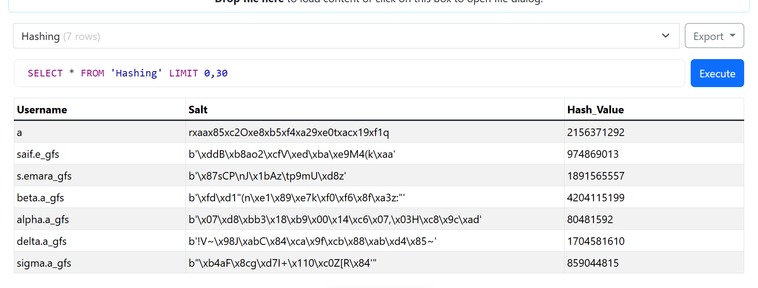

### 3.3.3 Objective 3:

**Separate Screens and permission for SLT and Normal Teachers respectively:**

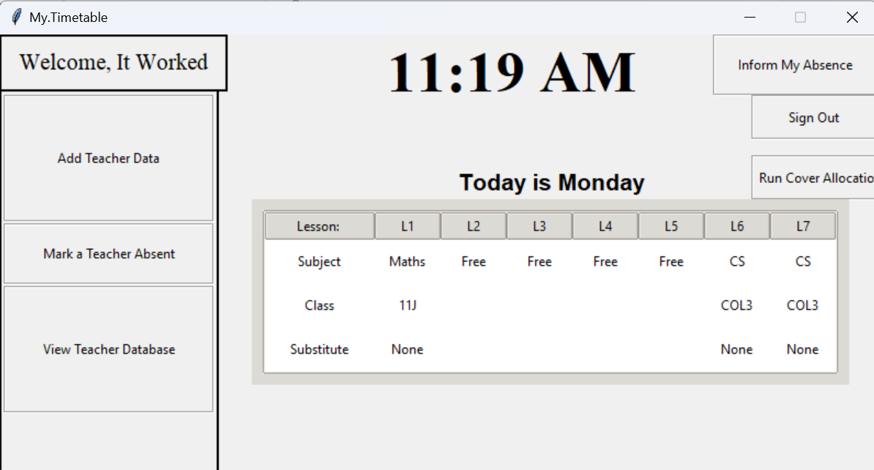

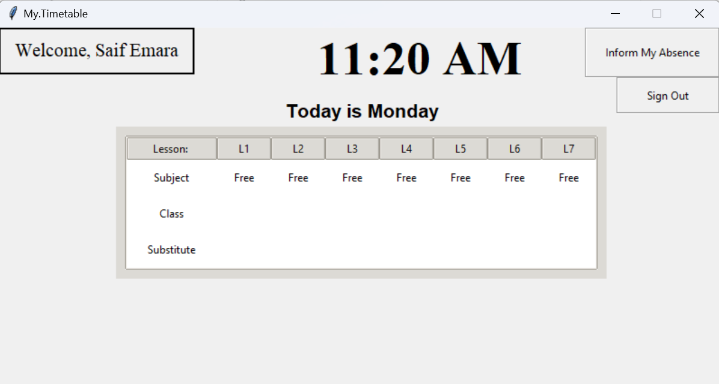

**Clear Interface to view and edit:**

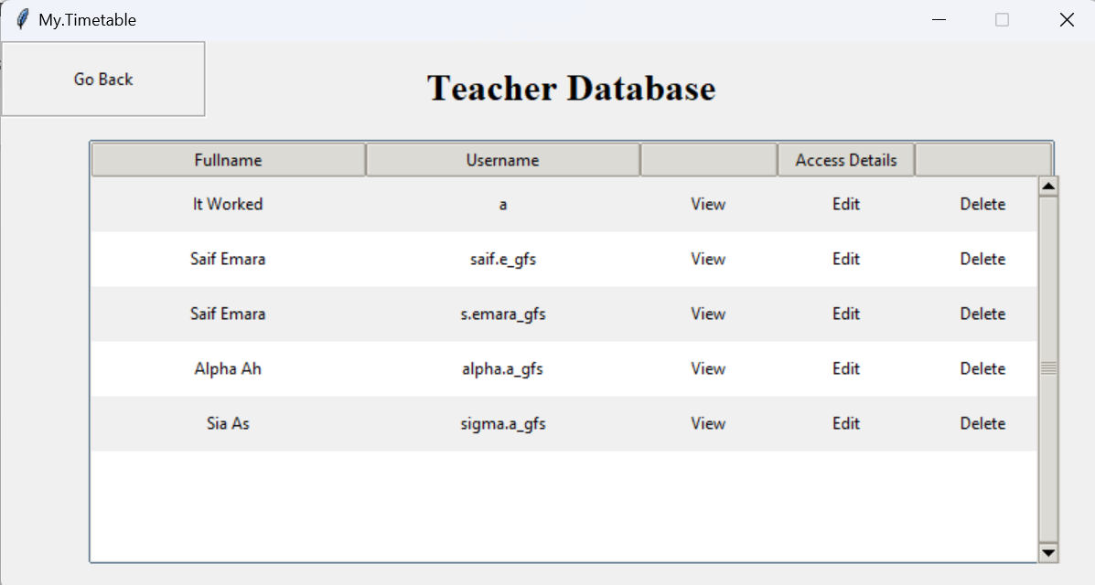

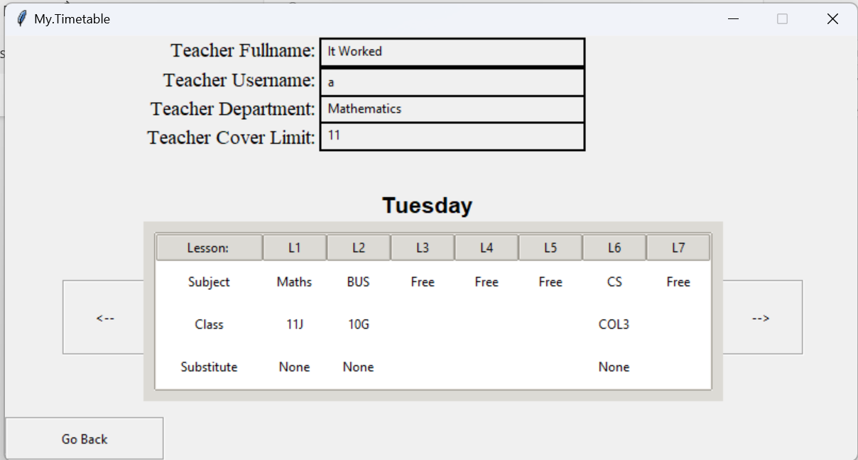

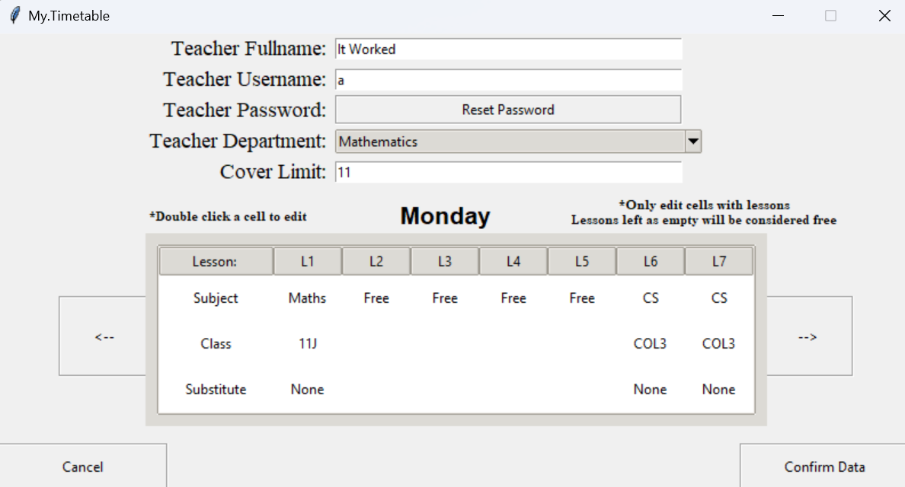

### 3.3.4 Objective 4:

**Clear Interface to view lesson and timetable of teachers:**





**Clear Interface to edit and delete records:**





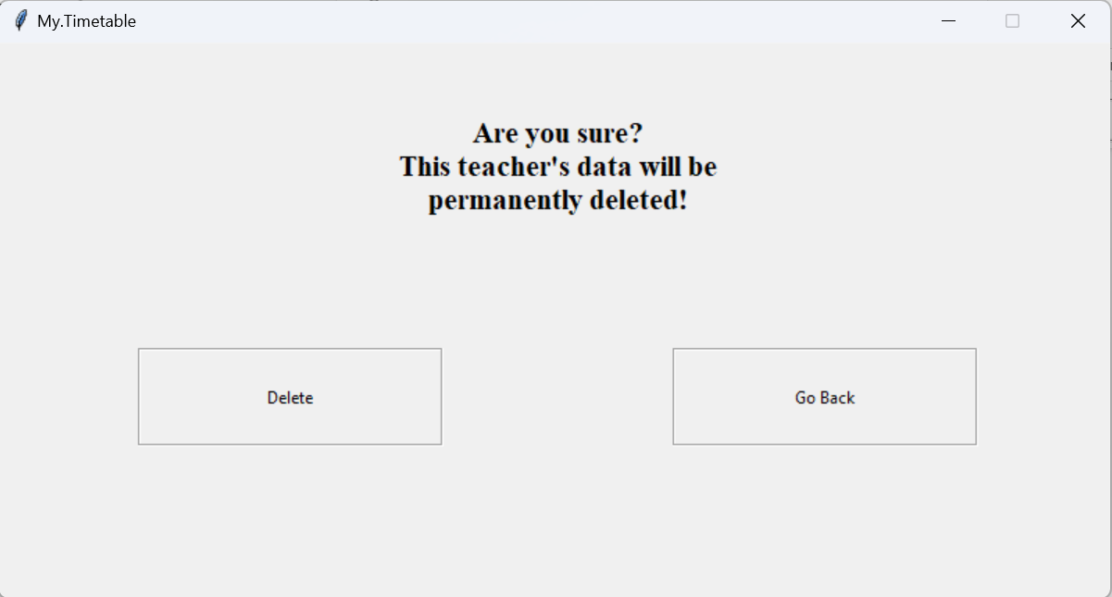

**Clear Interface to insert new teacher:**

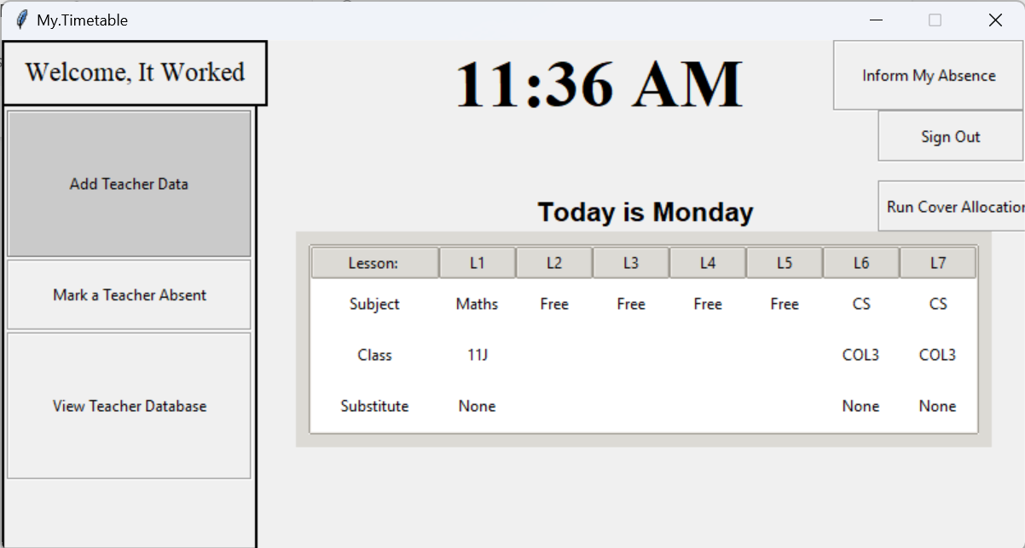

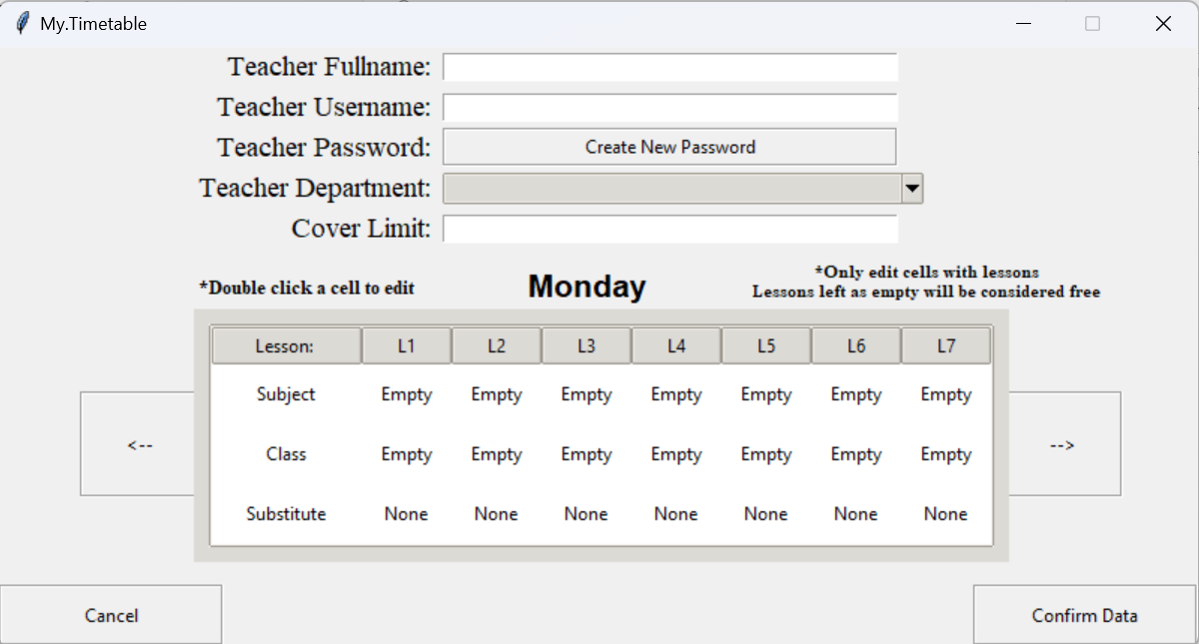

### 3.3.5 Objective 5:

**Runs Cover Algorithm Manually using testing purposes button:**

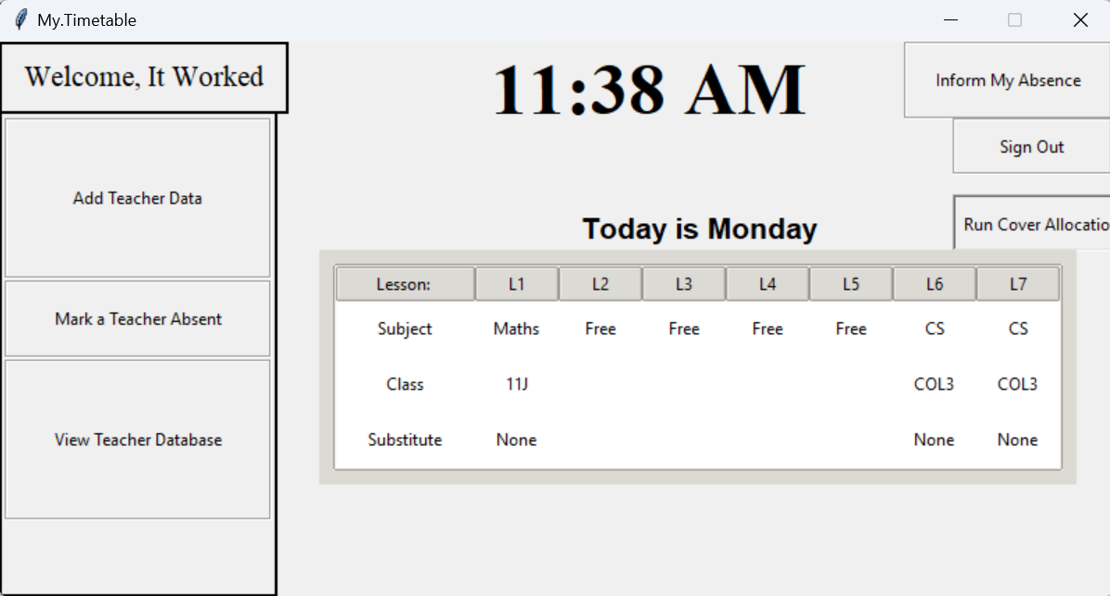

**Shows who the lesson is Subbed by and who a teacher is Subbing respectively:**

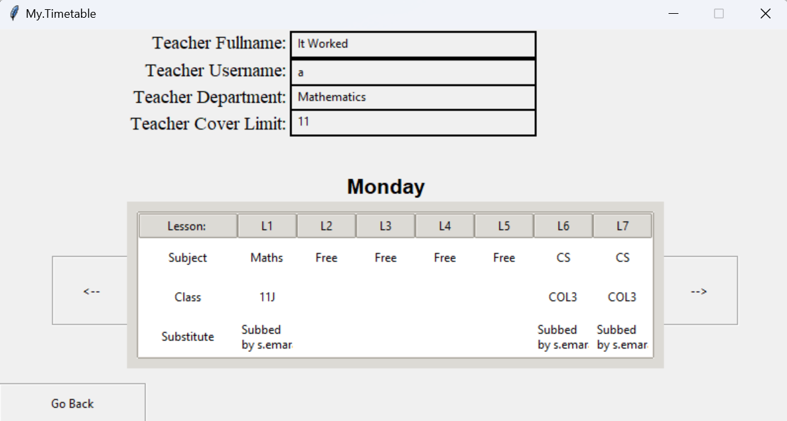

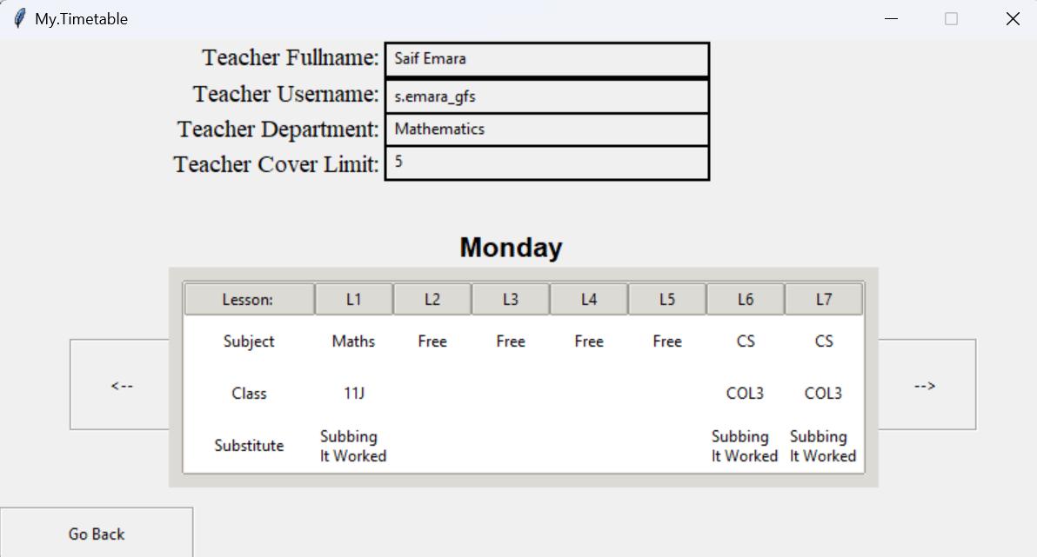

### 3.3.6 Objective 6:

**Clearly displays cover timetable on screen which gets updates daily at 6:30 A.M :**

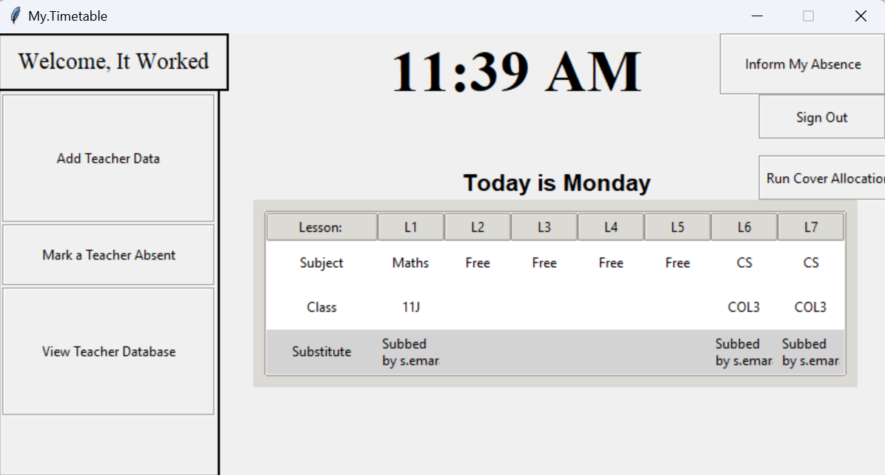

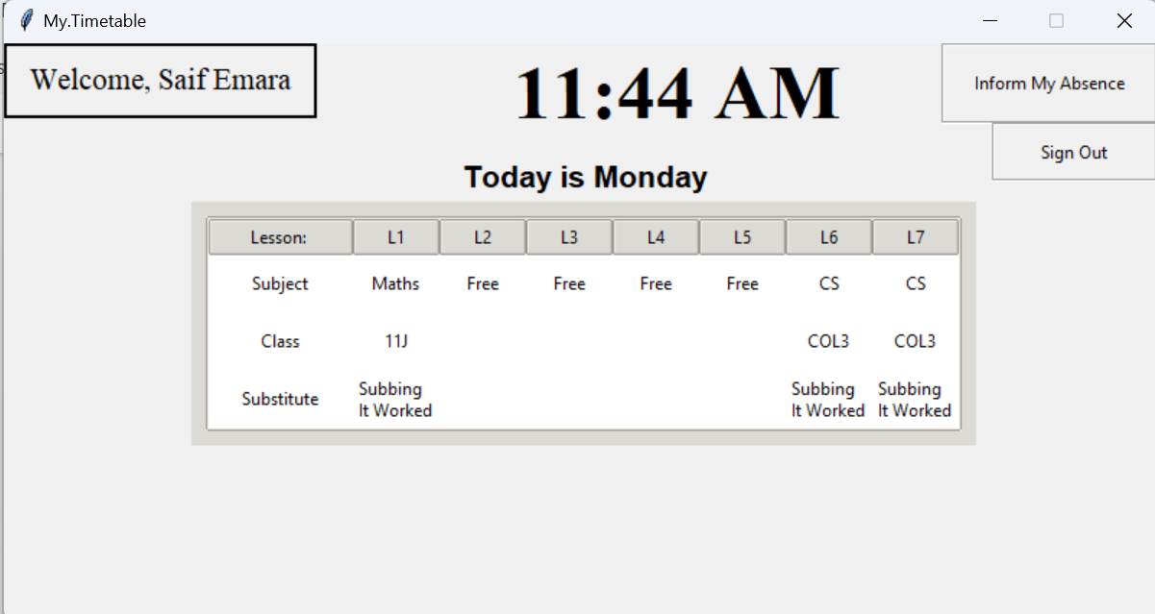

### 3.3.7 Objective 7:

**Interface for admins to access database and add teachers:**

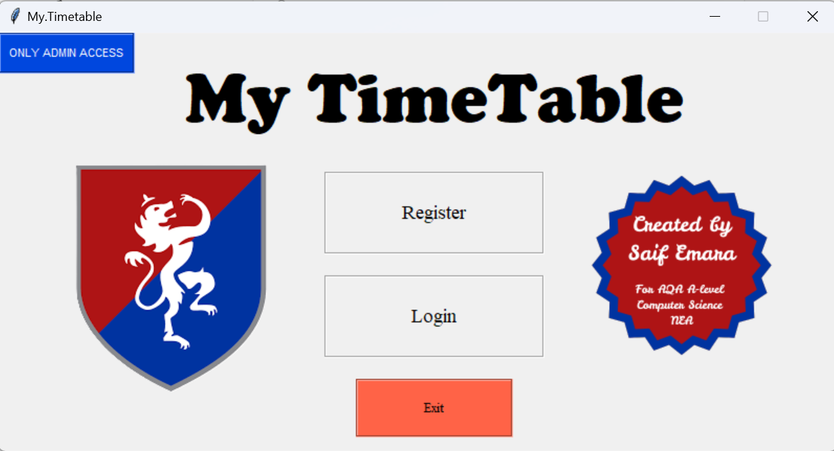

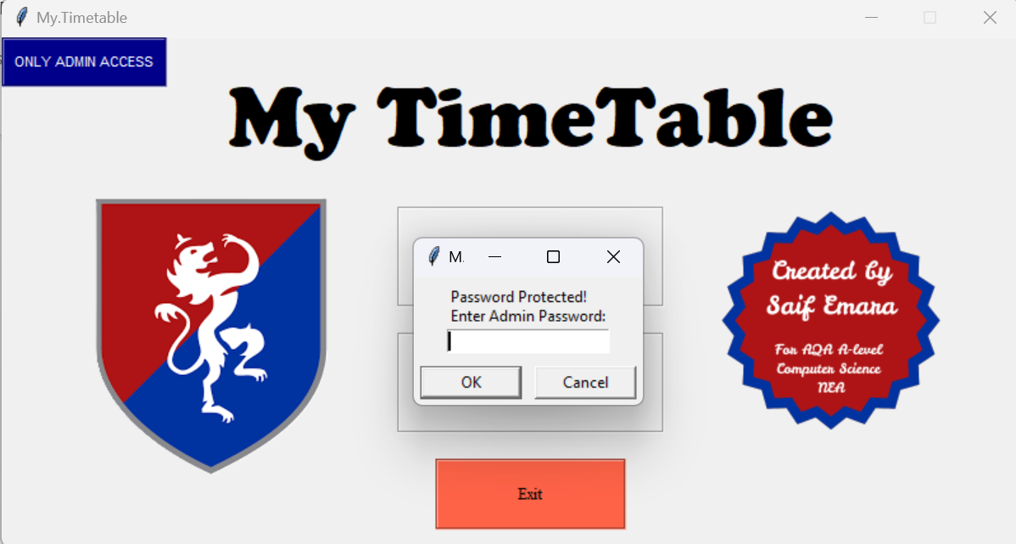

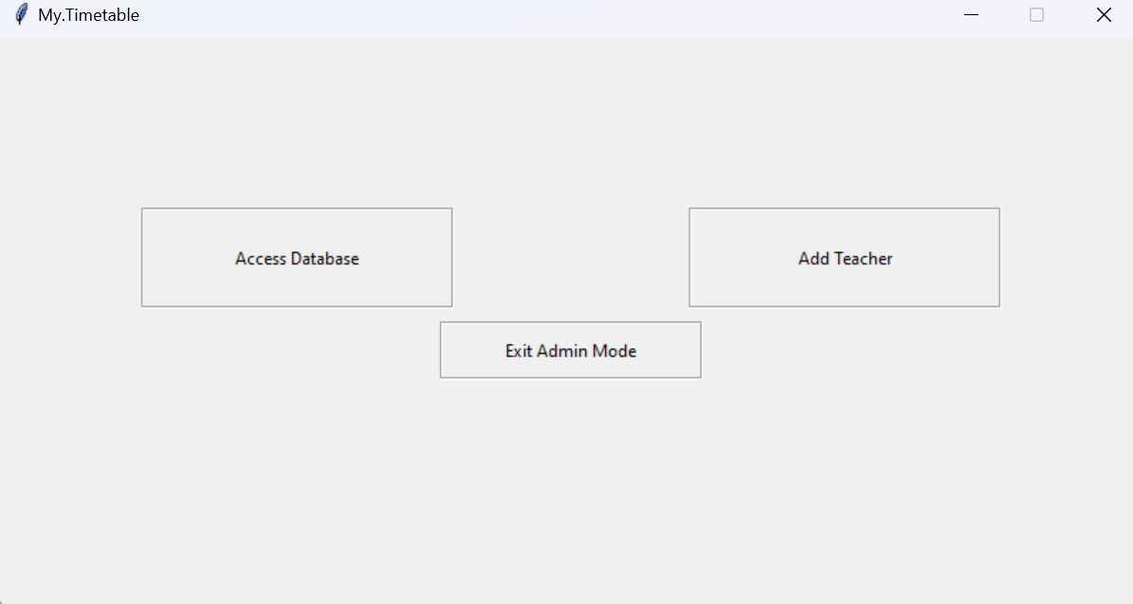

**Viewing of teacher data and timetable along with sensitive variables such as Role:**

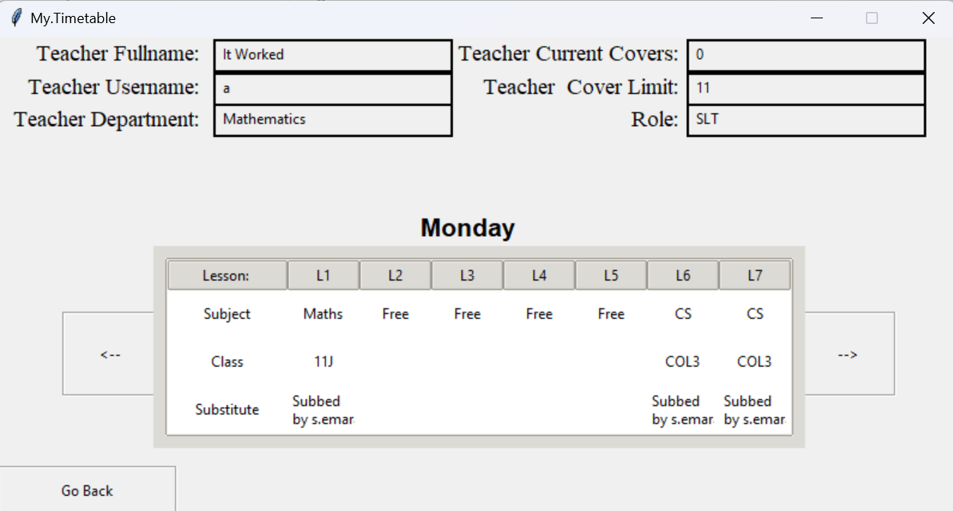

**Editing of teacher data and timetable along with sensitive variables such as Role:**

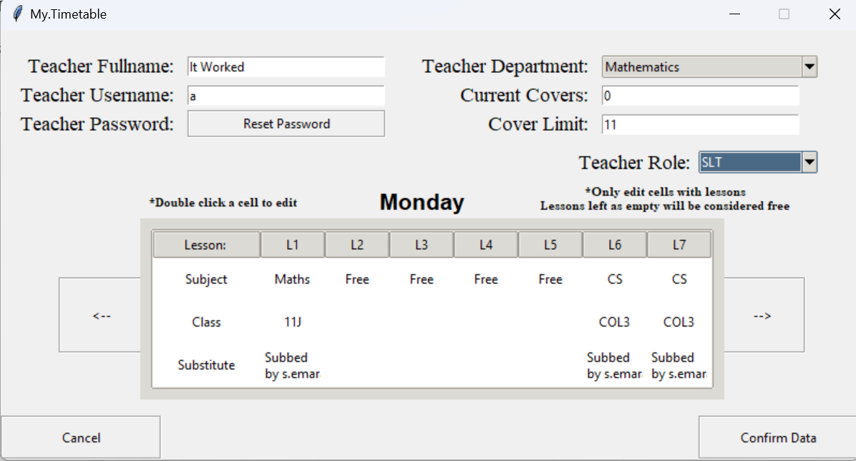

# 4 Technical Solution:

## 4.1 Tables and Relationships:

### 4.1.1 Creating Teachers Table:

# Create Teachers table if it does not exist to ensure a new table isn't created at run everytime

            cursor.execute("""CREATE TABLE IF NOT EXISTS Teachers (

                Username TEXT PRIMARY KEY,

                Fullname TEXT,

                Role TEXT,

                Subject_Department TEXT,

                Current_Covers INTEGER,

                Cover_Limit INTEGER

                )""")

### 4.1.2 Creating Weekly Lessons Table:

#Table creation for the 5 das of the week

            cursor.execute("""CREATE TABLE IF NOT EXISTS MondayLessons (

                Username TEXT,

                Lesson_Number INTEGER,

                Subject TEXT,

                Class TEXT,

                Substitute TEXT,

                PRIMARY KEY (Username, Lesson_Number),

                FOREIGN KEY (Username) REFERENCES Teachers(Username)

                )""")

            cursor.execute("""CREATE TABLE IF NOT EXISTS TuesdayLessons (

                Username TEXT,

                Lesson_Number INTEGER,

                Subject TEXT,

                Class TEXT,

                Substitute TEXT,

                PRIMARY KEY (Username, Lesson_Number),

                FOREIGN KEY (Username) REFERENCES Teachers(Username)

                )""")

            cursor.execute("""CREATE TABLE IF NOT EXISTS WednesdayLessons (

                Username TEXT,

                Lesson_Number INTEGER,

                Subject TEXT,

                Class TEXT,

                Substitute TEXT,

                PRIMARY KEY (Username, Lesson_Number),

                FOREIGN KEY (Username) REFERENCES Teachers(Username)

                )""")

            cursor.execute("""CREATE TABLE IF NOT EXISTS ThursdayLessons (

                Username TEXT,

                Lesson_Number INTEGER,

                Subject TEXT,

                Class TEXT,

                Substitute TEXT,

                PRIMARY KEY (Username, Lesson_Number),

                FOREIGN KEY (Username) REFERENCES Teachers(Username)

                )""")

            cursor.execute("""CREATE TABLE IF NOT EXISTS FridayLessons (

                Username TEXT,

                Lesson_Number INTEGER,

                Subject TEXT,

                Class TEXT,

                Substitute TEXT,

                PRIMARY KEY (Username, Lesson_Number),

                FOREIGN KEY (Username) REFERENCES Teachers(Username)

                )""")

### 4.1.3 Creating Absence Table:

cursor.execute("""CREATE TABLE IF NOT EXISTS AbsenceLog (

                Username TEXT,

                Date TEXT,

                Reason TEXT,

                PRIMARY KEY (Username, Date)

                )""")

### 4.1.4 Creating Hashing Table:

cursor.execute("""CREATE TABLE IF NOT EXISTS Hashing (

                Username TEXT,

                Salt TEXT,

                Hash_Value TEXT,

                PRIMARY KEY (Username)

                )""")

## 4.2 System Overview:

### 4.2.1 System Overview Diagram (Top Down):



### 4.2.2 Evidence of Built Classes, UI, Procedures and Variables:

As almost all of my code is in classes the Class relationship diagram and Python code evidence will be lengthy and will basically cover all the program’s code.

#### 4.2.2.1 Class Relationship Diagram:

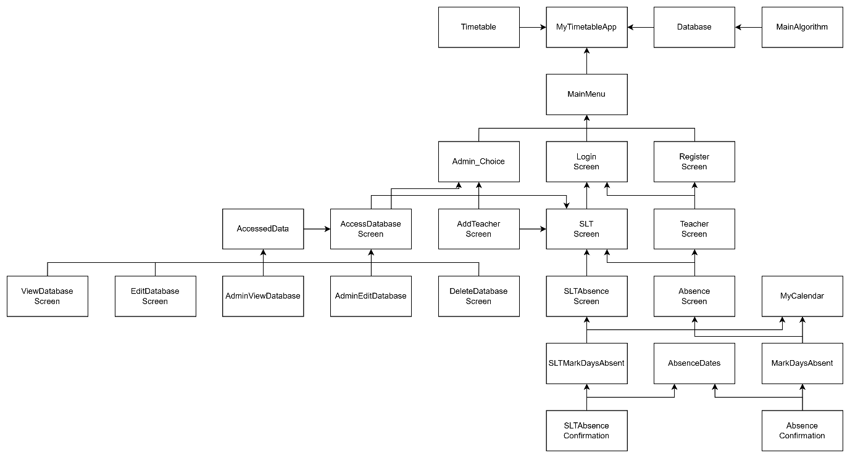

#### 4.2.2.2 Python Code Evidence:

##### 4.2.2.2.1 MyTimetableApp Class:

###### 4.2.2.2.1.1 Code:

class MyTimetableApp:

    """Main application class for managing the GUI."""

    def __init__(self, root):

        """Initialize the main application window."""

        self.root = root

        self.root.title("My.Timetable")

        self.root.geometry('800x400')

        self.root.resizable(False, False)

        self.current_user = None

        self.current_role = None

        self.allocated = False

        today = datetime.datetime.now()

        try:

            """Tries to open the file and sets it to False if empty"""

            f = open('state.txt', 'r')

            value = f.read().strip()

            if not value:

                value = "False"

            self.Cleared = value

            f.close()

        except FileNotFoundError:

            """Creates the file and sets the default state to False"""

            f = open("AbsenceLog.txt", "a")

            f.close()

            self.Cleared = "False"

        if self.Cleared == "False" and today.day == 1:

            """Clears Current Covers and sets state to cleared"""

            teachers = database.get_all_usernames()

            for teacher in teachers:

                database.reset_current_covers(teacher)

            self.Cleared = "True"

            f = open('state.txt', 'w')

            f.write(self.Cleared)

            f.close()

        elif today.day != 1:

            self.Cleared = "False"

            f = open('state.txt', 'w')

            f.write(self.Cleared)

            f.close()

        # Create a container frame

        self.container = tk.Frame(root)

        self.container.pack(fill="both", expand=True)

        #initializes empty dictionary to store frame instances

        self.frames = {}

        for F in (MainMenu, Admin_Choice, RegisterScreen, LoginScreen, SLTScreen, TeacherScreen, AbsenceScreen,

                   SLTAbsenceScreen, MarkDaysAbsent, SLTMarkDaysAbsent, AbsenceConfirmation,

                     SLTAbsenceConfirmation, AddTeacherScreen, AccessDatabaseScreen,

                       ViewDatabaseScreen, EditDatabaseScreen, DeleteDatabaseScreen,

                         AdminViewDatabase, AdminEditDatabase):

            frame = F(parent=self.container, controller=self)

            self.frames[F] = frame

            frame.grid(row=0, column=0, sticky="news")

        self.allocated = False

        self.reverted = False

        self.root.protocol("WM_DELETE_WINDOW", self.window_close)

        self.root.after(10000, self.check_time)  # Check every 10 seconds

        self.show_frame(MainMenu)  # Start with the main menu

    def show_frame(self, frame_class):

        #Raise a frame to the front for display.

        frame = self.frames[frame_class]

        frame.tkraise()

        # Ensure timetable refreshes when switching to SLT or Teacher screen

        if isinstance(frame, SLTScreen) or isinstance(frame, TeacherScreen):

            self.update_all_timelines()

    # Creates a function to ensure the user returns to the approporiate screen based on role

    def go_back(self):

        if self.current_role == "SLT":

            self.show_frame(SLTScreen)

        elif self.current_role =="Admin":

            self.show_frame(Admin_Choice)

        else:

            self.show_frame(TeacherScreen)

    # Creates a function that sets button colors on leave and enter events

    def binder(self, button):

        button.bind("<Enter>", lambda e: self.on_enter(button, "#cacaca"))

        button.bind("<Leave>", lambda e: self.on_leave(button, "SystemButtonFace"))

    def on_enter(self, button, backcolour):

        button.config(background=backcolour)

    def on_leave(self, button, backcolour):

        button.config(background=backcolour)

    # Ensures all screens and data base viewing tables are updating as it gets called

    def update_all_timelines(self):

        """Refreshes the timetable for both SLT and Normal Teacher screens."""

        if isinstance(self.frames[SLTScreen], SLTScreen):

            self.frames[SLTScreen].timetable.update_timetable()

        if isinstance(self.frames[TeacherScreen], TeacherScreen):

            self.frames[TeacherScreen].timetable.update_timetable()

        self.frames[AccessDatabaseScreen].update_treeview()

        self.frames[ViewDatabaseScreen].update_labels()

        self.frames[AdminViewDatabase].update_labels()

        self.frames[SLTAbsenceConfirmation].update_absent_teachers()

    # Closes the program

    def window_close(self):

        self.root.destroy()

        database.delete_absence()

    def check_time(self):

        #Check the time periodically and run cover allocation and reverts the allocations at the right time.

        now = datetime.datetime.now()

        # Allocate covers between 6:30 and 7:00 AM if not already allocated

        if now.hour == 6 and now.minute >= 30 and not self.allocated:

            M = MainAlgorithm(self)

            M.cover_allocation()

            self.allocated = True  # Prevent re-running allocation

        # Reset allocation flag after 3 PM to allow next day's allocation

        if (now.hour >= 15 and not self.reverted) or (now.hour < 6 and not self.reverted):

            M = MainAlgorithm(self)

            self.reverted = True

            self.allocated = False  # Reset for next day

            M.revert_covers()

        # Use Tkinter’s after() to call itself again in 10 seconds

        self.root.after(10000, self.check_time)  # Check again in 10 seconds

###### 4.2.2.2.1.2 Procedures and Variables:

|  |  |  |
| --- | --- | --- |
| MyTimetableApp is the main application class for a timetable management system built using the Tkinter library in Python. It serves as the central controller for the application, managing the user interface and interactions between various components. | | |
| **Global Variables** | self.root, self.current_user, self.current_role, self.allocated, self.Cleared, self.container, self.frames, self.reverted, self.current_role | |
| **Procedure** | **Purpose** | **Variables** |
| show_frame | Raises a frame/screen to the front so that it can be displayed | frame_class, frame, self.frames |
| go_back | Returns the user to the correct previous screen based on user role | self.current_role |
| binder | Binds the buttons enter and leave hover events to color darkening and returning to normal | button |
| on_enter | Configurates the button based on entering hover mode | button, backcolour |
| on_leave | Configurates the button based on leaving hover mode | button, backcolour |
| update_all_timelines | Ensures all the screen are updates and are displaying the latest updates made to the data in the database | self.frames, timetable |
| window_close | Closes the program | self.root, database |
| check_time | Checks the time periodically and runs the cover algorithm, resets cover allocations at certain times | now, self.allocated, M |

##### 4.2.2.2.2 Database Class:

###### 4.2.2.2.2.1 Code:

class Database:

    """Class for managing database interactions for the application"""

    def __init__(self):

            """Initialize the database and creates necessary tables."""

            connection = sqlite3.connect('MyTimetable.db') # Establish a connection to the SQLite database

            cursor = connection.cursor() # Create a cursor object to execute SQL commands

            # Create Teachers table if it does not exist to ensure a new table isn't created at run everytime

            cursor.execute("""CREATE TABLE IF NOT EXISTS Teachers (

                Username TEXT PRIMARY KEY,

                Fullname TEXT,

                Role TEXT,

                Subject_Department TEXT,

                Current_Covers INTEGER,

                Cover_Limit INTEGER

                )""")

            #Table creation for the 5 das of the week

            cursor.execute("""CREATE TABLE IF NOT EXISTS MondayLessons (

                Username TEXT,

                Lesson_Number INTEGER,

                Subject TEXT,

                Class TEXT,

                Substitute TEXT,

                PRIMARY KEY (Username, Lesson_Number),

                FOREIGN KEY (Username) REFERENCES Teachers(Username)

                )""")

            cursor.execute("""CREATE TABLE IF NOT EXISTS TuesdayLessons (

                Username TEXT,

                Lesson_Number INTEGER,

                Subject TEXT,

                Class TEXT,

                Substitute TEXT,

                PRIMARY KEY (Username, Lesson_Number),

                FOREIGN KEY (Username) REFERENCES Teachers(Username)

                )""")

            cursor.execute("""CREATE TABLE IF NOT EXISTS WednesdayLessons (

                Username TEXT,

                Lesson_Number INTEGER,

                Subject TEXT,

                Class TEXT,

                Substitute TEXT,

                PRIMARY KEY (Username, Lesson_Number),

                FOREIGN KEY (Username) REFERENCES Teachers(Username)

                )""")

            cursor.execute("""CREATE TABLE IF NOT EXISTS ThursdayLessons (

                Username TEXT,

                Lesson_Number INTEGER,

                Subject TEXT,

                Class TEXT,

                Substitute TEXT,

                PRIMARY KEY (Username, Lesson_Number),

                FOREIGN KEY (Username) REFERENCES Teachers(Username)

                )""")

            cursor.execute("""CREATE TABLE IF NOT EXISTS FridayLessons (

                Username TEXT,

                Lesson_Number INTEGER,

                Subject TEXT,

                Class TEXT,

                Substitute TEXT,

                PRIMARY KEY (Username, Lesson_Number),

                FOREIGN KEY (Username) REFERENCES Teachers(Username)

                )""")

            cursor.execute("""CREATE TABLE IF NOT EXISTS AbsenceLog (

                Username TEXT,

                Date TEXT,

                Reason TEXT,

                PRIMARY KEY (Username, Date)

                )""")

            cursor.execute("""CREATE TABLE IF NOT EXISTS Hashing (

                Username TEXT,

                Salt TEXT,

                Hash_Value TEXT,

                PRIMARY KEY (Username)

                )""")

            # Inserts values into the teacher, hashing, and weekday tables for testing purposes

            cursor.execute("""INSERT OR IGNORE INTO Teachers VALUES ("a", "It Worked", "SLT", "Mathematics", 0, 11)""")

            cursor.execute("""INSERT OR IGNORE INTO Hashing VALUES ("a", "rxaax85xc2Oxe8xb5xf4xa29xe0txacx19xf1q", "2156371292")""")

            cursor.executemany("""INSERT OR IGNORE INTO MondayLessons VALUES (?, ?, ?, ?, ?)""", [

                ("a", 1, "Maths", "11J", "None"),

                ("a", 2, "Free", " ", " "),

                ("a", 3, "Free", " ", " "),

                ("a", 4, "Free", " ", " "),

                ("a", 5, "Free", " ", " "),

                ("a", 6, "CS", "COL3", "None"),

                ("a", 7, "CS", "COL3", "None")

            ])

            # Insert Tuesday lessons

            cursor.executemany("""INSERT OR IGNORE INTO TuesdayLessons VALUES (?, ?, ?, ?, ?)""", [

                ("a", 1, "Maths", "11J", "None"),

                ("a", 2, "BUS", "10G", "None"),

                ("a", 3, "Free", " ", " "),

                ("a", 4, "Free", " ", " "),

                ("a", 5, "Free", " ", " "),

                ("a", 6, "CS", "COL3", "None"),

                ("a", 7, "Free", " ", " ")

            ])

            # Insert Wednesday lessons

            cursor.executemany("""INSERT OR IGNORE INTO WednesdayLessons VALUES (?, ?, ?, ?, ?)""", [

                ("a", 1, "BUS", "10G", "None"),

                ("a", 2, "Free", " ", " "),

                ("a", 3, "Free", " ", " "),

                ("a", 4, "Maths", "11J", "None"),

                ("a", 5, "Free", " ", " "),

                ("a", 6, "BUS", "10G", "None"),

                ("a", 7, "Maths", "11J", "None")

            ])

            # Insert Thursday lessons

            cursor.executemany("""INSERT OR IGNORE INTO ThursdayLessons VALUES (?, ?, ?, ?, ?)""", [

                ("a", 1, "Free", " ", " "),

                ("a", 2, "BUS", "10G", "None"),

                ("a", 3, "BUS", "10G", "None"),

                ("a", 4, "BUS", "10G", "None"),

                ("a", 5, "CS", "COL3", "None"),

                ("a", 6, "CS", "COL3", "None"),

                ("a", 7, "Maths", "11J", "None")

            ])

            # Insert Friday lessons

            cursor.executemany("""INSERT OR IGNORE INTO FridayLessons VALUES (?, ?, ?, ?, ?)""", [

                ("a", 1, "Maths", "11J", "None"),

                ("a", 2, "CS", "COL3", "None"),

                ("a", 3, "Free", " ", " "),

                ("a", 4, "Free", " ", " "),

                ("a", 5, "Free", " ", " ")

            ])

            connection.commit()

            connection.close()

    def add_teacher(self, username, fullname, role, subject_department, current_covers, cover_limit):

        connection = sqlite3.connect('MyTimetable.db')

        cursor = connection.cursor()

        if isinstance(username, tuple):

            username = username[0] # Extracts the username if it's a tuple

        # Inserts teacher data

        cursor.execute("""INSERT INTO Teachers VALUES (?, ?, ?, ?, ?, ?)""", (username, fullname, role, subject_department, current_covers, cover_limit))

        connection.commit()

        connection.close()

    def get_fullname(self, username):

        connection = sqlite3.connect('MyTimetable.db')

        cursor = connection.cursor()

        if isinstance(username, tuple):

            username = username[0] # Extracts the username if it's a tuple

        # Selects the fullname that matches the inputed username in the teachers table

        cursor.execute("""SELECT Fullname FROM Teachers WHERE Username = ?""", (username,))

        fullname = cursor.fetchone()

        connection.close()

        return fullname[0] if fullname else None # Returns the fullname or none if not found

    def get_role(self, username):

        connection = sqlite3.connect('MyTimetable.db')

        cursor = connection.cursor()

        if isinstance(username, tuple):

            username = username[0] # Extracts the username if it's a tuple

        # Selects the role that is saved under the inputed username in the teachers table

        cursor.execute("""SELECT Role FROM Teachers WHERE Username = ?""", (username,))

        role = cursor.fetchone()

        connection.close()

        return role[0] if role else None # Returns the role or none if not found

    def get_subject_department(self, username):

        connection = sqlite3.connect('MyTimetable.db')

        cursor = connection.cursor()

        if isinstance(username, tuple):

            username = username[0] # Extracts the username if it's a tuple

        # Selects the department that is saved under the inputed username in the teachers table

        cursor.execute("""SELECT Subject_Department FROM Teachers WHERE Username = ?""", (username,))

        subject_department = cursor.fetchone()

        connection.close()

        return subject_department[0] if subject_department else None # Return subject department or None if not found

    def get_cover_limit(self, username):

        connection = sqlite3.connect('MyTimetable.db')

        cursor = connection.cursor()

        if isinstance(username, tuple):

            username = username[0] # Extracts the username if it's a tuple

        # Selects the cover limit that is saved under the inputed username in the teachers table

        cursor.execute("""SELECT Cover_Limit FROM Teachers WHERE Username = ?""", (username,))

        cover_limit = cursor.fetchone()

        connection.close()

        return cover_limit[0] if cover_limit else None # Return the cover limit or None if not found

    def get_current_covers(self, username):

        connection = sqlite3.connect('MyTimetable.db')

        cursor = connection.cursor()

        if isinstance(username, tuple):

            username = username[0] # Extracts the username if it's a tuple

        cursor.execute("""SELECT Current_Covers FROM Teachers WHERE Username = ?""", (username,))

        current_covers = cursor.fetchone()

        connection.close()

        return current_covers[0] if current_covers else None # Return the current covers or None if not found

    def increment_current_covers(self, username):

        connection = sqlite3.connect('MyTimetable.db')

        cursor = connection.cursor()

        if isinstance(username, tuple):

            username = username[0] # Extracts the username if it's a tuple

        current_covers = database.get_current_covers(username) # Gets the current covers

        current_covers = current_covers + 1 # Increases/Increments the current covers by 1

        cursor.execute("""UPDATE Teachers SET Current_Covers = ? WHERE Username = ?""", (current_covers, username)) # Updates the system with the new value

        connection.commit()

        connection.close()

    def reset_current_covers(self, username):

        connection = sqlite3.connect('MyTimetable.db')

        cursor = connection.cursor()

        if isinstance(username, tuple):

            username = username[0] # Extracts the username if it's a tuple

        current_covers = database.get_current_covers(username)

        current_covers = 0

        cursor.execute("""UPDATE Teachers SET Current_Covers = ? WHERE Username = ?""", (current_covers, username)) # Resets current covers to 0

        connection.commit()

        connection.close()

    def add_lesson(self, username, day, lesson_number, subject, class_name, substitute):

        connection = sqlite3.connect('MyTimetable.db')

        cursor = connection.cursor()

        if isinstance(username, tuple):

            username = username[0] # Extracts the username if it's a tuple

        # Insert lesson into the appropriate day's table

        if day == "Monday":

            cursor.execute("""INSERT INTO MondayLessons (Username, Lesson_Number, Subject, Class, Substitute) VALUES (?, ?, ?, ?, ?)""", (username, lesson_number, subject, class_name, substitute))

        elif day == "Tuesday":

            cursor.execute("""INSERT INTO TuesdayLessons (Username, Lesson_Number, Subject, Class, Substitute) VALUES (?, ?, ?, ?, ?)""", (username, lesson_number, subject, class_name, substitute))

        elif day == "Wednesday":

            cursor.execute("""INSERT INTO WednesdayLessons (Username, Lesson_Number, Subject, Class, Substitute) VALUES (?, ?, ?, ?, ?)""", (username, lesson_number, subject, class_name, substitute))

        elif day == "Thursday":

            cursor.execute("""INSERT INTO ThursdayLessons (Username, Lesson_Number, Subject, Class, Substitute) VALUES (?, ?, ?, ?, ?)""", (username, lesson_number, subject, class_name, substitute))

        elif day == "Friday":

            cursor.execute("""INSERT INTO FridayLessons (Username, Lesson_Number, Subject, Class, Substitute) VALUES (?, ?, ?, ?, ?)""", (username, lesson_number, subject, class_name, substitute))

        connection.commit()

        connection.close()

    def edit_lesson(self, username, day, lesson_number, subject, class_name, substitute):

        """Edit an existing lesson for a teacher"""

        connection = sqlite3.connect('MyTimetable.db')

        cursor = connection.cursor()

        if isinstance(username, tuple):

            username = username[0] # Extracts the username if it's a tuple

        # Updates lesson in the appropriate day's table

        if day == "Monday":

            cursor.execute("""UPDATE MondayLessons SET Subject = ?, Class = ?, Substitute = ? WHERE Username = ? AND Lesson_Number = ?""", (subject, class_name, substitute, username, lesson_number))

        elif day == "Tuesday":

            cursor.execute("""UPDATE TuesdayLessons SET Subject = ?, Class = ?, Substitute = ? WHERE Username = ? AND Lesson_Number = ?""", (subject, class_name, substitute, username, lesson_number))

        elif day == "Wednesday":

            cursor.execute("""UPDATE WednesdayLessons SET Subject = ?, Class = ?, Substitute = ? WHERE Username = ? AND Lesson_Number = ?""", (subject, class_name, substitute, username, lesson_number))

        elif day == "Thursday":

            cursor.execute("""UPDATE ThursdayLessons SET Subject = ?, Class = ?, Substitute = ? WHERE Username = ? AND Lesson_Number = ?""", (subject, class_name, substitute, username, lesson_number))

        elif day == "Friday":

            cursor.execute("""UPDATE FridayLessons SET Subject = ?, Class = ?, Substitute = ? WHERE Username = ? AND Lesson_Number = ?""", (subject, class_name, substitute, username, lesson_number))

        connection.commit()

        connection.close()

    def get_all_teachers(self):

        connection = sqlite3.connect('MyTimetable.db')

        cursor = connection.cursor()

        cursor.execute("""SELECT * FROM Teachers""") # Query for all teachers

        teachers = cursor.fetchall() # Fetches all the results

        connection.close()

        return teachers # Returns the list of teachers

    def get_all_usernames(self):

        """Retrieves all usernames rom the Teachers table"""

        connection = sqlite3.connect('MyTimetable.db')

        cursor = connection.cursor()

        cursor.execute("""SELECT Username FROM Teachers""") # Query for all usernames

        usernames = cursor.fetchall()

        connection.close()

        return usernames #Returns the list of usernames

    def get_all_lessons(self, username, day):

        connection = sqlite3.connect('MyTimetable.db')

        cursor = connection.cursor()

        lessons = [] # Initializes an empty list to contain lessons

        if isinstance(username, tuple):

            username = username[0] # Extracts the username if it's a tuple

        # Query based on inputed day of the week

        if day == "Monday":

            cursor.execute("""SELECT * FROM MondayLessons WHERE Username = ?""", (username,))

        elif day == "Tuesday":

            cursor.execute("""SELECT * FROM TuesdayLessons WHERE Username = ?""", (username,))

        elif day == "Wednesday":

            cursor.execute("""SELECT * FROM WednesdayLessons WHERE Username = ?""", (username,))

        elif day == "Thursday":

            cursor.execute("""SELECT * FROM ThursdayLessons WHERE Username = ?""", (username,))

        elif day == "Friday":

            cursor.execute("""SELECT * FROM FridayLessons WHERE Username = ?""", (username,))

        lessons = cursor.fetchall() # Fetches all results

        connection.close()

        return lessons # Returns the list of lessons

    def get_one_lesson(self, username, day, lesson_num):

        """Retrieves a specific lesson for a teacher on a specific day"""

        connection = sqlite3.connect('MyTimetable.db')

        cursor = connection.cursor()

        if isinstance(username, tuple):

            username = username[0] # Extracts the username if it's a tuple

        cursor.execute(f"""SELECT * FROM {day}Lessons WHERE Username = ? AND Lesson_Number =?""", (username, lesson_num))

        lesson = cursor.fetchone()

        connection.close()

        return lesson # Return the lesson details

    def delete_teacher_user(self, username):

        """Delete a teacher from the database based on their username"""

        connection = sqlite3.connect('MyTimetable.db')

        cursor = connection.cursor()

        if isinstance(username, tuple):

            username = username[0] # Extracts the username if it's a tuple

        cursor.execute("""DELETE FROM Teachers WHERE Username = ?""", (username,)) # Delete the teacher's record and details from the system

        connection.commit()

        connection.close()

    def delete_teacher_data(self, username):

        """Delete all lesson data for a teacher based on their username"""

        connection = sqlite3.connect('MyTimetable.db')

        cursor = connection.cursor()

        if isinstance(username, tuple):

            username = username[0] # Extracts the username if it's a tuple

        # Delete lessons for each day of the week

        cursor.execute("""DELETE FROM MondayLessons WHERE Username = ?""", (username,))

        cursor.execute("""DELETE FROM TuesdayLessons WHERE Username = ?""", (username,))

        cursor.execute("""DELETE FROM WednesdayLessons WHERE Username = ?""", (username,))

        cursor.execute("""DELETE FROM ThursdayLessons WHERE Username = ?""", (username,))

        cursor.execute("""DELETE FROM FridayLessons WHERE Username = ?""", (username,))

        connection.commit()

        connection.close()

    def add_absence(self, username, date, reason):

        """Logs an absence of a teacher"""

        connection = sqlite3.connect('MyTimetable.db')

        cursor = connection.cursor()

        if isinstance(username, tuple):

            username = username[0] # Extracts the username if it's a tuple

        date_str = date.strftime("%Y-%m-%d") if isinstance(date, datetime.date) else date # Formats data into an appropriate format

        cursor.execute("""INSERT INTO AbsenceLog (Username, Date, Reason) VALUES (?, ?, ?)""", (username, date_str, reason)) # Logs the absence in the databasse

        connection.commit()

        connection.close()

    def delete_absence(self):

        """Delete absence records for all teachers for the current date (Only for testing purposes)"""

        connection = sqlite3.connect('MyTimetable.db')

        cursor = connection.cursor()

        teachers = self.get_all_usernames() # Gets all the usernames

        date = datetime.datetime.now().strftime('%Y-%m-%d') # Gets today's date

        for teacher in teachers:

            teacher = teacher[0] # Extract username from list

            cursor.execute("""DELETE FROM AbsenceLog WHERE Username = ? and Date = ?""", (teacher, date)) # Deletes the absence

        connection.commit()

        connection.close()

    def is_absent(self, username, date):

        """Check if a teacher is absent on a specific date"""

        connection = sqlite3.connect('MyTimetable.db')

        cursor = connection.cursor()

        date_str = date.strftime("%Y-%m-%d") if isinstance(date, datetime.date) else date # Formats date

        if isinstance(username, tuple):

            username = username[0] # Extracts the username if it's a tuple

        cursor.execute("""SELECT * FROM AbsenceLog WHERE Username = ? AND Date = ?""", (username, date_str)) # Checks if a record of the absence is present

        return True if cursor.fetchone() is not None else False # Returns True if the teacher is absent, otherwise returns False

    def generate_salt(self):

        """Generate a random 16 byte salt for password hashing"""

        length = 16 # Length of the salt

        salt = os.urandom(length) # Generate random bytes

        salt = str(salt) # Converts them to string format

        return salt # Returns the generated salt

    def hashing_algorithm(self, password, salt): # Use of hashing

        """Hashes a password using a custom algorithm with the provided salt"""

        hash_value = 0 # Initializes the hash value variable

        combined = salt + password # Combines the salt and password

        for _ in range(100): # Performs the process 100 iterations for safety purposes

            for char in combined:

                hash_value += ord(char) # Adds the ASCII values

                hash_value = (hash_value * 31) ^ (hash_value >> 16) # Hashing operation

                hash_value = hash_value % (2**32) # Ensures hash value fits in 32 bits making sure its a limited size

            combined = salt + str(hash_value) # Updates the combined value for the next iteration

        return hash_value # Returns the final hash value

    def store_password(self, username, password):

        salt = self.generate_salt() # Generates a salt

        hash_value = self.hashing_algorithm(password, salt) # Hashes the password without ever saving it

        connection = sqlite3.connect('MyTimetable.db')

        cursor = connection.cursor()

        if isinstance(username, tuple):

            username = username[0] # Extracts the username if it's a tuple

        #Stores the hash value and generated salt under the username in the hashing table

        cursor.execute("""INSERT INTO Hashing (Username, Salt, Hash_Value) VALUES (?, ?, ?)""", (username, salt, hash_value))

        connection.commit()

        connection.close()

    def delete_password(self, username):

        connection = sqlite3.connect('MyTimetable.db')

        cursor = connection.cursor()

        if isinstance(username, tuple):

            username = username[0] # Extracts the username if it's a tuple

        cursor.execute("""DELETE FROM Hashing WHERE Username = ?""",(username,)) # Delete all hashing/password details from the system

        connection.commit()

        connection.close()

    def get_hash(self, username):

        connection = sqlite3.connect('MyTimetable.db')

        cursor = connection.cursor()

        if isinstance(username, tuple):

            username = username[0] # Extracts the username if it's a tuple

        # Query for hash value based on username

        cursor.execute("""SELECT Hash_Value FROM Hashing WHERE Username = ?""", (username,))

        hash = cursor.fetchone()

        connection.close()

        return hash[0] if hash else None # Returns hash value or None if not found

    def get_salt(self, username):

        connection = sqlite3.connect('MyTimetable.db')

        cursor = connection.cursor()

        if isinstance(username, tuple):

            username = username[0] # Extracts the username if it's a tuple

        #Query for salt

        cursor.execute("""SELECT Salt FROM Hashing WHERE Username = ?""", (username,))

        salt = cursor.fetchone()

        connection.close()

        return salt[0] if salt else None # Returns salt or None if not found

    def verify_password(self, username, password):

        stored_hash = str(self.get_hash(username)) # Gets the stored hash value in the database

        salt = self.get_salt(username) # Gets the stored salt in the database

        current_hash = str(self.hashing_algorithm(password, salt)) # Runs the hashing algorithm on the newly entered password

        if current_hash == stored_hash: # Checks that the entered password generates the same hash as the saved password

            return True # Thus returns True since password hashes match

        else:

            return False # Return false since password don't match

###### 4.2.2.2.2.2 Procedures and Variables:

|  |  |  |
| --- | --- | --- |
| The Database class is responsible for managing all interactions with the SQLite database in the timetable management application. It encapsulates the logic for creating tables, inserting, updating, retrieving, and deleting records related to teachers, lessons, and absences. This class serves as the primary interface for the application to perform database operations, ensuring data integrity and facilitating efficient data management. | | |
| **Global Variables** |  | |
| **Procedure** | **Purpose** | **Variables** |
| add_teacher | Adds a teachers credentials into the database | username, fullname, role, subject_department, current_covers, cover_limit, connection, cursor |
| get_fullname | Returns the fullname of the username given | username, connection, cursor, fullname |
| get_role | Returns the role of the username given | username, connection, cursor, role |
| get_subject_department | Returns the subject department of the username given | username, connection, cursor, subject_department |
| get_cover_limit | Returns the cover limit of the username given | username, connection, cursor, cover_limit |
| get_current_covers | Returns the current covers of the username given | username, connection, cursor, current_covers |
| increment_current_covers | Increments the current covers of a teacher by 1 | username, connection, cursor, current_covers |
| reset_current_covers | Resets the current covers of a teacher back to 0 | username, connection, cursor, current_covers |
| add_lesson | Adds the lesson to the database under the username given | username, day, lesson_number, subject, class_name, substitute, connection, cursor |
| edit_lesson | Edits the given lesson and its details of the username given | username, day, lesson_number, subject, class_name, substitute, connection, cursor |
| get_all_teachers | Returns the list of all the teachers in the database | connection, cursor, teachers |
| get_all_usernames | Returns the list of all the usernames in the database | connection, cursor, usernames |
| get_all_lessons | Returns the list of the lessons of the given username on the given day | username, day, connection, cursor, lessons |
| get_one_lesson | Returns the details of the lesson of the given username on the given day and lesson number | username, day, lesson_num, connection, cursor, lesson |
| delete_teacher_user | Deletes the teacher’s credentials from the teachers table | username, connection, cursor |
| delete_teacher_data | Deletes the teacher’s timetable from the weekday tables | username, connection, cursor |
| add_absence | Registers the absence of the user on the date given with reason in the absence log table | username, date, reason, connection, cursor, date_str |
| delete_absence | Deletes all the absences from the table mainly for testing purposes | connection, cursor, teachers, date, teacher |
| is_absent | Returns Boolean true or false based on whether the user is absent on the given day | username, date, connection, cursor, date_str |
| generate_salt | Generates a random 16 byte salt for password hashing | length, salt |
| hashing_algorithm | A custom made hashing algorithm to hash the password into a hash value using the password and a randomly generated salt | password, salt, hash_value, combined |
| store_password | Stores the password into the hashing table by hashing it and storing the salt and hash value instead | username, password, salt, hash_value, connection, cursor |
| delete_password | Deletes the user’s hashed password details from the hashing table | username, connection, cursor |
| get_hash | Returns the hash value of the given username | username, connection, cursor, hash |
| get_salt | Returns the stored salt of the given username | username, connection, cursor, salt |
| verify_password | Verifies password by returning boolean true or false depending on whether the hash values the one created and the previously stored one match or not | username, password, stored_hash, salt, current_hash |

##### 4.2.2.2.3 MainMenu Class:

###### 4.2.2.2.3.1 Code:

class MainMenu(tk.Frame):

    """Main Menu Screen."""

    def __init__(self, parent, controller):

        """Initializes the MainMenu class"""

        #calling the constructor of a parent from a child (sub-class)

        super().__init__(parent) # Use of OOP with inheritance

        self.controller = controller # Store the reference to the main application controller

        # Creates a label for the title

        tk.Label(self, text="My TimeTable", font=("Cooper Black", 50)).pack(padx=175,pady=20) # Use of meaningful identifier names

        # Create buttons for navigation to other screens

        register = tk.Button(self, text="Register", font=("Times", 14), width=20, height=3, relief="groove",

                  command=lambda: controller.show_frame(RegisterScreen)) # Modularization of code

        register.pack(pady=10) # Adds the button with padding to determine location on screen

        login = tk.Button(self, text="Login", font=("Times", 14), width=20, height=3, relief="groove",

                  command=lambda: controller.show_frame(LoginScreen))

        login.pack(pady=10)

        exit = tk.Button(self, text="Exit", font=("Times", 10), width=20, height=3, bg="tomato", relief="groove",

                  command=lambda: controller.window_close()) # Use of local variables

        exit.pack(pady=10)

        admin = tk.Button(self, text="ONLY ADMIN ACCESS", font=("Futurama, 8"), width=20, height=2, bg="darkblue", relief="groove", fg="white",

                  command=lambda: self.admin())

        admin.place(x=0, y=0) # Positioning the admin button using place in this case the top left corner of the screen

        # Binds the hover effects for buttons

        self.binder(register) # Binds hover effects to the register button

        self.binder(login) # Binds hover effects to the login button

        exit.bind("<Enter>", lambda e: self.on_enter(exit, "#e20000", "black")) # Change color of the button on hover

        exit.bind("<Leave>", lambda e: self.on_leave(exit, "tomato", "black")) # Reset color on leave

        admin.bind("<Enter>", lambda e: self.on_enter(admin, "#0047de", "white"))

        admin.bind("<Leave>", lambda e: self.on_leave(admin, "darkblue", "white"))

        # Loads images for the logo and watermark to customize main menu screen

        self.logo = ImageTk.PhotoImage(Image.open(r"C:\Users\Administrator\Desktop\Logo.png")) # Use of image handling

        self.watermark = ImageTk.PhotoImage(Image.open(r"C:\Users\Administrator\Desktop\Watermark.png"))

        # Places the images on the screen

        Label(self, image=self.logo).place(x=50, y=120)

        Label(self, image=self.watermark).place(x=550, y=120)

    def admin(self):

        """Prompts the user for an admin password"""

        protection = askstring("","Password Protected!\nEnter Admin Password:",show="*") # Use of User-defined algorithms

        if protection is None:

            return # Exits smoothly if no input is provided

        if protection == "11235813": # Checks for the correct admind password

            self.controller.current_role = 'Admin' # Sets user tole to Admin allowing special permissions

            self.controller.show_frame(Admin_Choice) # Raises the admin choice screen

        else:

            messagebox.showerror("Error", "Wrong Password\nEntry Denied!") # Use of Exception Handling

    def binder(self, button):

        """Binds hover effects to buttons"""

        button.bind("<Enter>", lambda e: self.on_enter(button, "#cacaca", "black")) # Change background on hover

        button.bind("<Leave>", lambda e: self.on_leave(button, "SystemButtonFace", "black")) # Reset background on leave

    def on_enter(self, button, backcolour, textcolour):

        """Handles mouse enter event to change button appearance"""

        button.config(background=backcolour, foreground=textcolour) # Changes button background and text color on hover

    def on_leave(self, button, backcolour, textcolour):

        """Handle mouse leave event to reset button appearance"""

        button.config(background=backcolour, foreground=textcolour) # Reset button background and text color

###### 4.2.2.2.3.2 User Interface:

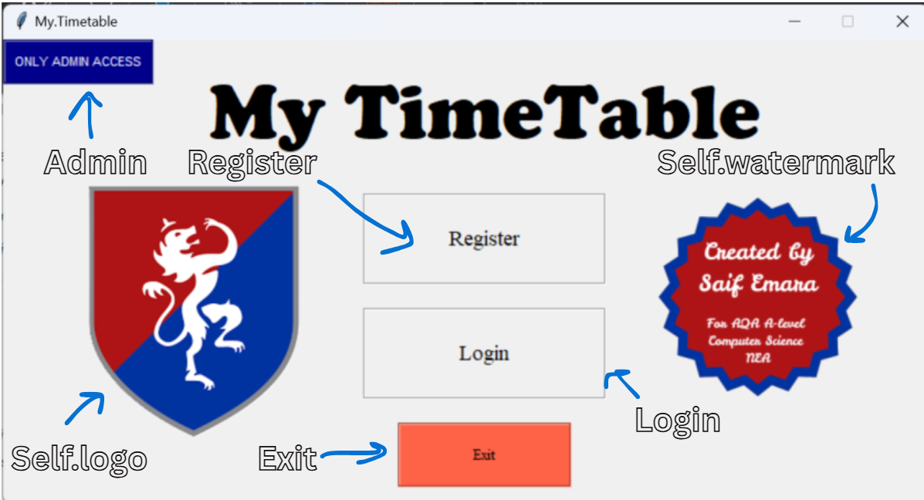

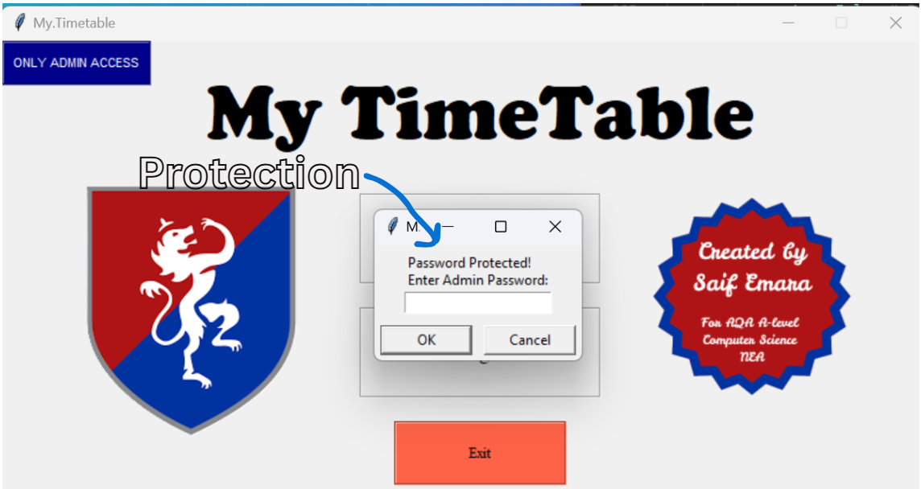

###### 4.2.2.2.3.3 Procedures and Variables:

|  |  |  |
| --- | --- | --- |
| The MainMenu class represents the main menu screen of the timetable management application, providing users with a user-friendly interface to navigate through different functionalities of the application. It serves as the entry point for users to access various features such as registration, login, and administrative functions. | | |
| **Global Variables** | self.controller, self.logo, self.watermark | |
| **Procedure** | **Purpose** | **Variables** |
| admin | Gives the user access to a password entering message box to access admin screens | protection, self.controller |
| binder | Binds the hover effects to the buttons | button |
| on_enter | Handles the mouse enter event to change the colour of the button | button, backcolour, textcolour |
| on_leave | Handles the mouse leave event to return the colour button to default | button, backcolour, textcolour |

##### 4.2.2.2.4 Admin_Choice Class:

###### 4.2.2.2.4.1 Code:

class Admin_Choice(tk.Frame):

    """Admin Choice Screen for managing and editing admin exclusive variables"""

    def __init__(self, parent, controller):

        """Initialize the AdminChoice class"""

        super().__init__(parent) # Use of OOP with inheritance

        self.controller = controller

        # Create buttons for various admin tasks

        add = tk.Button(self, text="Add Teacher", width=30, height=4, relief="groove",

                  command=lambda: self.controller.show_frame(AddTeacherScreen)) # Raises the AddTeacher Screen

        add.place(x=485, y=120)

        access = tk.Button(self, text="Access Database", width=30, height=4, relief="groove",

                  command=lambda: self.controller.show_frame(AccessDatabaseScreen)) # Raises the AccessDatabase Screen

        access.place(x=100, y=120)

        exitadmin = tk.Button(self, text="Exit Admin Mode", width=25, height=2, relief="groove",

                  command=lambda: self.leave_admin()) # Exits admin mode and returns to the main menu

        exitadmin.place(x=310, y=200)

        controller.binder(add)

        controller.binder(access)

        controller.binder(exitadmin)

    def leave_admin(self):

        """Handles exiting admin mode and returning to the main menu"""

        self.controller.current_role = None # Resets the current role to None so that permissions are stripped

        self.controller.show_frame(MainMenu) # Raises the MainMenu screen

###### 4.2.2.2.4.2 User Interface:

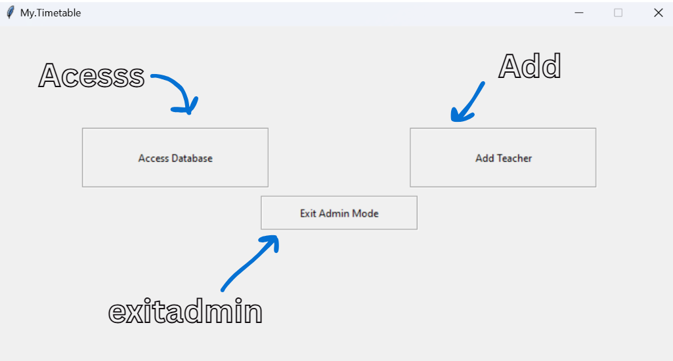

###### 4.2.2.2.4.3 Procedures and Variables:

|  |  |  |
| --- | --- | --- |
| The Admin_Choice class represents the administrative choice screen in the timetable management application. It provides a user interface for administrators to perform various management tasks related to teachers and the database. This class is designed to facilitate administrative functions, ensuring that admins can efficiently manage the application's data. | | |
| **Global Variables** | self.controller | |
| **Procedure** | **Purpose** | **Variables** |
| leave_admin | Handles exiting admin mode and returning to main menu | self.controller |

##### 4.2.2.2.5 RegisterScreen Class:

###### 4.2.2.2.5.1 Code:

class RegisterScreen(tk.Frame):

    """Registration Screen for new users to create an account"""

    def __init__(self, parent, controller):

        """Initializes the RegisterScreen class"""

        super().__init__(parent)

        self.controller = controller

        # Creates labels and entry fields for user registration

        tk.Label(self, text="Fullname:", font=("Times", 14)).grid(row=0, column=1, padx=160, pady=10, sticky="w")

        self.fullname = tk.Entry(self, width=50)

        self.fullname.grid(row=0, column=1, padx=250, pady=10)

        tk.Label(self, text="Username:", font=("Times", 14)).grid(row=1, column=1, padx=160, pady=10, sticky="w")

        self.username = tk.Entry(self, width=50)

        self.username.grid(row=1, column=1, padx=250, pady=10)

        tk.Label(self, text="Password:", font=("Times", 14)).grid(row=2, column=1, padx=160, pady=10, sticky="w")

        self.password = tk.Entry(self, show="*", width=50)

        self.password.grid(row=2, column=1, padx=250, pady=10)

        tk.Label(self, text="Repeat Password:", font=("Times", 14)).grid(row=3, column=1, padx=103.5, pady=10, sticky="w")

        self.repeated_password = tk.Entry(self, show="*", width=50)

        self.repeated_password.grid(row=3, column=1, padx=250, pady=10)

        # Creates buttons for registration and cancel

        register = tk.Button(self, text="Register", width=20, height=2, relief="groove",

                  command=lambda: self.register_user())

        register.grid(row=5, column=1, pady=20)

        cancel = tk.Button(self, text="Cancel", width=20, height=2, relief="groove",

                  command=lambda: self.clear_entries())

        cancel.grid(row=6, column=1, pady=10)

        # Bind hover effectos for buttons

        controller.binder(register)

        controller.binder(cancel)

    def register_user(self):

        """Handle user registration""" # Use of OOP Encapsulation

        # Gets and formats the variables

        fullname = self.fullname.get().strip().title()

        username = self.username.get().strip().lower()

        password = self.password.get().strip()

        repeat_password = self.repeated_password.get().strip()

        self.days = ["Monday", "Tuesday", "Wednesday", "Thursday"]

        #check if all fields are filled

        if not fullname or not username or not password:

            messagebox.showerror("Error", "All fields are required!") # Use of Exception Handling

            return #Returns if validation fails

        if len(fullname.split()) <= 1:

            messagebox.showerror("Error", "Fullname must include atleast first and last name!")

            return

        #check if passwords match

        if password != repeat_password:

            messagebox.showerror("Error", "Passwords do not match!")

            return

        #check if username ends with "_gfs"

        if not username.endswith("_gfs"):

            messagebox.showerror("Error", "Username must end with '_gfs'!")

            return

        if not re.match(r"^(?!.*\..*\..*)[A-Za-z0-9]+(\.[A-Za-z0-9]+)?$", username.replace("_gfs","")):

            messagebox.showerror("Error", "Start of Username must only include alphanumeric characters and one fullstop")

            return

        if not username[0].isalpha():

            messagebox.showerror("Error", "Username must start with a letter!")

            return

        #check if username already exists

        if database.get_fullname(username):

            messagebox.showerror("Error", "Username already exists!")

            return

        #checks that the password does not contain any spaces

        if " " in password:

            messagebox.showerror("Error", "Password must not contain spaces!")

            return

        #Regular Expression checks that the password contains at least 8 characters, one uppercase letter, one lowercase letter, one digit, and one special character

        if not re.match(r"^(?=.*[a-z])(?=.*[A-Z])(?=.*\d)(?=.*[@$!%*?_&])[A-Za-z\d@$!%*?_&].{8,}$", password):

            messagebox.showerror("Error", "Password must contain at least 9 characters, one uppercase letter, one lowercase letter, one digit, and one special character from (@$!%*?_&)")

            return

        # If all validations pass, adds the user to the database

        database.add_teacher(username, fullname, 'Normal Teacher',' ', 0, ' ')

        database.store_password(username, password)

        for x in range(4):

            day = self.days[x] # Iterates the first four days of the week

            for i in range(7): # Iterates through the 7 lessons a day

                database.add_lesson(username, day, i+1, "Empty", "Empty", "None") # Adds default empty entries in the timetable

                self.controller.current_user = username

                self.controller.current_role = 'Normal Teacher' # Sets role to Normal teacher

        for i in range(5): # Iterates similarly for Friday

            database.add_lesson(username, "Friday", i+1, "Empty", "Empty", "None")

        messagebox.showinfo("Registration Successful!", "Contact an SLT member to get your timetable configured.") # Informs the user of successful registration

        self.controller.frames[TeacherScreen].update_welcome_message() # Updates the welcome message with the teacher's name

        self.clear_entries() # Clears the entry fields

    def clear_entries(self):

        """Clear all input entry fields."""

        self.fullname.delete(0, tk.END)

        self.username.delete(0, tk.END)

        self.password.delete(0, tk.END)

        self.repeated_password.delete(0, tk.END)

        # Updates the appropriate screens and raises the correct screen based on role

        self.controller.frames[AccessDatabaseScreen].update_treeview()

        if self.controller.current_role == "SLT":

            self.controller.frames[SLTScreen].timetable.update_timetable()

        elif self.controller.current_role == "Normal Teacher":

            self.controller.frames[TeacherScreen].timetable.update_timetable()

            self.controller.show_frame(TeacherScreen)

        elif self.controller.current_role == None:

            self.controller.show_frame(MainMenu)

    def binder(self, button):

        button.bind("<Enter>", lambda e: self.on_enter(button, "#cacaca"))

        button.bind("<Leave>", lambda e: self.on_leave(button, "SystemButtonFace"))

    def on_enter(self, button, backcolour):

        button.config(background=backcolour)

    def on_leave(self, button, backcolour):

        button.config(background=backcolour)

###### 4.2.2.2.5.2 User Interface:

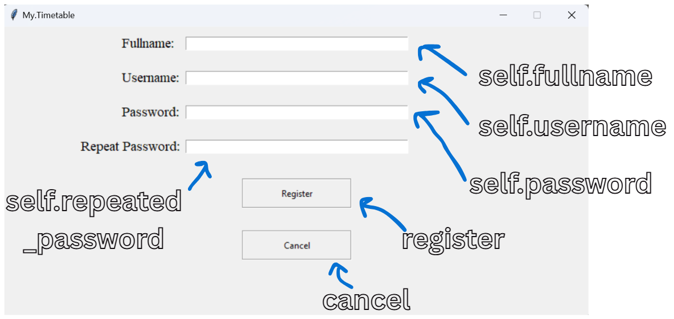

###### 4.2.2.2.5.3 Procedures and Variables:

|  |  |  |
| --- | --- | --- |
| The RegisterScreen class represents the user registration interface in the timetable management application. It allows new users to create an account by providing their personal information, including their full name, username, and password. This class is designed to facilitate the registration process while ensuring that user input is validated and handled securely. | | |
| **Global Variables** | self.controller, self.fullname, self.username, self.password, self.repeated_password, self.days, | |
| **Procedure** | **Purpose** | **Variables** |
| register_user | Registers the user adding them to the database after validating their inputs | fullname, self.fullname, username, self.username, password, self.password, repeat_password, self.repeated_password, self.days, database, x, i, self.controller |
| clear_entries | Clears all the input entry fields | self.fullname, self.username, self.password, self.repeated_password, self.controller |
| binder | Binds the hover effects to the buttons allowing them to change colour | username, connection, cursor, role |
| on_enter | Configurates the button based on entering hover | button, backcolour |
| on_leave | Configurates the button based on leaving hover | button, backcolour |

##### 4.2.2.2.6 LoginScreen Class:

###### 4.2.2.2.6.1 Code:

class LoginScreen(tk.Frame):

    """Login Screen for existing users to access their account."""

    def __init__(self, parent, controller):

        """Initializes the LoginScreen class"""

        super().__init__(parent)

        self.controller = controller

        # Create labels and entry fields for user login

        tk.Label(self, text="Username:", font=("Times", 14)).grid(row=2, column=1, padx=160, pady=5, sticky="w")

        self.username = tk.Entry(self, width=50)

        self.username.grid(row=2, column=1, padx=250, pady=30)

        tk.Label(self, text="Password:", font=("Times", 14)).grid(row=3, column=1, padx=160, pady=0, sticky="w")

        self.password = tk.Entry(self, show="*", width=50)

        self.password.grid(row=3, column=1, padx=250, pady=5, sticky="n")

        login = tk.Button(self, text="Login", width=20, height=2, relief="groove",

                  command=lambda: self.login_user())

        login.grid(row=4, column=1, pady=20)

        cancel = tk.Button(self, text="Cancel", width=20, height=2, relief="groove",

                  command=lambda: self.clear_entries())

        cancel.grid(row=5, column=1, pady=10)

        # Binds hover effects for buttons

        controller.binder(login)

        controller.binder(cancel)

    def login_user(self):

        """Handles login authentication and role-based redirection."""

        username = self.username.get().strip().lower()

        password = self.password.get().strip()

        # Checks if all fields are filled

        if not username or not password:

            messagebox.showerror("Error", "All fields are required!")

            return

        # Validates credentials by checking against the database

        if database.verify_password(username, password) == True:

            role = database.get_role(username)

            self.controller.current_user = username

            if role == "SLT":

                self.controller.frames[SLTScreen].update_welcome_message()

                self.controller.current_role = 'SLT'

                self.controller.frames[SLTScreen].timetable.update_timetable()

                self.controller.show_frame(SLTScreen)

                self.clear_entries()

            else:

                self.controller.frames[TeacherScreen].update_welcome_message()

                self.controller.current_role = 'Normal Teacher'

                self.controller.frames[TeacherScreen].timetable.update_timetable()

                self.controller.show_frame(TeacherScreen)

                self.clear_entries()

        else:

            messagebox.showerror("Error", "Invalid username or password!")

    def clear_entries(self):

        """Clear all entry fields."""

        self.username.delete(0, tk.END)

        self.password.delete(0, tk.END)

        if self.controller.current_role == None:

            self.controller.show_frame(MainMenu)

###### 4.2.2.2.6.2 User Interface:

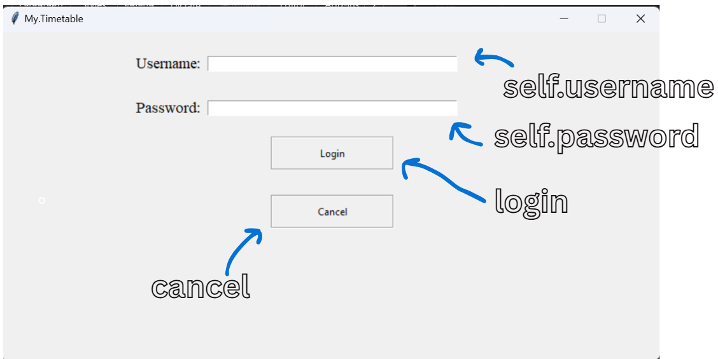

###### 4.2.2.2.6.3 Procedures and Variables:

|  |  |  |
| --- | --- | --- |
| The LoginScreen class represents the user login interface in the timetable management application. It allows existing users to authenticate themselves by entering their username and password. This class is designed to facilitate secure access to the application, ensuring that only authorized users can log in and access their respective functionalities. | | |
| **Global Variables** | self.controller, self.username, self.password | |
| **Procedure** | **Purpose** | **Variables** |
| login_user | Validates the user’s login details and allows them to login if the details are valid | username, self.username, password, self.password, database, role, self.controller |
| clear_entries | Clears all the input entry fields | self.username, self.password, self.controller |

##### 4.2.2.2.7 Timetable Class:

###### 4.2.2.2.7.1 Code:

class Timetable(ttk.Frame):

    """Timetable widget for SLT and Teacher screens."""

    def __init__(self, parent, controller):

        """Initialize the Timetable class"""

        super().__init__(parent)

        self.controller = controller

        # Get todays weekday

        self.weekday = datetime.datetime.today().strftime('%A') # Determines and stores the current day

        # Determine number of lessons: Monday-Thursday = 7, Friday = 5,

        self.num_lessons = 5 if self.weekday == "Friday" else 7 # Sets the number of lessons based on the day

        # Creates column headers for the timetable

        if self.weekday == "Friday":

            self.columns = ["Lesson: "] + [f"L{i+1}" for i in range(self.num_lessons)]

        else:

            self.columns = ["Lesson: "] + [f"L{i+1}" for i in range(self.num_lessons)]

        #Binds double click to the timetable

        self.bind("<Double-1>", self.on_double_click)

        style = ttk.Style() # Creates a style variable

        style.theme_use('clam') # Sets the theme of the timetable cells

        style.configure("Treeview", rowheight=40) # Configures row height

        # Creates the treeview widget to display the timetable

        self.tree = ttk.Treeview(self, columns=self.columns, show="headings", height=3, selectmode="none", style="Treeview")

        self.tree.bind('<Button-1>', "break") # Prevents default behaviour when button 1 is clicked

        self.tree.bind("<Double-1>", self.on_double_click) # Binds double-click event

        self.tree.bind("<Motion>", self.on_hover) # Binds the mouse motion event so it runs when it hovers

        self.tree.bind("<Leave>", self.on_leave) # Bind mouse leave event

        self.tree.tag_configure('focus', background='#D3D3D3') # Configures background colour to darken for when a row is hovered over

        # Set headers for the timetable columns

        for col in self.columns:

            self.tree.heading(col, text=col) # Sets column headings

            self.tree.column(col, anchor="center", stretch=True) # Center aligns and stretches columns

            if col == "Lesson: ":

                self.tree.column(col, width=100, anchor="center")

            else:

                self.tree.column(col, width=60, anchor="center")

        # Insert default values into the timetable based on the current weekday

        if self.weekday in ["Monday", "Tuesday", "Wednesday", "Thursday", "Friday"]:

            self.tree.insert("", "end", values=["Subject"] + ["Empty"] * self.num_lessons) # Insert subject row

            self.tree.insert("", "end", values=["Class"] + ["Empty"] * self.num_lessons) # Insert class row

            self.tree.insert("", "end", values=["Substitute"] + ["None"] * self.num_lessons) # Insert substitute row

            self.tree.pack(pady=10, padx=10, fill="x")

        else:

            self.tree.insert("", "end", values=["Subject"] + [" "] * 7)

            self.tree.insert("", "end", values=["Class"] + [" "] * 7)

            self.tree.insert("", "end", values=["Substitute"] + [" "] * 7)

            self.tree.pack(pady=10, padx=10, fill="x")

    def update_timetable(self):

        """Update the timetable with the current user's lessons."""

        if self.weekday in ["Monday", "Tuesday", "Wednesday", "Thursday", "Friday"]:

            connection = sqlite3.connect("MyTimetable.db")

            cursor = connection.cursor()

            self.tree.delete(*self.tree.get_children()) # Clear existing timetable entries

            # Query to fetch lessons for the current user based on the weekday

            cursor.execute(f"""SELECT Subject, Class, Substitute

                            FROM {self.weekday}Lessons

                            WHERE Username = ?

                            ORDER BY Lesson_Number""", (self.controller.current_user,))

            lessons = cursor.fetchall() # Fetches all the lessons

            # Extracts the subjects, classes, and substitutes from the lessons lists

            subjects = [lesson[0] for lesson in lessons] # List of subjects

            classes = [lesson[1] for lesson in lessons] # List of classes

            substitutes = [lesson[2] for lesson in lessons] # List of substitutes

            # Insert the fetched data into the timetable

            self.tree.insert("", "end", values=["Subject"] + subjects)

            self.tree.insert("", "end", values=["Class"] + classes)

            self.tree.insert("", "end", values=["Substitute"] + substitutes)

            self.tree.pack(pady=10, padx=10, fill="x")

            connection.close()

    def on_double_click(self, event):

        """Handles double-click events on the timetable"""

        if self.tree.identify_region(event.x, event.y) == "heading":

            return "break" # Prevents editing if double-clicking on the header

        # Identifies double clicked region

        region_clicked = self.identify(event.x, event.y)

        # Get the item and column at the clicked position

        item = self.tree.identify_row(event.y) # Identify the row clicked

        column = self.tree.identify_column(event.x) # Identify the column clicked

        # Get the value of the item in the column

        value = self.tree.set(item, column)

        rows = self.tree.get_children()

        # Open a popup to enter the new value

        if isinstance(self.master, (AddTeacherScreen, EditDatabaseScreen, AdminEditDatabase)):

            if value in ("Subject","Class","Substitute"):

                return "break" # Prevents editing the header column

            elif item == rows[0]:

                new_value = simpledialog.askstring("Edit Contents", f"Enter new subject name:") # Prompt for new subject

                try:

                    new_value = new_value.strip()

                except:

                    pass

                if new_value is not None:

                    self.tree.set(item, column, new_value)

            elif item == rows[1]:

                new_value = simpledialog.askstring("Edit Contents", f"Enter new class location:") # Prompt for new class

                try:

                    new_value = new_value.strip()

                except:

                    pass

                if new_value is not None:

                    self.tree.set(item, column, new_value)

            elif item == rows[2]:

                new_value = simpledialog.askstring("Edit Contents", f"Enter new substitute, leave empty if none:") # Prompt for new substituting teacher

                try:

                    new_value = new_value.strip()

                except:

                    pass

                if new_value is not None:

                    self.tree.set(item, column, new_value)

    def on_hover(self, event):

        """Highlight the cell that the mouse is over."""

        item = self.tree.identify_row(event.y)

        column = self.tree.identify_column(event.x)

        try:

            value = self.tree.set(item, column)

        except:

            return "break"

        if self.tree.identify_region(event.x, event.y) == "heading":

            return "break" # Prevents action if hovering over the header

        if item:

            for i in self.tree.get_children():

                self.tree.item(i, tags=()) # Clears tags for all items

            self.tree.item(item, tags=('focus')) # Highlight the current item

    def on_leave(self, event):

        """Reset the highlight when the mouse leaves the timetable"""

        for i in self.tree.get_children():

            self.tree.item(i, tags=()) # Clears tags for all the items

    def Create_Empty_Timetable(self):

        """Create an empty timetable for Monday to Thursday."""

        self.tree.delete(*self.tree.get_children()) # Clears existing timetable entries

        self.columns = ["Lesson: "] + [f"L{i+1}" for i in range(7)] # Define columns for the timetable

        self.tree["columns"] = self.columns

        # Set headers for the timetable columns

        for col in self.columns:

            self.tree.heading(col, text=col)

            self.tree.column(col, anchor="center", stretch=True)

            if col == "Lesson: ":

                self.tree.column(col, width=100, anchor="center")

            else:

                self.tree.column(col, width=60, anchor="center")

        # Inserts default empty values into the timetable

        self.tree.insert("", "end", values=["Subject"] + ["Empty"] * 7)

        self.tree.insert("", "end", values=["Class"] + ["Empty"] * 7)

        self.tree.insert("", "end", values=["Substitute"] + ["None"] * 7)

    def Create_Friday_Timetable(self):

        """Create a Friday timetable."""

        self.tree.delete(*self.tree.get_children())

        self.columns = ["Lesson: "] + [f"L{i+1}" for i in range(5)]

        self.tree["columns"] = self.columns

        # Set headers

        for col in self.columns:

            self.tree.heading(col, text=col)

            self.tree.column(col, anchor="center", stretch=True)

            if col == "Lesson: ":

                self.tree.column(col, width=100, anchor="center")

            else:

                self.tree.column(col, width=60, anchor="center")

        self.tree.insert("", "end", values=["Subject"] + ["Empty"] * 5)

        self.tree.insert("", "end", values=["Class"] + ["Empty"] * 5)

        self.tree.insert("", "end", values=["Substitute"] + ["None"] * 5)

###### 4.2.2.2.7.2 Procedures and Variables:

|  |  |  |
| --- | --- | --- |
| The Timetable class is responsible for displaying and managing the timetable interface within the timetable management application. It provides a structured view of lessons for teachers and SLT (Senior Leadership Team) members, allowing them to view their schedules and make necessary updates. This class is designed to facilitate the organization and presentation of lesson data in a user-friendly manner. | | |
| **Global Variables** | self.controller, self.weekday, self.num_lessons, self.columns, self.tree, self.master, | |
| **Procedure** | **Purpose** | **Variables** |
| update_timetable | Updates the timetable inputting the current user’s lessons | self.weekday, connection, cursor, self.tree, self.controller, lessons, subjects, lesson, classes, substitutes |
| on_double_click | Handles the double click events on the timetable to facilitate editing | event, self.tree, region_clicked, item, column, value, rows, self.master, new_value |
| on_hover | Highlights the row that that mouse is hovering over darkening its colour slightly for user friendliness | event, item, self.tree, column, value, i |
| on_leave | Resets the highlight when the mouse leave the row / stops hovering over it | event, i, self.tree |
| Create_Empty_Timetable | Creates a default empty timetable for Monday to Thursday | self.tree, self.columns, i, col |
| Create_Friday_Timetable | Creates a default empty timetable for Friday | self.tree, self.columns, i, col |

##### 4.2.2.2.8 SLTScreen Class:

###### 4.2.2.2.8.1 Code:

class SLTScreen(tk.Frame):

    """Senior Leader Teacher Screen."""

    def __init__(self, parent, controller):

        """Initializes the SLTScreen class"""

        super().__init__(parent)

        self.controller = controller

        self.welcome_label = tk.Label(self, text=("   Welcome, Admin   "), borderwidth=2, relief="solid", font=("Times", 16), height=2)

        self.welcome_label.place(x=0, y=0)

        # Creates buttons for various SLT tasks

        tk.LabelFrame(self, width=200, height=400, relief="solid").grid(row=1, column=0, sticky="w")

        add = tk.Button(self, text="Add Teacher Data", width=26, height=7, relief="groove",

                  command=lambda: controller.show_frame(AddTeacherScreen))

        add.grid(row=1, column=0, sticky="n", pady=55)

        sltabsent = tk.Button(self, text="Mark a Teacher Absent", width=26, height=3, relief="groove",

                  command=lambda: controller.show_frame(SLTAbsenceScreen))

        sltabsent.grid(row=1, column=0, pady=65)

        view = tk.Button(self, text="View Teacher Database", width=26, height=7, relief="groove",

                  command=lambda: controller.show_frame(AccessDatabaseScreen))

        view.grid(row=1, column=0, sticky="s", pady=55)

        absent = tk.Button(self, text="Inform My Absence", width=20, height=3, relief="groove",

                  command=lambda: controller.show_frame(AbsenceScreen))

        absent.place(x=650, y=0)

        signout = tk.Button(self, text="Sign Out", width=15, height=2, relief="groove",

                  command=lambda: self.sign_out())

        signout.place(x=685, y=55)

        # Binds all the buttons with hover functionality

        controller.binder(add)

        controller.binder(sltabsent)

        controller.binder(view)

        controller.binder(absent)

        controller.binder(signout)

        #to instantly run the algorithm for testing purposes

        tk.Button(self, text="Run Cover Allocation Test", width=20, height=2, relief="groove",

                  command=lambda: MainAlgorithm(self.controller).cover_allocation()).place(x=685, y=110)

        weekday = datetime.datetime.today().strftime('%A')

        # Label displaying today's date

        self.day_label = tk.Label(self, text=f"Today is {weekday}", font=("Arial", 16, "bold"))

        self.day_label.place(x=415, y=120)

        # Add timetable inside SLTScreen

        self.timetable = Timetable(self, controller)

        if weekday == "Friday":

            self.timetable.place(x=285, y=150)

        else:

            self.timetable.place(x=230, y=150)  # Adjust position as needed

        # Adds a clock on the screen

        self.clock = tk.Label(self, text = "", font=('Times', 40, 'bold'))

        self.clock.place(x=350, y=0)

        self.time()

        self.welcome_label.lift()

    def update_welcome_message(self):

        """Update the welcome message with the logged-in username."""

        fullname = database.get_fullname(self.controller.current_user)

        self.welcome_label.config(text=f"   Welcome, {fullname}   ")

    def sign_out(self):

        # Forgets the user's username and role to reset permissions

        self.controller.current_user = None

        self.controller.current_role = None

        self.controller.show_frame(MainMenu)

    def time(self):

        string = strftime('%H:%M %p')

        self.clock.config(text=string)

        self.clock.after(10000, self.time) #Attempts to update the clock every 10 seconds

###### 4.2.2.2.8.2 User Interface:

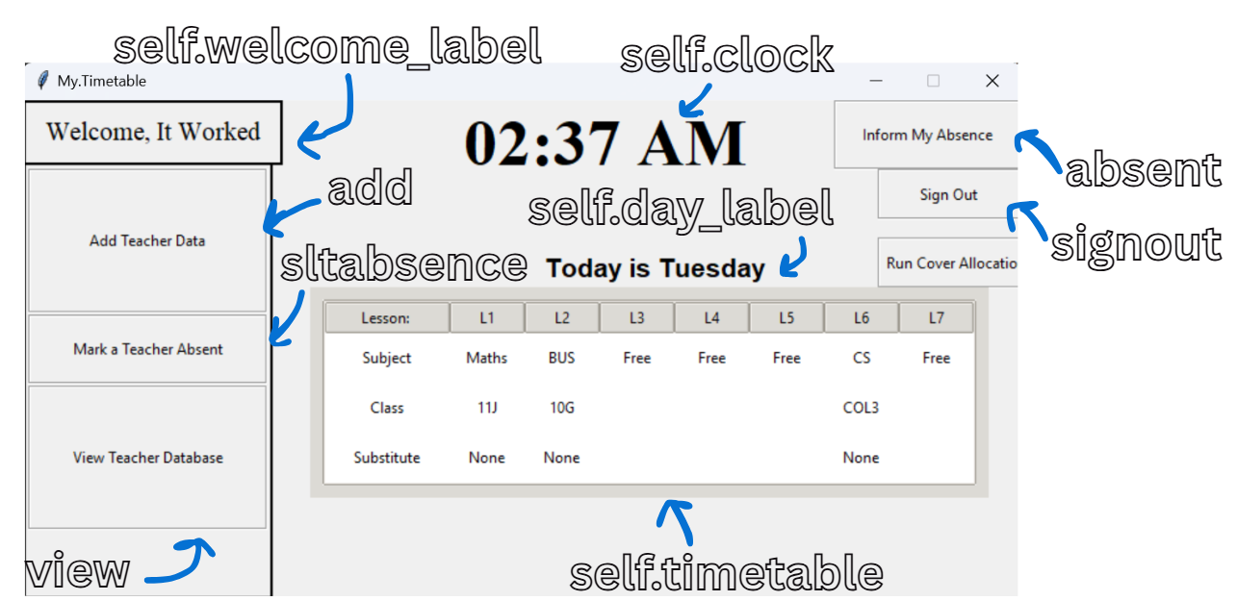

###### 4.2.2.2.8.3 Procedures and Variables:

|  |  |  |
| --- | --- | --- |
| The SLTScreen class represents the interface for Senior Leadership Team (SLT) members within the timetable management application. It provides a dedicated space for SLT members to access various administrative functions, manage teacher data, and view relevant information related to the school's timetable. This class is designed to facilitate the responsibilities of SLT members in an organized and user-friendly manner. | | |
| **Global Variables** | self.controller, self.welcome_label, self.day_label, self.timetable, self.clock | |
| **Procedure** | **Purpose** | **Variables** |
| update_welcome_message | Updates the welcome message with the current logged in user’s username | fullname, database, self.controller, self.welcome_label |
| sign_out | Forgets the user’s username and resets permissions | self.controller |
| time | Attempts to change the clock display every 10 seconds to display the current time on the digital clock | string, self.clock |

##### 4.2.2.2.9 TeacherScreen Class:

###### 4.2.2.2.9.1 Code:

class TeacherScreen(tk.Frame):

    """Normal Teacher Screen."""

    def __init__(self, parent, controller):

        super().__init__(parent)

        self.controller = controller

        self.welcome_label = tk.Label(self, text=("   Welcome, Admin   "), borderwidth=2, relief="solid", font=("Times", 16), height=2)

        self.welcome_label.grid(row=0, column=0, sticky="w")

        absent = tk.Button(self, text="Inform My Absence", width=20, height=3, relief="groove",

                  command=lambda: controller.show_frame(AbsenceScreen))

        absent.place(x=650, y=0)

        signout = tk.Button(self, text="Sign Out", width=15, height=2, relief="groove",

                  command=lambda: self.sign_out())

        signout.place(x=685, y=55)

        # Binds hover effect to buttons

        controller.binder(absent)

        controller.binder(signout)

        # Gets today's weekday

        weekday = datetime.datetime.today().strftime('%A')

        # Label displaying today's date

        self.day_label = tk.Label(self, text=f"Today is {weekday}", font=("Arial", 16, "bold"))

        self.day_label.place(x=315, y=78)

        # Add timetable inside SLTScreen

        self.timetable = Timetable(self, controller)

        # Determines position based on whether its on friday or the other days of the week

        if weekday == "Friday":

            self.timetable.place(x=185, y=150)

        else:

            self.timetable.place(x=130, y=110) # Adjust position as needed

        # Creates a clock on the screen

        self.clock = tk.Label(self, text = "", font=('Times', 40, 'bold'))

        self.clock.place(x=350, y=0)

        self.time() # Starts the clock

    def update_welcome_message(self):

        """Update the welcome message with the logged-in username."""

        fullname = database.get_fullname(self.controller.current_user)

        self.welcome_label.config(text=f"   Welcome, {fullname}   ")

    def sign_out(self):

        # Resets the current user and role to none to strip permissions

        self.controller.current_user = None

        self.controller.current_role = None

        self.controller.show_frame(MainMenu) # Raises the MainMenu screen

    def time(self):

        string = strftime('%H:%M %p')

        self.clock.config(text=string) # Updates the clock label with the new time

        self.clock.after(10000, self.time) # Checks the time every 10 seconds and attempts to update it

###### 4.2.2.2.9.2 User Interface:

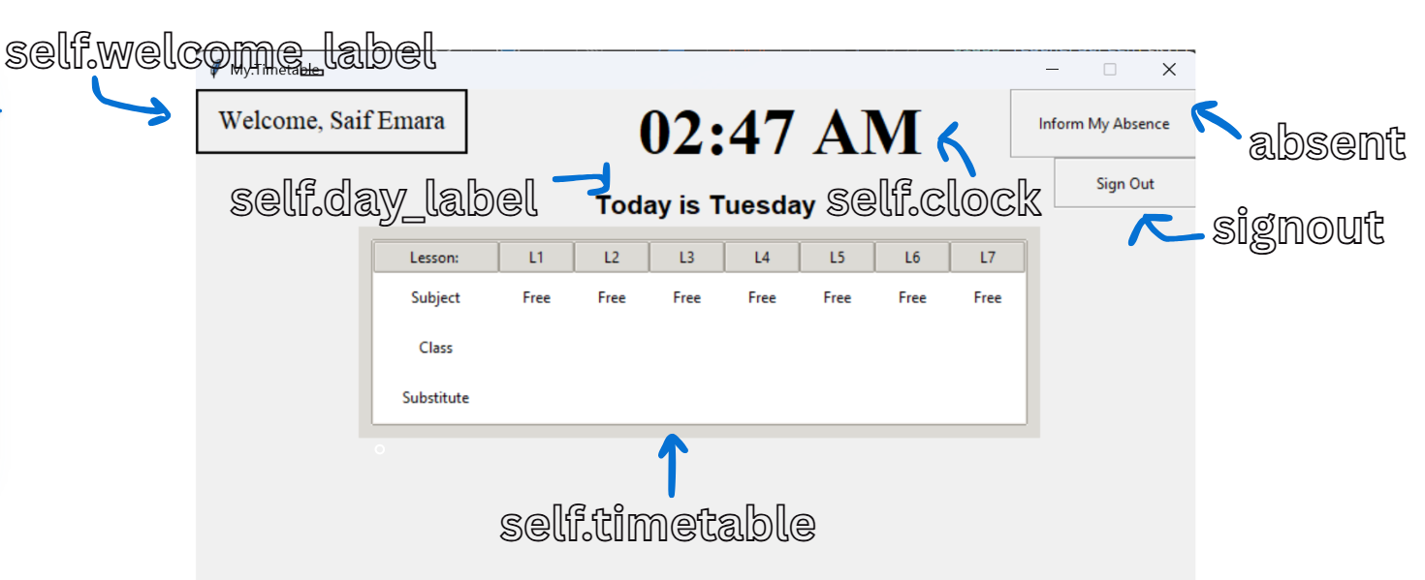

###### 4.2.2.2.9.3 Procedures and Variables:

|  |  |  |
| --- | --- | --- |
| The TeacherScreen class represents the interface for regular teachers within the timetable management application. It provides a dedicated space for teachers to view their schedules and manage their absences. This class is designed to facilitate the daily activities of teachers in an organized and user-friendly manner. | | |
| **Global Variables** | self.controller, self.welcome_label, self.day_label, self.timetable, self.clock | |
| **Procedure** | **Purpose** | **Variables** |
| update_welcome_message | Updates the welcome message with the current logged in user’s username | fullname, database, self.controller, self.welcome_label |
| sign_out | Forgets the user’s username and resets permissions | self.controller |
| time | Attempts to change the clock display every 10 seconds to display the current time on the digital clock | string, self.clock |

##### 4.2.2.2.10 AbsenceScreen Class:

###### 4.2.2.2.10.1 Code:

class AbsenceScreen(tk.Frame):

    """Absence Screen."""

    def __init__(self, parent, controller):

        super().__init__(parent)

        self.controller = controller

        # Creates buttons for navigation of absent options based on user need

        today = tk.Button(self, text="Only Absent Today", width=30, height=5, relief="groove",

                  command=lambda: self.only_absent_today())

        today.grid(row=0, column=0, padx=110, pady=110)

        multiple = tk.Button(self, text="Mark Multiple Days Absent", width=30, height=5, relief="groove",

                  command=lambda: controller.show_frame(MarkDaysAbsent))

        multiple.grid(row=0, column=1, padx=30, pady=110)

        cancel = tk.Button(self, text="Cancel", width=15, height=2, relief="groove",

                  command=lambda: controller.go_back())

        cancel.place(x=342, y=210)

        # Binds the buttons for hover effect

        controller.binder(today)

        controller.binder(multiple)

        controller.binder(cancel)

    def only_absent_today(self):

        now = datetime.datetime.now() # Gets the current time

        cutoff_time = datetime.time(6, 30) # Sets the latest time for Non-SLT members to mark absence today

        # Avoids a teacher getting marked absent twice for the same day

        if database.is_absent(self.controller.current_user, datetime.datetime.today().date()):

            messagebox.showerror("Error", "You are already marked as absent today!")

            return

        elif self.controller.current_role != "SLT":

            if now.time() <= cutoff_time: # Checks that the current time is before the cutoff time

                dates = AbsenceDates()

                dates.sorted_dates = [datetime.datetime.today().date()]

                self.controller.show_frame(AbsenceConfirmation)

            else:

                messagebox.showerror("Error", "Cannot select today as it is past 6:30 AM!\nContact an SLT member for support")

                return

        else:

            dates = AbsenceDates()

            dates.sorted_dates = [datetime.datetime.today().date()] # Sorts the dates

            self.controller.show_frame(AbsenceConfirmation) # Raises the Absence confirmation screen

###### 4.2.2.2.10.2 User Interface:

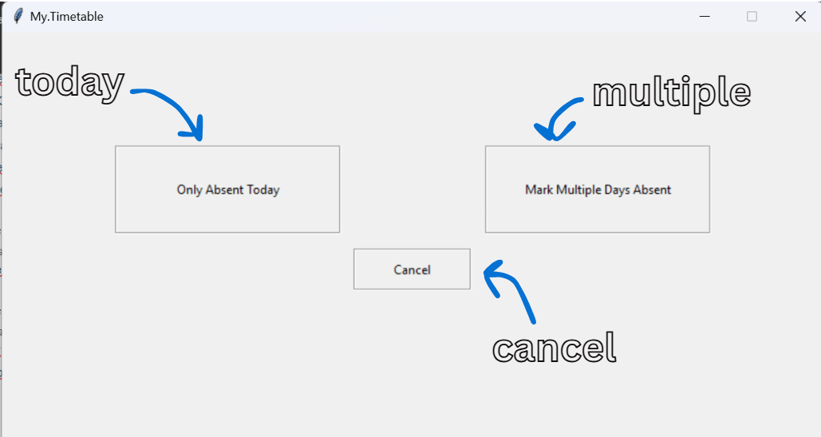

###### 4.2.2.2.10.3 Procedures and Variables:

|  |  |  |
| --- | --- | --- |
| The AbsenceScreen class represents the interface for managing absences within the timetable management application. It provides options for users (both teachers and SLT members) to report their absences and manage multiple days of absence efficiently. This class is designed to facilitate the process of notifying the administration about absences in a user-friendly manner. | | |
| **Global Variables** | self.controller | |
| **Procedure** | **Purpose** | **Variables** |
| only_absent_today | Ensures that the user is marking a duplicate absence, and is marking absence at an appropriate time if they are a normal teacher | now, cutoff_time, database, self.controller, dates |

##### 4.2.2.2.11 SLTAbsenceScreen Class:

###### 4.2.2.2.11.1 Code:

class SLTAbsenceScreen(tk.Frame):

    """SLT Absence Screen."""

    def __init__(self, parent, controller):

        super().__init__(parent)

        self.controller = controller

        today = tk.Button(self, text="Only Absent Today", width=30, height=5, relief="groove",

                  command=lambda: self.only_absent_today())

        today.grid(row=0, column=0, padx=110, pady=110)

        multiple = tk.Button(self, text="Mark Multiple Days Absent", width=30, height=5, relief="groove",

                  command=lambda: controller.show_frame(SLTMarkDaysAbsent))

        multiple.grid(row=0, column=1, padx=30, pady=110)

        cancel = tk.Button(self, text="Cancel", width=15, height=2, relief="groove",

                  command=lambda: controller.go_back())

        cancel.place(x=342, y=210)

        controller.binder(today)

        controller.binder(multiple)

        controller.binder(cancel)

    def only_absent_today(self):

        dates = AbsenceDates()

        dates.sorted_dates = [datetime.datetime.today().date()]

        self.controller.show_frame(SLTAbsenceConfirmation)

###### 4.2.2.2.11.2 User Interface:



###### 4.2.2.2.11.3 Procedures and Variables:

|  |  |  |
| --- | --- | --- |
| The SLTAbsenceScreen class represents the interface for Senior Leadership Team (SLT) members to manage teacher absences within the timetable management application. It provides SLT members with the tools to report absences for teachers and manage multiple days of absence efficiently. This class is designed to facilitate the administrative responsibilities of SLT members regarding attendance management. | | |
| **Global Variables** | self.controller | |
| **Procedure** | **Purpose** | **Variables** |
| only_absent_today | Navigates the user to the confirmation screen and selects the date as just today | dates, self.controller |

##### 4.2.2.2.12 MyCalendar Class:

###### 4.2.2.2.12.1 Code:

class MyCalendar(tkc.Calendar):

    """Custom Calender class to restrict selection to specific weekdays"""

    def __init__(self, master=None, allowed_weekdays=(calendar.MONDAY,), **kw):

        """Initializes the Calendar class with the first allowed weekday being Monday"""

        self._select_only = allowed_weekdays # Stores the allowed weekdays

        tkc.Calendar.__init__(self, master, **kw)

        # Ensures the selected date is within the allowed weekdays

        if self._sel_date and not (self._sel_date.isoweekday() - 1) in allowed_weekdays:

            year, week, wday = self._sel_date.isocalendar() # Gets the year, week, and weekday of the selected date

            # Finds the next allowed weekday

            next_wday = max(allowed_weekdays, key=lambda d: (d - wday + 1) > 0) + 1

            sel_date = self.date.fromisocalendar(year, week + int(next_wday < wday), next_wday) # Calculates the next selectable date

            self.selection_set(sel_date)

    def _display_calendar(self):

        """Displays the calendar and disables selection for non allowed weekday"""

        tkc.Calendar._display_calendar(self)

        for i in range(6): # Iterates through the rows of the calendar

            for j in range(7): # Iterates through the columns / days of the week

                if j in self._select_only: # Check if the current day of the week is a allowed weekday

                    continue # Skips allowed weekdays

                self._calendar[i][j].state(['disabled']) # Disables the button for non allowed weekdays

###### 4.2.2.2.12.2 Procedures and Variables:

|  |  |  |
| --- | --- | --- |
| The MyCalendar class is a custom calendar component designed to restrict date selection to specific weekdays within the timetable management application. It extends the functionality of the standard calendar widget, providing a tailored experience for users who need to select dates for scheduling purposes, such as marking absences. | | |
| **Global Variables** | self._select_only, self._sel_date, self.date.fromisocalendar, self._calendar | |
| **Procedure** | **Purpose** | **Variables** |
| _displat_calendar | Dsiplays the calendar and disables selection of certain chosen dates | i, j, self._select_only, self._calendar |

##### 4.2.2.2.13 MarkDaysAbsent Class:

###### 4.2.2.2.13.1 Code:

class MarkDaysAbsent(tk.Frame):

    """Screen for marking multiple days absent"""

    def __init__(self, parent, controller):

        super().__init__(parent)

        self.controller = controller

        self.sorted_dates = set() # Set to store selected absence dates

        # Get current date and time

        now = datetime.datetime.now()

        current_date = now.date()

        cutoff_time = datetime.time(6, 30) # Sets the latest time for marking absence to 6:30

        # If time is past 6:30 AM, today cannot be selected

        self.min_selectable_date = current_date if now.time() <= cutoff_time else current_date + datetime.timedelta(days=1)

        # Title Label

        tk.Label(self, text="Select Multiple Days of Absence", font=("Times", 14, "bold")).grid(row=0, column=0, columnspan=2, pady=(10, 5))

        # Calendar Widget

        self.cal = MyCalendar(self, allowed_weekdays=(calendar.MONDAY, calendar.TUESDAY, calendar.WEDNESDAY, calendar.THURSDAY, calendar.FRIDAY),

                               selectmode="day", mindate=self.min_selectable_date, width=400, height=300)

        self.cal.grid(row=1, column=0, columnspan=2, padx=276, pady=(5, 10))

        # Selected Dates Listbox

        tk.Label(self, text="Selected Dates:", font=("Times", 12)).grid(row=2, column=0, columnspan=2, pady=(5, 0))

        self.selected_dates_listbox = tk.Listbox(self, height=5, width=30) # Displats selected dates

        self.selected_dates_listbox.grid(row=3, column=0, columnspan=2, padx=10, pady=(0, 5))

        # Instructions to aid users improving user friendliness

        tk.Label(self, text="Select date from the calender \nand click 'Add Date'\n to add it to the list.", font=("Times", 8)).place(x=155, y=300, anchor="w")

        tk.Label(self, text="Select date from the list \nand click 'Remove Date'\n to remove a date from the list.", font=("Times", 8)).place(x=500, y=300, anchor="w")

        # Add & Remove Buttons

        self.add_date_btn = tk.Button(self, text="Add Date", width=12, relief="groove",

                                      command=lambda: self.add_date())

        self.add_date_btn.grid(row=4, column=0, padx=5, pady=1, sticky="e")

        self.remove_date_btn = tk.Button(self, text="Remove Date", width=12, relief="groove",

                                         command=lambda: self.remove_selected_date())

        self.remove_date_btn.grid(row=4, column=1, padx=5, pady=1, sticky="w")

        # Cancel & Confirm Buttons

        self.cancel_btn = tk.Button(self, text="Cancel", width=20, height=3, relief="groove",

                                    command=lambda: self.clear_entries())

        self.cancel_btn.place(x=0, y=345)

        self.confirm_btn = tk.Button(self, text="Confirm", width=20, height=3, relief="groove",

                                     command=lambda: self.confirm_absences())

        self.confirm_btn.place(x=651, y=345)

        # Bind hover effects for buttons

        controller.binder(self.add_date_btn)

        controller.binder(self.remove_date_btn)

        controller.binder(self.cancel_btn)

        controller.binder(self.confirm_btn)

        # Store selected dates

        self.selected_dates = set()

    def add_date(self):

        """Adds the selected date from the calendar to the listbox."""

        selected_date = self.cal.get_date() # Get the selected date from the calendar

        formatted_date = datetime.datetime.strptime(selected_date, "%m/%d/%y").date() # Format the date

        # Prevent selecting past dates

        if formatted_date < self.min_selectable_date:

            messagebox.showerror("Error", "Cannot select past dates!")

            return # Exit the method if validation fails

        # Add to set (avoid duplicates)

        self.selected_dates.add(formatted_date)

        # Updates Listbox

        self.selected_dates_listbox.delete(0, tk.END) # Clears the listbox

        for date in sorted(self.selected_dates): # Sorts and displays selected dates

            self.selected_dates_listbox.insert(tk.END, date) # Inserts each date into the listbox

    def remove_selected_date(self):

        """Removes a selected date from the listbox."""

        try:

            selected_index = self.selected_dates_listbox.curselection()[0]  # Get selected item index

            selected_date = self.selected_dates_listbox.get(selected_index)  # Get date string

            self.selected_dates.remove(datetime.datetime.strptime(selected_date, "%Y-%m-%d").date())  # Convert back to date

            self.selected_dates_listbox.delete(selected_index)  # Remove from listbox

        except IndexError:

            messagebox.showerror("Error", "No date selected!") # Use of exception handling

    def confirm_absences(self):

        """Processes selected absence dates."""

        if not self.selected_dates:

            messagebox.showerror("Error", "Please select at least one date!")

            return # Exit if no dates are selected

        # Convert to sorted list

        sorted_dates = self.merge_sort(self.selected_dates) # Sorts the selected dates

        dates = AbsenceDates() # Creates an instance of AbsenceeDtaes

        dates.sorted_dates = sorted_dates # Assigns the sorted dates to the instance

        for x in range(len(sorted_dates)):

            if database.is_absent(self.controller.current_user, sorted_dates[x]):

                messagebox.showerror("Error", f"You are already marked as absent on {sorted_dates[x]}!")

                return # Exits if the user is already marked absent

        self.clear_entries() # Clears the entries after confirmation

        # Navigate to the next screen

        self.controller.show_frame(AbsenceConfirmation) # Raises the AbsenceConfirmation screen

    def merge_sort(self, dates): # Use of Efficient sorting algorithm

        """Performs merge sort on the list of dates"""

        dates = list(dates) # Converts the set to a list

        if len(dates) <= 1:

            return dates # Returns if the list consists of only 1 item or is empty since its already sorted

        mid = len(dates) // 2 # Finds the midpoint

        # Use of recursive algorithms

        left_half = self.merge_sort(dates[:mid]) # Recursively sorts the left half

        right_half = self.merge_sort(dates[mid:]) # Recursively sorts the right half

        return self.merge(left_half, right_half)

    def merge(self, left, right):

        """Merges two sorted lists"""

        sorted_list = [] # List to hold the merged result

        while left and right: # Checks that neither of the lists are empty

            if left[0] < right[0]: # Compares the first date of each half

                sorted_list.append(left.pop(0)) # Appends the left date if its smaller and pops it from the left side

            else:

                sorted_list.append(right.pop(0)) # Appends the right daye if its smaller and pops it from the right side

        sorted_list.extend(left or right) # Adds the remaining elements of the none empty half

        return sorted_list # Returns the merged sorted list

    def clear_entries(self):

        """Clear all selected dates and resets the calendar"""

        self.selected_dates.clear()

        self.selected_dates_listbox.delete(0, tk.END)

        self.cal.selection_set(datetime.datetime.now().date())

        self.controller.show_frame(AbsenceScreen) # Raises the Absence screen

###### 4.2.2.2.13.2 User Interface:

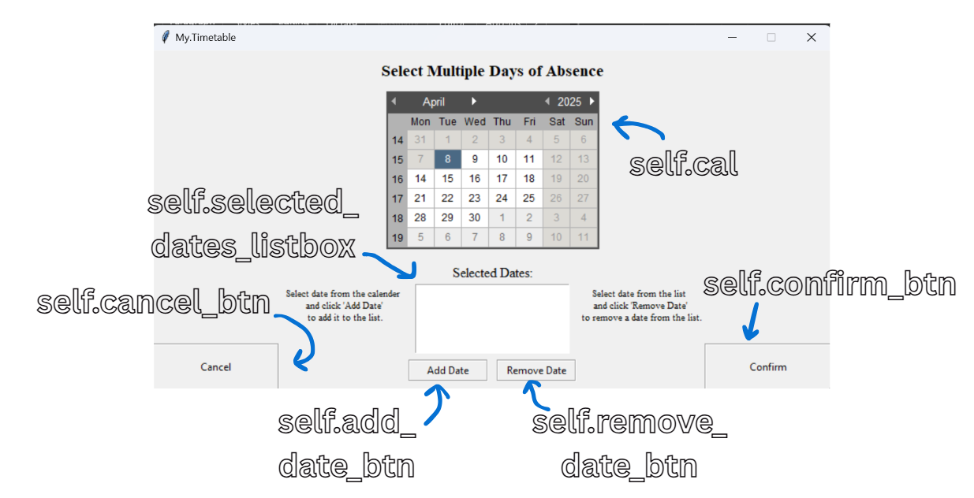

###### 4.2.2.2.13.3 Procedures and Variables:

|  |  |  |
| --- | --- | --- |
| The MarkDaysAbsent class is designed to facilitate the process of marking multiple days of absence for users within the timetable management application. It provides a user-friendly interface that allows users to select specific dates from a calendar and manage their absence reporting efficiently. | | |
| **Global Variables** | self.controller, self.sorted_dates, self.min_selectable_date, self.cal, self.selected_dates_listbox, self.add_date_btn, self.remove_date_btn, self.cancel_btn, self.confirm_btn, self.selected_dates, | |
| **Procedure** | **Purpose** | **Variables** |
| add_date | Adds the selected date from the calendar to the listbox | selected_date, self.cal, formatted_date, self.min_selectable_date, self.selected_dates, self.selected_dates_listbox, date |
| remove_selected_date | Removes a selected date from the listbox | selected_index, self.selected_dates_listbox, selected_date, self.selected_dates |
| confirm_absences | Processes the selected absence dates and ensures there are no duplicates | self.selected_dates, sorted_dates, dates, x, database, self.controller |
| merge_sort | Custom made efficient merge sort algorithm to sort a list of dates in order | dates, mid, left_half, right_half |
| merge | Merges two sorted lists | left, right, sorted_list |
| clear_entries | Clears all the selected dates and resets the calendar | self.selected_dates, self.selected_dates_listbox, self.cal, self.controller |

##### 4.2.2.2.14 SLTMarkDaysAbsent Class:

###### 4.2.2.2.14.1 Code:

class SLTMarkDaysAbsent(tk.Frame):

    """Screen for SLT members to mark teachers multiple days absent"""

    def __init__(self, parent, controller):

        super().__init__(parent)

        self.controller = controller

        # Get current date and time

        now = datetime.datetime.now()

        current_date = now.date()

        self.min_selectable_date = current_date

        # Title Label

        tk.Label(self, text="Select Multiple Days of Absence", font=("Times", 14, "bold")).grid(row=0, column=0, columnspan=2, pady=(10, 5))

        # Calendar Widget

        self.cal = MyCalendar(self, allowed_weekdays=(calendar.MONDAY, calendar.TUESDAY, calendar.WEDNESDAY, calendar.THURSDAY, calendar.FRIDAY),

                               selectmode="day", mindate=self.min_selectable_date, width=400, height=300)

        self.cal.grid(row=1, column=0, columnspan=2, padx=276, pady=(5, 10))

        # Selected Dates Listbox

        tk.Label(self, text="Selected Dates:", font=("Times", 12)).grid(row=2, column=0, columnspan=2, pady=(5, 0))

        self.selected_dates_listbox = tk.Listbox(self, height=5, width=30)

        self.selected_dates_listbox.grid(row=3, column=0, columnspan=2, padx=10, pady=(0, 5))

        tk.Label(self, text="Select date from the calender \nand click 'Add Date'\n to add it to the list.", font=("Times", 8)).place(x=155, y=300, anchor="w")

        tk.Label(self, text="Select date from the list \nand click 'Remove Date'\n to remove a date from the list.", font=("Times", 8)).place(x=500, y=300, anchor="w")

        # Add & Remove Buttons

        self.add_date_btn = tk.Button(self, text="Add Date", width=12, relief="groove",

                                      command=lambda: self.add_date())

        self.add_date_btn.grid(row=4, column=0, padx=5, pady=1, sticky="e")

        self.remove_date_btn = tk.Button(self, text="Remove Date", width=12, relief="groove",

                                         command=lambda: self.remove_selected_date())

        self.remove_date_btn.grid(row=4, column=1, padx=5, pady=1, sticky="w")

        # Cancel & Confirm Buttons

        self.cancel_btn = tk.Button(self, text="Cancel", width=20, height=3, relief="groove",

                                    command=lambda: self.clear_entries())

        self.cancel_btn.place(x=0, y=345)

        self.confirm_btn = tk.Button(self, text="Confirm", width=20, height=3, relief="groove",

                                     command=lambda: self.confirm_absences())

        self.confirm_btn.place(x=651, y=345)

        controller.binder(self.add_date_btn)

        controller.binder(self.remove_date_btn)

        controller.binder(self.cancel_btn)

        controller.binder(self.confirm_btn)

        # Store selected dates

        self.selected_dates = set()

    def add_date(self):

        """Adds the selected date from the calendar to the listbox."""

        selected_date = self.cal.get_date()

        formatted_date = datetime.datetime.strptime(selected_date, "%m/%d/%y").date()

        # Prevent selecting past dates

        if formatted_date < self.min_selectable_date:

            messagebox.showerror("Error", "Cannot select past dates!")

            return

        # Add to set (avoid duplicates)

        self.selected_dates.add(formatted_date)

        # Update Listbox

        self.selected_dates_listbox.delete(0, tk.END)

        for date in sorted(self.selected_dates):

            self.selected_dates_listbox.insert(tk.END, date)

    def remove_selected_date(self):

        """Removes a selected date from the listbox."""

        try:

            selected_index = self.selected_dates_listbox.curselection()[0]  # Get selected item index

            selected_date = self.selected_dates_listbox.get(selected_index)  # Get date string

            self.selected_dates.remove(datetime.datetime.strptime(selected_date, "%Y-%m-%d").date())  # Convert back to date

            self.selected_dates_listbox.delete(selected_index)  # Remove from listbox

        except IndexError:

            messagebox.showerror("Error", "No date selected!")

    def confirm_absences(self):

        """Processes selected absence dates."""

        if not self.selected_dates:

            messagebox.showerror("Error", "Please select at least one date!")

            return # Exit if no dates are selected

        # Convert to sorted list

        sorted_dates = self.merge_sort(self.selected_dates)

        dates = AbsenceDates()

        dates.sorted_dates = sorted_dates

        self.clear_entries()

        # Navigate to the next screen

        self.controller.show_frame(SLTAbsenceConfirmation)

    def merge_sort(self, dates):

        """Performs merge sort on the list of dates"""

        dates = list(dates)

        if len(dates) <= 1:

            return dates

        mid = len(dates) // 2

        left_half = self.merge_sort(dates[:mid])

        right_half = self.merge_sort(dates[mid:])

        return self.merge(left_half, right_half)

    def merge(self, left, right):

        """Merges two sorted lists"""

        sorted_list = []

        while left and right:

            if left[0] < right[0]:

                sorted_list.append(left.pop(0))

            else:

                sorted_list.append(right.pop(0))

        sorted_list.extend(left or right)

        return sorted_list

    def clear_entries(self):

        self.selected_dates.clear()

        self.selected_dates_listbox.delete(0, tk.END)

        self.cal.selection_set(datetime.datetime.now().date())

        self.controller.show_frame(SLTAbsenceScreen)

###### 4.2.2.2.14.2 User Interface:



###### 4.2.2.2.14.3 Procedures and Variables:

|  |  |  |
| --- | --- | --- |
| The SLTMarkDaysAbsent class is designed for Senior Leadership Team (SLT) members within the timetable management application, providing a dedicated interface for marking multiple days of absence for teachers. This class facilitates the administrative task of managing teacher attendance and ensures that SLT members can efficiently report absences for multiple days. | | |
| **Global Variables** | self.controller, self.min_selectable_date, self.cal, self.selected_dates_listbox, self.add_date_btn, self.remove_date_btn, self.cancel_btn, self.confirm_btn, self.selected_dates | | |
| **Procedure** | **Purpose** | **Variables** | |
| add_date | Adds the selected date from the calendar to the listbox | selected_date, self.cal, formatted_date, self.min_selectable_date, self.selected_dates, self.selected_dates_listbox, date | |
| remove_selected_date | Removes a selected date from the listbox | selected_index, self.selected_dates_listbox, selected_date, self.selected_dates | |
| confirm_absences | Processes the selected absence dates and ensures there are no duplicates | self.selected_dates, sorted_dates, dates, self.controller | |
| merge_sort | Custom made efficient merge sort algorithm to sort a list of dates in order | dates, mid, left_half, right_half | |
| merge | Merges two sorted lists | left, right, sorted_list | |
| clear_entries | Clears all the selected dates and resets the calendar | self.selected_dates, self.selected_dates_listbox, self.cal, self.controller | |

##### 4.2.2.2.15 AbsenceDates Class:

###### 4.2.2.2.15.1 Code:

class AbsenceDates:

    """Class to manage temporary saving and moving of absence dates"""

    sorted_dates = [] # Class variable to hold the sorted absence dates

    _instance = None

    def __new__(cls):

        """Creates a new instance of AbsenceDates or returns the existing instance"""

        if cls._instance is None: # Checks if an instance already exists

            cls._instance = super(AbsenceDates, cls).__new__(cls) # Creates a new instance

            cls._instance.sorted_dates = [] # Initializes the sorted_dates list

        return cls._instance # Returns the instance

###### 4.2.2.2.15.2 Procedures and Variables:

|  |  |  |
| --- | --- | --- |
| The AbsenceDates class is designed to manage the temporary storage and handling of absence dates within the timetable management application. It serves as a singleton class, ensuring that there is only one instance of absence dates throughout the application. This class is crucial for tracking the dates on which users (teachers or SLT members) are marked absent. | | |
| **Global Variables** | sorted_dates (Class Variable) | | |
| **Procedure** | **Purpose** | **Variables** | |
|  |  |  | |

##### 4.2.2.2.16 AbsenceConfirmation Class:

###### 4.2.2.2.16.1 Code:

class AbsenceConfirmation(tk.Frame):

    """Screen to confirm the absence dates selected"""

    def __init__(self, parent, controller):

        super().__init__(parent)

        self.controller = controller

        tk.Label(self, text="Reason:", font=("Times", 18)).pack(padx=103.5, pady=40)

        self.reason = tk.Entry(self, width=50)

        self.reason.pack(padx=250, pady=0, side="top")

        cancel = tk.Button(self, text="Cancel", width=10, height=2, relief="groove",

                  command=lambda: self.clear_entries())

        cancel.place(x=80, y=225)

        tk.Label(self, text="Are you sure?", font=("Times", 14)).pack(padx=103.5, pady=10)

        tk.Label(self, text="(You will be considered absent!)", font=("Times", 14)).pack(padx=103.5, pady=0)

        confirm = tk.Button(self, text="Confirm", width=10, height=2, relief="groove",

                  command=lambda: self.save_absence())

        confirm.place(x=360, y=225)

        controller.binder(cancel)

        controller.binder(confirm)

    def save_absence(self):

        absences = AbsenceDates() # Extracts the dates from the AbsenceDates instance

        username = self.controller.current_user # Gets current username

        fullname = database.get_fullname(username)

        dates = absences.sorted_dates

        reason = self.reason.get()

        numofdates = len(dates)

        if reason == "" or not re.match(r"^[A-Za-z\s]+$", reason):  # Allow letters and spaces

            messagebox.showerror("Error", "Please enter a valid reason for the absence!")

            return

        # Open the absence log file to append absence records

        f = open("AbsenceLog.txt", "a") # Open file in append mode

        for x in range(numofdates): # Iterates through the absence dates

            date = dates[x] # Get each date

            line = f"{fullname} is absent on the {date}. Reason = {reason}\n" # Formats the log entry

            f.write(line) # Writes the entry to the file

            database.add_absence(username, date, reason) # Saves absence details to the database

        f.close() # Close the file

        # Reopen the absence log file to sort entries

        f = open("AbsenceLog.txt", "r") # Open file in read mode

        content = f.readlines() # Read all the lines

        content.sort(key=lambda x: datetime.datetime.strptime(x.split("is absent on the ")[1].split(". Reason =")[0], "%Y-%m-%d")) # Sort entries by date

        f.close() # Close the file

        # Write the sorted content back to the file

        f = open("AbsenceLog.txt", "w") # Open file in write mode

        f.writelines(content) # Write sorted entries back to the file

        f.close() # Close the file

        # Show success message

        messagebox.showinfo("Success", f"You are marked Absent for: {', '.join(map(str, dates))}")

        self.clear_entries()

        self.controller.go_back() # Navigate back to the approporiate previous screen

    def clear_entries(self):

        self.reason.delete(0, tk.END) # Resets reason entry box to empty

        self.controller.show_frame(AbsenceScreen) # Raises the absence screen

###### 4.2.2.2.16.2 User Interface:

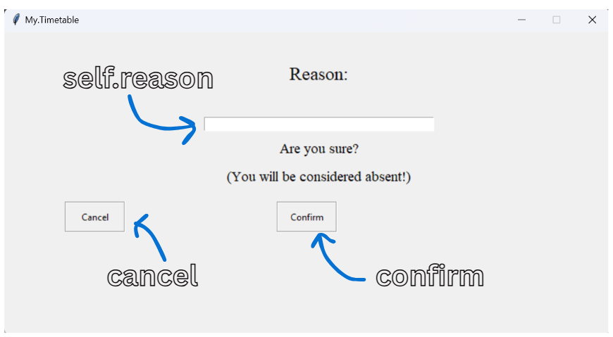

###### 4.2.2.2.16.3 Procedures and Variables:

|  |  |  |
| --- | --- | --- |
| The AbsenceConfirmation class is designed to provide a confirmation interface for users (teachers or SLT members) who have reported their absences within the timetable management application. This class facilitates the finalization of absence reports, allowing users to review and confirm their absence details before submission. | | |
| **Global Variables** | self.controller, self.reason | |
| **Procedure** | **Purpose** | **Variables** |
| save_absence | Validates the reason for absence and logs the absence/s into the database and the absence log text file | absences, username, self.controller, fullname, database, dates, reason, self.reason, numofdates, f, x, date, line, content |
| clear_entries | Clears the data entry boxes | self.reason, self.controller |

##### 4.2.2.2.17 SLTAbsenceConfirmation Class:

###### 4.2.2.2.17.1 Code:

class SLTAbsenceConfirmation(tk.Frame):

    """Screen for SLT members to confirm absences"""

    def __init__(self, parent, controller):

        super().__init__(parent)

        self.controller = controller

        # Label for selecting the teacher's username

        tk.Label(self, text="Teacher Username:", font=("Times", 16)).pack(padx=103.5, pady=(10,0))

        # Combobox for selecting absent teacher's username

        self.absent_teacher = ttk.Combobox(self, values=database.get_all_usernames(), width=50, state="normal") # Dropdown for usernames

        self.absent_teacher.pack(padx=250, pady=(0, 15), side="top")

        self.absent_teacher.bind("<KeyRelease>", self.checkkey) # Binds key release for filtering usernames

        tk.Label(self, text="Reason:", font=("Times", 16)).pack(padx=103.5, pady=(0,0))

        self.reason = tk.Entry(self, width=50)

        self.reason.pack(padx=250, pady=(0, 15), side="top")

        cancel = tk.Button(self, text="Cancel", width=10, height=2, relief="groove",

                  command=lambda: self.clear_entries())

        cancel.place(x=80, y=235)

        # Confirmation prompt

        tk.Label(self, text="Are you sure?", font=("Times", 14)).pack(padx=103.5, pady=10)

        tk.Label(self, text="(This teacher will be considered absent!)", font=("Times", 14)).pack(padx=103.5, pady=0)

        confirm = tk.Button(self, text="Confirm", width=10, height=2, relief="groove",

                  command=lambda: self.save_absence())

        confirm.place(x=360, y=235)

        controller.binder(cancel)

        controller.binder(confirm)

    def save_absence(self):

        """Save the absence details to the database and log file."""

        absences = AbsenceDates()  # Create an instance of AbsenceDates to get selected dates

        username = self.absent_teacher.get()  # Get the selected username from the combobox

        fullname = database.get_fullname(username)  # Fetch the full name from the database

        dates = absences.sorted_dates  # Get the sorted absence dates

        reason = self.reason.get()  # Get the reason for absence

        numofdates = len(dates)  # Count the number of absence dates

        now = datetime.datetime.now().time()  # Get the current date and time

        first_time = datetime.time(6, 30)  # Define the cutoff time for marking absence

        last_time = datetime.time(15, 0)  # Define the latest time for marking absence

        # Validate the selected username

        if username not in [item[0] for item in database.get_all_usernames()]:

            messagebox.showerror("Error", "Selected username does not exist!\nPlease select a valid username from the dropdown list.")

            return

        # Validate the reason input

        if reason == "" or not re.match(r"^[A-Za-z\s]+$", reason): # Check that the reason isn't empty and consists of alphabetic characters and spaces

            messagebox.showerror("Error", "Please enter a valid reason for the absence!")

            return

        # Checks if the teacher is already marked absent on the selected dates

        for x in range(numofdates):

            if database.is_absent(username, dates[x]):

                messagebox.showerror("Error", f"This teacher is already marked as absent on {dates[x]}!")

                self.clear_entries() # Clears entries if the teacher is already marked absent

                return

        f = open("AbsenceLog.txt", "a")

        for x in range(numofdates):

            date = dates[x]

            line = f"{fullname} is absent on the {date}. Reason = {reason}\n"

            f.write(line)

            database.add_absence(username, date, reason)

        f.close()

        f = open("AbsenceLog.txt", "r")

        content = f.readlines()

        content.sort(key=lambda x: datetime.datetime.strptime(x.split("is absent on the ")[1].split(". Reason =")[0], "%Y-%m-%d"))

        f.close()

        f = open("AbsenceLog.txt", "w")

        f.writelines(content)

        f.close()

        #Displays absence success message

        messagebox.showinfo("Success", f"{fullname} is marked Absent for: {', '.join(map(str, dates))}")

        # Checks if the current time is within the allowed range for cover allocation

        if now >= first_time and now <= last_time:

            M = MainAlgorithm(self.controller) # Creates an instance of MainAlgorithm

            M.cover_allocation() # Calls the cover allocation algorithm

        self.clear_entries()

        self.controller.go_back()

    def update_absent_teachers(self):

        """Updates the absent teachers in the combobox"""

        self.absent_teacher.config(values=database.get_all_usernames())

    def clear_entries(self):

        """Clears all the entry fields"""

        self.absent_teacher.delete(0, tk.END)

        self.reason.delete(0, tk.END)

        self.controller.show_frame(SLTAbsenceScreen)

    def checkkey(self, event):

        """Filers the usernames in the combobox based on user input"""

        value = self.absent_teacher.get() # Gets the current input

        if value == '':

            data = database.get_all_usernames() # Gets all the username if input is empty

        else:

            #Filers the usernames based on the input value

            data = [item[0] for item in database.get_all_usernames() if value.lower() in item[0].lower()]

        self.absent_teacher.config(values=data) # Updates the combobox with filtered username

###### 4.2.2.2.17.2 User Interface:

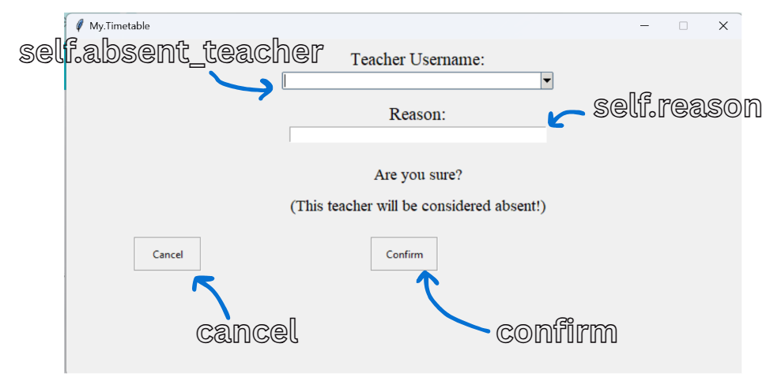

###### 4.2.2.2.17.3 Procedures and Variables:

|  |  |  |
| --- | --- | --- |
| The SLTAbsenceConfirmation class is designed to provide a confirmation interface specifically for Senior Leadership Team (SLT) members who are managing teacher absences within the timetable management application. This class facilitates the finalization of absence reports for teachers, allowing SLT members to review and confirm the details before submission. | | |
| **Global Variables** | self.controller, self.absent_teacher, self.reason | |
| **Procedure** | **Purpose** | **Variables** |
| save_absence | Validates the reason for absence and logs the absence/s into the database and the absence log text file if absence isn’t a duplicate | absences, username, self.absent_teacher, fullname, database, dates, reason, self.reason, numofdates, now, first_time, last_time, item, x, f, date, line, content, M, self.controller |
| update_absent_teachers | Updates the absent teachers in the combobox | self.absent_teacher, database |
| clear_entries | Clears all the data entry fields | self.absent_teacher, self.reason, self.controller |
| checkkey | Filters the usernames in the combobox based on the user’s input | event, value, self.absent_teacher, data, database, item |

##### 4.2.2.2.18 AddTeacherScreen Class:

###### 4.2.2.2.18.1 Code:

class AddTeacherScreen(tk.Frame):

    def __init__(self, parent, controller):

        super().__init__(parent)

        self.controller = controller

        self.counter = 0 # Counter to track the current day of the week

        self.password = None # Placeholder for the generated password

        # Labels and entries for teacher data

        tk.Label(self, text="Teacher Fullname: ", font=("Times", 14)).grid(row=0, column=0, padx=(130, 0), sticky="e")

        self.fullname = tk.Entry(self, width=50)

        self.fullname.grid(row=0, column=1, sticky="w")

        tk.Label(self, text="Teacher Username: ", font=("Times", 14)).grid(row=1, column=0, padx=(130, 0), sticky="e")

        self.username = tk.Entry(self, width=50)

        self.username.grid(row=1, column=1, sticky="w")

        tk.Label(self, text="Teacher Password: ", font=("Times", 14)).grid(row=2, column=0, padx=(130, 0), sticky="e")

        # Label and button for generating a new password

        create = tk.Button(self, text="Create New Password", width=42, height=1, relief="groove",

                  command=lambda: self.randomize_password())

        create.grid(row=2, column=1, sticky="w")

        # Label and combobox for Teacher Department

        tk.Label(self, text="Teacher Department: ", font=("Times", 14)).grid(row=3, column=0, padx=(130, 0), sticky="e")

        department_list = ["Mathematics", "English", "Science", "History", "Geography", "MFL", "Art", "Music", "PE", "CS"]

        self.department = ttk.Combobox(self, values=department_list, width=50, state="readonly")

        self.department.grid(row=3, column=1, sticky="w")

        tk.Label(self, text="Cover Limit: ", font=("Times", 14)).grid(row=4, column=0, padx=(130, 0), sticky="e")

        self.cover_limit = tk.Entry(self, width=50)

        self.cover_limit.grid(row=4, column=1, sticky="w")

        # Instructions for editingg cells to aid user friendliness

        tk.Label(self, text="*Double click a cell to edit", font=("Times", 10, "bold")).grid(row=5, column=0, padx=(130, 0),pady=(15,4), sticky="sw")

        tk.Label(self, text="*Only edit cells with lessons\nLessons left as empty will be considered free", font=("Times", 8, "bold")).place(x=500, y=140)

        # Navigation buttons for changing days

        left = tk.Button(self, text="<--", width=10, height=4, relief="groove",

                  command=lambda: self.decrease_counter())

        left.place(x=54, y=230)

        right = tk.Button(self, text="-->", width=10, height=4, relief="groove",

                  command=lambda: self.increase_counter())

        right.place(x=670, y=230)

        # Confirmation and cancel buttons

        cancel = tk.Button(self, text="Cancel", width=20, height=2, relief="groove",

                  command=lambda: self.clear_entries())

        cancel.place(x=0, y=359)

        confirm = tk.Button(self, text="Confirm Data", width=20, height=2, relief="groove",

                  command=lambda: self.confirm_teacher_data())

        confirm.place(x=650, y=359)

        # Binds buttons for hover effects

        controller.binder(create)

        controller.binder(left)

        controller.binder(right)

        controller.binder(cancel)

        controller.binder(confirm)

        # Initializes timetable for each day of the week

        self.timetables = {}

        for i in range(4):

            self.timetables[i] = Timetable(self, controller)

            self.timetables[i].Create_Empty_Timetable() # Creates empty timetable for monday to thursday

        self.timetables[4] = Timetable(self, controller)

        self.timetables[4].Create_Friday_Timetable() # Creates an empty timetable for fridaty

        self.current_timetable = self.timetables[0] # Starts with monday's timetable

        self.current_timetable.place(x=130, y=175)

        # Label to display the current day

        self.day_label = tk.Label(self, text="Monday", font=("Arial", 16, "bold"))

        self.day_label.place(x=350, y=145)

    def increase_counter(self):

        """Increases the day counter to show the next day's timetable"""

        if self.counter < 4:

            self.counter += 1

            self.update_day() # Updates the display to show the next day

    def decrease_counter(self):

        """Decreases the day counter to show the previous day's timetable"""

        if self.counter > 0:

            self.counter -= 1

            self.update_day() # Updates the display to show the previous day

    def update_display(self):

        """Updates the display to show the correct day timetable"""

        self.current_timetable.place_forget() # Hides the current timetable

        self.current_timetable = self.timetables[self.counter] # Get the timetable for the current day

        if self.counter == 4:  # If it's Friday

            self.current_timetable.place(x=190, y=175)

        else:

            self.current_timetable.place(x=130, y=175)

    def update_day(self):

        """Updates the day label and display based on the current counter"""

        self.days = ["Monday", "Tuesday", "Wednesday", "Thursday", "Friday"]

        self.update_daylabel(self.days[self.counter]) # Updates the day label

        self.update_display() # Updates the timetable display

    def update_daylabel(self, day):

        """Updates the day label with the correct day"""

        self.day_label.config(text=f"{day}")

    def get_lesson(self, column):

        """Retrieves lesson details from the current timetable for a specific column"""

        values = []

        for item in self.current_timetable.tree.get_children():

            value = self.current_timetable.tree.item(item)['values'][column]

            values.append(value)

        return values

    def get_friday_lesson(self, column):

        """Retrieves lesson details for Friday from the current timetable for a specific column"""

        # Get all three rows directly

        rows = self.current_timetable.tree.get_children()

        # Get values from specific column for each row

        subject = self.current_timetable.tree.item(rows[0])['values'][column]

        class_name = self.current_timetable.tree.item(rows[1])['values'][column]

        substitute = self.current_timetable.tree.item(rows[2])['values'][column]

        values = [subject, class_name, substitute] # Returns values as a list

        return values

    def randomize_password(self):

        """Generates a random password for the teacher"""

        s1 = list(string.ascii_lowercase)

        s2 = list(string.ascii_uppercase)

        s3 = list("@$!%*?_&")

        s4 = list(string.digits)

        random.shuffle(s1)  # Shuffles lowercase letters

        random.shuffle(s2)  # Shuffles uppercase letters

        random.shuffle(s3)  # Shuffles special characters

        random.shuffle(s4)  # Shuffles digits

        result = []

        for x in range(3):

            result.append(s1[x]) # Adds 3 random lowercase letters

            result.append(s2[x]) # Adds 3 random uppercase letters

        for x in range(2):

            result.append(s3[x]) # Adds 2 random special characters

            result.append(s4[x]) # Adds 2 random digits

        random.shuffle(result) # Shuffles the final password characters

        password = "".join(result) # Sets the password to the shuffled result

        self.password = password # Stores the generated password

        messagebox.showinfo("Password Reset", f"The new password is {password}") # Shows the new password in a message box

    def confirm_teacher_data(self):

        """Confirm the teacher data and save it to the database."""

        fullname = self.fullname.get().strip().title()

        username = self.username.get().strip().lower()

        password = self.password

        department = self.department.get()

        cover_limit = self.cover_limit.get()

        role = "Normal Teacher"

        detected = 0 # Flag to check for empty cells

        # Validate the data

        if not fullname or not username or not department or not cover_limit:

            messagebox.showerror("Error", "All fields are required!")

            return

        if not password:

            messagebox.showerror("Error", "Please generate a password")

            return

        if len(fullname.split()) <= 1:

            messagebox.showerror("Error", "Fullname must include atleast first and last name!")

            return

        #check if username ends with "_gfs"

        if not username.endswith("_gfs"):

            messagebox.showerror("Error", "Username must end with '_gfs'!")

            return

        if not username[0].isalpha():

            messagebox.showerror("Error", "Username must start with a letter!")

            return

        # Check if the username already exists

        if database.get_fullname(username):

            messagebox.showerror("Error", "Username already exists!")

            return

        if not re.match(r"^(?!.*\..*\..*)[A-Za-z0-9]+(\.[A-Za-z0-9]+)?$", username.replace("_gfs","")):

            messagebox.showerror("Error", "Start of Username must only include alphanumeric characters and one fullstop")

            return

        if not cover_limit.isdigit():

            messagebox.showerror("Error", "Cover limit must be a integer!")

            return

        # Add the lessons to the database

        self.days = ["Monday", "Tuesday", "Wednesday", "Thursday"]

        for x in range(4):

            day = self.days[x]

            self.current_timetable = self.timetables[x]

            for i in range(7):

                subject, class_name, substitute = self.get_lesson(i+1)

                if subject == "Empty" or subject == "":

                    detected = 1 # Flag if any subject is empty

        day = "Friday"

        self.current_timetable = self.timetables[4]

        for i in range(5):

            subject, class_name, substitute = self.get_friday_lesson(i+1)

            if subject == "Empty" or subject == "":

                detected = 1 # Flag if any subject is empty

        if detected == 1:

            response = tk.messagebox.askquestion(title="Empty Cells Detected",

                                                message="Are you sure you want to save these changes?\nAll empty cells will be considered Free",

                                                icon="warning") # Confirms saving with empty cells turning to free by default

            if response == "no":

                detected = 0

                return

        # Adds the teacher to the database and stores password as hash keeping no record of the actual password

        database.add_teacher(username, fullname, role, department, 0, cover_limit)

        database.store_password(username, password)

        for x in range(4):

            day = self.days[x]

            self.current_timetable = self.timetables[x]

            for i in range(7):

                subject, class_name, substitute = self.get_lesson(i+1)

                if subject == "Empty" or subject == "" or subject == "Free":

                    subject = "Free" # Set empty subjects to free

                    class_name = ""

                    substitute = ""

                else:

                    substitute = "None" # Set substitute to None

                database.add_lesson(username, day, i+1, subject, class_name, substitute) # Adds lesson to the database

        day = "Friday"

        self.current_timetable = self.timetables[4]

        for i in range(5):

            subject, class_name, substitute = self.get_friday_lesson(i+1)

            if subject == "Empty" or subject == "" or subject == "Free":

                subject = "Free"

                class_name = ""

                substitute = ""

            else:

                substitute = "None"

            database.add_lesson(username, day, i+1, subject, class_name, substitute)

        self.controller.update_all_timelines()

        # Updates timetable based on role

        if self.controller.current_role == "SLT":

            self.controller.frames[SLTScreen].timetable.update_timetable()

        else:

            self.controller.frames[TeacherScreen].timetable.update_timetable()

        self.clear_entries() # Clear all entry fields and timetable after saving

    def clear_entries(self):

        """Clear all entry fields."""

        self.fullname.delete(0, tk.END)

        self.username.delete(0, tk.END)

        self.department.set("")

        self.cover_limit.delete(0, tk.END)

        self.password = None

        # Resets timetables to empty state

        for i in range(4):

            self.timetables[i].tree.delete(*self.timetables[i].tree.get_children())

            self.timetables[i].tree.insert("", "end", values=["Subject"] + ["Empty"] * 7)

            self.timetables[i].tree.insert("", "end", values=["Class"] + ["Empty"] * 7)

            self.timetables[i].tree.insert("", "end", values=["Substitute"] + ["None"] * 7)

        self.timetables[4].tree.delete(*self.timetables[4].tree.get_children())

        self.timetables[4].tree.insert("", "end", values=["Subject"] + ["Empty"] * 5)

        self.timetables[4].tree.insert("", "end", values=["Class"] + ["Empty"] * 5)

        self.timetables[4].tree.insert("", "end", values=["Substitute"] + ["None"] * 5)

        self.counter = 0 # Reset day counter

        self.update_day() # Update display to show the first day

        self.controller.go_back()

###### 4.2.2.2.18.2 User Interface:

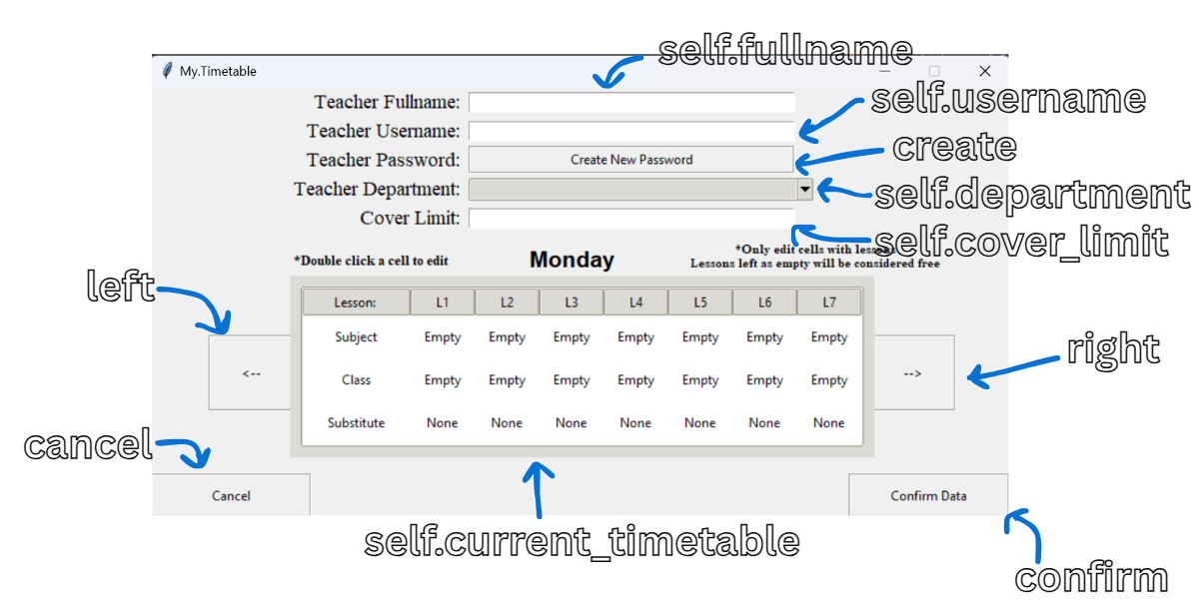

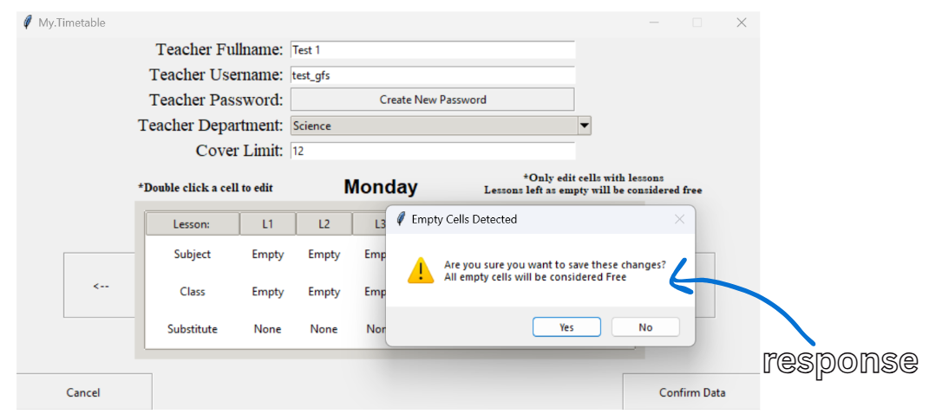

###### 4.2.2.2.18.3 Procedures and Variables:

|  |  |  |
| --- | --- | --- |
| The AddTeacherScreen class is designed to provide an interface for adding new teachers to the timetable management application. This class facilitates the input of teacher information, including personal details and timetable, ensuring that the data is collected in a structured and user-friendly manner. | | |
| **Global Variables** | self.controller, self.counter, self.password, self.fullname, self.username, self.department, self.cover_limit, self.timetables, self.current_timetable, self.day_label, self.days | |
| **Procedure** | **Purpose** | **Variables** |
| increase_counter | Increases the day counter to show the next day’s timetable | self.counter |
| decrease_counter | Decreases the day counter to show the previous day’s timetable | self.counter |
| update_display | Updates the display to show the correct timetable | self.current_timetable, self.timetables, self.counter |
| update_day | Updates the day label and display based on the current counter | self.days, self.counter |
| update_daylabel | Updates the day label with the correct day | day, self.day_label |
| get_lesson | Retrieves the lesson details from the current timetable from a specific column | column, values, item, self.current_timetable, value |
| get_friday_lesson | Retrieves the friday lesson details from the current timetable from a specific column | column, rows, self.current_timetable, subject, class_name, substitute, values |
| randomize_password | Generates a random password for the teacher with certain requirements | s1, s2, s3, s4, result, x, password, self.password |
| confirm_teacher_data | Validates and confirms the teacher’s data and then saves it to the database | fullname, self.fullname, username, self.username, password, self.password, department, self.department, cover_limit, self.cover_limit, role, detected, database, self.days, x, day, self.current_timetable, self.timetables, i, subject, class_name, substitute, response, self.controller |
| clear_entries | Clears all the data entry fields | self.fullname, self.username, self.department, self.cover_limit, self.password, i, self.timetables, self.counter, self.controller |

##### 4.2.2.2.19 AccessDatabaseScreen Class:

###### 4.2.2.2.19.1 Code:

class AccessDatabaseScreen(tk.Frame):

    def __init__(self, parent, controller):

        super().__init__(parent)

        self.controller = controller

        self.accessed_username = None

        tk.Label(self, text="Teacher Database", font=("Times", 20, "bold")).pack(padx=103.5, pady=(15,10))

        back = tk.Button(self, text="Go Back", width=20, height=3, relief="groove",

                  command=lambda: self.controller.go_back())

        back.place(x=0, y=0)

        controller.binder(back)

        # Configures the style for the treeview

        style = ttk.Style()

        style.configure("Treeview", rowheight=30) # Sets row height

        # Create a treeview widget to display teacher data

        self.tree = ttk.Treeview(self, columns=("Fullname", "Username", "View", "Edit", "Delete"), show="headings", style="Treeview", selectmode="none")

        self.tree.heading("Fullname", text="Fullname")  # Column for teacher's full name

        self.tree.heading("Username", text="Username")  # Column for teacher's username

        self.tree.heading("View", text=" ")  # Column for viewing details

        self.tree.heading("Edit", text="Access Details")  # Column for editing details

        self.tree.heading("Delete", text=" ")  # Column for deleting records

        # Sets column widths and alignment

        for col in ("Fullname", "Username"):

            self.tree.column(col, width=200, anchor="center")

        for col in ("View", "Edit", "Delete"):

            self.tree.column(col, width=100, anchor="center")

        # Creates a vertical scrollbar for the Treeview

        scrollbar = ttk.Scrollbar(self, orient=tk.VERTICAL, command=self.tree.yview)

        scrollbar.place(x=755, y=98, relheight=0.707, relwidth=0.02)

        self.tree.configure(yscrollcommand=scrollbar.set)

        # Bind mouse click events to the Treeview

        self.tree.bind('<Button-1>', self.on_click)

        max_height = 155 # Maximum height for the Treeview

        # Adjust the height of the Treeview based on its content

        self.tree.bind('<Configure>', lambda e: self.adjust_treeview_height(max_height))

        self.tree.pack(padx=50, pady=(10,0))

        self.update_treeview() # Populates the Treeview with data

    def update_treeview(self):

        """ Updates the Treeview with the latest teacher data"""

        self.tree.delete(*self.tree.get_children())

        for index, teacher in enumerate(database.get_all_teachers()):

            username = teacher[0]

            fullname = teacher[1]

            tag = 'evenrow' if index % 2 == 0 else 'oddrow' # Alternates row colors for better readability and user friendliness

            # Inserts a new row into the Treeview for each teacher

            self.tree.insert("", "end", values=(fullname, username, "View", "Edit", "Delete"), tags=(tag))

        # Configure row colors

        self.tree.tag_configure('evenrow', background='#f0f0f0')  # Light gray for even rows

        self.tree.tag_configure('oddrow', background='white')

    def adjust_treeview_height(self, max_height):

        """Adjusts the height of the Treeview to a maximum value"""

        height = self.tree.winfo_height()

        if height > max_height:

            self.tree.configure(height=max_height // 20)

    def on_click(self, event):

        """Handles click events on the Treeview"""

        # Prevents interaction with the header and seperator

        if self.tree.identify_region(event.x, event.y) == "heading":

            return "break"

        if self.tree.identify_region(event.x, event.y) == "separator":

            return "break"

        # Checks if a cell was clicked

        if self.tree.identify_region(event.x, event.y) == "cell":

            self.current_item = self.tree.identify_row(event.y)

            self.current_column = self.tree.identify_column(event.x)

            self.current_value = self.tree.set(self.current_item, self.current_column)

            accessed_username = self.tree.set(self.current_item, "#2")

            current_data = AccessedData() # Creates an instance to store accessed data

            current_data.accessed_username = accessed_username # Stores the accessed username

            # Handle different actions based on the clicked cell value

            if self.current_value == "View":

                if self.controller.current_role == 'Admin':

                    self.controller.frames[AdminViewDatabase].update_labels()

                    self.controller.show_frame(AdminViewDatabase)

                else:

                    self.controller.frames[ViewDatabaseScreen].update_labels()

                    self.controller.show_frame(ViewDatabaseScreen)

            elif self.current_value == "Edit":

                if self.controller.current_role == 'Admin':

                    self.controller.frames[AdminEditDatabase].update_entries()

                    self.controller.show_frame(AdminEditDatabase)

                else:

                    self.controller.frames[EditDatabaseScreen].update_entries()

                    self.controller.show_frame(EditDatabaseScreen)

            elif self.current_value == "Delete":

                current_data = AccessedData()

                if current_data.accessed_username == self.controller.current_user:

                    messagebox.showerror("Error", "You cannot delete yourself!")

                else:

                    self.controller.show_frame(DeleteDatabaseScreen)

###### 4.2.2.2.19.2 User Interface:

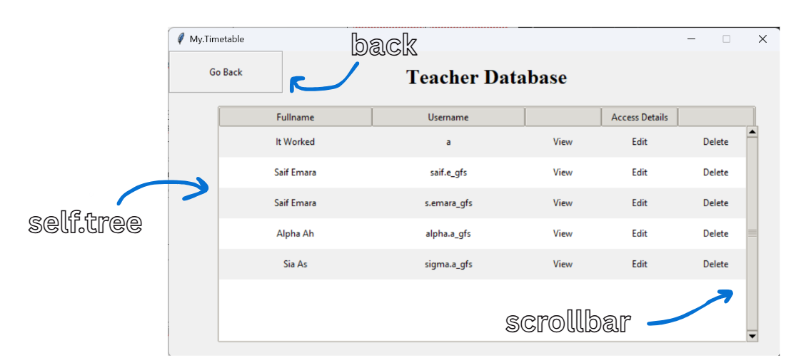

###### 4.2.2.2.19.3 Procedures and Variables:

|  |  |  |
| --- | --- | --- |
| The AccessDatabaseScreen class is designed to provide an interface for accessing and managing teacher data within the timetable management application. This class allows users, particularly administrators and SLT teachers, to view, edit, and delete records from the teacher database, facilitating effective management of teacher information. | | |
| **Global Variables** | self.controller, self.accessed_username, self.tree, self.current_item, self.current_column, self.current_value | |
| **Procedure** | **Purpose** | **Variables** |
| update_treeview | Updates the treeview with the latest teacher data and updates | self.tree, index, teacher, database, username, fullname, tag |
| adjust_treeview_height | Adjusts the height of the Treeview to a maximum value | max_height, height, self.tree |
| on_click | Handles the event of mouse clicking and what screens get raised based on what cell was clicked on | event, self.tree, self.current_item, self.current_column, self.current_value, accessed_username, current_data, self.controller |

##### 4.2.2.2.20 AccessedData Class:

###### 4.2.2.2.20.1 Code:

class AccessedData:

    accessed_username = None # Class variable to store the accessed username

    _instance = None

    def __new__(cls):

        if cls._instance is None:

            cls._instance = super(AccessedData, cls).__new__(cls)

            cls._instance.accessed_username = None

        return cls._instance

###### 4.2.2.2.20.2 Procedures and Variables:

|  |  |  |
| --- | --- | --- |
| The AccessedData class is a vital component of the timetable management application, providing a centralized and consistent way to manage information about the currently accessed user. By implementing the singleton pattern, it ensures that there is only one instance of accessed data, facilitating easy access to user information throughout the application. This class plays a crucial role in maintaining user context and supporting various functionalities related to user management within the application. | | |
| **Global Variables** | accessed_username (Class Variable) | |
| **Procedure** | **Purpose** | **Variables** |
|  |  |  |

##### 4.2.2.2.21 ViewDatabaseScreen Class:

###### 4.2.2.2.21.1 Code:

class ViewDatabaseScreen(tk.Frame):

    def __init__(self, parent, controller):

        super().__init__(parent)

        self.controller = controller

        self.counter = 0

        left = tk.Button(self, text="<--", width=10, height=4, relief="groove",

                  command=lambda: self.decrease_counter())

        left.place(x=54, y=230)

        right = tk.Button(self, text="-->", width=10, height=4, relief="groove",

                  command=lambda: self.increase_counter())

        right.place(x=670, y=230)

        back = tk.Button(self, text="Go Back", width=20, height=2, relief="groove",

                  command=lambda: self.clear_entries())

        back.place(x=0, y=359)

        controller.binder(left)

        controller.binder(right)

        controller.binder(back)

        self.timetables = {}

        for i in range(4):

            self.timetables[i] = Timetable(self, controller)

            self.timetables[i].Create_Empty_Timetable()

        self.timetables[4] = Timetable(self, controller)

        self.timetables[4].Create_Friday_Timetable()

        self.current_timetable = self.timetables[0]

        self.current_timetable.place(x=130, y=175)

        self.day_label = tk.Label(self, text="Monday", font=("Arial", 16, "bold"))

        self.day_label.place(x=350, y=145)

    def update_labels(self):

        """Updates the labels with the current teacher's information."""

        current_data = AccessedData()

        self.username = current_data.accessed_username

        self.fullname = database.get_fullname(self.username)

        self.department = database.get_subject_department(self.username)

        self.cover_limit = database.get_cover_limit(self.username)

        # Display the teacher's information in labels

        tk.Label(self, text="Teacher Fullname: ", font=("Times", 14)).grid(row=0, column=0, padx=(130, 0), pady=(1,1), sticky="e")

        tk.Label(self, text="Teacher Username: ", font=("Times", 14)).grid(row=1, column=0, padx=(130, 0), sticky="e")

        tk.Label(self, text="Teacher Department: ", font=("Times", 14)).grid(row=2, column=0, padx=(130, 0), sticky="e")

        tk.Label(self, text="Teacher Cover Limit: ", font=("Times", 14)).grid(row=3, column=0, padx=(130, 0), sticky="e")

        # Create frames to display the fetched information

        tk.LabelFrame(self, width=250, height=28, relief="solid").place(x=295, y=1.5)

        tk.Label(self, text=f"{self.fullname}").place(x=300, y=4)

        tk.LabelFrame(self, width=250, height=28, relief="solid").place(x=295, y=30)

        tk.Label(self, text=f"{self.username}").place(x=300, y=33)

        tk.LabelFrame(self, width=250, height=28, relief="solid").place(x=295, y=55.5)

        tk.Label(self, text=f"{self.department}").place(x=300, y=58)

        tk.LabelFrame(self, width=250, height=28, relief="solid").place(x=295, y=80.5)

        tk.Label(self, text=f"{self.cover_limit}").place(x=300, y=83)

        self.updateview_timetable() # Update the timetable display

    def updateview_timetable(self):

        """Updates the timetable display with the current teacher's lessons."""

        current_data = AccessedData()

        self.username = current_data.accessed_username

        # Fetches lessons for each day of the week for the database

        MondayData = database.get_all_lessons(self.username, "Monday")

        TuesdayData = database.get_all_lessons(self.username, "Tuesday")

        WednesdayData = database.get_all_lessons(self.username, "Wednesday")

        ThursdayData = database.get_all_lessons(self.username, "Thursday")

        FridayData = database.get_all_lessons(self.username, "Friday")

        # Extracts lesson details for each day

        self.MondayLessons = [lesson[2] for lesson in MondayData]

        self.MondayClasses = [lesson[3] for lesson in MondayData]

        self.MondaySubstitutes = [lesson[4] for lesson in MondayData]

        self.TuesdayLessons = [lesson[2] for lesson in TuesdayData]

        self.TuesdayClasses = [lesson[3] for lesson in TuesdayData]

        self.TuesdaySubstitutes = [lesson[4] for lesson in TuesdayData]

        self.WednesdayLessons = [lesson[2] for lesson in WednesdayData]

        self.WednesdayClasses = [lesson[3] for lesson in WednesdayData]

        self.WednesdaySubstitutes = [lesson[4] for lesson in WednesdayData]

        self.ThursdayLessons = [lesson[2] for lesson in ThursdayData]

        self.ThursdayClasses = [lesson[3] for lesson in ThursdayData]

        self.ThursdaySubstitutes = [lesson[4] for lesson in ThursdayData]

        self.FridayLessons = [lesson[2] for lesson in FridayData]

        self.FridayClasses = [lesson[3] for lesson in FridayData]

        self.FridaySubstitutes = [lesson[4] for lesson in FridayData]

        # Clears existing entries in the timetables

        for i in range(5):

            self.timetables[i].tree.delete(*self.timetables[i].tree.get_children())

        # Fills the timetables with the fetched lesson data

        self.fillnormal() # Monday to Thursday

        self.fillfriday() # Friday

    def fillnormal(self):

        """Fills the first 4 weekday's timetables with lesson data"""

        self.timetables[0].tree.insert("", "end", values=["Subject"] + self.MondayLessons)

        self.timetables[0].tree.insert("", "end", values=["Class"] + self.MondayClasses)

        self.timetables[0].tree.insert("", "end", values=["Substitute"] + self.MondaySubstitutes)

        self.timetables[1].tree.insert("", "end", values=["Subject"] + self.TuesdayLessons)

        self.timetables[1].tree.insert("", "end", values=["Class"] + self.TuesdayClasses)

        self.timetables[1].tree.insert("", "end", values=["Substitute"] + self.TuesdaySubstitutes)

        self.timetables[2].tree.insert("", "end", values=["Subject"] + self.WednesdayLessons)

        self.timetables[2].tree.insert("", "end", values=["Class"] + self.WednesdayClasses)

        self.timetables[2].tree.insert("", "end", values=["Substitute"] + self.WednesdaySubstitutes)

        self.timetables[3].tree.insert("", "end", values=["Subject"] + self.ThursdayLessons)

        self.timetables[3].tree.insert("", "end", values=["Class"] + self.ThursdayClasses)

        self.timetables[3].tree.insert("", "end", values=["Substitute"] + self.ThursdaySubstitutes)

    def fillfriday(self):

        """Fills the Friday timetable with lesson data."""

        self.timetables[4].tree.insert("", "end", values=["Subject"] + self.FridayLessons)

        self.timetables[4].tree.insert("", "end", values=["Class"] + self.FridayClasses)

        self.timetables[4].tree.insert("", "end", values=["Substitute"] + self.FridaySubstitutes)

    def increase_counter(self):

        if self.counter < 4:

            self.counter += 1

            self.update_day()

    def decrease_counter(self):

        if self.counter > 0:

            self.counter -= 1

            self.update_day()

    def update_display(self):

        self.current_timetable.place_forget()

        self.current_timetable = self.timetables[self.counter]

        if self.counter == 4:  # If it's Friday

            self.current_timetable.place(x=190, y=175)

        else:

            self.current_timetable.place(x=130, y=175)

    def update_day(self):

        self.days = ["Monday", "Tuesday", "Wednesday", "Thursday", "Friday"]

        self.update_daylabel(self.days[self.counter])

        self.update_display()

    def update_daylabel(self, day):

        """Updates the day label"""

        self.day_label.config(text=f"{day}")

    def clear_entries(self):

        self.counter = 0

        self.update_day()

        self.controller.show_frame(AccessDatabaseScreen)

###### 4.2.2.2.21.2 User Interface:

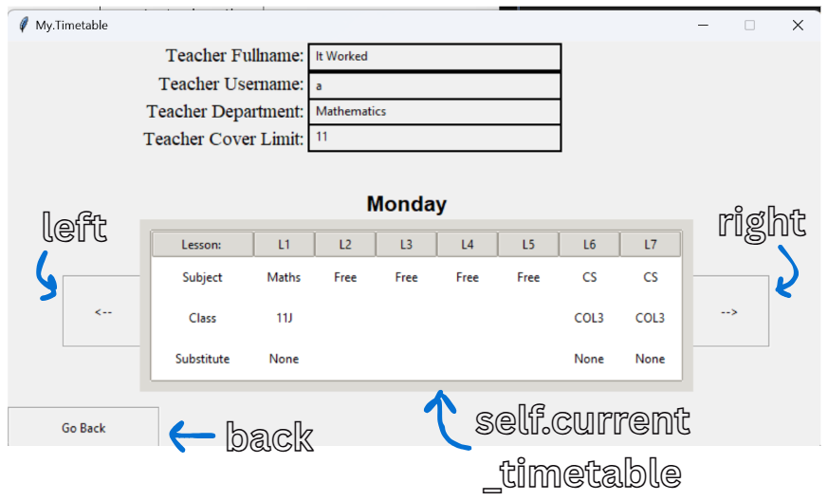

###### 4.2.2.2.21.3 Procedures and Variables:

|  |  |  |
| --- | --- | --- |
| The ViewDatabaseScreen class is designed to provide an interface for viewing detailed information about teachers within the timetable management application. This class allows users, particularly SLT members, to access and review teacher data, including their schedules and personal information. | | |
| **Global Variables** | self.controller, self.counter, self.timetables, self.current_timetable, self.day_label, self.username, self.fullname, self.department, self.cover_limit, self.MondayLessons, self.MondayClasses, self.MondaySubstitutes, self.TuesdayLessons, self.TuesdayClasses, self.TuesdaySubstitutes, self.WednesdayLessons, self.WednesdayClasses, self.WednesdaySubstitutes, self.ThursdayLessons, self.ThursdayClasses, self.ThursdaySubstitutes, self.FridayLessons, self.FridayClasses, self.FridaySubstitutes, self.days | |
| **Procedure** | **Purpose** | **Variables** |
| update_labels | Updates the labels with the current teacher’s information | current_data, self.username, self.fullname, self.department, self.cover_limit |
| updateview_timetable | Updates the timetable display with the current teacher’s lessons | current_data, self.username, MondayData, TuesdayData, WednesdayData, ThursdayData, FridayData, self.MondayLessons, lesson, self.MondayClasses, self.MondaySubstitutes, self.TuesdayLessons, self.TuesdayClasses, self.TuesdaySubstitutes, self.WednesdayLessons, self.WednesdayClasses, self.WednesdaySubstitutes, self.ThursdayLessons, self.ThursdayClasses, self.ThursdaySubstitutes, self.FridayLessons, self.FridayClasses, self.FridaySubstitutes, i, self.timetables |
| fillnormal | Fills the first 4 week day’s timetables with lessons | self.timetables, self.MondayLessons, self.MondayClasses, self.MondaySubstitutes, self.TuesdayLessons, self.TuesdayClasses, self.TuesdaySubstitutes, self.WednesdayLessons, self.WednesdayClasses, self.WednesdaySubstitutes, self.ThursdayLessons, self.ThursdayClasses, self.ThursdaySubstitutes |
| fillfriday | Fills the Friday timetable with lessons | self.timetables, self.FridayLessons, self.FridayClasses, self.FridaySubstitutes |
| increase_counter | Increases the day counter to show the next day’s timetable | self.counter |
| decrease_counter | Decreases the day counter to show the previous day’s timetable | self.counter |
| update_display | Updates the display to show the correct timetable | self.current_timetable, self.timetables, self.counter |
| update_day | Updates the day label and display based on the current counter | self.days, self.counter |
| update_daylabel | Updates the day label with the correct day | day, self.day_label |
| clear_entries | Resets the counter to 0 | self.counter, self.controller |

##### 4.2.2.2.22 EditDatabaseScreen Class:

###### 4.2.2.2.22.1 Code:

class EditDatabaseScreen(tk.Frame):

    def __init__(self, parent, controller):

        super().__init__(parent)

        self.controller = controller

        self.counter = 0

        self.password = None

        self.changed = False

        department_list = ["Mathematics", "English", "Science", "History", "Geography", "MFL", "Art", "Music", "PE", "CS"]

        tk.Label(self, text="Teacher Fullname: ", font=("Times", 14)).grid(row=0, column=0, padx=(130, 0), sticky="e")

        self.fullname = tk.Entry(self, width=50)

        self.fullname.grid(row=0, column=1, sticky="w")

        tk.Label(self, text="Teacher Username: ", font=("Times", 14)).grid(row=1, column=0, padx=(130, 0), sticky="e")

        self.username = tk.Entry(self, width=50)

        self.username.grid(row=1, column=1, sticky="w")

        tk.Label(self, text="Teacher Password: ", font=("Times", 14)).grid(row=2, column=0, padx=(130, 0), sticky="e")

        reset = tk.Button(self, text="Reset Password", width=42, height=1, relief="groove",

                  command=lambda: self.randomize_password())

        reset.grid(row=2, column=1, sticky="w")

        tk.Label(self, text="Teacher Department: ", font=("Times", 14)).grid(row=3, column=0, padx=(130, 0), sticky="e")

        self.department = ttk.Combobox(self, values=department_list, width=50, state="readonly")

        self.department.grid(row=3, column=1, sticky="w")

        tk.Label(self, text="Cover Limit: ", font=("Times", 14)).grid(row=4, column=0, padx=(130, 0), sticky="e")

        self.cover_limit = tk.Entry(self, width=50)

        self.cover_limit.grid(row=4, column=1, sticky="w")

        tk.Label(self, text="*Double click a cell to edit", font=("Times", 8, "bold")).grid(row=5, column=0, padx=(130, 0),pady=(15,4), sticky="sw")

        tk.Label(self, text="*Only edit cells with lessons\nLessons left as empty will be considered free", font=("Times", 8, "bold")).place(x=500, y=140)

        left = tk.Button(self, text="<--", width=10, height=4, relief="groove",

                  command=lambda: self.decrease_counter())

        left.place(x=54, y=230)

        right = tk.Button(self, text="-->", width=10, height=4, relief="groove",

                  command=lambda: self.increase_counter())

        right.place(x=670, y=230)

        cancel = tk.Button(self, text="Cancel", width=20, height=2, relief="groove",

                  command=lambda: self.clear_entries())

        cancel.place(x=0, y=359)

        confirm = tk.Button(self, text="Confirm Data", width=20, height=2, relief="groove",

                  command=lambda: self.confirm_teacher_data())

        confirm.place(x=650, y=359)

        controller.binder(reset)

        controller.binder(left)

        controller.binder(right)

        controller.binder(cancel)

        controller.binder(confirm)

        self.timetables = {}

        for i in range(4):

            self.timetables[i] = Timetable(self, controller)

            self.timetables[i].Create_Empty_Timetable()

        self.timetables[4] = Timetable(self, controller)

        self.timetables[4].Create_Friday_Timetable()

        self.current_timetable = self.timetables[0]

        self.current_timetable.place(x=130, y=175)

        self.day_label = tk.Label(self, text="Monday", font=("Arial", 16, "bold"))

        self.day_label.place(x=350, y=145)

    def update_entries(self):

        """Updates the entry fields with the current teacher's data for editing."""

        current_data = AccessedData()

        self.edit_username = current_data.accessed_username

        self.edit_fullname = database.get_fullname(self.edit_username)

        self.edit_department = database.get_subject_department(self.edit_username)

        self.edit_cover_limit = database.get_cover_limit(self.edit_username)

        # Inserts the data into the entry boxes

        self.fullname.insert(0, f"{self.edit_fullname}")

        self.username.insert(0, f"{self.edit_username}")

        self.department.set(f"{self.edit_department}")

        self.cover_limit.insert(0, f"{self.edit_cover_limit}")

        self.updateview_timetable()

    def updateview_timetable(self):

        """Updates the timetable display with the current teacher's lessons."""

        current_data = AccessedData() # Creates an instance to access the accessed username

        self.edit_username = current_data.accessed_username

        # Fetches lessons for each day of the week from the database

        MondayData = database.get_all_lessons(self.edit_username, "Monday")

        TuesdayData = database.get_all_lessons(self.edit_username, "Tuesday")

        WednesdayData = database.get_all_lessons(self.edit_username, "Wednesday")

        ThursdayData = database.get_all_lessons(self.edit_username, "Thursday")

        FridayData = database.get_all_lessons(self.edit_username, "Friday")

        # Extracts lesson details for each day

        MondayLessons = [lesson[2] for lesson in MondayData]

        MondayClasses = [lesson[3] for lesson in MondayData]

        MondaySubstitutes = [lesson[4] for lesson in MondayData]

        TuesdayLessons = [lesson[2] for lesson in TuesdayData]

        TuesdayClasses = [lesson[3] for lesson in TuesdayData]

        TuesdaySubstitutes = [lesson[4] for lesson in TuesdayData]

        WednesdayLessons = [lesson[2] for lesson in WednesdayData]

        WednesdayClasses = [lesson[3] for lesson in WednesdayData]

        WednesdaySubstitutes = [lesson[4] for lesson in WednesdayData]

        ThursdayLessons = [lesson[2] for lesson in ThursdayData]

        ThursdayClasses = [lesson[3] for lesson in ThursdayData]

        ThursdaySubstitutes = [lesson[4] for lesson in ThursdayData]

        FridayLessons = [lesson[2] for lesson in FridayData]

        FridayClasses = [lesson[3] for lesson in FridayData]

        FridaySubstitutes = [lesson[4] for lesson in FridayData]

        # Clear existing entries in the timetables

        for i in range(5):

            self.timetables[i].tree.delete(*self.timetables[i].tree.get_children())

        # Fill the timetables with the fetched lesson data

        self.timetables[0].tree.insert("", "end", values=["Subject"] + MondayLessons)

        self.timetables[0].tree.insert("", "end", values=["Class"] + MondayClasses)

        self.timetables[0].tree.insert("", "end", values=["Substitute"] + MondaySubstitutes)

        self.timetables[1].tree.insert("", "end", values=["Subject"] + TuesdayLessons)

        self.timetables[1].tree.insert("", "end", values=["Class"] + TuesdayClasses)

        self.timetables[1].tree.insert("", "end", values=["Substitute"] + TuesdaySubstitutes)

        self.timetables[2].tree.insert("", "end", values=["Subject"] + WednesdayLessons)

        self.timetables[2].tree.insert("", "end", values=["Class"] + WednesdayClasses)

        self.timetables[2].tree.insert("", "end", values=["Substitute"] + WednesdaySubstitutes)

        self.timetables[3].tree.insert("", "end", values=["Subject"] + ThursdayLessons)

        self.timetables[3].tree.insert("", "end", values=["Class"] + ThursdayClasses)

        self.timetables[3].tree.insert("", "end", values=["Substitute"] + ThursdaySubstitutes)

        self.timetables[4].tree.insert("", "end", values=["Subject"] + FridayLessons)

        self.timetables[4].tree.insert("", "end", values=["Class"] + FridayClasses)

        self.timetables[4].tree.insert("", "end", values=["Substitute"] + FridaySubstitutes)

    def get_lesson(self, column):

        values = []

        for item in self.current_timetable.tree.get_children():

            value = self.current_timetable.tree.item(item)['values'][column]

            values.append(value)

        return values

    def get_friday_lesson(self, column):

        # Get all three rows directly

        rows = self.current_timetable.tree.get_children()

        # Get values from specific column for each row

        subject = self.current_timetable.tree.item(rows[0])['values'][column]

        class_name = self.current_timetable.tree.item(rows[1])['values'][column]

        substitute = self.current_timetable.tree.item(rows[2])['values'][column]

        values = [subject, class_name, substitute]

        return values

    def increase_counter(self):

        if self.counter < 4:

            self.counter += 1

            self.update_day()

    def decrease_counter(self):

        if self.counter > 0:

            self.counter -= 1

            self.update_day()

    def update_display(self):

        self.current_timetable.place_forget()

        self.current_timetable = self.timetables[self.counter]

        if self.counter == 4:  # If it's Friday

            self.current_timetable.place(x=190, y=175)

        else:

            self.current_timetable.place(x=130, y=175)

    def update_day(self):

        self.days = ["Monday", "Tuesday", "Wednesday", "Thursday", "Friday"]

        self.update_daylabel(self.days[self.counter])

        self.update_display()

    def update_daylabel(self, day):

        """Updates the day label"""

        self.day_label.config(text=f"{day}")

    def randomize_password(self):

        s1 = list(string.ascii_lowercase)

        s2 = list(string.ascii_uppercase)

        s3 = list("@$!%*?_&")

        s4 = list(string.digits)

        random.shuffle(s1)

        random.shuffle(s2)

        random.shuffle(s3)

        random.shuffle(s4)

        result = []

        for x in range(3):

            result.append(s1[x])

            result.append(s2[x])

        for x in range(2):

            result.append(s3[x])

            result.append(s4[x])

        random.shuffle(result)

        password = "".join(result)

        self.changed = True

        self.password = password

        messagebox.showinfo("Password Reset", f"The new password is {password}")

    def confirm_teacher_data(self):

        fullname = self.fullname.get().strip().title()

        username = self.username.get().strip().lower()

        password = self.password

        department = self.department.get().strip()

        current_covers = database.get_current_covers(username)

        cover_limit = self.cover_limit.get().strip()

        role = database.get_role(username)

        detected = 0

        database.delete_teacher_data(self.edit_username)

        database.delete_teacher_user(self.edit_username)

        if not fullname or not username or not department or not cover_limit:

            messagebox.showerror("Error", "All fields are required!")

            return

        if len(fullname.split()) <= 1:

            messagebox.showerror("Error", "Fullname must include atleast first and last name!")

            return

        #check if username ends with "_gfs"

        if not username.endswith("_gfs"):

            messagebox.showerror("Error", "Username must end with '_gfs'!")

            return

        if not username[0].isalpha():

            messagebox.showerror("Error", "Username must start with a letter!")

            return

        if database.get_fullname(username):

            messagebox.showerror("Error", "Username already exists!")

            return

        if not re.match(r"^(?!.*\..*\..*)[A-Za-z0-9]+(\.[A-Za-z0-9]+)?$", username.replace("_gfs","")):

            messagebox.showerror("Error", "Start of Username must only include alphanumeric characters and one fullstop")

            return

        if not cover_limit.isdigit():

            messagebox.showerror("Error", "Cover limit must be a integer!")

            return

        database.add_teacher(username, fullname, role, department, current_covers, cover_limit)

        if self.changed == True:

            database.delete_password(username)

            database.store_password(username, password)

        self.days = ["Monday", "Tuesday", "Wednesday", "Thursday"]

        for x in range(4):

            day = self.days[x]

            self.current_timetable = self.timetables[x]

            for i in range(7):

                subject, class_name, substitute = self.get_lesson(i+1)

                if subject == "Empty" or subject == "":

                    detected = 1

        day = "Friday"

        self.current_timetable = self.timetables[4]

        for i in range(5):

            subject, class_name, substitute = self.get_friday_lesson(i+1)

            if subject == "Empty" or subject == "":

                detected = 1

        if detected == 1:

            response = tk.messagebox.askquestion(title="Empty Cells Detected",

                                                message="Are you sure you want to save these changes?\nAll empty cells will be considered Free",

                                                icon="warning")

            if response == "no":

                detected = 0

                return

        for x in range(4):

            day = self.days[x]

            self.current_timetable = self.timetables[x]

            for i in range(7):

                subject, class_name, substitute = self.get_lesson(i+1)

                if subject == "Empty" or subject == "" or subject == "Free":

                    subject = "Free"

                    class_name = ""

                    substitute = ""

                else:

                    substitute = "None"

                database.add_lesson(username, day, i+1, subject, class_name, substitute)

        day = "Friday"

        self.current_timetable = self.timetables[4]

        for i in range(5):

            subject, class_name, substitute = self.get_friday_lesson(i+1)

            if subject == "Empty" or subject == "" or subject == "Free":

                subject = "Free"

                class_name = ""

                substitute = ""

            else:

                substitute = "None"

            database.add_lesson(username, day, i+1, subject, class_name, substitute)

        self.controller.update_all_timelines()

        self.controller.frames[AccessDatabaseScreen].update_treeview()

        self.controller.frames[ViewDatabaseScreen].update_labels()

        self.controller.frames[AdminViewDatabase].update_labels()

        self.controller.frames[SLTAbsenceConfirmation].update_absent_teachers()

        if self.controller.current_role == "SLT":

            self.controller.frames[SLTScreen].timetable.update_timetable()

        else:

            self.controller.frames[TeacherScreen].timetable.update_timetable()

        self.clear_entries()

    def clear_entries(self):

        self.fullname.delete(0, tk.END)

        self.username.delete(0, tk.END)

        self.department.set("")

        self.cover_limit.delete(0, tk.END)

        self.password = None

        self.changed = False

        self.counter = 0

        self.update_day()

        self.controller.show_frame(AccessDatabaseScreen)

###### 4.2.2.2.22.2 User Interface:

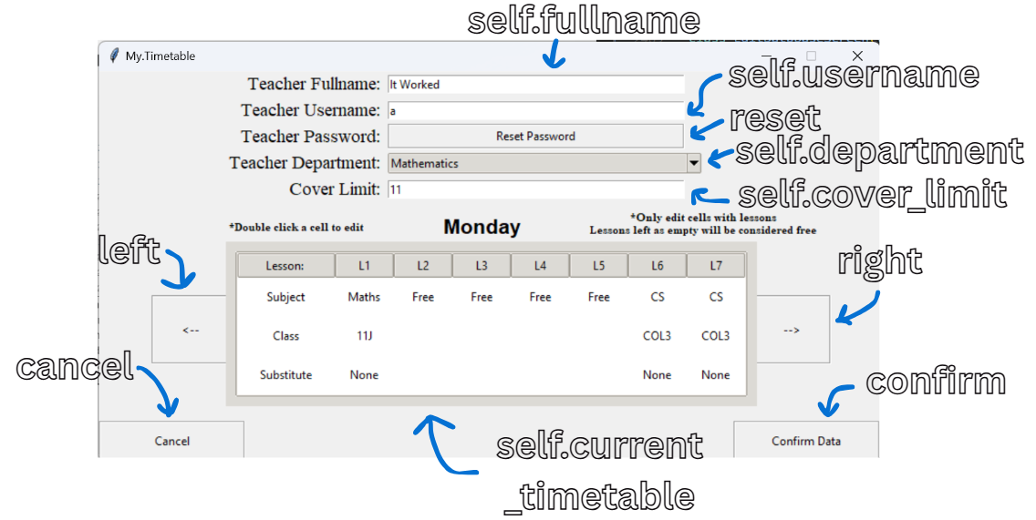

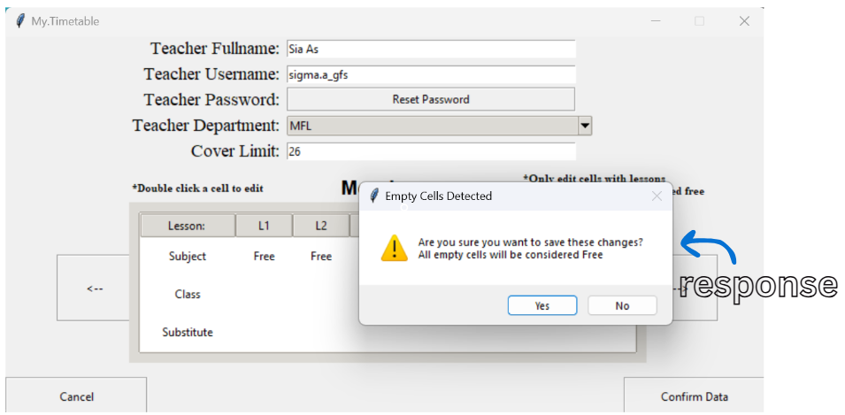

###### 4.2.2.2.22.3 Procedures and Variables:

|  |  |  |
| --- | --- | --- |
| The EditDatabaseScreen class is designed to provide an interface for editing existing teacher records within the timetable management application. This class allows SLT members to modify teacher information, including personal details and lesson schedules, ensuring that the data remains accurate and up-to-date. | | |
| **Global Variables** | self.controller, self.counter, self.password, self.changed, self.fullname, self.username, self.department, self.cover_limit, self.timetables, self.current_timetable, self.day_label, self.edit_username, self.edit_fullname, self.edit_department, self.edit_cover_limit, self.days | |
| **Procedure** | **Purpose** | **Variables** |
| update_entries | Updates the entries with the current teacher’s information | current_data, self.edit_username, self.edit_fullname, database, self.edit_department, self.edit_cover_limit, self.fullname, self.username, self.department, self.cover_limit |
| updateview_timetable | Updates the timetable display with the current teacher’s lessons | current_data, self.edit_username, MondayData, TuesdayData, WednesdayData, ThursdayData, FridayData, MondayLessons, lesson, MondayClasses, MondaySubstitutes, TuesdayLessons, TuesdayClasses, TuesdaySubstitutes, WednesdayLessons, WednesdayClasses, WednesdaySubstitutes, ThursdayLessons, ThursdayClasses, ThursdaySubstitutes, FridayLessons, FridayClasses, FridaySubstitutes, i, self.timetables |
| get_lesson | Retrieves the lesson details from the current timetable from a specific column | column, values, item, self.current_timetable, value |
| get_friday_lesson | Retrieves the friday lesson details from the current timetable from a specific column | column, rows, self.current_timetable, subject, class_name, substitute, values |
| increase_counter | Increases the day counter to show the next day’s timetable | self.counter |
| decrease_counter | Decreases the day counter to show the previous day’s timetable | self.counter |
| update_display | Updates the display to show the correct timetable | self.current_timetable, self.timetables, self.counter |
| update_day | Updates the day label and display based on the current counter | self.days, self.counter |
| update_daylabel | Updates the day label with the correct day | day, self.day_label |
| randomize_password | Create a random password with certain requirements | s1, s2, s3, s4, result, x, password, self.changed, self.password |
| confirm_teacher_data | Validates the teachers data and edits the database entries | fullname, self.fullname, username, self.username, password, self.password, department, self.department, current_covers, database, cover_limit, self.cover_limit, role, detected, self.changed, self.days, x, day, self.current_timetable, self.timetables, i, subject class_name, substitute, response, self.controller |
| clear_entries | Clears all the data entries | self.fullname, self.username, self.department, self.cover_limit, self.password, self.changed, self.counter, self.controller |

##### 4.2.2.2.23 DeleteDatabaseScreen Class:

###### 4.2.2.2.23.1 Code:

class DeleteDatabaseScreen(tk.Frame):

    def __init__(self, parent, controller):

        super().__init__(parent)

        self.controller = controller

        # Title label for the delete confirmation screen

        tk.Label(self, text="Are you sure?\nThis teacher's data will be\npermanently deleted!", font=("Times", 16, "bold")).place(x=285, y=50)

        # Back, and Delete buttons

        back = tk.Button(self, text="Go Back", width=30, height=4, relief="groove",

                  command=lambda: self.controller.show_frame(AccessDatabaseScreen))

        back.place(x=485, y=220)

        delete = tk.Button(self, text="Delete", width=30, height=4, relief="groove",

                  command=lambda: self.delete_teacher())

        delete.place(x=100, y=220)

        # Binds buttons for hover effects

        controller.binder(back)

        controller.binder(delete)

    def delete_teacher(self):

        """Deletes the teacher's data from the database"""

        current_data = AccessedData()

        database.delete_teacher_data(current_data.accessed_username)

        database.delete_teacher_user(current_data.accessed_username)

        database.delete_password(current_data.accessed_username)

        # Updates all timelines in the program to reflect the deletion

        self.controller.update_all_timelines()

        self.controller.frames[AccessDatabaseScreen].update_treeview()

        self.controller.frames[ViewDatabaseScreen].update_labels()

        self.controller.frames[AdminViewDatabase].update_labels()

        self.controller.frames[SLTAbsenceConfirmation].update_absent_teachers()

        self.controller.show_frame(AccessDatabaseScreen) # Raises the AccessDatabase screen

###### 4.2.2.2.23.2 User Interface:

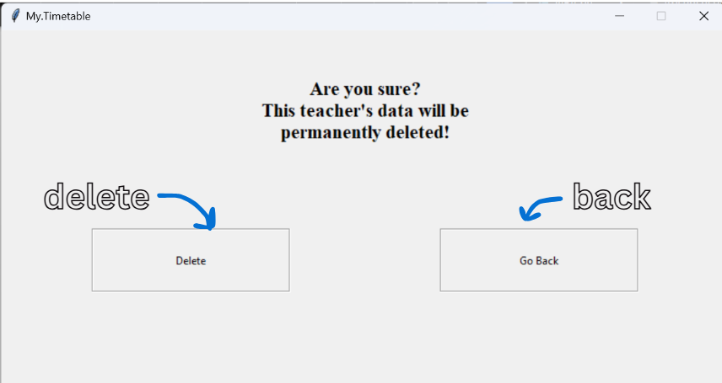

###### 4.2.2.2.23.3 Procedures and Variables:

|  |  |  |
| --- | --- | --- |
| The DeleteDatabaseScreen class is designed to provide an interface for confirming the deletion of teacher records within the timetable management application. This class allows administrators and SLT members to manage teacher data by permanently removing records, ensuring that the database remains accurate and up-to-date. | | |
| **Global Variables** | self.controller | |
| **Procedure** | **Purpose** | **Variables** |
| delete_teacher | Deletes the teacher’s data from the database | current_data, database, self.controller |

##### 4.2.2.2.24 AdminViewDatabase Class:

###### 4.2.2.2.24.1 Code:

class AdminViewDatabase(tk.Frame): # Similar to ViewDatabase but with viewing access of additional variables

    def __init__(self, parent, controller):

        super().__init__(parent)

        self.controller = controller

        self.counter = 0

        left = tk.Button(self, text="<--", width=10, height=4, relief="groove",

                  command=lambda: self.decrease_counter())

        left.place(x=54, y=230)

        right = tk.Button(self, text="-->", width=10, height=4, relief="groove",

                  command=lambda: self.increase_counter())

        right.place(x=670, y=230)

        back = tk.Button(self, text="Go Back", width=20, height=2, relief="groove",

                  command=lambda: self.clear_entries())

        back.place(x=0, y=359)

        controller.binder(left)

        controller.binder(right)

        controller.binder(back)

        self.timetables = {}

        for i in range(4):

            self.timetables[i] = Timetable(self, controller)

            self.timetables[i].Create_Empty_Timetable()

        self.timetables[4] = Timetable(self, controller)

        self.timetables[4].Create_Friday_Timetable()

        self.current_timetable = self.timetables[0]

        self.current_timetable.place(x=130, y=175)

        self.day_label = tk.Label(self, text="Monday", font=("Arial", 16, "bold"))

        self.day_label.place(x=350, y=145)

    def update_labels(self):

        current_data = AccessedData()

        self.username = current_data.accessed_username

        self.fullname = database.get_fullname(self.username)

        self.department = database.get_subject_department(self.username)

        self.current_covers = database.get_current_covers(self.username)

        self.cover_limit = database.get_cover_limit(self.username)

        self.role = database.get_role(self.username)

        tk.Label(self, text="Teacher Fullname: ", font=("Times", 14)).grid(row=0, column=0, padx=(10, 0), pady=(1,1), sticky="e")

        tk.Label(self, text="Teacher Username: ", font=("Times", 14)).grid(row=1, column=0, padx=(10, 0), sticky="e")

        tk.Label(self, text="Teacher Department: ", font=("Times", 14)).grid(row=2, column=0, padx=(10, 0), sticky="e")

        tk.Label(self, text="Teacher Current Covers: ", font=("Times", 14)).grid(row=0, column=2, padx=(205, 0), sticky="e")

        tk.Label(self, text="Teacher  Cover Limit: ", font=("Times", 14)).grid(row=1, column=2, padx=(205, 0), sticky="e")

        tk.Label(self, text="Role: ", font=("Times", 14)).grid(row=2, column=2, padx=(205, 0), sticky="e")

        tk.LabelFrame(self, width=200, height=28, relief="solid").place(x=180, y=1.5)

        tk.Label(self, text=f"{self.fullname}").place(x=185, y=4)

        tk.LabelFrame(self, width=200, height=28, relief="solid").place(x=180, y=30)

        tk.Label(self, text=f"{self.username}").place(x=185, y=32)

        tk.LabelFrame(self, width=200, height=28, relief="solid").place(x=180, y=55.5)

        tk.Label(self, text=f"{self.department}").place(x=185, y=58)

        tk.LabelFrame(self, width=200, height=28, relief="solid").place(x=575, y=1.5)

        tk.Label(self, text=f"{self.current_covers}").place(x=580, y=4)

        tk.LabelFrame(self, width=200, height=28, relief="solid").place(x=575, y=30)

        tk.Label(self, text=f"{self.cover_limit}").place(x=580, y=32)

        tk.LabelFrame(self, width=200, height=28, relief="solid").place(x=575, y=55.5)

        tk.Label(self, text=f"{self.role}").place(x=580, y=58)

        self.updateview_timetable()

    def updateview_timetable(self):

        current_data = AccessedData()

        self.username = current_data.accessed_username

        MondayData = database.get_all_lessons(self.username, "Monday")

        TuesdayData = database.get_all_lessons(self.username, "Tuesday")

        WednesdayData = database.get_all_lessons(self.username, "Wednesday")

        ThursdayData = database.get_all_lessons(self.username, "Thursday")

        FridayData = database.get_all_lessons(self.username, "Friday")

        self.MondayLessons = [lesson[2] for lesson in MondayData]

        self.MondayClasses = [lesson[3] for lesson in MondayData]

        self.MondaySubstitutes = [lesson[4] for lesson in MondayData]

        self.TuesdayLessons = [lesson[2] for lesson in TuesdayData]

        self.TuesdayClasses = [lesson[3] for lesson in TuesdayData]

        self.TuesdaySubstitutes = [lesson[4] for lesson in TuesdayData]

        self.WednesdayLessons = [lesson[2] for lesson in WednesdayData]

        self.WednesdayClasses = [lesson[3] for lesson in WednesdayData]

        self.WednesdaySubstitutes = [lesson[4] for lesson in WednesdayData]

        self.ThursdayLessons = [lesson[2] for lesson in ThursdayData]

        self.ThursdayClasses = [lesson[3] for lesson in ThursdayData]

        self.ThursdaySubstitutes = [lesson[4] for lesson in ThursdayData]

        self.FridayLessons = [lesson[2] for lesson in FridayData]

        self.FridayClasses = [lesson[3] for lesson in FridayData]

        self.FridaySubstitutes = [lesson[4] for lesson in FridayData]

        for i in range(5):

            self.timetables[i].tree.delete(*self.timetables[i].tree.get_children())

        self.fillnormal()

        self.fillfriday()

    def fillnormal(self):

        self.timetables[0].tree.insert("", "end", values=["Subject"] + self.MondayLessons)

        self.timetables[0].tree.insert("", "end", values=["Class"] + self.MondayClasses)

        self.timetables[0].tree.insert("", "end", values=["Substitute"] + self.MondaySubstitutes)

        self.timetables[1].tree.insert("", "end", values=["Subject"] + self.TuesdayLessons)

        self.timetables[1].tree.insert("", "end", values=["Class"] + self.TuesdayClasses)

        self.timetables[1].tree.insert("", "end", values=["Substitute"] + self.TuesdaySubstitutes)

        self.timetables[2].tree.insert("", "end", values=["Subject"] + self.WednesdayLessons)

        self.timetables[2].tree.insert("", "end", values=["Class"] + self.WednesdayClasses)

        self.timetables[2].tree.insert("", "end", values=["Substitute"] + self.WednesdaySubstitutes)

        self.timetables[3].tree.insert("", "end", values=["Subject"] + self.ThursdayLessons)

        self.timetables[3].tree.insert("", "end", values=["Class"] + self.ThursdayClasses)

        self.timetables[3].tree.insert("", "end", values=["Substitute"] + self.ThursdaySubstitutes)

    def fillfriday(self):

        self.timetables[4].tree.insert("", "end", values=["Subject"] + self.FridayLessons)

        self.timetables[4].tree.insert("", "end", values=["Class"] + self.FridayClasses)

        self.timetables[4].tree.insert("", "end", values=["Substitute"] + self.FridaySubstitutes)

    def increase_counter(self):

        if self.counter < 4:

            self.counter += 1

            self.update_day()

    def decrease_counter(self):

        if self.counter > 0:

            self.counter -= 1

            self.update_day()

    def update_display(self):

        self.current_timetable.place_forget()

        self.current_timetable = self.timetables[self.counter]

        if self.counter == 4:  # If it's Friday

            self.current_timetable.place(x=190, y=175)

        else:

            self.current_timetable.place(x=130, y=175)

    def update_day(self):

        self.days = ["Monday", "Tuesday", "Wednesday", "Thursday", "Friday"]

        self.update_daylabel(self.days[self.counter])

        self.update_display()

    def update_daylabel(self, day):

        """Updates the day label"""

        self.day_label.config(text=f"{day}")

    def clear_entries(self):

        self.counter = 0

        self.update_day()

        self.controller.show_frame(AccessDatabaseScreen)

###### 4.2.2.2.24.2 User Interface:

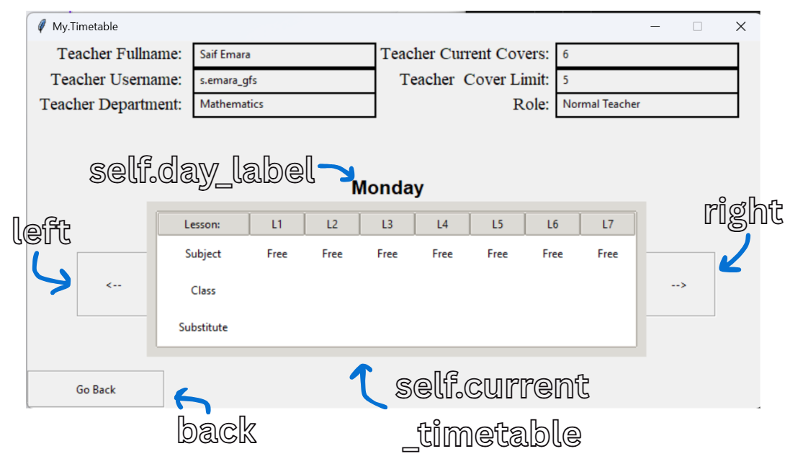

###### 4.2.2.2.24.3 Procedures and Variables:

|  |  |  |
| --- | --- | --- |
| The AdminViewDatabase class is designed to provide an interface for administrators to view detailed information about teachers within the timetable management application. This class allows administrators to access and review teacher data, including personal details and lesson schedules, facilitating effective management of teacher information. | | |
| **Global Variables** | self.controller, self.counter, self.timetables, self.current_timetable, self.day_label, self.username, self.fullname, self.department, self.current_covers, self.cover_limit, self.role, self.MondayLessons, self.MondayClasses, self.MondaySubstitutes, self.TuesdayLessons, self.TuesdayClasses, self.TuesdaySubstitutes, self.WednesdayLessons, self.WednesdayClasses, self.WednesdaySubstitutes, self.ThursdayLessons, self.ThursdayClasses, self.ThursdaySubstitutes, self.FridayLessons, self.FridayClasses, self.FridaySubstitutes, self.days | |
| **Procedure** | **Purpose** | **Variables** |
| update_labels | Updates the labels with the current teacher’s information | current_data, self.username, self.fullname, self.department, self.current_covers, self.cover_limit, self.role |
| updateview_timetable | Updates the timetable display with the current teacher’s lessons | current_data, self.username, MondayData, TuesdayData, WednesdayData, ThursdayData, FridayData, self.MondayLessons, lesson, self.MondayClasses, self.MondaySubstitutes, self.TuesdayLessons, self.TuesdayClasses, self.TuesdaySubstitutes, self.WednesdayLessons, self.WednesdayClasses, self.WednesdaySubstitutes, self.ThursdayLessons, self.ThursdayClasses, self.ThursdaySubstitutes, self.FridayLessons, self.FridayClasses, self.FridaySubstitutes, i, self.timetables |
| fillnormal | Fills the first 4 week day’s timetables with lessons | self.timetables, self.MondayLessons, self.MondayClasses, self.MondaySubstitutes, self.TuesdayLessons, self.TuesdayClasses, self.TuesdaySubstitutes, self.WednesdayLessons, self.WednesdayClasses, self.WednesdaySubstitutes, self.ThursdayLessons, self.ThursdayClasses, self.ThursdaySubstitutes |
| fillfriday | Fills the Friday timetable with lessons | self.timetables, self.FridayLessons, self.FridayClasses, self.FridaySubstitutes |
| increase_counter | Increases the day counter to show the next day’s timetable | self.counter |
| decrease_counter | Decreases the day counter to show the previous day’s timetable | self.counter |
| update_display | Updates the display to show the correct timetable | self.current_timetable, self.timetables, self.counter |
| update_day | Updates the day label and display based on the current counter | self.days, self.counter |
| update_daylabel | Updates the day label with the correct day | day, self.day_label |
| clear_entries | Resets the counter to 0 | self.counter, self.controller |

##### 4.2.2.2.25 AdminEditDatabase Class:

###### 4.2.2.2.25.1 Code:

class AdminEditDatabase(tk.Frame): # Similar to EditDatabase but with editing access of additional variables

    def __init__(self, parent, controller):

        super().__init__(parent)

        self.controller = controller

        self.counter = 0

        self.password = None

        self.changed = False

        department_list = ["Mathematics", "English", "Science", "History", "Geography", "MFL", "Art", "Music", "PE", "CS"]

        tk.Label(self, text="Teacher Fullname: ", font=("Times", 14)).grid(row=0, column=0, padx=(15, 0), pady=(20, 0), sticky="e")

        self.fullname = tk.Entry(self, width=30)

        self.fullname.grid(row=0, column=1, padx=(5, 0), pady=(20, 0), sticky="w")

        tk.Label(self, text="Teacher Username: ", font=("Times", 14)).grid(row=1, column=0, padx=(15, 0), sticky="e")

        self.username = tk.Entry(self, width=30)

        self.username.grid(row=1, column=1, padx=(5, 0), sticky="w")

        tk.Label(self, text="Teacher Password: ", font=("Times", 14)).grid(row=2, column=0, padx=(15, 0), sticky="e")

        reset = tk.Button(self, text="Reset Password", width=25, height=1, relief="groove",

                  command=lambda: self.randomize_password())

        reset.grid(row=2, column=1, padx=(5, 0), sticky="w")

        tk.Label(self, text="Teacher Department: ", font=("Times", 14)).grid(row=0, column=2, padx=(30, 0), pady=(20, 0), sticky="e")

        self.department = ttk.Combobox(self, values=department_list, width=30, state="readonly")

        self.department.grid(row=0, column=3, padx=(5, 15), pady=(20, 0), sticky="w")

        tk.Label(self, text="Current Covers: ", font=("Times", 14)).grid(row=1, column=2, padx=(30, 0), sticky="e")

        self.current_covers = tk.Entry(self, width=30)

        self.current_covers.grid(row=1, column=3, padx=(5, 15), sticky="w")

        tk.Label(self, text="Cover Limit: ", font=("Times", 14)).grid(row=2, column=2, padx=(30, 0), sticky="e")

        self.cover_limit = tk.Entry(self, width=30)

        self.cover_limit.grid(row=2, column=3, padx=(5, 15), sticky="w")

        tk.Label(self, text="Teacher Role: ", font=("Times", 14)).place(x=535, y=110)

        self.role = ttk.Combobox(self, values=["SLT", "Normal Teacher"], width=15, state="readonly")

        self.role.place(x=650, y=112)

        tk.Label(self, text="*Double click a cell to edit", font=("Times", 8, "bold")).place(x=135, y=150)

        tk.Label(self, text="*Only edit cells with lessons\nLessons left as empty will be considered free", font=("Times", 8, "bold")).place(x=500, y=140)

        left = tk.Button(self, text="<--", width=10, height=4, relief="groove",

                  command=lambda: self.decrease_counter())

        left.place(x=54, y=230)

        right = tk.Button(self, text="-->", width=10, height=4, relief="groove",

                  command=lambda: self.increase_counter())

        right.place(x=670, y=230)

        cancel = tk.Button(self, text="Cancel", width=20, height=2, relief="groove",

                  command=lambda: self.clear_entries())

        cancel.place(x=0, y=359)

        confirm = tk.Button(self, text="Confirm Data", width=20, height=2, relief="groove",

                  command=lambda: self.confirm_teacher_data())

        confirm.place(x=650, y=359)

        controller.binder(reset)

        controller.binder(left)

        controller.binder(right)

        controller.binder(cancel)

        controller.binder(confirm)

        self.timetables = {}

        for i in range(4):

            self.timetables[i] = Timetable(self, controller)

            self.timetables[i].Create_Empty_Timetable()

        self.timetables[4] = Timetable(self, controller)

        self.timetables[4].Create_Friday_Timetable()

        self.current_timetable = self.timetables[0]

        self.current_timetable.place(x=130, y=175)

        self.day_label = tk.Label(self, text="Monday", font=("Arial", 16, "bold"))

        self.day_label.place(x=350, y=145)

    def update_entries(self):

        current_data = AccessedData()

        self.edit_username = current_data.accessed_username

        self.edit_fullname = database.get_fullname(self.edit_username)

        self.edit_department = database.get_subject_department(self.edit_username)

        self.edit_current_covers = database.get_current_covers(self.edit_username)

        self.edit_cover_limit = database.get_cover_limit(self.edit_username)

        self.edit_role = database.get_role(self.edit_username)

        self.fullname.insert(0, f"{self.edit_fullname}")

        self.username.insert(0, f"{self.edit_username}")

        self.department.set(f"{self.edit_department}")

        self.current_covers.insert(0, f"{self.edit_current_covers}")

        self.cover_limit.insert(0, f"{self.edit_cover_limit}")

        self.role.set(f"{self.edit_role}")

        self.updateview_timetable()

    def updateview_timetable(self):

        current_data = AccessedData()

        self.edit_username = current_data.accessed_username

        MondayData = database.get_all_lessons(self.edit_username, "Monday")

        TuesdayData = database.get_all_lessons(self.edit_username, "Tuesday")

        WednesdayData = database.get_all_lessons(self.edit_username, "Wednesday")

        ThursdayData = database.get_all_lessons(self.edit_username, "Thursday")

        FridayData = database.get_all_lessons(self.edit_username, "Friday")

        MondayLessons = [lesson[2] for lesson in MondayData]

        MondayClasses = [lesson[3] for lesson in MondayData]

        MondaySubstitutes = [lesson[4] for lesson in MondayData]

        TuesdayLessons = [lesson[2] for lesson in TuesdayData]

        TuesdayClasses = [lesson[3] for lesson in TuesdayData]

        TuesdaySubstitutes = [lesson[4] for lesson in TuesdayData]

        WednesdayLessons = [lesson[2] for lesson in WednesdayData]

        WednesdayClasses = [lesson[3] for lesson in WednesdayData]

        WednesdaySubstitutes = [lesson[4] for lesson in WednesdayData]

        ThursdayLessons = [lesson[2] for lesson in ThursdayData]

        ThursdayClasses = [lesson[3] for lesson in ThursdayData]

        ThursdaySubstitutes = [lesson[4] for lesson in ThursdayData]

        FridayLessons = [lesson[2] for lesson in FridayData]

        FridayClasses = [lesson[3] for lesson in FridayData]

        FridaySubstitutes = [lesson[4] for lesson in FridayData]

        for i in range(5):

            self.timetables[i].tree.delete(*self.timetables[i].tree.get_children())

        self.timetables[0].tree.insert("", "end", values=["Subject"] + MondayLessons)

        self.timetables[0].tree.insert("", "end", values=["Class"] + MondayClasses)

        self.timetables[0].tree.insert("", "end", values=["Substitute"] + MondaySubstitutes)

        self.timetables[1].tree.insert("", "end", values=["Subject"] + TuesdayLessons)

        self.timetables[1].tree.insert("", "end", values=["Class"] + TuesdayClasses)

        self.timetables[1].tree.insert("", "end", values=["Substitute"] + TuesdaySubstitutes)

        self.timetables[2].tree.insert("", "end", values=["Subject"] + WednesdayLessons)

        self.timetables[2].tree.insert("", "end", values=["Class"] + WednesdayClasses)

        self.timetables[2].tree.insert("", "end", values=["Substitute"] + WednesdaySubstitutes)

        self.timetables[3].tree.insert("", "end", values=["Subject"] + ThursdayLessons)

        self.timetables[3].tree.insert("", "end", values=["Class"] + ThursdayClasses)

        self.timetables[3].tree.insert("", "end", values=["Substitute"] + ThursdaySubstitutes)

        self.timetables[4].tree.insert("", "end", values=["Subject"] + FridayLessons)

        self.timetables[4].tree.insert("", "end", values=["Class"] + FridayClasses)

        self.timetables[4].tree.insert("", "end", values=["Substitute"] + FridaySubstitutes)

    def get_lesson(self, column):

        values = []

        for item in self.current_timetable.tree.get_children():

            value = self.current_timetable.tree.item(item)['values'][column]

            values.append(value)

        return values

    def get_friday_lesson(self, column):

        # Get all three rows directly

        rows = self.current_timetable.tree.get_children()

        # Get values from specific column for each row

        subject = self.current_timetable.tree.item(rows[0])['values'][column]

        class_name = self.current_timetable.tree.item(rows[1])['values'][column]

        substitute = self.current_timetable.tree.item(rows[2])['values'][column]

        values = [subject, class_name, substitute]

        return values

    def increase_counter(self):

        if self.counter < 4:

            self.counter += 1

            self.update_day()

    def decrease_counter(self):

        if self.counter > 0:

            self.counter -= 1

            self.update_day()

    def update_display(self):

        self.current_timetable.place_forget()

        self.current_timetable = self.timetables[self.counter]

        if self.counter == 4:  # If it's Friday

            self.current_timetable.place(x=190, y=175)

        else:

            self.current_timetable.place(x=130, y=175)

    def update_day(self):

        self.days = ["Monday", "Tuesday", "Wednesday", "Thursday", "Friday"]

        self.update_daylabel(self.days[self.counter])

        self.update_display()

    def update_daylabel(self, day):

        """Updates the day label"""

        self.day_label.config(text=f"{day}")

    def randomize_password(self):

        s1 = list(string.ascii_lowercase)

        s2 = list(string.ascii_uppercase)

        s3 = list("@$!%*?_&")

        s4 = list(string.digits)

        random.shuffle(s1)

        random.shuffle(s2)

        random.shuffle(s3)

        random.shuffle(s4)

        result = []

        for x in range(3):

            result.append(s1[x])

            result.append(s2[x])

        for x in range(2):

            result.append(s3[x])

            result.append(s4[x])

        random.shuffle(result)

        password = "".join(result)

        self.changed = True

        self.password = password

        messagebox.showinfo("Password Reset", f"The new password is {password}")

    def confirm_teacher_data(self):

        fullname = self.fullname.get().strip().title()

        username = self.username.get().strip().lower()

        password = self.password

        department = self.department.get().strip()

        current_covers = self.current_covers.get().strip()

        cover_limit = self.cover_limit.get().strip()

        role = self.role.get().strip()

        detected = 0

        database.delete_teacher_data(self.edit_username)

        database.delete_teacher_user(self.edit_username)

        if not fullname or not username or not department or not current_covers or not role or not cover_limit:

            messagebox.showerror("Error", "All fields are required!")

            return

        if len(fullname.split()) <= 1:

            messagebox.showerror("Error", "Fullname must include atleast first and last name!")

            return

        if not username.endswith("_gfs"):

            messagebox.showerror("Error", "Username must end with '_gfs'!")

            return

        if not username[0].isalpha():

            messagebox.showerror("Error", "Username must start with a letter!")

            return

        if database.get_fullname(username):

            messagebox.showerror("Error", "Username already exists!")

            return

        if not re.match(r"^(?!.*\..*\..*)[A-Za-z0-9]+(\.[A-Za-z0-9]+)?$", username.replace("_gfs","")):

            messagebox.showerror("Error", "Start of Username must only include alphanumeric characters and one fullstop")

            return

        if not current_covers.isdigit():

            messagebox.showerror("Error", "Current Covers must be a integer!")

            return

        if not cover_limit.isdigit():

            messagebox.showerror("Error", "Cover limit must be a integer!")

            return

        self.days = ["Monday", "Tuesday", "Wednesday", "Thursday"]

        for x in range(4):

            day = self.days[x]

            self.current_timetable = self.timetables[x]

            for i in range(7):

                subject, class_name, substitute = self.get_lesson(i+1)

                if subject == "Empty":

                    detected = 1

        day = "Friday"

        self.current_timetable = self.timetables[4]

        for i in range(5):

            subject, class_name, substitute = self.get_friday_lesson(i+1)

            if subject == "Empty":

                detected = 1

        if detected == 1:

            response = tk.messagebox.askquestion(title="Empty Cells Detected",

                                                message="Are you sure you want to save these changes?\nAll empty cells will be considered Free",

                                                icon="warning")

            if response == "no":

                detected = 0

                return

        database.add_teacher(username, fullname, role, department, current_covers, cover_limit)

        if self.changed == True:

            database.delete_password(username)

            database.store_password(username, password)

        for x in range(4):

            day = self.days[x]

            self.current_timetable = self.timetables[x]

            for i in range(7):

                subject, class_name, substitute = self.get_lesson(i+1)

                if subject == "Empty" or subject == "" or subject == "Free":

                    subject = "Free"

                    class_name = ""

                    substitute = ""

                else:

                    substitute = "None"

                database.add_lesson(username, day, i+1, subject, class_name, substitute)

        day = "Friday"

        self.current_timetable = self.timetables[4]

        for i in range(5):

            subject, class_name, substitute = self.get_friday_lesson(i+1)

            if subject == "Empty" or subject == "" or subject == "Free":

                subject = "Free"

                class_name = ""

                substitute = ""

            else:

                substitute = "None"

            database.add_lesson(username, day, i+1, subject, class_name, substitute)

        self.controller.update_all_timelines()

        self.controller.frames[AccessDatabaseScreen].update_treeview()

        self.controller.frames[ViewDatabaseScreen].update_labels()

        self.controller.frames[AdminViewDatabase].update_labels()

        self.controller.frames[SLTAbsenceConfirmation].update_absent_teachers()

        if self.controller.current_role == "SLT":

            self.controller.frames[SLTScreen].timetable.update_timetable()

        else:

            self.controller.frames[TeacherScreen].timetable.update_timetable()

        self.clear_entries()

    def clear_entries(self):

        self.fullname.delete(0, tk.END)

        self.username.delete(0, tk.END)

        self.department.set("")

        self.current_covers.delete(0, tk.END)

        self.cover_limit.delete(0, tk.END)

        self.role.set("")

        self.password = None

        self.changed = False

        self.counter = 0

        self.update_day()

        self.controller.show_frame(AccessDatabaseScreen)

###### 4.2.2.2.25.2 User Interface:

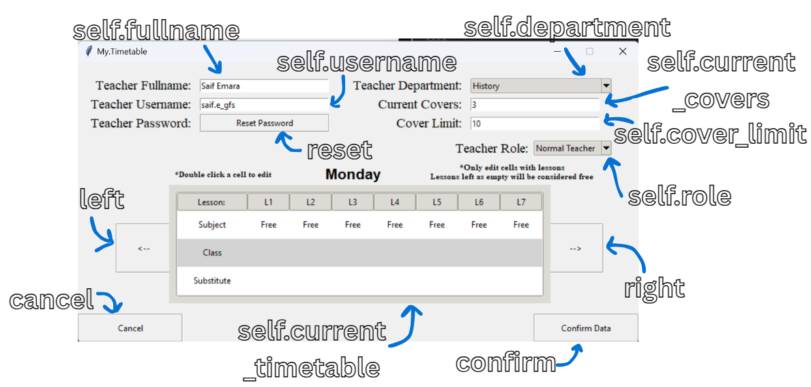

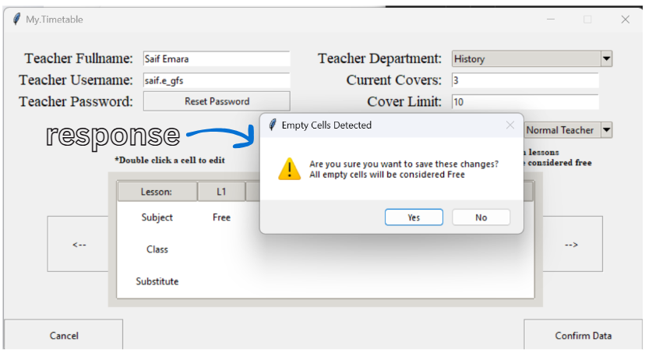

###### 4.2.2.2.25.3 Procedures and Variables:

|  |  |  |
| --- | --- | --- |
| The AdminEditDatabase class is designed to provide an interface for administrators to edit existing teacher records within the timetable management application. This class allows administrators to modify teacher information, including personal details and lesson schedules, ensuring that the data remains accurate and up-to-date. | | |
| **Global Variables** | self.controller, self.counter, self.password, self.changed, self.fullname, self.username, self.department, self.current_covers, self.cover_limit, self.role, self.timetables, self.current_timetable, self.day_label, self.edit_username, self.edit_fullname, self.edit_department, self.edit_current_covers, self.edit_cover_limit, self.edit_role, self.days | |
| **Procedure** | **Purpose** | **Variables** |
| update_entries | Updates the entries with the current teacher’s information | current_data, self.edit_username, self.edit_fullname, database, self.edit_department, self.edit_current_covers, self.edit_cover_limit, self.edit_role, self.fullname, self.username, self.department, self.current_covers, self.cover_limit, self.role |
| updateview_timetable | Updates the timetable display with the current teacher’s lessons | current_data, self.edit_username, MondayData, TuesdayData, WednesdayData, ThursdayData, FridayData, self.MondayLessons, lesson, self.MondayClasses, self.MondaySubstitutes, self.TuesdayLessons, self.TuesdayClasses, self.TuesdaySubstitutes, self.WednesdayLessons, self.WednesdayClasses, self.WednesdaySubstitutes, self.ThursdayLessons, self.ThursdayClasses, self.ThursdaySubstitutes, self.FridayLessons, self.FridayClasses, self.FridaySubstitutes, i, self.timetables |
| get_lesson | Gets the lesson details of the given teacher at the given column | column, values, item, self.current_timetable, value |
| get_friday_lesson | Gets the friday lesson details of the given teacher at the given column | column, rows, self.current_timetable, subject, class_name, substitute, values |
| increase_counter | Increases the day counter to show the next day’s timetable | self.counter |
| decrease_counter | Decreases the day counter to show the previous day’s timetable | self.counter |
| update_display | Updates the display to show the correct timetable | self.current_timetable, self.timetables, self.counter |
| update_day | Updates the day label and display based on the current counter | self.days, self.counter |
| update_daylabel | Updates the day label with the correct day | day, self.day_label |
| randomize_password | Create a random password with certain requirements | s1, s2, s3, s4, result, x, password, self.changed, self.password |
| confirm_teacher_data | Validates the teachers data and edits the database entries | fullname, self.fullname, username, self.username, password, self.password, department, self.department, current_covers, self.current_covers, cover_limit, self.cover_limit, role, self.role, detected, database, self.days, x, day, self.current_timetable, self.timetables, i, subject class_name, substitute, detected, response, self.changed, self.controller |
| clear_entries | Clears all the entry fields | self.fullname, self.username, self.department, self.current_covers, self.cover_limit, self.role, self.password, self.changed, self.counter, self.controller |

##### 4.2.2.2.26 MainAlgorithm Class:

###### 4.2.2.2.26.1 Code:

class MainAlgorithm():

    def __init__(self, controller):

        self.controller = controller  # Store reference to MyTimetableApp

        self.date = datetime.datetime.now() # Gets the current data and time

        self.weekday = datetime.datetime.today().strftime('%A') # Gets the current day of the week

        self.AllTeachers = [] # List to store all the teachers

        self.AllTeachers = database.get_all_usernames() # Fetches all usernames from the database

        self.AbsentTeachers = [] # List to store absent teachers

        self.NonAbsentTeachers = [] # List to store teachers that aren't absent

        self.CoverNeedingLessons = [] # List to store lessons that need cover

        self.CoverAllocations = [] # List to store cover allocations

    def cover_allocation(self):

        """Allocates cover for absent teachers based on their lessons."""

        # Identify absent teachers

        for Teacher in self.AllTeachers: # Iterate all the teachers

            if database.is_absent(Teacher, self.date): # Check if they are absent

                self.AbsentTeachers.append(Teacher) # Appends them to the AbsentTeachers list

        self.NonAbsentTeachers = self.AllTeachers

        for Teacher in self.AbsentTeachers: # Iterates all the absent teachers

            self.NonAbsentTeachers.remove(Teacher) # Removes teachers who are absent from the non absent teachers list

        for Teacher in self.AbsentTeachers: # Iterates all the absent teachers

            lessons = database.get_all_lessons(Teacher, self.weekday) # Gets all the lessons of the teacher

            for lesson in lessons: # Iterates all lessons

                if lesson[2] != "Free" and lesson[3] != "" and lesson[4] == "None" and lesson[2] != "Empty":

                    self.CoverNeedingLessons.append(lesson) # Appends all non free lessons

        for x in range(len(self.CoverNeedingLessons)): # Iterates all cover need lessons

            # Defines absent teacher's info

            absent_teacher = self.CoverNeedingLessons[x][0]

            absent_teacher_name = database.get_fullname(absent_teacher)

            absent_teacher_department = database.get_subject_department(absent_teacher)

            absent_lesson_num = self.CoverNeedingLessons[x][1]

            absent_subject = self.CoverNeedingLessons[x][2]

            absent_class = self.CoverNeedingLessons[x][3]

            FreeTeachers = []

            SameDepartmentTeachers = []

            SuitableTeachers = []

            for teacher in self.NonAbsentTeachers: # Iterates all non absent teachers

                lesson = database.get_one_lesson(teacher, self.weekday, absent_lesson_num)

                if lesson[2] == "Free":

                    FreeTeachers.append(teacher) # Appends if they are free during a cover needing lesson

            if not FreeTeachers: # Sends an email if there are no free teachers found for a certain cover needing lesson

                self.send_email(absent_teacher_name, absent_lesson_num, absent_subject, absent_class)

            else:

                for teacher in FreeTeachers: # Iterates through free teachers

                    department = database.get_subject_department(teacher)

                    if department == absent_teacher_department: # Checks teacher's department against the absent teacher's department

                        SameDepartmentTeachers.append(teacher) # Appends if same department

                if not SameDepartmentTeachers: # If there are no same department teachers

                    lowest_cover_percentage = 9999 # Sets lowest percentage to an extremely high amount

                    for teacher in FreeTeachers: # Iterates through free teachers since there are no same department teachers

                        current = database.get_current_covers(teacher)

                        limit = database.get_cover_limit(teacher)

                        cover_precentage = ( current / limit ) * 100 # Calculates cover percentage using curren covers and cover limit

                        # Iterates to find the teacher with the lowest cover percentage

                        if cover_precentage < lowest_cover_percentage:

                            lowest_cover_percentage = cover_precentage

                            SuitableTeachers = [teacher]

                        elif cover_precentage == lowest_cover_percentage:

                            SuitableTeachers.append(teacher)

                    selected_teacher = random.choice(SuitableTeachers) # Randomly selects between suitable teachers

                    # Appends the cover allocation list and edits the lessons in the database

                    self.CoverAllocations.append([absent_teacher, selected_teacher, self.weekday, absent_lesson_num, absent_subject, absent_class])

                    database.edit_lesson(selected_teacher, self.weekday, absent_lesson_num, absent_subject, absent_class, f"Subbing\n{absent_teacher_name}")

                    database.edit_lesson(absent_teacher, self.weekday, absent_lesson_num, absent_subject, absent_class, f"Subbed\nby {selected_teacher[0]}")

                    database.increment_current_covers(selected_teacher) # Increments the current covers

                else:

                    # Iterates similarly based on cover percentage but for same department teachers

                    lowest_cover_percentage = 999

                    for teacher in SameDepartmentTeachers:

                        current = database.get_current_covers(teacher)

                        limit = database.get_cover_limit(teacher)

                        cover_precentage = ( current / limit ) * 100

                        if cover_precentage < lowest_cover_percentage:

                            lowest_cover_percentage = cover_precentage

                            SuitableTeachers = [teacher]

                        elif cover_precentage == lowest_cover_percentage:

                            SuitableTeachers.append(teacher)

                    selected_teacher = random.choice(SuitableTeachers)

                    self.CoverAllocations.append([absent_teacher, selected_teacher, self.weekday, absent_lesson_num, absent_subject, absent_class])

                    database.edit_lesson(selected_teacher, self.weekday, absent_lesson_num, absent_subject, absent_class, f"Subbing\n{absent_teacher_name}")

                    database.edit_lesson(absent_teacher, self.weekday, absent_lesson_num, absent_subject, absent_class, f"Subbed\nby {selected_teacher[0]}")

                    database.increment_current_covers(selected_teacher)

        #Refresh the entire timetable UI

        self.controller.frames[SLTScreen].timetable.update_timetable()

        self.controller.frames[TeacherScreen].timetable.update_timetable()

        self.controller.frames[AccessDatabaseScreen].update_treeview()

        self.controller.frames[ViewDatabaseScreen].update_labels()

        self.controller.frames[AdminViewDatabase].update_labels()

        self.controller.frames[SLTAbsenceConfirmation].update_absent_teachers()

    def revert_covers(self):

        days = ["Monday", "Tuesday", "Wednesday", "Thursday", "Friday"]

        for teacher in self.AllTeachers: # Iterates all the teachers

            for x in range(5):

                lessons = database.get_all_lessons(teacher, days[x])

                for lesson in lessons: # Iterates all lessons

                    if lesson[4] != "None":

                        if lesson[4].startswith("Subbing"): # If teacher used to be substituting a lesson it returns to a free lesson

                            lesson_num = lesson[1]

                            subject = "Free"

                            class_name = ""

                            substitute = ""

                            database.edit_lesson(teacher, days[x], lesson_num, subject, class_name, substitute)

                        elif lesson[4].startswith("Subbed"): # If teacher was absent and got subbed returns lesson to normal with subsititute as None

                            lesson_num = lesson[1]

                            original = database.get_one_lesson(teacher, days[x], lesson_num)

                            subject = original[2]

                            class_name = original[3]

                            substitute = "None"

                            database.edit_lesson(teacher, days[x], lesson_num, subject, class_name, substitute)

        #Refresh the entire timetable UI

        self.controller.update_all_timelines()

    def send_email(self, Teacher, Lesson, Subject, Class):

        try:

            email_sender = "cover.allocation@gmail.com"

            email_password = "cluolalrbzzelgzg"

            email_receiver = "clashemara@gmail.com" # Test Email for testing purposes

            Title = f"Issue with Cover Allocation - Action Required, {self.date.strftime('%Y-%m-%d')}"

            Body = f"""

            Dear Saif,

            We were not able to find a cover for the teacher with the following details

            Kindly arrange a substitute

            Today: {self.date.strftime('%Y-%m-%d')},

            Absent Teacher Name : {Teacher}

            Lesson Number : {Lesson}

            Lesson Subject : {Subject}

            Class : {Class}

            Kind Regards,

            Cover Allocation Program

            """

            email = yagmail.SMTP(email_sender, email_password)

            email.send(email_receiver, Title, Body)

        except:

            pass

###### 4.2.2.2.26.2 Procedures and Variables:

|  |  |  |
| --- | --- | --- |
| The MainAlgorithm class is a core component of the timetable management application, responsible for implementing the main logic and algorithms that govern the scheduling and management of teacher timetables. This class serves as the backbone for processing data related to teachers, lessons, and absences, ensuring that the application allocated substitutes and covers effectively. | | |
| **Global Variables** | self.controller, self.date, self.weekday, self.AllTeachers, Self.AbsentTeachers, Self.NonAbsentTeachers, Self.CoverNeedingLessons, self.CoverAllocations | |
| **Procedure** | **Purpose** | **Variables** |
| cover_allocation | Allocates cover for absent teachers based on their lessons | Teacher, self.AllTeachers, database, self.date, self.AbsentTeachers, self.NonAbsentTeachers, lessons, self.weekday, lesson, self.CoverNeedingLessons, x, absent_teacher, absent_teacher_name, absent_teacher_department, absent_lesson_num, absent_subject, absent_class, FreeTeachers, SameDepartmentTeachers, SuitableTeachers, teacher, lowest_cover_percentage, current, limit, cover_percentage, selected_teacher, self.CoverAllocations, self.controller |
| revert_covers | Reverts the cover allocations of the previous school day to ensure no confusion is created and the timetables are ready for the next day of allocations | days, teacher, self.AllTeachers, x, lessons, database, lesson, lesson_num, subject, class_name, substitute, self.controller |
| send_email | Sends an email to inform of a cover not being able to find allocation due to lack of free teachers | Teacher, Lesson, Subject, Class, email_sender, email_password, email_receiver, Title, self.date, Body, email, |

##### 4.2.2.3.1 Imports:

# Import required libraries

import tkinter as tk # Importing the tkinter library for GUI

import tkcalendar as tkc

import calendar

import datetime

import sqlite3 # Importing sqlite3 for database interactions

import re

import random

import yagmail

import os

import string

from tkinter import messagebox

from tkinter import ttk

from tkinter import simpledialog # Importing specific components from tkinter

from tkinter.simpledialog import askstring

from tkinter import *

from time import strftime

from PIL import Image, ImageTk # Importing PIL for image handling

##### 4.2.2.3.2 Main Loop:

# Tkinter main loop

if __name__ == "__main__":

    database = Database()

    root = tk.Tk()

    app = MyTimetableApp(root)

    root.mainloop()

## 4.3 Skills Checklist:

### 4.3.1 Skill Table:

|  |  |
| --- | --- |
| Skill | Page Number |
| Stack Data Structure | 75 |
| Queue Data Structure | 76 |
| Graph Data Structure | 77 and 78 |
| Depth First Search (Recursive) | 82 |
| Breadth First Search (Recursive) | 86 |
| Merge Sort | 96 and 97 |
| Inheritance | 92 |
| Polymorphism | 93 |
| Encapsulation | 77, 78, 89, 94 |
| Parameterized SQL | 95 to 97 |
| Dynamic Generation of Objects | 82 to 85 |
| List Operations | 79 to 81 |

### 4.3.1 Candidate written classes (OOP):

class Admin_Choice(tk.Frame):

    """Admin Choice Screen for managing and editing admin exclusive variables"""

    def __init__(self, parent, controller):

        """Initialize the AdminChoice class"""

        super().__init__(parent) # Use of OOP with inheritance

        self.controller = controller

        # Create buttons for various admin tasks

        add = tk.Button(self, text="Add Teacher", width=30, height=4, relief="groove",

                  command=lambda: self.controller.show_frame(AddTeacherScreen)) # Raises the AddTeacher Screen

        add.place(x=485, y=120)

        access = tk.Button(self, text="Access Database", width=30, height=4, relief="groove",

                  command=lambda: self.controller.show_frame(AccessDatabaseScreen)) # Raises the AccessDatabase Screen

        access.place(x=100, y=120)

        exitadmin = tk.Button(self, text="Exit Admin Mode", width=25, height=2, relief="groove",

                  command=lambda: self.leave_admin()) # Exits admin mode and returns to the main menu

        exitadmin.place(x=310, y=200)

        controller.binder(add)

        controller.binder(access)

        controller.binder(exitadmin)

    def leave_admin(self):

        """Handles exiting admin mode and returning to the main menu"""

        self.controller.current_role = None # Resets the current role to None so that permissions are stripped

        self.controller.show_frame(MainMenu) # Raises the MainMenu screen

### 4.3.2 Complex standard algorithms and structures (trees):

class Timetable(ttk.Frame):

    """Timetable widget for SLT and Teacher screens."""

    def __init__(self, parent, controller):

        """Initialize the Timetable class"""

        super().__init__(parent)

        self.controller = controller

        # Get todays weekday

        self.weekday = datetime.datetime.today().strftime('%A') # Determines and stores the current day

        # Determine number of lessons: Monday-Thursday = 7, Friday = 5,

        self.num_lessons = 5 if self.weekday == "Friday" else 7 # Sets the number of lessons based on the day

        # Creates column headers for the timetable

        if self.weekday == "Friday":

            self.columns = ["Lesson: "] + [f"L{i+1}" for i in range(self.num_lessons)]

        else:

            self.columns = ["Lesson: "] + [f"L{i+1}" for i in range(self.num_lessons)]

        #Binds double click to the timetable

        self.bind("<Double-1>", self.on_double_click)

        style = ttk.Style() # Creates a style variable

        style.theme_use('clam') # Sets the theme of the timetable cells

        style.configure("Treeview", rowheight=40) # Configures row height

        # Creates the treeview widget to display the timetable

        self.tree = ttk.Treeview(self, columns=self.columns, show="headings", height=3, selectmode="none", style="Treeview")

        self.tree.bind('<Button-1>', "break") # Prevents default behaviour when button 1 is clicked

        self.tree.bind("<Double-1>", self.on_double_click) # Binds double-click event

        self.tree.bind("<Motion>", self.on_hover) # Binds the mouse motion event so it runs when it hovers

        self.tree.bind("<Leave>", self.on_leave) # Bind mouse leave event

        self.tree.tag_configure('focus', background='#D3D3D3') # Configures background colour to darken for when a row is hovered over

        # Set headers for the timetable columns

        for col in self.columns:

            self.tree.heading(col, text=col) # Sets column headings

            self.tree.column(col, anchor="center", stretch=True) # Center aligns and stretches columns

            if col == "Lesson: ":

                self.tree.column(col, width=100, anchor="center")

            else:

                self.tree.column(col, width=60, anchor="center")

        # Insert default values into the timetable based on the current weekday

        if self.weekday in ["Monday", "Tuesday", "Wednesday", "Thursday", "Friday"]:

            self.tree.insert("", "end", values=["Subject"] + ["Empty"] * self.num_lessons) # Insert subject row

            self.tree.insert("", "end", values=["Class"] + ["Empty"] * self.num_lessons) # Insert class row

            self.tree.insert("", "end", values=["Substitute"] + ["None"] * self.num_lessons) # Insert substitute row

            self.tree.pack(pady=10, padx=10, fill="x")

        else:

            self.tree.insert("", "end", values=["Subject"] + [" "] * 7)

            self.tree.insert("", "end", values=["Class"] + [" "] * 7)

            self.tree.insert("", "end", values=["Substitute"] + [" "] * 7)

            self.tree.pack(pady=10, padx=10, fill="x")

    def update_timetable(self):

        """Update the timetable with the current user's lessons."""

        if self.weekday in ["Monday", "Tuesday", "Wednesday", "Thursday", "Friday"]:

            connection = sqlite3.connect("MyTimetable.db")

            cursor = connection.cursor()

            self.tree.delete(*self.tree.get_children()) # Clear existing timetable entries

            # Query to fetch lessons for the current user based on the weekday

            cursor.execute(f"""SELECT Subject, Class, Substitute

                            FROM {self.weekday}Lessons

                            WHERE Username = ?

                            ORDER BY Lesson_Number""", (self.controller.current_user,))

            lessons = cursor.fetchall() # Fetches all the lessons

            # Extracts the subjects, classes, and substitutes from the lessons lists

            subjects = [lesson[0] for lesson in lessons] # List of subjects

            classes = [lesson[1] for lesson in lessons] # List of classes

            substitutes = [lesson[2] for lesson in lessons] # List of substitutes

            # Insert the fetched data into the timetable

            self.tree.insert("", "end", values=["Subject"] + subjects)

            self.tree.insert("", "end", values=["Class"] + classes)

            self.tree.insert("", "end", values=["Substitute"] + substitutes)

            self.tree.pack(pady=10, padx=10, fill="x")

            connection.close()

    def on_double_click(self, event):

        """Handles double-click events on the timetable"""

        if self.tree.identify_region(event.x, event.y) == "heading":

            return "break" # Prevents editing if double-clicking on the header

        # Identifies double clicked region

        region_clicked = self.identify(event.x, event.y)

        # Get the item and column at the clicked position

        item = self.tree.identify_row(event.y) # Identify the row clicked

        column = self.tree.identify_column(event.x) # Identify the column clicked

        # Get the value of the item in the column

        value = self.tree.set(item, column)

        rows = self.tree.get_children()

        # Open a popup to enter the new value

        if isinstance(self.master, (AddTeacherScreen, EditDatabaseScreen, AdminEditDatabase)):

            if value in ("Subject","Class","Substitute"):

                return "break" # Prevents editing the header column

            elif item == rows[0]:

                new_value = simpledialog.askstring("Edit Contents", f"Enter new subject name:") # Prompt for new subject

                try:

                    new_value = new_value.strip()

                except:

                    pass

                if new_value is not None:

                    self.tree.set(item, column, new_value)

            elif item == rows[1]:

                new_value = simpledialog.askstring("Edit Contents", f"Enter new class location:") # Prompt for new class

                try:

                    new_value = new_value.strip()

                except:

                    pass

                if new_value is not None:

                    self.tree.set(item, column, new_value)

            elif item == rows[2]:

                new_value = simpledialog.askstring("Edit Contents", f"Enter new substitute, leave empty if none:") # Prompt for new substituting teacher

                try:

                    new_value = new_value.strip()

                except:

                    pass

                if new_value is not None:

                    self.tree.set(item, column, new_value)

    def on_hover(self, event):

        """Highlight the cell that the mouse is over."""

        item = self.tree.identify_row(event.y)

        column = self.tree.identify_column(event.x)

        try:

            value = self.tree.set(item, column)

        except:

            return "break"

        if self.tree.identify_region(event.x, event.y) == "heading":

            return "break" # Prevents action if hovering over the header

        if item:

            for i in self.tree.get_children():

                self.tree.item(i, tags=()) # Clears tags for all items

            self.tree.item(item, tags=('focus')) # Highlight the current item

    def on_leave(self, event):

        """Reset the highlight when the mouse leaves the timetable"""

        for i in self.tree.get_children():

            self.tree.item(i, tags=()) # Clears tags for all the items

    def Create_Empty_Timetable(self):

        """Create an empty timetable for Monday to Thursday."""

        self.tree.delete(*self.tree.get_children()) # Clears existing timetable entries

        self.columns = ["Lesson: "] + [f"L{i+1}" for i in range(7)] # Define columns for the timetable

        self.tree["columns"] = self.columns

        # Set headers for the timetable columns

        for col in self.columns:

            self.tree.heading(col, text=col)

            self.tree.column(col, anchor="center", stretch=True)

            if col == "Lesson: ":

                self.tree.column(col, width=100, anchor="center")

            else:

                self.tree.column(col, width=60, anchor="center")

        # Inserts default empty values into the timetable

        self.tree.insert("", "end", values=["Subject"] + ["Empty"] * 7)

        self.tree.insert("", "end", values=["Class"] + ["Empty"] * 7)

        self.tree.insert("", "end", values=["Substitute"] + ["None"] * 7)

    def Create_Friday_Timetable(self):

        """Create a Friday timetable."""

        self.tree.delete(*self.tree.get_children())

        self.columns = ["Lesson: "] + [f"L{i+1}" for i in range(5)]

        self.tree["columns"] = self.columns

        # Set headers

        for col in self.columns:

            self.tree.heading(col, text=col)

            self.tree.column(col, anchor="center", stretch=True)

            if col == "Lesson: ":

                self.tree.column(col, width=100, anchor="center")

            else:

                self.tree.column(col, width=60, anchor="center")

        self.tree.insert("", "end", values=["Subject"] + ["Empty"] * 5)

        self.tree.insert("", "end", values=["Class"] + ["Empty"] * 5)

        self.tree.insert("", "end", values=["Substitute"] + ["None"] * 5)

### 4.3.3 Use of regular expressions:

if not re.match(r"^(?!.*\..*\..*)[A-Za-z0-9]+(\.[A-Za-z0-9]+)?$", username.replace("_gfs","")):

            messagebox.showerror("Error", "Start of Username must only include alphanumeric characters and one fullstop")

            return

#Regular Expression checks that the password contains at least 8 characters, one uppercase letter, one lowercase letter, one digit, and one special character

        if not re.match(r"^(?=.*[a-z])(?=.*[A-Z])(?=.*\d)(?=.*[@$!%*?_&])[A-Za-z\d@$!%*?_&].{8,}$", password):

            messagebox.showerror("Error", "Password must contain at least 9 characters, one uppercase letter, one lowercase letter, one digit, and one special character from (@$!%*?_&)")

            return

if reason == "" or not re.match(r"^[A-Za-z\s]+$", reason):  # Allow letters and spaces

            messagebox.showerror("Error", "Please enter a valid reason for the absence!")

            return

### 4.3.4 Use of hashing techniques:

cursor.execute("""CREATE TABLE IF NOT EXISTS Hashing (

                Username TEXT,

                Salt TEXT,

                Hash_Value TEXT,

                PRIMARY KEY (Username)

                )""")

def generate_salt(self):

        """Generate a random 16 byte salt for password hashing"""

        length = 16 # Length of the salt

        salt = os.urandom(length) # Generate random bytes

        salt = str(salt) # Converts them to string format

        return salt # Returns the generated salt

    def hashing_algorithm(self, password, salt): # Use of hashing

        """Hashes a password using a custom algorithm with the provided salt"""

        hash_value = 0 # Initializes the hash value variable

        combined = salt + password # Combines the salt and password

        for _ in range(100): # Performs the process 100 iterations for safety purposes

            for char in combined:

                hash_value += ord(char) # Adds the ASCII values

                hash_value = (hash_value * 31) ^ (hash_value >> 16) # Hashing operation

                hash_value = hash_value % (2**32) # Ensures hash value fits in 32 bits making sure its a limited size

            combined = salt + str(hash_value) # Updates the combined value for the next iteration

        return hash_value # Returns the final hash value

    def store_password(self, username, password):

        salt = self.generate_salt() # Generates a salt

        hash_value = self.hashing_algorithm(password, salt) # Hashes the password without ever saving it

        connection = sqlite3.connect('MyTimetable.db')

        cursor = connection.cursor()

        if isinstance(username, tuple):

            username = username[0] # Extracts the username if it's a tuple

        #Stores the hash value and generated salt under the username in the hashing table

        cursor.execute("""INSERT INTO Hashing (Username, Salt, Hash_Value) VALUES (?, ?, ?)""", (username, salt, hash_value))

        connection.commit()

        connection.close()

    def delete_password(self, username):

        connection = sqlite3.connect('MyTimetable.db')

        cursor = connection.cursor()

        if isinstance(username, tuple):

            username = username[0] # Extracts the username if it's a tuple

        cursor.execute("""DELETE FROM Hashing WHERE Username = ?""",(username,)) # Delete all hashing/password details from the system

        connection.commit()

        connection.close()

    def get_hash(self, username):

        connection = sqlite3.connect('MyTimetable.db')

        cursor = connection.cursor()

        if isinstance(username, tuple):

            username = username[0] # Extracts the username if it's a tuple

        # Query for hash value based on username

        cursor.execute("""SELECT Hash_Value FROM Hashing WHERE Username = ?""", (username,))

        hash = cursor.fetchone()

        connection.close()

        return hash[0] if hash else None # Returns hash value or None if not found

    def get_salt(self, username):

        connection = sqlite3.connect('MyTimetable.db')

        cursor = connection.cursor()

        if isinstance(username, tuple):

            username = username[0] # Extracts the username if it's a tuple

        #Query for salt

        cursor.execute("""SELECT Salt FROM Hashing WHERE Username = ?""", (username,))

        salt = cursor.fetchone()

        connection.close()

        return salt[0] if salt else None # Returns salt or None if not found

    def verify_password(self, username, password):

        stored_hash = str(self.get_hash(username)) # Gets the stored hash value in the database

        salt = self.get_salt(username) # Gets the stored salt in the database

        current_hash = str(self.hashing_algorithm(password, salt)) # Runs the hashing algorithm on the newly entered password

        if current_hash == stored_hash: # Checks that the entered password generates the same hash as the saved password

            return True # Thus returns True since password hashes match

        else:

            return False # Return false since password don't match

### 4.3.5 Use of recursion:

def merge_sort(self, dates): # Use of Efficient sorting algorithm

        """Performs merge sort on the list of dates"""

        dates = list(dates) # Converts the set to a list

        if len(dates) <= 1:

            return dates # Returns if the list consists of only 1 item or is empty since its already sorted

        mid = len(dates) // 2 # Finds the midpoint

        # Use of recursive algorithms

        left_half = self.merge_sort(dates[:mid]) # Recursively sorts the left half

        right_half = self.merge_sort(dates[mid:]) # Recursively sorts the right half

        return self.merge(left_half, right_half)

    def merge(self, left, right):

        """Merges two sorted lists"""

        sorted_list = [] # List to hold the merged result

        while left and right: # Checks that neither of the lists are empty

            if left[0] < right[0]: # Compares the first date of each half

                sorted_list.append(left.pop(0)) # Appends the left date if its smaller and pops it from the left side

            else:

                sorted_list.append(right.pop(0)) # Appends the right daye if its smaller and pops it from the right side

        sorted_list.extend(left or right) # Adds the remaining elements of the none empty half

        return sorted_list # Returns the merged sorted list

### 4.3.6 Merge sorting:

def merge_sort(self, dates): # Use of Efficient sorting algorithm

        """Performs merge sort on the list of dates"""

        dates = list(dates) # Converts the set to a list

        if len(dates) <= 1:

            return dates # Returns if the list consists of only 1 item or is empty since its already sorted

        mid = len(dates) // 2 # Finds the midpoint

        # Use of recursive algorithms

        left_half = self.merge_sort(dates[:mid]) # Recursively sorts the left half

        right_half = self.merge_sort(dates[mid:]) # Recursively sorts the right half

        return self.merge(left_half, right_half)

    def merge(self, left, right):

        """Merges two sorted lists"""

        sorted_list = [] # List to hold the merged result

        while left and right: # Checks that neither of the lists are empty

            if left[0] < right[0]: # Compares the first date of each half

                sorted_list.append(left.pop(0)) # Appends the left date if its smaller and pops it from the left side

            else:

                sorted_list.append(right.pop(0)) # Appends the right daye if its smaller and pops it from the right side

        sorted_list.extend(left or right) # Adds the remaining elements of the none empty half

        return sorted_list # Returns the merged sorted list

### 4.3.7 Time simulation / scheduling:

def check_time(self):

        #Check the time periodically and run cover allocation and reverts the allocations at the right time.

        now = datetime.datetime.now()

        # Allocate covers between 6:30 and 7:00 AM if not already allocated

        if now.hour == 6 and now.minute >= 30 and not self.allocated:

            M = MainAlgorithm(self)

            M.cover_allocation()

            self.allocated = True  # Prevent re-running allocation

        # Reset allocation flag after 3 PM to allow next day's allocation

        if (now.hour >= 15 and not self.reverted) or (now.hour < 6 and not self.reverted):

            M = MainAlgorithm(self)

            self.reverted = True

            self.allocated = False  # Reset for next day

            M.revert_covers()

        # Use Tkinter’s after() to call itself again in 10 seconds

        self.root.after(10000, self.check_time)  # Check again in 10 seconds

def time(self):

        string = strftime('%H:%M %p')

        self.clock.config(text=string)

        self.clock.after(10000, self.time) #Attempts to update the clock every 10 seconds

# Checks if the current time is within the allowed range for cover allocation

        if now >= first_time and now <= last_time:

            M = MainAlgorithm(self.controller) # Creates an instance of MainAlgorithm

            M.cover_allocation() # Calls the cover allocation algorithm

### 4.3.8 Complex client server model:

    def login_user(self):

        """Handles login authentication and role-based redirection."""

        username = self.username.get().strip().lower()

        password = self.password.get().strip()

        # Checks if all fields are filled

        if not username or not password:

            messagebox.showerror("Error", "All fields are required!")

            return

        # Validates credentials by checking against the database

        if database.verify_password(username, password) == True:

            role = database.get_role(username)

            self.controller.current_user = username

            if role == "SLT":

                self.controller.frames[SLTScreen].update_welcome_message()

                self.controller.current_role = 'SLT'

                self.controller.frames[SLTScreen].timetable.update_timetable()

                self.controller.show_frame(SLTScreen)

                self.clear_entries()

            else:

                self.controller.frames[TeacherScreen].update_welcome_message()

                self.controller.current_role = 'Normal Teacher'

                self.controller.frames[TeacherScreen].timetable.update_timetable()

                self.controller.show_frame(TeacherScreen)

                self.clear_entries()

        else:

            messagebox.showerror("Error", "Invalid username or password!")

    def clear_entries(self):

        """Clear all entry fields."""

        self.username.delete(0, tk.END)

        self.password.delete(0, tk.END)

        if self.controller.current_role == None:

            self.controller.show_frame(MainMenu)

class SLTScreen(tk.Frame):

    """Senior Leader Teacher Screen."""

    def __init__(self, parent, controller):

        """Initializes the SLTScreen class"""

        super().__init__(parent)

        self.controller = controller

        self.welcome_label = tk.Label(self, text=("   Welcome, Admin   "), borderwidth=2, relief="solid", font=("Times", 16), height=2)

        self.welcome_label.place(x=0, y=0)

        # Creates buttons for various SLT tasks

        tk.LabelFrame(self, width=200, height=400, relief="solid").grid(row=1, column=0, sticky="w")

        add = tk.Button(self, text="Add Teacher Data", width=26, height=7, relief="groove",

                  command=lambda: controller.show_frame(AddTeacherScreen))

        add.grid(row=1, column=0, sticky="n", pady=55)

        sltabsent = tk.Button(self, text="Mark a Teacher Absent", width=26, height=3, relief="groove",

                  command=lambda: controller.show_frame(SLTAbsenceScreen))

        sltabsent.grid(row=1, column=0, pady=65)

        view = tk.Button(self, text="View Teacher Database", width=26, height=7, relief="groove",

                  command=lambda: controller.show_frame(AccessDatabaseScreen))

        view.grid(row=1, column=0, sticky="s", pady=55)

        absent = tk.Button(self, text="Inform My Absence", width=20, height=3, relief="groove",

                  command=lambda: controller.show_frame(AbsenceScreen))

        absent.place(x=650, y=0)

        signout = tk.Button(self, text="Sign Out", width=15, height=2, relief="groove",

                  command=lambda: self.sign_out())

        signout.place(x=685, y=55)

        # Binds all the buttons with hover functionality

        controller.binder(add)

        controller.binder(sltabsent)

        controller.binder(view)

        controller.binder(absent)

        controller.binder(signout)

        #to instantly run the algorithm for testing purposes

        tk.Button(self, text="Run Cover Allocation Test", width=20, height=2, relief="groove",

                  command=lambda: MainAlgorithm(self.controller).cover_allocation()).place(x=685, y=110)

        weekday = datetime.datetime.today().strftime('%A')

        # Label displaying today's date

        self.day_label = tk.Label(self, text=f"Today is {weekday}", font=("Arial", 16, "bold"))

        self.day_label.place(x=415, y=120)

        # Add timetable inside SLTScreen

        self.timetable = Timetable(self, controller)

        if weekday == "Friday":

            self.timetable.place(x=285, y=150)

        else:

            self.timetable.place(x=230, y=150)  # Adjust position as needed

        # Adds a clock on the screen

        self.clock = tk.Label(self, text = "", font=('Times', 40, 'bold'))

        self.clock.place(x=350, y=0)

        self.time()

        self.welcome_label.lift()

    def update_welcome_message(self):

        """Update the welcome message with the logged-in username."""

        fullname = database.get_fullname(self.controller.current_user)

        self.welcome_label.config(text=f"   Welcome, {fullname}   ")

    def sign_out(self):

        # Forgets the user's username and role to reset permissions

        self.controller.current_user = None

        self.controller.current_role = None

        self.controller.show_frame(MainMenu)

    def time(self):

        string = strftime('%H:%M %p')

        self.clock.config(text=string)

        self.clock.after(10000, self.time) #Attempts to update the clock every 10 seconds

def admin(self):

        """Prompts the user for an admin password"""

        protection = askstring("","Password Protected!\nEnter Admin Password:",show="*") # Use of User-defined algorithms

        if protection is None:

            return # Exits smoothly if no input is provided

        if protection == "11235813": # Checks for the correct admind password

            self.controller.current_role = 'Admin' # Sets user tole to Admin allowing special permissions

            self.controller.show_frame(Admin_Choice) # Raises the admin choice screen

        else:

            messagebox.showerror("Error", "Wrong Password\nEntry Denied!") # Use of Exception Handling

### 4.3.9 A complex data model with many related tables:

"""Initialize the database and creates necessary tables."""

            connection = sqlite3.connect('MyTimetable.db') # Establish a connection to the SQLite database

            cursor = connection.cursor() # Create a cursor object to execute SQL commands

            # Create Teachers table if it does not exist to ensure a new table isn't created at run everytime

            cursor.execute("""CREATE TABLE IF NOT EXISTS Teachers (

                Username TEXT PRIMARY KEY,

                Fullname TEXT,

                Role TEXT,

                Subject_Department TEXT,

                Current_Covers INTEGER,

                Cover_Limit INTEGER

                )""")

            #Table creation for the 5 das of the week

            cursor.execute("""CREATE TABLE IF NOT EXISTS MondayLessons (

                Username TEXT,

                Lesson_Number INTEGER,

                Subject TEXT,

                Class TEXT,

                Substitute TEXT,

                PRIMARY KEY (Username, Lesson_Number),

                FOREIGN KEY (Username) REFERENCES Teachers(Username)

                )""")

            cursor.execute("""CREATE TABLE IF NOT EXISTS TuesdayLessons (

                Username TEXT,

                Lesson_Number INTEGER,

                Subject TEXT,

                Class TEXT,

                Substitute TEXT,

                PRIMARY KEY (Username, Lesson_Number),

                FOREIGN KEY (Username) REFERENCES Teachers(Username)

                )""")

            cursor.execute("""CREATE TABLE IF NOT EXISTS WednesdayLessons (

                Username TEXT,

                Lesson_Number INTEGER,

                Subject TEXT,

                Class TEXT,

                Substitute TEXT,

                PRIMARY KEY (Username, Lesson_Number),

                FOREIGN KEY (Username) REFERENCES Teachers(Username)

                )""")

            cursor.execute("""CREATE TABLE IF NOT EXISTS ThursdayLessons (

                Username TEXT,

                Lesson_Number INTEGER,

                Subject TEXT,

                Class TEXT,

                Substitute TEXT,

                PRIMARY KEY (Username, Lesson_Number),

                FOREIGN KEY (Username) REFERENCES Teachers(Username)

                )""")

            cursor.execute("""CREATE TABLE IF NOT EXISTS FridayLessons (

                Username TEXT,

                Lesson_Number INTEGER,

                Subject TEXT,

                Class TEXT,

                Substitute TEXT,

                PRIMARY KEY (Username, Lesson_Number),

                FOREIGN KEY (Username) REFERENCES Teachers(Username)

                )""")

            cursor.execute("""CREATE TABLE IF NOT EXISTS AbsenceLog (

                Username TEXT,

                Date TEXT,

                Reason TEXT,

                PRIMARY KEY (Username, Date)

                )""")

            cursor.execute("""CREATE TABLE IF NOT EXISTS Hashing (

                Username TEXT,

                Salt TEXT,

                Hash_Value TEXT,

                PRIMARY KEY (Username)

                )""")

### 4.3.10 Using parameterized cross-table SQL statements:

def get_all_teachers(self):

        connection = sqlite3.connect('MyTimetable.db')

        cursor = connection.cursor()

        cursor.execute("""SELECT * FROM Teachers""") # Query for all teachers

        teachers = cursor.fetchall() # Fetches all the results

        connection.close()

        return teachers # Returns the list of teachers

    def get_all_usernames(self):

        """Retrieves all usernames rom the Teachers table"""

        connection = sqlite3.connect('MyTimetable.db')

        cursor = connection.cursor()

        cursor.execute("""SELECT Username FROM Teachers""") # Query for all usernames

        usernames = cursor.fetchall()

        connection.close()

        return usernames #Returns the list of usernames

def get_all_lessons(self, username, day):

        connection = sqlite3.connect('MyTimetable.db')

        cursor = connection.cursor()

        lessons = [] # Initializes an empty list to contain lessons

        if isinstance(username, tuple):

            username = username[0] # Extracts the username if it's a tuple

        # Query based on inputed day of the week

        if day == "Monday":

            cursor.execute("""SELECT * FROM MondayLessons WHERE Username = ?""", (username,))

        elif day == "Tuesday":

            cursor.execute("""SELECT * FROM TuesdayLessons WHERE Username = ?""", (username,))

        elif day == "Wednesday":

            cursor.execute("""SELECT * FROM WednesdayLessons WHERE Username = ?""", (username,))

        elif day == "Thursday":

            cursor.execute("""SELECT * FROM ThursdayLessons WHERE Username = ?""", (username,))

        elif day == "Friday":

            cursor.execute("""SELECT * FROM FridayLessons WHERE Username = ?""", (username,))

        lessons = cursor.fetchall() # Fetches all results

        connection.close()

        return lessons # Returns the list of lessons

### 4.3.11 User generated Data Definition statements:

"""Initialize the database and creates necessary tables."""

            connection = sqlite3.connect('MyTimetable.db') # Establish a connection to the SQLite database

            cursor = connection.cursor() # Create a cursor object to execute SQL commands

            # Create Teachers table if it does not exist to ensure a new table isn't created at run everytime

            cursor.execute("""CREATE TABLE IF NOT EXISTS Teachers (

                Username TEXT PRIMARY KEY,

                Fullname TEXT,

                Role TEXT,

                Subject_Department TEXT,

                Current_Covers INTEGER,

                Cover_Limit INTEGER

                )""")

            #Table creation for the 5 das of the week

            cursor.execute("""CREATE TABLE IF NOT EXISTS MondayLessons (

                Username TEXT,

                Lesson_Number INTEGER,

                Subject TEXT,

                Class TEXT,

                Substitute TEXT,

                PRIMARY KEY (Username, Lesson_Number),

                FOREIGN KEY (Username) REFERENCES Teachers(Username)

                )""")

            cursor.execute("""CREATE TABLE IF NOT EXISTS TuesdayLessons (

                Username TEXT,

                Lesson_Number INTEGER,

                Subject TEXT,

                Class TEXT,

                Substitute TEXT,

                PRIMARY KEY (Username, Lesson_Number),

                FOREIGN KEY (Username) REFERENCES Teachers(Username)

                )""")

            cursor.execute("""CREATE TABLE IF NOT EXISTS WednesdayLessons (

                Username TEXT,

                Lesson_Number INTEGER,

                Subject TEXT,

                Class TEXT,

                Substitute TEXT,

                PRIMARY KEY (Username, Lesson_Number),

                FOREIGN KEY (Username) REFERENCES Teachers(Username)

                )""")

            cursor.execute("""CREATE TABLE IF NOT EXISTS ThursdayLessons (

                Username TEXT,

                Lesson_Number INTEGER,

                Subject TEXT,

                Class TEXT,

                Substitute TEXT,

                PRIMARY KEY (Username, Lesson_Number),

                FOREIGN KEY (Username) REFERENCES Teachers(Username)

                )""")

            cursor.execute("""CREATE TABLE IF NOT EXISTS FridayLessons (

                Username TEXT,

                Lesson_Number INTEGER,

                Subject TEXT,

                Class TEXT,

                Substitute TEXT,

                PRIMARY KEY (Username, Lesson_Number),

                FOREIGN KEY (Username) REFERENCES Teachers(Username)

                )""")

            cursor.execute("""CREATE TABLE IF NOT EXISTS AbsenceLog (

                Username TEXT,

                Date TEXT,

                Reason TEXT,

                PRIMARY KEY (Username, Date)

                )""")

            cursor.execute("""CREATE TABLE IF NOT EXISTS Hashing (

                Username TEXT,

                Salt TEXT,

                Hash_Value TEXT,

                PRIMARY KEY (Username)

                )""")

# 5 Evaluation:

## 5.1 Comparing Performance against Objectives:

|  |  |  |  |
| --- | --- | --- | --- |
| No. | Objective | Performance Criteria | Performance Achieved |
| 1 | Design a user-friendly graphical user interface. | Must be straightforward and intuitive to use and disguises complexity of the operations executed in the background to be easy to navigate. | -- Completely Achieved --  The tests conducted in Part 2 effectively demonstrated the system's intuitiveness and ease of navigation. Following improvements, the tests in Part 6 further enhanced user-friendliness, showcasing a smoother and more accessible interface. |
| 2 | A secure login system. | A separate view for login, registration, and deletion of accounts. Robust use of validation for formatting of passwords. Generate a hash key as well as a salt for every password and store only the hash key and salt on the database. Must be able to create and delete accounts easily. | -- Completely Achieved --  In Part 1, the tests successfully validated the separation of login and registration views. Additionally, by observing the database during testing, it was confirmed that input validation and password hashing were functioning correctly. |
| 3 | Create a secure program to store teacher timetables and cover lesson information securely in the database. | Uses separate permissions for SLT members and normal teachers regarding database editing and viewing.  Must be secure enough so that only the end user can access the contents of the database. | -- Completely Achieved --  Part 4 focused on testing user permissions and access controls based on roles. These tests confirmed that access to high-level functions is securely restricted through password protection and validation, ensuring that only authorized users can access sensitive account actions. |
| 4 | Using SQL queries; delete, insert, and view timetable data. | Uses a central database system to contain all information about lessons.  Displays specific teacher names and corresponding timetable.  SLT members must be able to insert and delete records to the timetables. | -- Completely Achieved --  The tests in Part 5 clearly illustrated the execution of delete, insert, and view operations through a user-friendly interface. These functionalities were properly limited to SLT members and administrators, as intended. |
| 5 | Create an automatic sorting system to allocate lessons needing cover. | Checks against the database and calculates which teachers should cover which lessons based on cover limit, free lessons available, number of covers taken and department. | -- Completely Achieved --  Since the program isn’t a multi server database SQLite’s limitations it is not 100% automatic if the program is not currently running. However, In Part 3, the functionality of the cover allocation program was tested. The system runs automatically between 6:30 and 7:00 AM, depending on the time the program started running, and allocates covers based on departments and cover limits. |
| 6 | Create a feature to display a complete cover timetable daily. | Displays final cover timetable daily for teachers to access. | -- Completely Achieved --  The final tests in Part 1, along with the majority of those in Part 2, demonstrated the real-time updating of the cover timetable whenever the cover allocation algorithm is executed. Additional tests in Part 3 confirmed that manual activation of the algorithm via a test button also updated the timetable instantly. |
| 7 | Create an interface for admins to access and edit sensitive parts of the database | Creates a password protected GUI where admins can edit a teacher’s role and thus permissions, cover limit and current number of lessons covered. | -- Completely Achieved --  Throughout various tests in Parts 1 and 4, the password-protected graphical user interface (GUI) was displayed, highlighting the range of permissions available to administrators. These included actions such as viewing and modifying database information, further emphasizing the system’s security and role-based access structure. |

## 5.2 Getting and Analyzing Independant Feedback:

### 5.2.1 Response from End User:

Date: 07/04/2025

End User: Mrs. Sharol, Mr. Patrick

Hi Saif. So, I spent some time trying out your system using the latest version you shared. Overall, I found the experience to be really smooth and well thought out. The navigation was intuitive, and I appreciated how clearly the different roles and permissions were laid out—it made testing much easier without having to guess what each user was allowed to do.

I especially enjoyed testing the cover allocation module. The automatic scheduling between 6:30 and 7:00 AM worked seamlessly in the test environment, and being able to manually trigger the allocation through the test button was a really helpful feature. It gave me a clear idea of how responsive the system is. I also liked how the allocation considered department and cover limits—it felt very tailored and logical.

The real-time update to the cover timetable display was a standout feature for me. As soon as the algorithm ran, either automatically or manually, the UI updated instantly. That kind of responsiveness is honestly very impressive and something that would be very useful in a real school environment where people need accurate info right away.

On the admin side, having access to things like user details, permissions, and account management in one place made sense and felt secure. The password protection worked well, and it was good to see that higher-level features couldn’t be accessed unless logged in with the right credentials. That kind of access control really adds to the credibility and security of the system.

The interface for inserting, deleting, and viewing records was also quite user-friendly. I liked how it was limited to SLT members and admins—it reflects a thoughtful approach to data integrity. I did notice that while everything functioned correctly, a few of the windows looked like they could use a bit of aesthetic polish—just to bring a more cohesive and professional look across all the sections.

Also, one small thing I ran into: I forgot my password on a second login attempt, and while the system was secure, I didn’t find an option to reset it easily. I had to start over by creating a new user. That might be a helpful improvement to think about in future updates—maybe adding a reset password function?

**Did any teachers test it out?**

Yes, actually. One of the senior teachers I work with gave it a try. While I had to walk them through a few steps at first—understandable since they’re not too familiar with the tech side—they did comment on how clearly the timetable and allocation info was laid out. They also appreciated that they couldn’t accidentally change things not meant for their role, which gave them some peace of mind.

**How was the user experience overall?**

Overall, I’d say the system is very functional, secure, and surprisingly intuitive. It definitely feels like a big upgrade from something like using Excel for managing covers or permissions. The role-based access really stood out as a smart move, and the responsiveness of the system makes it feel reliable. Aside from a few UI elements that could use a visual touch-up, it’s solid work.

### 5.2.2 Response from Mr. Jeremy:

Date: 16/04/2025

Hi Saif,

It’s been great seeing how far the system has come since those early planning stages we worked on. You’ve done a solid job building on that foundation and bringing the concept to life. The constant updates and your implementation of me and Mr. Luke’s updates has been wonderful.

Testing the latest version went smoothly. The automated cover allocation—especially the early morning scheduling—ran exactly as intended, and the manual trigger was a helpful addition. It’s great to see how the logic now handles department load and role levels with clarity and fairness.

The live timetable updates were a highlight. It’s quick and responsive, which makes it practical for real-time use. I also appreciated how well the role-based permissions worked—secure and intuitive. One small suggestion would be to add a password reset option down the line, as I had to recreate a user after forgetting mine.

Overall, it’s a very functional and thoughtfully built system. Looking forward to seeing how it works in a live school setting.

### 5.2.3 Comments:

After speaking with Mrs. Sharol, I noted her suggestions, but due to time constraints, I wasn’t able to fully test the system with a teacher. However, the feedback highlighted the need for easier inputting of data into the system. In future updates, this could be addressed by adding an excel file import option to allow for quick and seamless movement between systems.   
Regarding the GUI, time limitations affected the visual polish. While the core functionality is solid, refining the interface would enhance the overall user experience. Mr. Jeremy agreed and noted that improving data entry and visual consistency would make the system even more practical for everyday use.

### 5.2.4 Improvements:

**Objective 1 -**

Refine the aesthetics and visual consistency of certain screens, such as the add teacher screen, to enhance professionalism and improve user experience.

**Objective 2 -**

Implement a password reset or recovery feature (possibly linked to email) to support users who forgot their credentials, reducing the need to manually delete and recreate accounts.

**Objective 3 -**

Add logging or activity tracking for admin actions for enhanced transparency and accountability when around sensitive data.

**Objective 4 -**

Include an undo feature after deletions and / or edits to prevent accidental data loss by SLT members or admins.

**Objective 5 -**

Improve automation by integrating a multi-server model or a background service to ensure consistent cover allocation even if the program isn’t manually started.

**Objective 6 -**

Create an option to send the timetable as an email attachment when covers are allocated or potentially in calendar.

**Objective 7 -**

Enhance the admin choice screen with a more intuitive layout to assist admins.

### 5.2.5 Things I would do differently:

If I were to revisit this project, I would implement password hashing much earlier in the development process to integrate security measures more seamlessly. I also would’ve started coding sooner, even while still finalizing the design, to allow more time for testing and iterative improvements. Moreover, because i realized that as you code functions and screens previously planned for tend to change as you try to fix and find solutions.

Additionally, instead of building the system as one large monolithic program, I’d explore a more modular or layered style. This would make debugging, updating, and adding new features far more manageable. Experimenting with different coding styles could also potentially make the code cleaner and improve readability.

# 6 References & Sources:

## 6.1 References:

* Python Software Foundation. (2025, February 4). *Python 3.13.2 Release Notes.* Retrieved from <https://www.python.org/downloads/release/python-3132/>
* Python Software Foundation. *sqlite3 — DB-API 2.0 interface for SQLite databases.* Retrieved from <https://docs.python.org/3/library/sqlite3.html>
* Python Software Foundation. *tkinter — Python interface to Tcl/Tk.* Retrieved from <https://docs.python.org/3/library/tkinter.html>

## 6.2 Sources:

* Stack Overflow. *Stack Overflow – Where Developers Learn, Share, & Build Careers.* Retrieved from [https://stackoverflow.com](https://stackoverflow.com/)
* GitHub Issues. *GitHub – Issue Tracking and Collaboration Platform.* Retrieved from [https://github.com](https://github.com/)
* GeeksforGeeks. *GeeksforGeeks – A Computer Science Portal for Geeks.* Retrieved from [https://www.geeksforgeeks.org](https://www.geeksforgeeks.org/)
* Reddit. *Reddit – Programming Communities (e.g., r/learnprogramming).* Retrieved from [https://www.reddit.com](https://www.reddit.com/)